How to process cheques received from customers
Pound Cheques to the Bank

When a UK Pound cheque comes in we make a note of the cheque number on the paperwork it came with or make a copy of the cheque and this copy can be used as the remit. This paperwork goes in the red Remits to be Processed tray in the accounts office.

Then on the back of the cheque make a note of the invoice, quote or proforma number. This then needs to be put with the paying in book.

Fine the next free page of the paying in book and check it doesn’t have the word counterfoil printed on it, put the carbon paper in between the first and second sheet, this will have the word counterfoil on it. Make sure the blue side of the carbon paper is facing upwards. Go to the back of the counterfoil page and list the cheques you are putting in the bank. Put the company name in the first column, titled Cheques, etc. and the amount of the cheque in the second column. Under the company name put the invoice, quote or proforma number. When they are all in, add them up and put a total at the bottom. Turn over the carbon paper and go to the front page of the two. Fill in the date. The paid in by box, with your name. Put the number of cheques being put in to the No. of Chqs/Pos box. Then put the total on on the right hand side next to the £ sign. Remove the carbon paper and put the cheque into the book.

These can then be taken to any branch of Barclays Bank. We usually put the cheques in at the Cross Hills branch. Once there give the book and cheques to the cashier and when done bring the book back and start again.

Any cheques that are not from customers should be put on a separate page so it can be picked up as special on the bank statement.

US Dollar Cheque processing

Make a copy of the cheque, as if it get lost in processing we can use this to push the bank in to paying out. Before sending the cheque stamp the back of it with the company stamp.

We then have to fill in a currency lodgement form. It comes in three parts the instructions and two copies of the form. The tow forms need to be filled in on top of each other as the top one puts a carbon imprint on to the bottom one. I have also included the form filled in below.
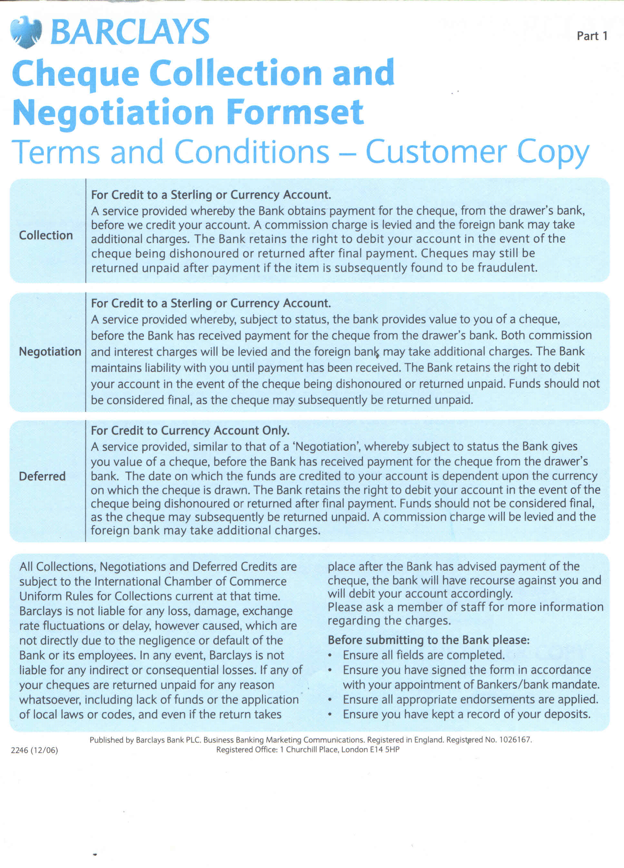
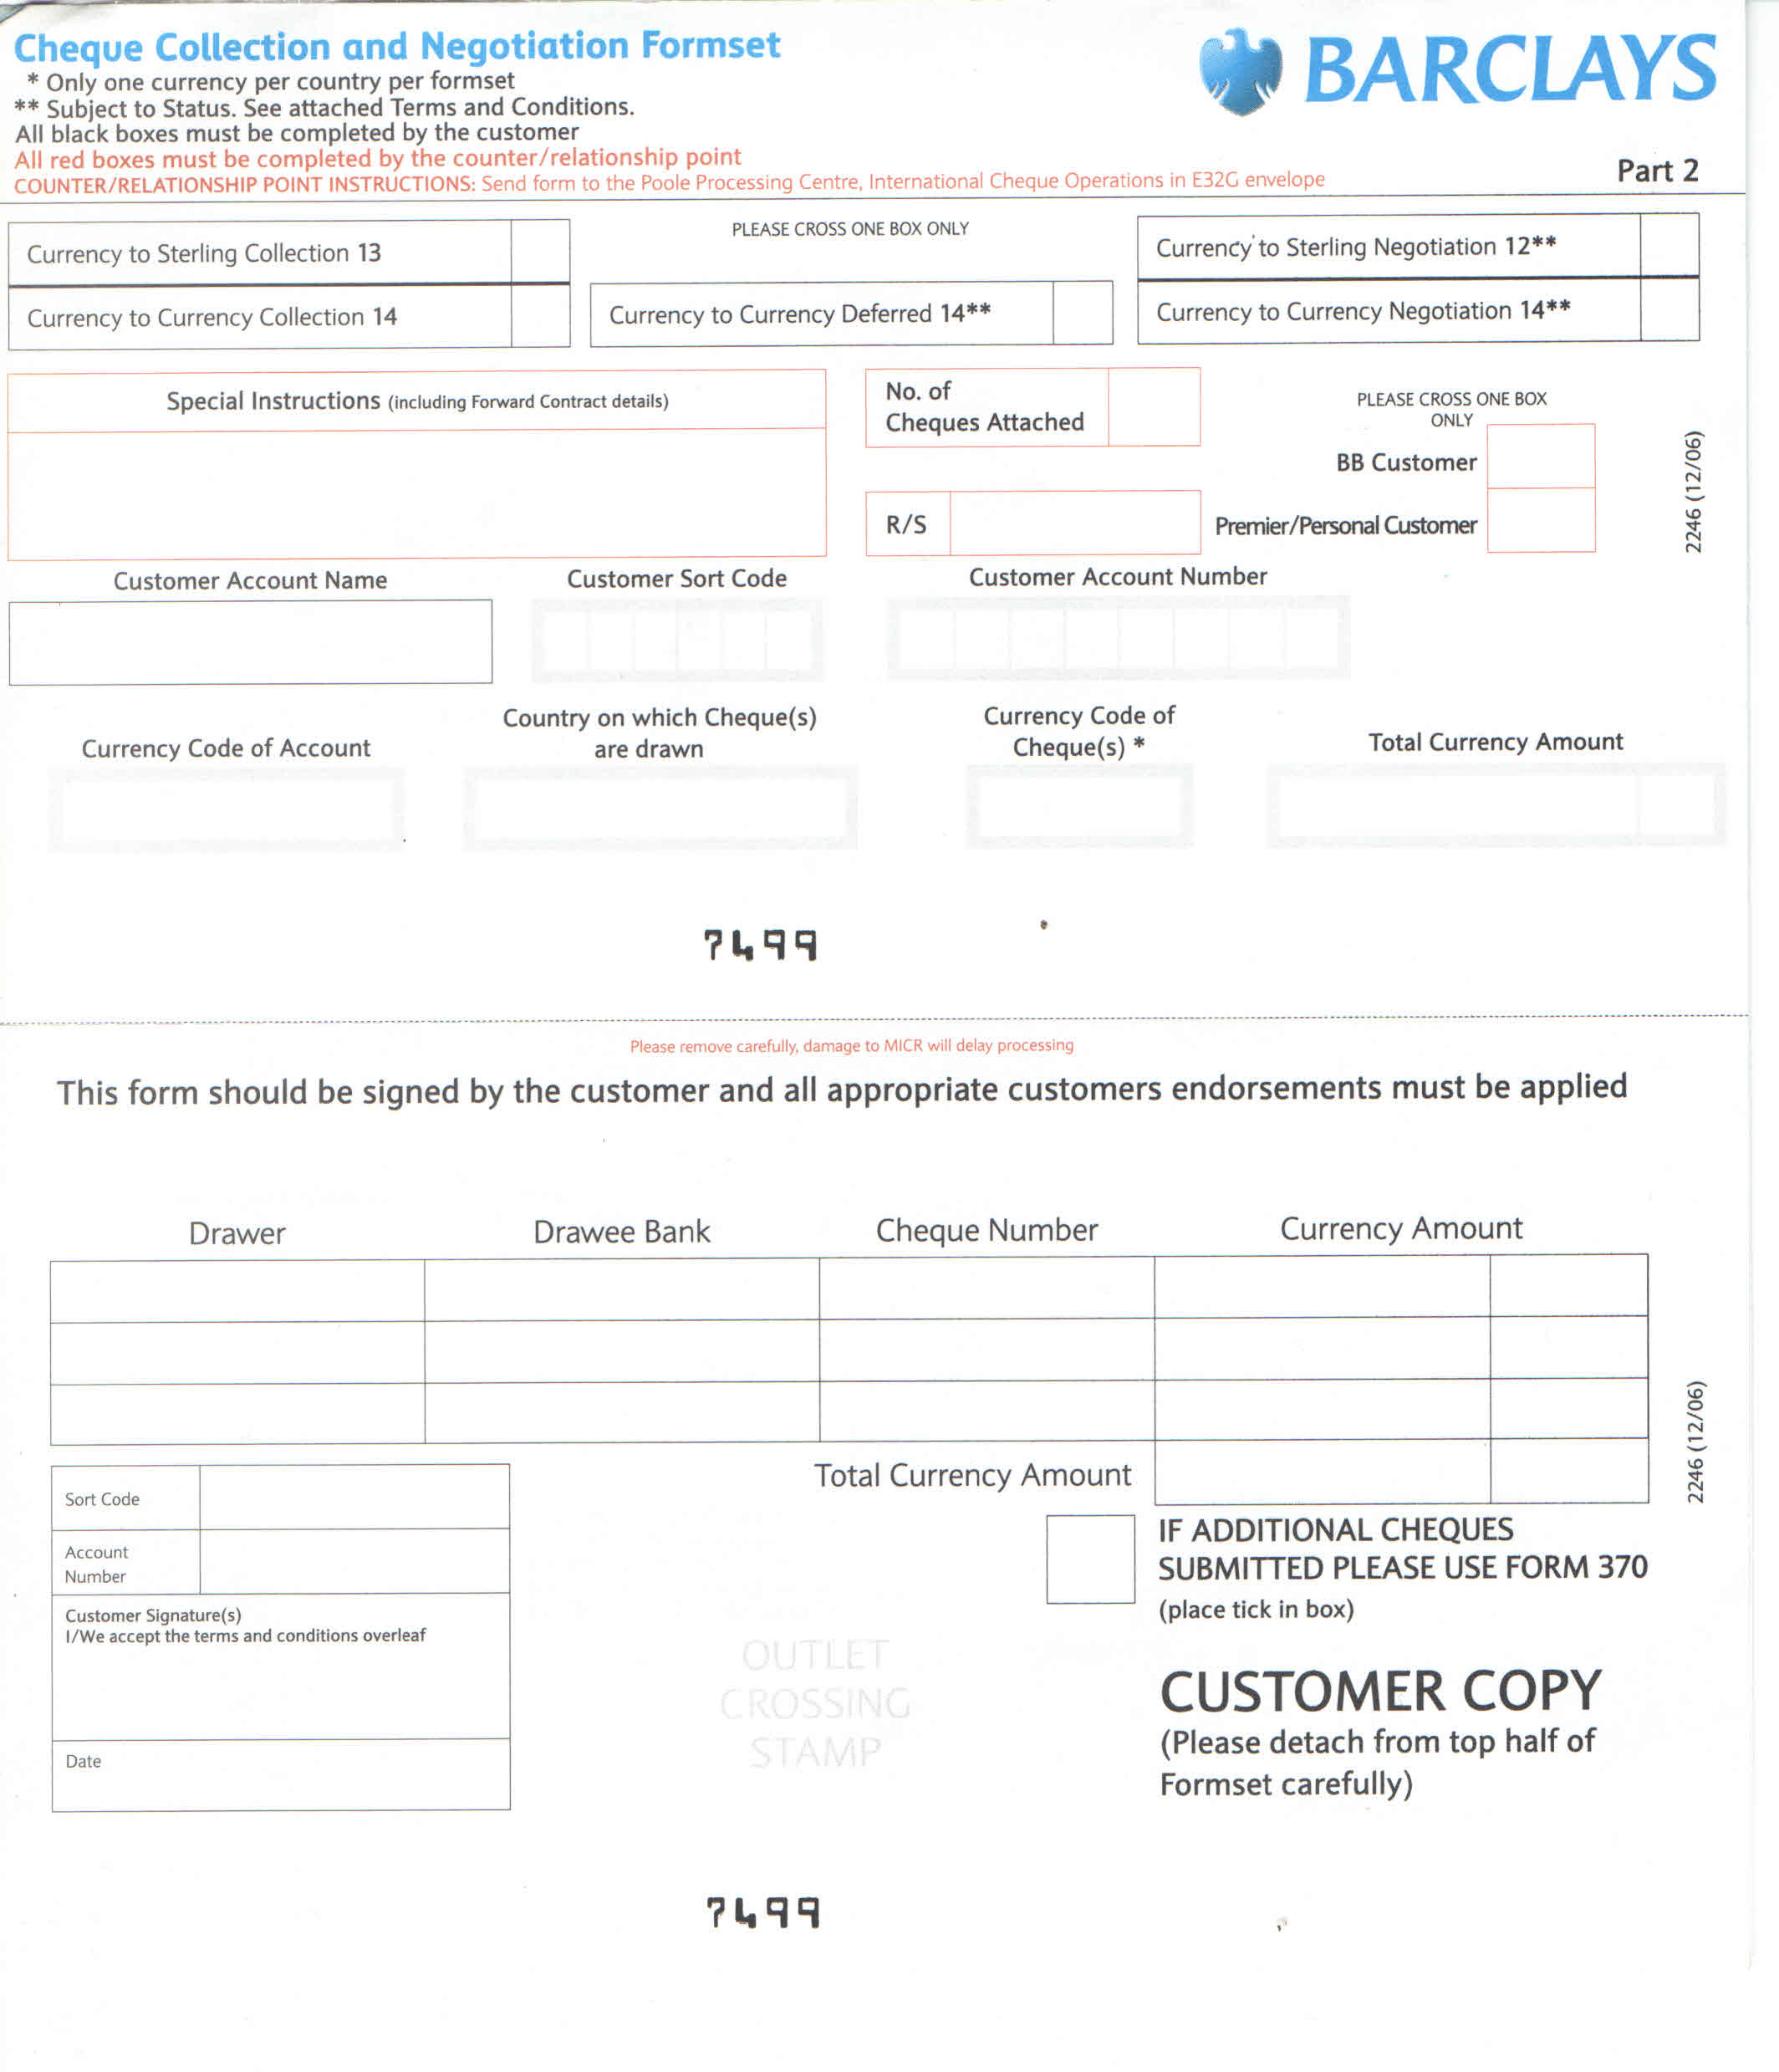

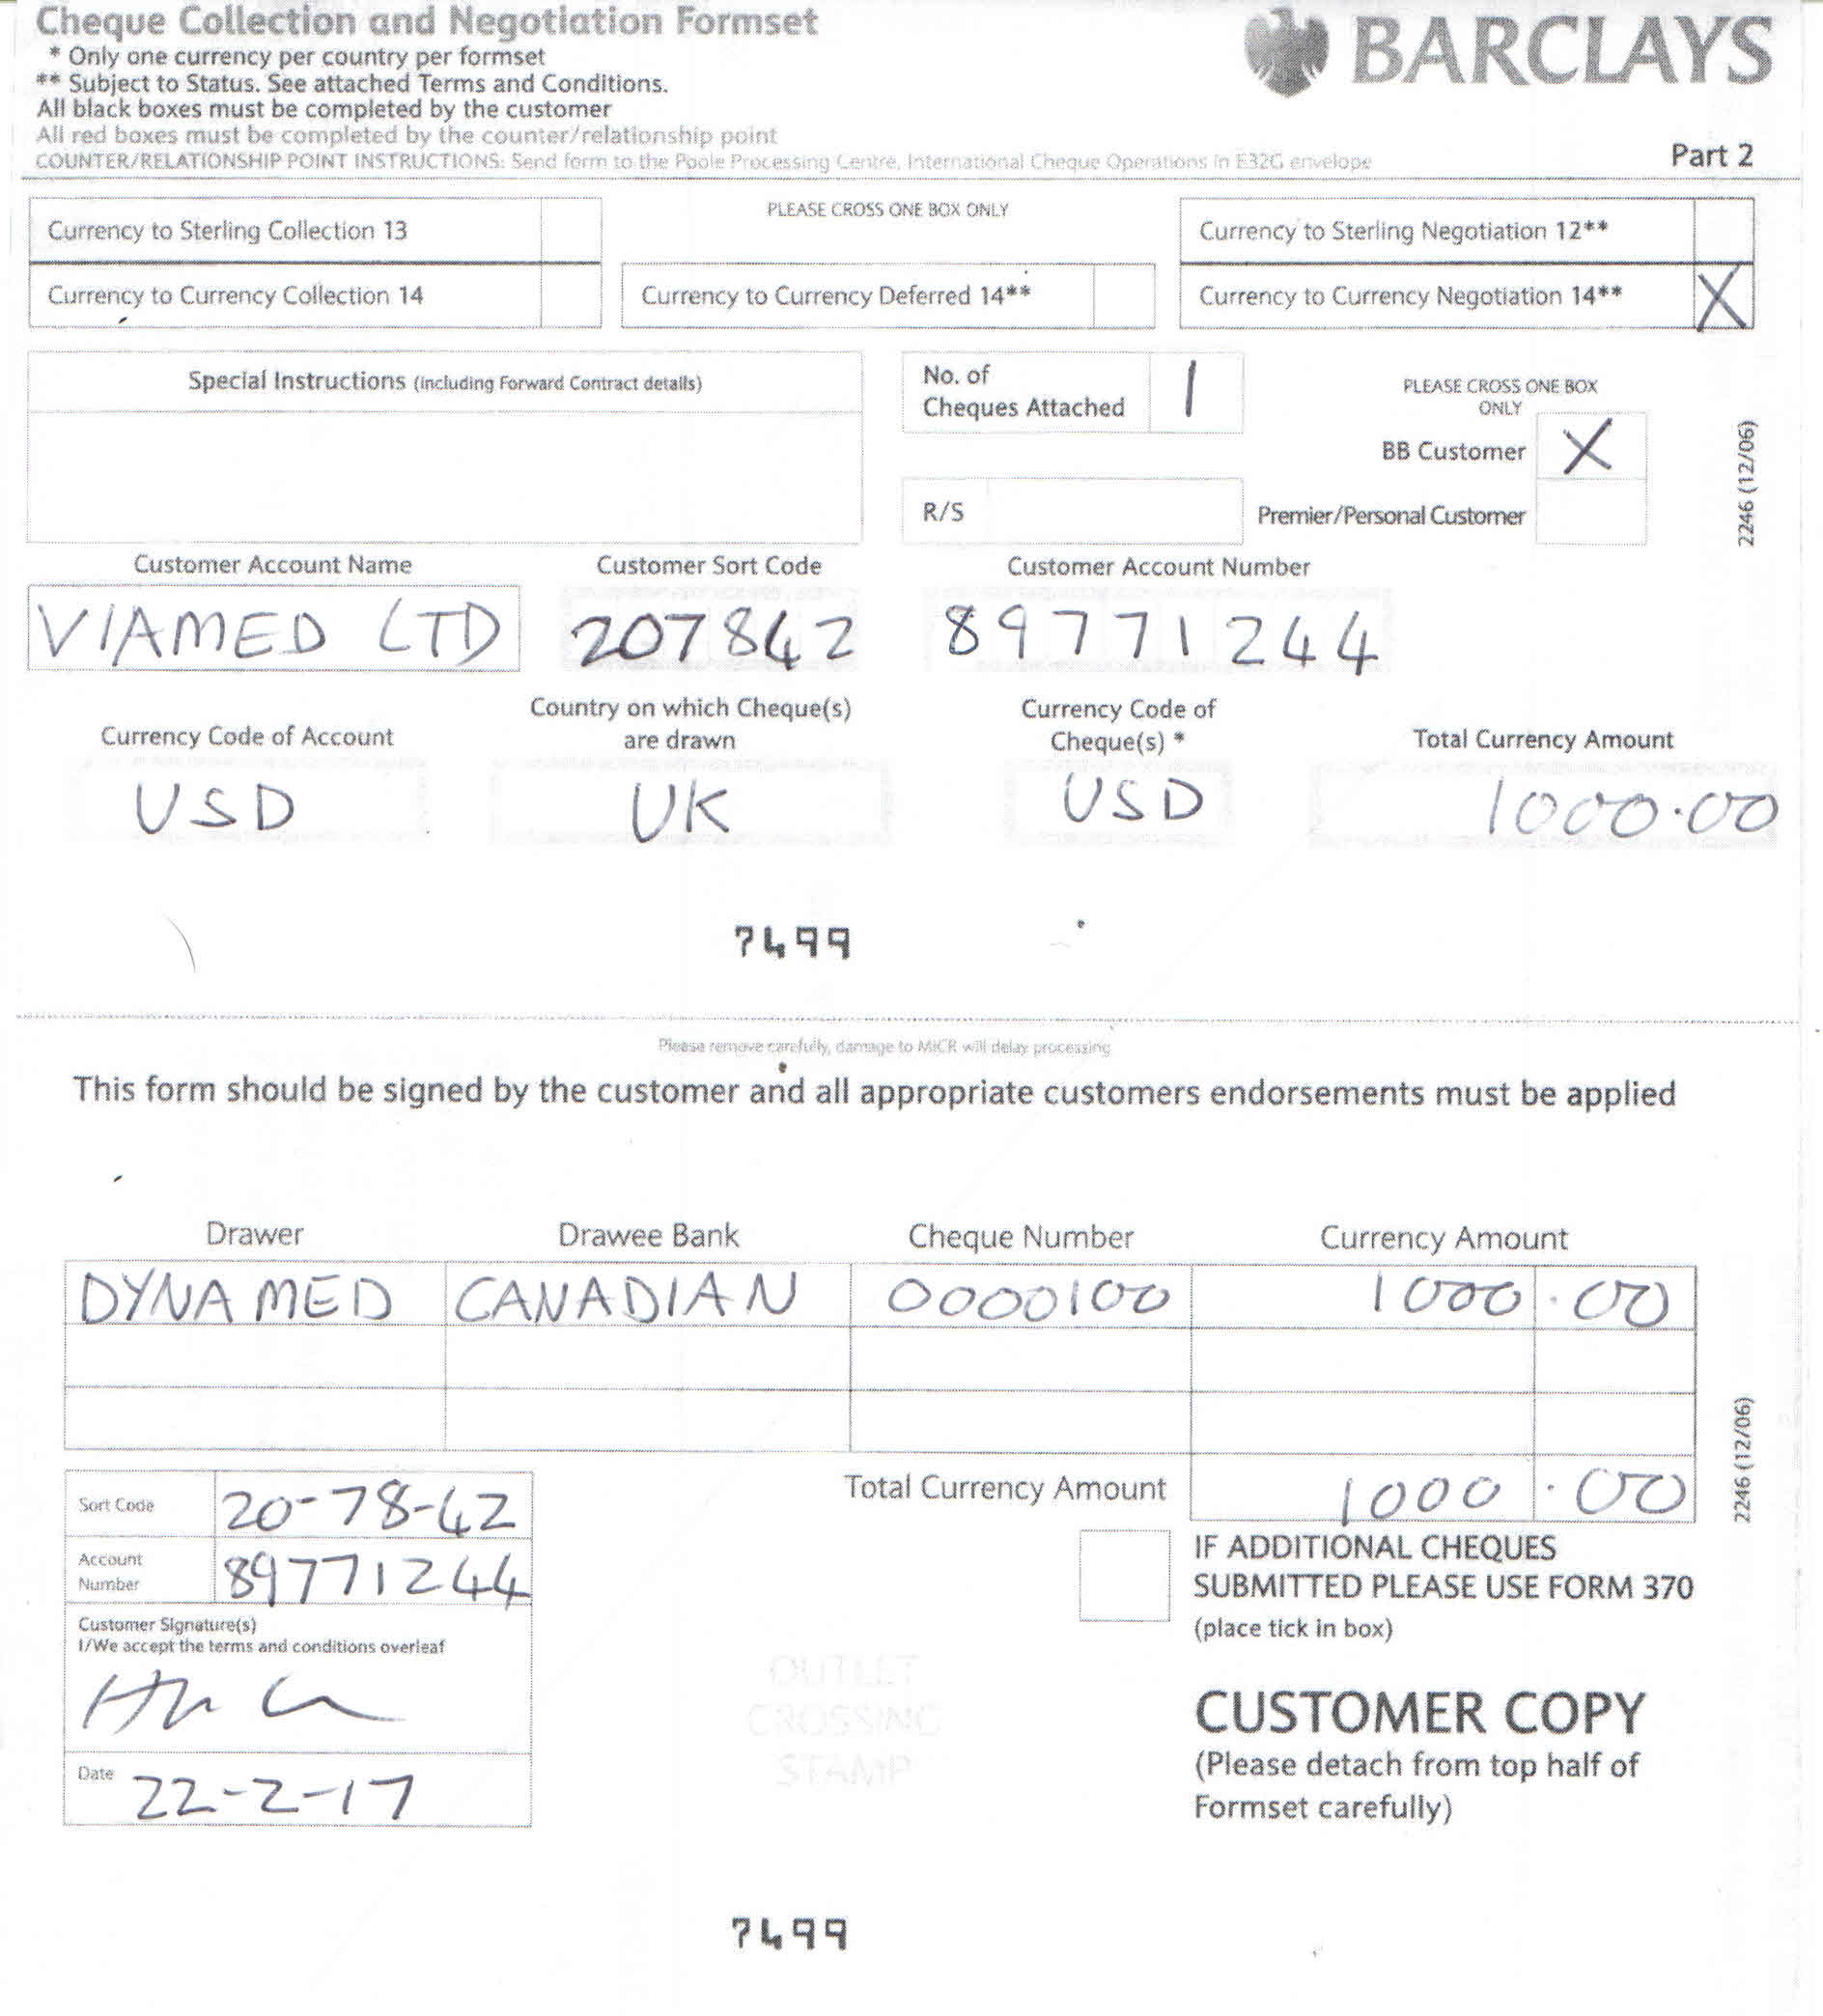

This is how the form is filled in when submitting a USD cheque. If you had a Euro cheques you would substitute the customer account number to 87399700. You use one form per cheque unless you have more then one from the same customer.

Once completed tear off the front bottom section, this part is to keep for our records.

Once filled in you need to produce a letter to the currency lodgement team at Barclays. There are templates in intrastats for this. You can edit the dates and amounts. I have included a copy of the letter at the end of the document. When done, print on to letterhead and sign.

Now the remaining parts of the form, the cheque and the letter go in to a windowed envelope and is posted by recorded delivery.

Keep a note of the recorded deliver reference number with the copy of the cheque and the retained part of the form. This then goes in the top Export remits for processing tray.

Barclays Bank Plc
Poole Processing Centre
BPS Enable Floor 4B
Barclays House
POOLE
Dorset BH15 2BB

22nd February 2017

Dear Sirs,

Please find enclosed one cheque.

To go into the Viamed Limited US Dollar account, number 89771244, sort code 20-78-42. From Dyna Medical dated 222nd Feb 17 for $1000.00.

I have included a currency lodgement form with this.
Thank you for your help

Yours faithfully

Helen Lamb
Credit Control

