Quick Start Guide
MD300-D Finger Pulse Oximeter

This Quick Start Guide describes the steps to successfully start and use the MD300-D.  Before placing the MD300-D in service please read the user manual that accompanies the device. |  | 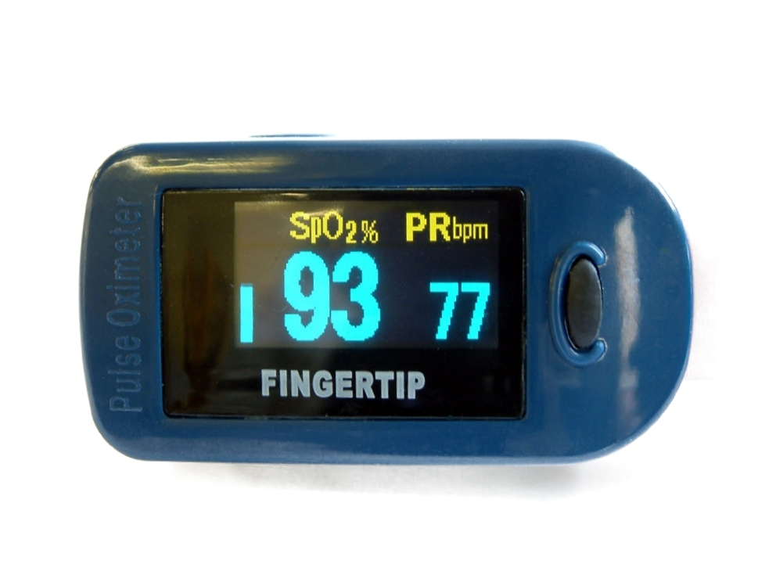
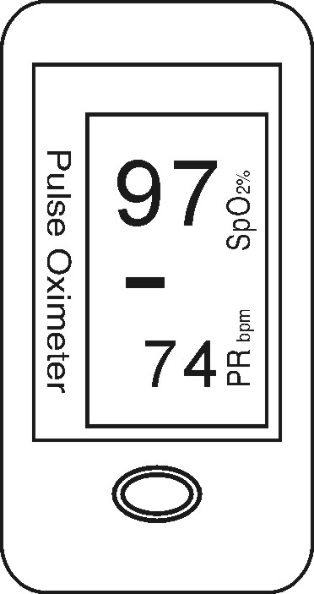  SPO₂  PR  Power Switch  PR Bar graph  SpO₂ = Blood oxygen saturation  PR = Pulse rate  PR Bar graph = Pulse rate signal strength | Low power indicator  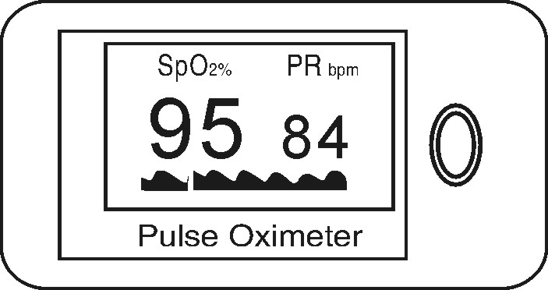  SPO₂ waveform

Battery Installation

- Install the two AAA batteries into the battery cassette, observing the correct battery polarities.

- Slide the battery cover horizontally along the case (as below):
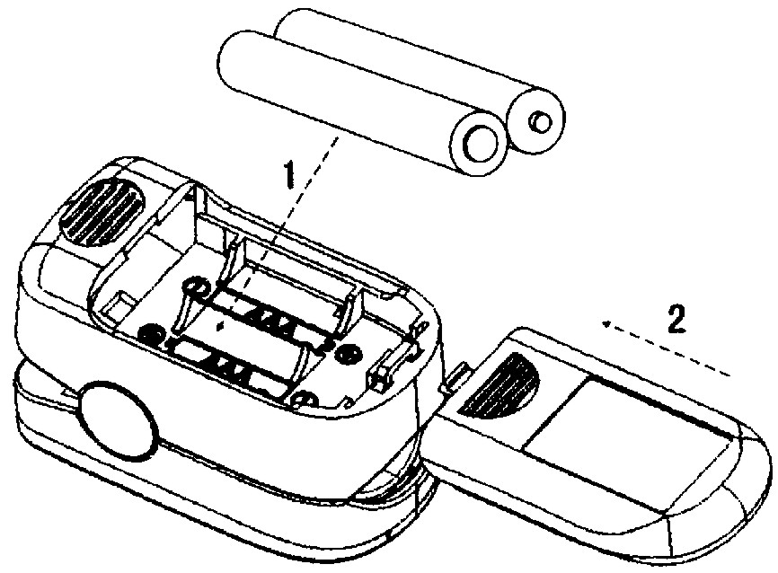

Please remove the batteries if the Oximeter is not to be used for long periods of time.

To Use the Oximeter

- Pinch the clamp, as shown in the diagram.

- Place one finger, nail upward, into the Oximeter.

- Release the clamp.

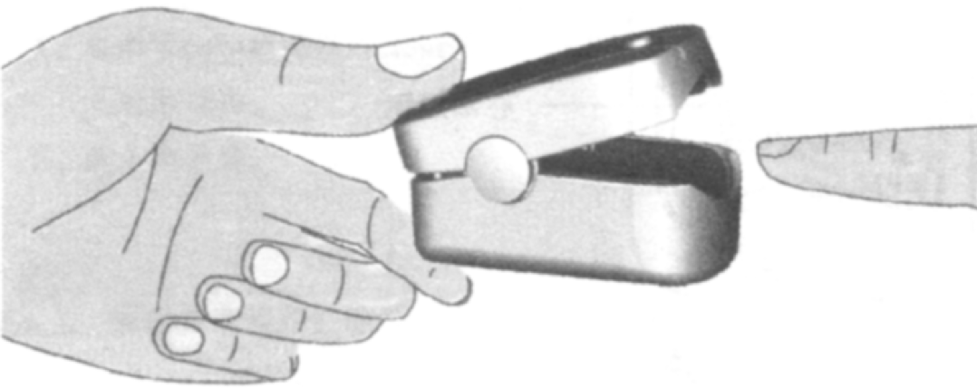

Switching the Oximeter on

Press the power switch button once on the front panel.

Switching the Oximeter off

The Oximeter automatically powers off when there is no finger present for more than 8 seconds.

Display Rotations

The Oximeter has 4 display rotations. Each time you press the power switch the Oximeter will rotate the display.

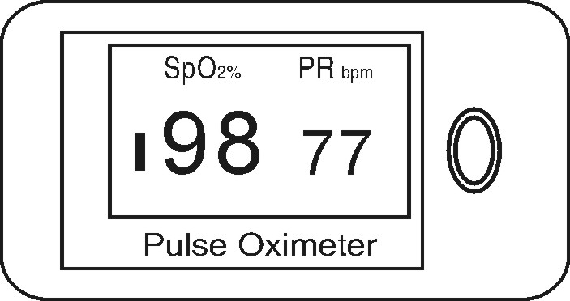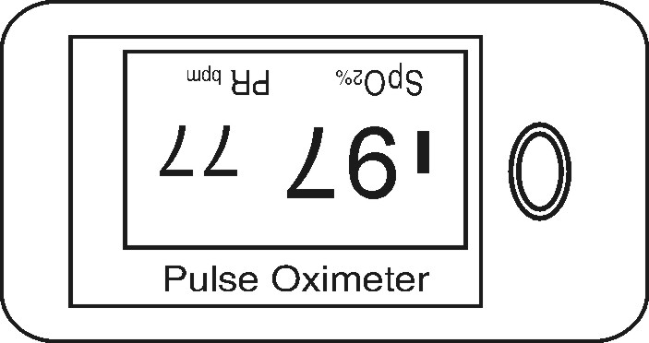

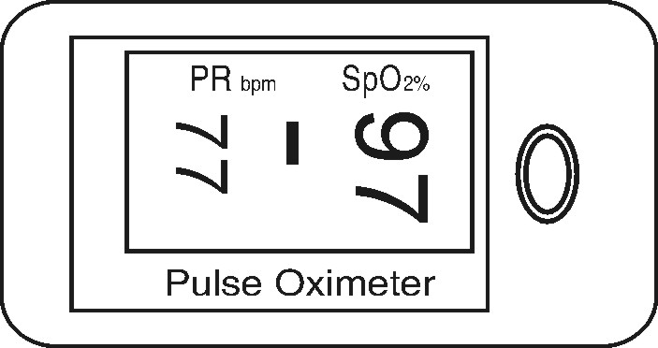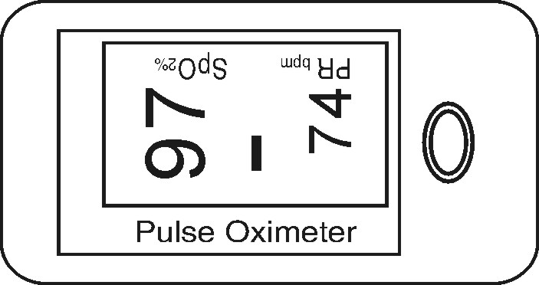

The final two displays of the Oximeter show the Pleth Waveform in two different formats; line trace or solid waveform.

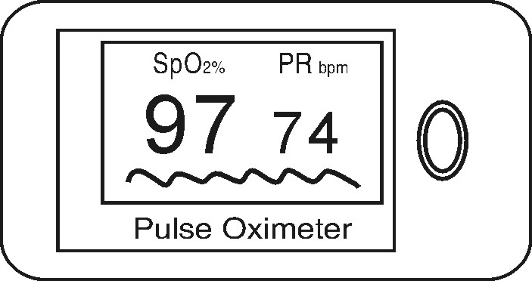

Display Brightness Adjustment

When you press the power switch for more than a second, the brightness of the Oximeter will be changed by degrees, there are 10 levels of brightness; the default level is level four.

