Draft Summary Specification Sheet
Keenova INOmax Evolve DS Gas Sampling Line
Document No. | KGSL-SS-001 | Revision | Draft B
Status | Development Specification | Date | 07 August 2026
Intended Equipment | INOmax Evolve DS | Customer | Keenova Therapeutics
Project | Gas Sampling Line Development | Current Phase | Prototype feasibility evaluation
Document purpose: This summary specification consolidates the current agreed project requirements and development status. It remains a development document and is subject to revision following prototype evaluation and design verification.

1. Product Purpose
Disposable gas sampling line for use with the Keenova Therapeutics INOmax Evolve DS nitric oxide delivery and monitoring system. The INOmax Evolve DS works alongside a mechanical ventilator to deliver inhaled nitric oxide therapy, including treatment of neonatal patients suffering from persistent pulmonary hypertension of the newborn (PPHN).
The sampling line transports a representative respiratory gas sample from the patient breathing circuit to the device gas-analysis module while managing moisture and protecting the analyser from liquid water, particulates and nebulised drug aerosols.

2. Project Objective
- Develop an economical replacement for the existing sampling line and integrated water-trap solution.
- Eliminate the need for a separate water trap by combining moisture-diffusive tubing, a suitable inline filter and a mid-stream sidestream airway-adapter arrangement.
- Reduce consumable replacement frequency, patient-circuit disruption, staff time and material cost per patient treatment.
- Maintain reliable gas sampling in actively humidified ventilator circuits and in the presence of specified anaesthetic gases and nebulised medications.

2.1 Existing Keenova Reference Configuration
The existing Keenova sampling arrangement incorporates a sampling line together with a PTFE membrane filter and water-trap assembly to protect the INOmax Evolve DS gas-analysis system from moisture. The development programme is intended to replace this arrangement with a lower-cost solution that manages moisture without requiring a separate water trap while also providing suitable protection from nebulised drug aerosols.
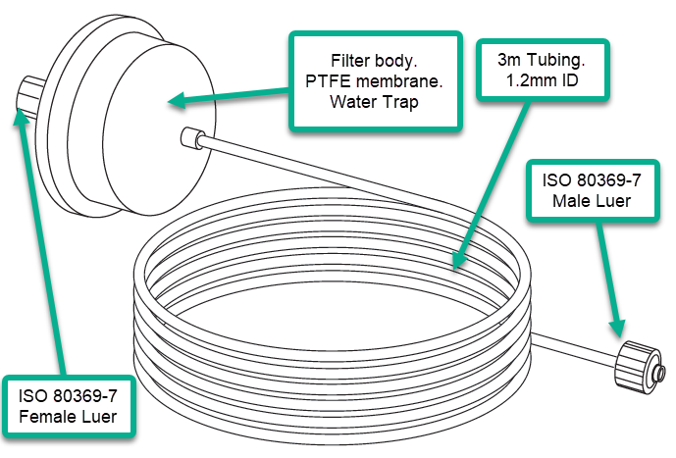
Figure 1 - Existing Keenova gas sampling line / water-trap reference configuration. Reference illustration - not for dimensional control.
The existing design provides the baseline against which the new sampling-line concept is being developed. The new design aims to eliminate the separate water trap, reduce consumable changes and cost per patient treatment, and maintain reliable sampling at the fixed 230 ml/min operating sample flow.

2.2 Proposed Custom Luer Lock Female Connector
A bespoke female Luer Lock connector is under development for the equipment end of the sampling line. The connector is intended to facilitate easy and secure connection to the recessed gas-sampling input port of the INOmax Evolve DS while retaining the required Luer interface.
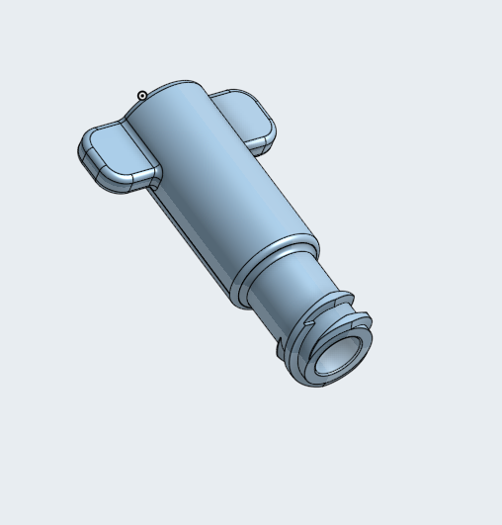
Figure 2 - Proposed custom Luer Lock Female (LLF) connector. Development concept - not for dimensional control.
The controlled engineering drawing and CAD model shall remain the dimensional authority for the connector. The illustration above is provided only to show the intended form and ergonomic features of the development concept.

3. Intended Use and Clinical Range
- Single-patient use.
- Neonatal, infant, paediatric and adult patients.
- Mechanically ventilated patients receiving inhaled nitric oxide therapy.
- Actively humidified breathing circuits.
- Anaesthesia and critical-care applications.
- Use during administration of specified nebulised drugs.

4. Sampling Line Configuration
Parameter | Requirement
Product type | Bespoke H-Type gas sampling line with inline filter
Overall line length | 3.0 m target
Tubing internal diameter | 1.2 mm
Patient-end connector | Luer Lock Male (LLM)
Equipment-end connector | Custom Luer Lock Female (LLF)
Connector arrangement | LLM to custom LLF
Airway adapter | Separate sidestream airway adapter
Operating gas sample flow rate | 230 ml/min (fixed by the INOmax Evolve DS)
Respiration rate range | 12-60 breaths per minute, neonatal through adult
Target service life - no nebulised drugs | 96 hours
Minimum target service life - nebulised drugs | 18 hours
Operating flow: 230 ml/min is the operating sample flow rate, not a pressure-drop requirement. The sample flow is fixed by the INOmax Evolve DS and is independent of respiration rate and other ventilator parameters.

5. Moisture Management
The sampling system shall remove or manage sufficient moisture so that a separate water trap is not required during intended use. The system shall:
- minimise condensation within the sampling line;
- reduce entrainment of condensed water at the patient-circuit sampling point;
- prevent liquid water from reaching the INOmax Evolve DS gas-analysis system;
- maintain the required 230 ml/min operating sample flow throughout the intended service life;
- continue protecting the device if the hydrophobic filter becomes occluded.
The current Keenova engineering drawing specifies that the filter shall prevent ingress of water to the device for a minimum of 5 hours after occlusion.

6. Filter Requirements
- Protect the gas sensors and pump from particulates.
- Prevent liquid-water ingress.
- Minimise blockage caused by nebulised drug aerosols.
- Maintain the required operating sample flow rate of 230 ml/min throughout the intended service life.
- Be suitable for the specified operating duration.
- Use hydrophobic filter media suitable for respiratory gas sampling.
The current engineering drawing identifies 0.2 micron polypropylene-backed PTFE hydrophobic filter media. Final filter construction remains subject to confirmation through development testing. No specific allowable pressure-drop limit has yet been defined in the available project documentation.

7. Gas Compatibility
The sampling line shall operate with respiratory gases associated with the INOmax Evolve DS application, including nitric oxide, oxygen, air, nitrogen and carbon dioxide.

8. Anaesthetic Gas Compatibility
The line shall be assessed for operation in the presence of the following volatile anaesthetic agents:
- Sevoflurane
- Isoflurane
- Desflurane
Project correspondence indicates operation with anaesthetic agents has been described as proven up to 72 hours. The 96-hour project target requires confirmation through the agreed verification programme.

9. Nebulised Drug Compatibility
The sampling line and filter shall be assessed with:
- Albuterol
- Flolan
- Hypertonic saline, including 3% and 7%
The project target is a minimum operating life of 18 hours in the presence of nebulised drugs. The current Keenova engineering drawing contains a 12-hour minimum non-occlusion requirement under active humidification and nebulised-drug exposure; this difference shall be formally aligned before final design release.

10. Airway Adapter Compatibility and Mid-Stream Sampling
The gas sampling line shall use a separate sidestream airway adapter incorporating a female Luer Lock sampling sideport for connection to the Luer Lock Male patient end of the sampling line.

10.1 Adult/Paediatric
- Sidestream airway adapter with female Luer Lock sampling sideport.
- Patient-circuit size: 15 mm O.D. to 15 mm I.D. / 22 mm O.D.
- Current development/evaluation references: 4420531 / 4420532.

10.2 Infant/Neonatal
- Patient-circuit size: 15 mm O.D. to 4 mm I.D. / 15 mm I.D.
- Separate adapter configuration required for the neonatal/infant application.

10.3 Advantage of Mid-Stream Gas Sampling
The sidestream airway-adapter design takes the sample from approximately the middle of the breathing-gas pathway rather than directly from the wall of the breathing circuit. This reduces the likelihood of condensed water being drawn into the sampling port and lowers the liquid-water burden presented to the moisture-diffusive tubing and inline filter.
- reduces entrainment of condensed water droplets into the sampling line;
- lowers the moisture burden presented to the tubing and filter;
- reduces the likelihood of premature hydrophobic-filter blockage caused by liquid water;
- complements the moisture-removal function of the VersaStream-type tubing.

10.4 Advantage of a Separate Airway Adapter
The separate airway-adapter configuration also allows the adapter to remain installed in the active patient breathing circuit when the gas sampling line requires replacement. This can:
- reduce unnecessary disruption of the active patient circuit;
- reduce the time required to change a sampling line;
- allow the airway adapter potentially to remain in use for the duration of a patient treatment, subject to the approved instructions for use;
- reduce material and consumable cost by avoiding unnecessary replacement of the airway adapter each time the sampling line is changed.

11. Connector Requirements
Interface | Requirement
Patient end | Standard Luer Lock Male connection; compatible with separate LLF airway adapters.
Equipment end | Custom Luer Lock Female connector compatible with the recessed INOmax Evolve DS sampling port and designed for easy, secure connection.
Standard | Luer interface to comply with ISO 80369-7, subject to confirmation of final applicable requirements.

12. Materials, Construction and Packaging
- Latex free.
- DEHP free.
- Medical-grade materials suitable for respiratory gas contact.
- Clean and individually packaged.
- Certificate of Compliance supplied where required.
- Target tubing length: 3.0 m +/-50 mm.
- Tubing I.D.: 1.2 mm +/-0.05 mm.
- Tubing marked "GAS SAMPLE" at 80 mm intervals, per current drawing.

13. Preliminary Verification Requirements
- line length and tubing I.D.;
- connector dimensions, fit and retention;
- leak rate;
- operating sample flow at 230 ml/min;
- moisture removal and water-ingress protection;
- 96-hour standard-use performance;
- minimum 18-hour performance with nebulised drugs;
- anaesthetic-gas compatibility;
- packaging integrity and material compliance;
- functional operation with the INOmax Evolve DS.
The current engineering drawing includes a maximum leak rate of 0.207 sccm after pressure stabilisation at a minimum of 10 psig and a minimum flow of 1.7 slpm under its defined bench-test conditions. Applicability of these bench-test limits to the final supplier specification shall be confirmed.

14. Prototype and Evaluation History
Stage / Invoice | Sampling Line | Airway Adapter | Filter | Outcome / Purpose
Initial commercial evaluation  RVM161874-1 | 4420873 commercial VersaStream; 1.0 mm I.D.; integrated Adult/Paediatric airway adapter; LLM equipment connection. | 4420531 Adult/Paediatric sidestream airway adapter, female Luer Lock sideport; 1 box of 25 supplied separately for evaluation. | Standard integrated VersaStream filter | Commercial baseline. Evaluated moisture-diffusive tubing and compared integrated versus separate airway-adapter concepts.
First bespoke H-Type evaluation  RVM162478-1 | Qty 4 x 4421619; 2.5 m; 1.2 mm I.D.; LLM to LLF. | Separate Adult/Paediatric sidestream airway-adapter configuration associated with the development evaluation. The current invoice copy does not separately itemise an adapter. | Type E11 | Moisture removal worked very well and supported elimination of the water trap. Type E11 filter blocked during nebulised-drug exposure.
Large-format filter evaluation  RVM164903-1 | Qty 2 bespoke H-Type; supplied at 2.15 m rather than target 3.0 m; 1.2 mm I.D.; LLM to LLF. | Qty 2 x 4420532 Adult/Paediatric sidestream airway adapters with female Luer Lock sideport. | 4.5 cm development large-format filter | Current go/no-go assessment of resistance to blockage during nebulised-drug administration. Awaiting Keenova feedback.

15. Current Project Status
Project phase | Prototype feasibility evaluation
Current activity | Awaiting feedback from Aidan Boland at Keenova following testing of the latest two large-format-filter samples.
Current test objective | Quick go/no-go assessment of whether the 4.5 cm development filter provides sufficient resistance to blockage from nebulised drugs.
Known limitation of current samples | Latest lines were supplied at 2.15 m rather than the required 3.0 m; they are development samples and are not suitable for final design verification.
Next step following successful result | Manufacture and evaluate a full-length 3.0 m prototype using the selected filter and custom LLF connector.

16. Key Project References
- Invoice RVM161874-1 - initial VersaStream 4420873 and 4420531 airway-adapter evaluation shipment.
- Invoice RVM162478-1 - four bespoke H-Type 2.5 m LLM-to-LLF development lines.
- Invoice RVM164903-1 - two 2.15 m large-format-filter development lines and two 4420532 sidestream airway adapters.
- Keenova / Mallinckrodt draft engineering drawing - Evolve Gas Sample Line and Filter.
- Viamed VersaStream Luer Lock Male selection guide and product leaflet.
- Project correspondence covering mid-stream sampling port, nebulised-drug testing, filter development and current requirements.

Revision History
Revision | Date | Status | Summary of Changes
Draft B | 07 Aug 2026 | Current working draft | Updated operating flow terminology; corrected respiration rate to 12-60 breaths/min; identified Type E11 filter; expanded sidestream airway-adapter shipment history; added mid-stream sampling, patient-circuit disruption, time and material-cost advantages; updated current go/no-go filter evaluation status; added existing Keenova reference configuration and proposed custom LLF connector figures/captions.

