David Watson
Darlington Memorial Hospital
Clinical Engineering Department
Hollyhurst Road
Darlington
DL3 6HX

28th January 2025

Dear Andrew,

Re: Tom Thumb service exchange units ref. SOR971

Please find enclosed 2 Tom Thumb TT480 service exchange units to allow you to return your devices for annual service 2 at a time.

Serial Number | Description
SE020 | Tom Thumb Infant Resuscitator TT480
SE022 | Tom Thumb Infant Resuscitator TT480
Please can you send your devices back to us using returns ref SRS69013 to the following address:

Returns Dept – SRS69013
Viamed Ltd.
15 Station Road
Cross Hills
Keighley
BD20 7DT
Our Service Department will provide a quotation to request a purchase order so that we can service your units and return them to you as soon as possible.

Regards,
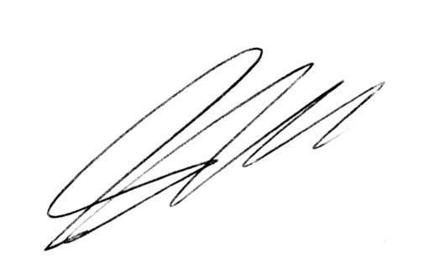
Steve Hardaker
Technical Support Manager
Viamed Ltd.

