Barclays Iportal Barlcays.net How to install, login and authorise staff.

Put card in to the card reader and a pop up should appear to re set the pin form the one that was sent by Barclays. If this does not appear re install the software from the Barclays software page. You will need the card number and date on the card to access the software links..
You may need an admin to Activate new device in their log in – Administration – User 3 dots at the end. Activate New device or activate a renewed device. Depending on it this is your first card and / or reader.

It may ask you to add a memorable word and Numeric characters only, 6 digits. Add these and make a note somewhere secure.

I new software is needed download the zipped file and extract it. Run the application file and click through.
This process will require a reboot. Once rebooted load Google Chrome and make sure the add the Gemalto browser extension.

You will need to install the certificates for the card using the classic Client Tool box. This loads up
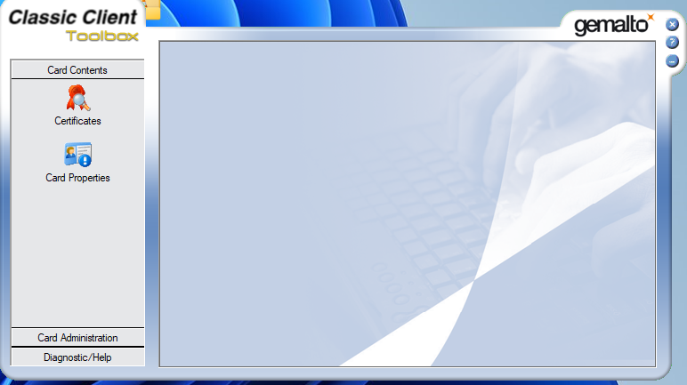

You can verify the card and reader is working in here by clicking diagnostic/help – diagnostic tool – smart card and reader diagnostics start (make sure card is fully in and reader is plugged in.)
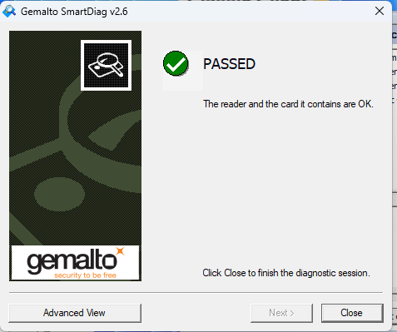

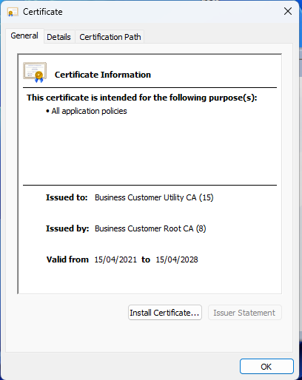
In card contents click certificates. It should allow you to login using your pin (if not re install the software if you haven’t already.) Once logged on right click on each certificate and install the certificate for each line. Once you click, a second box will come up and let you install the certificate. Close and the do the next one.
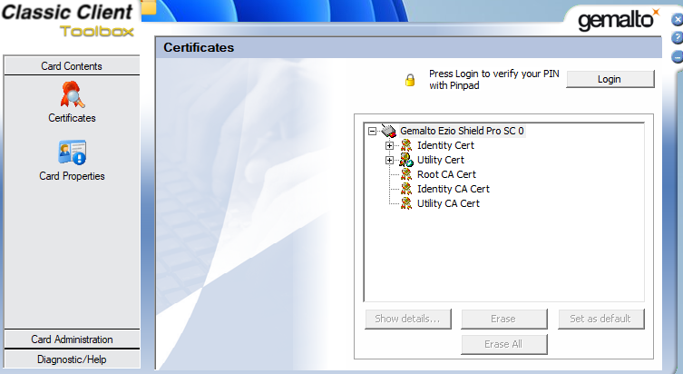

I have not found a way to do all them together.

This Classic client / Gemalto program is the place to change the user pin.

Once all that is done you should be able to go the Barclays Iportal and login using your smartcard and pin. Once in Iportal you can get to Barclays.net from the link at the top right corner.

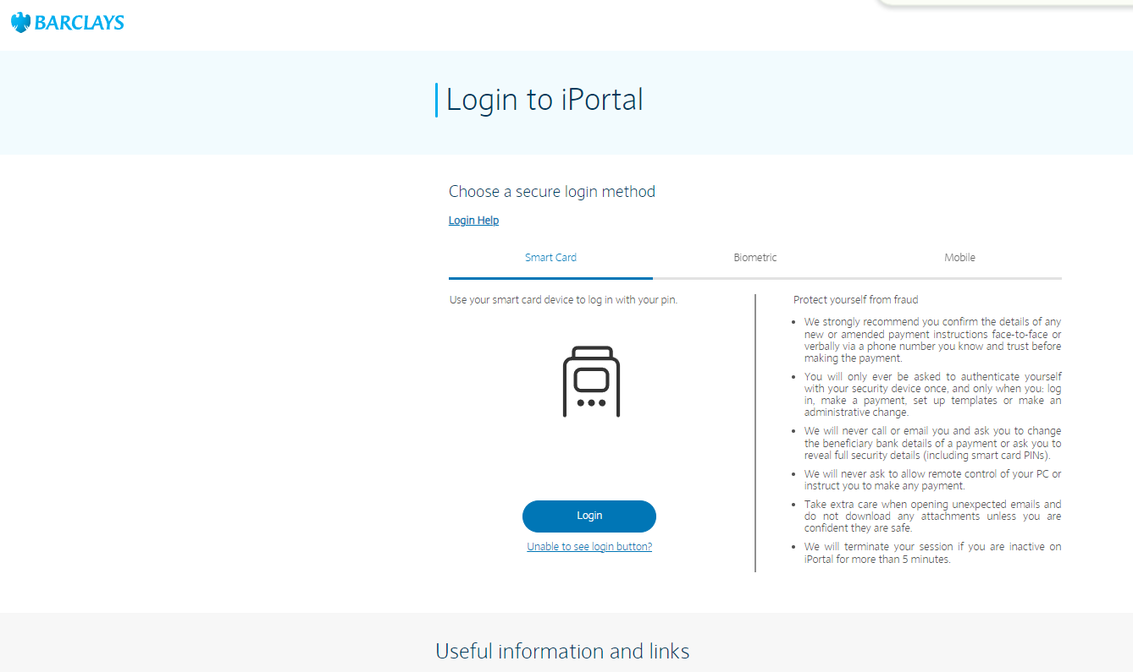


When setting up the mobile login. You have to have the card and reader already set up. Once that's done ask the member of staff to install the Barclays Corporate App With this log and just the work Corporate under it.

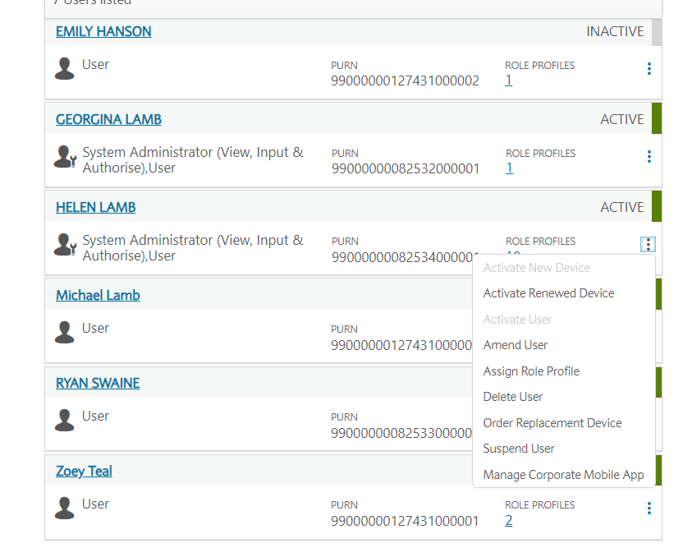
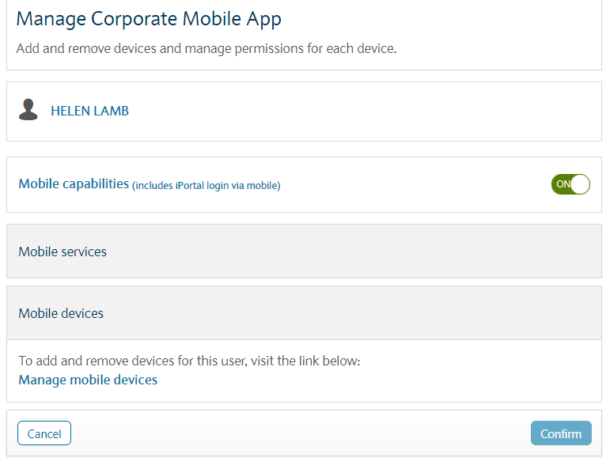

In the Admin section Users you can Manage Corporate Mobile App – in here tick Mobile Capabilities. This will allow the staff member to register the app. Once they are on, this section will allow the admin to Manage the mobile devices of the staff member. It should come up with the make and model of the phone the staff member is planning to use to log in to the Iportal.

Authorise this (you will need your own Iportal App to Re-Authenticate or Sign) using the QR code.

The staff member will have to wait 24 hours from registering their Corporate app before you can activate device in the Manage Mobile Devices in Manage Corporate Mobile App.
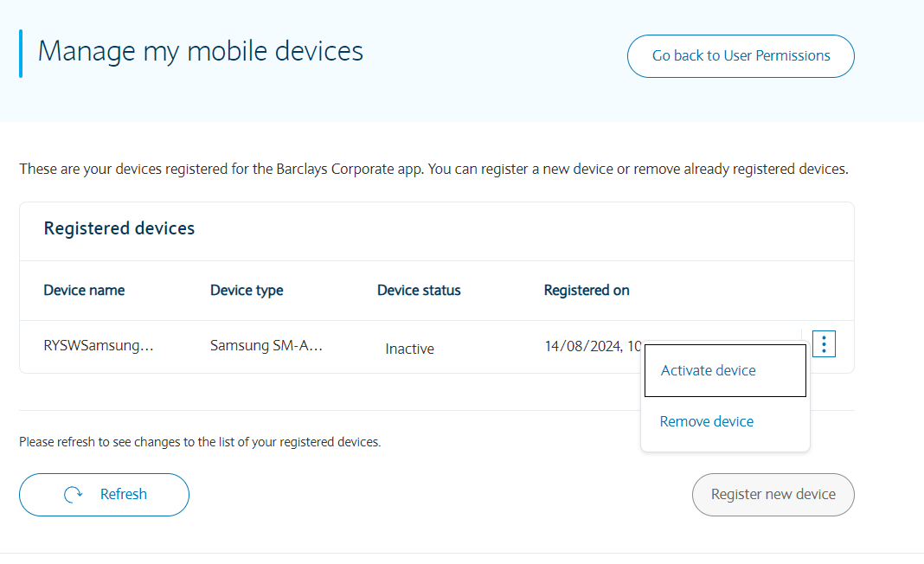
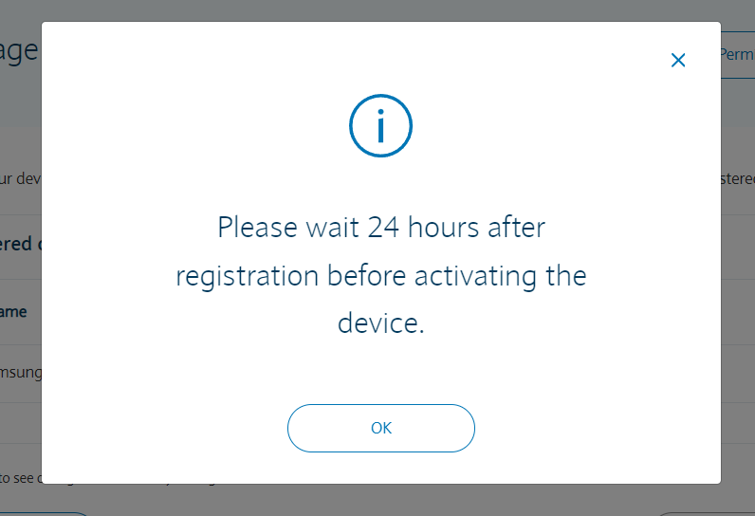

Trouble shooting

This set of programs is hard to deal with. If its a totally new user I think we have to go in to Barclays.net and set up role profiles. Last time I had a go but the Barclays call help line is very good.

Admin – User

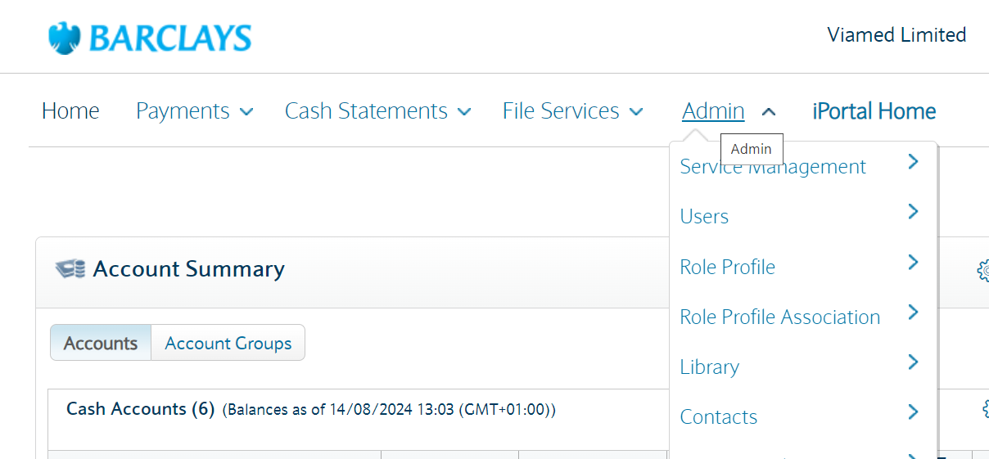

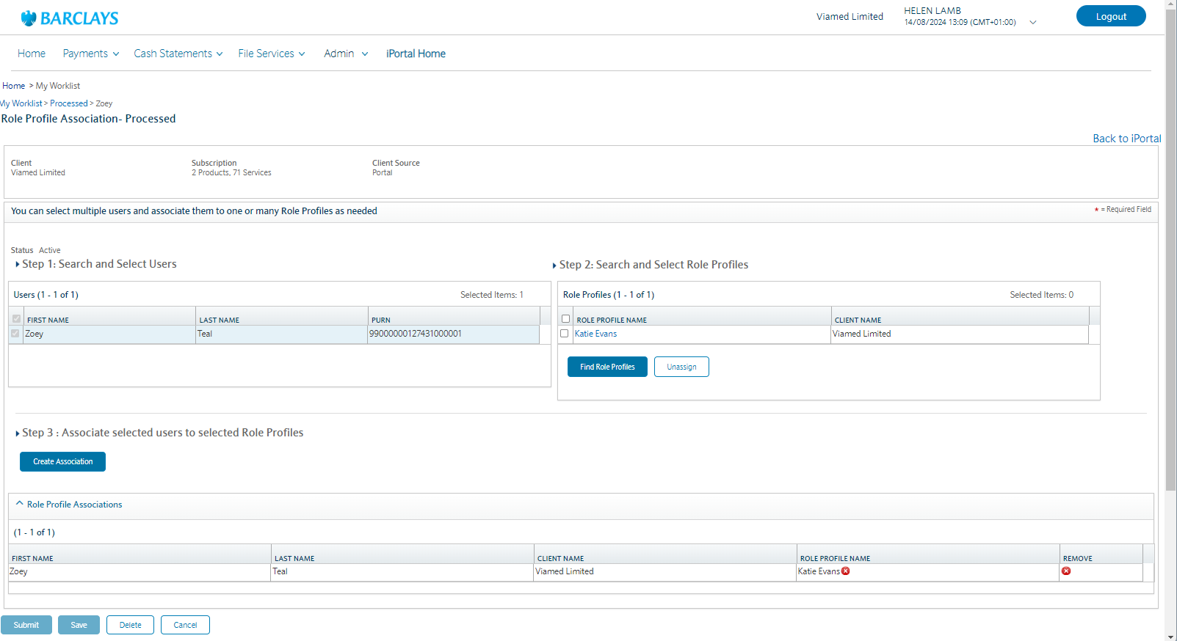

So new user needs a role or roles adding to allow them to access any sections in the barclays.net.

You can link them to an exiting profile that has the permissions you want the new staff to have. If you want a better role profile you’ll have to work it out yourself.
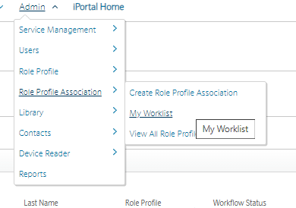

Create Role profile associations – find user

Role Profile Association – My Worklist

Role Profile Association – Process
Step 1: is the new user
Step 2: is the role you are linking the user to
Then Step 3: Associate selected users to selected role profiles.

Then Submit and authorise in the mobile app



