Duty and VAT break downs

Go to https://www.tax.service.gov.uk/customs/payment-records/

Log in

943418914517 Viamed Linked to HL Phone viamed1978
124693049463 Vandagraph Linked to HL Phone gfbd1313
389844758776 VST Linked to HL Phone mLGVm!5E9EVnB

The C79 forms are found in here for use when reconciling Xero and the Deferment statements.
Note – We do not use Postponed import VAT accounting. We are not set up for it so if you are asked say no.

Duty
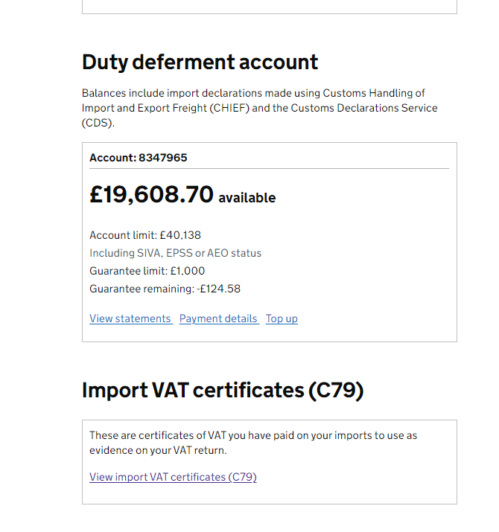
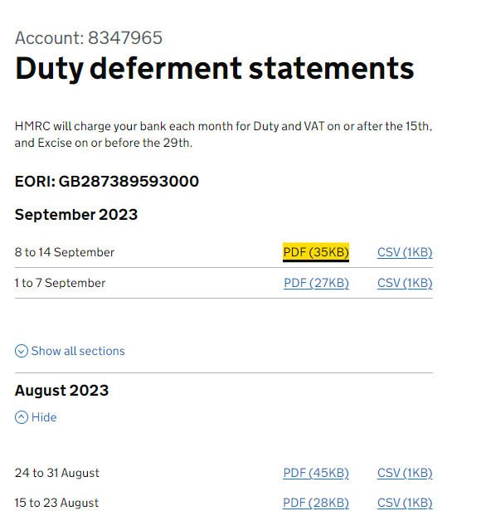

Duty deferment statements are for looking at what we were changed in Duty and VAT. Click view statement then select the correct pdf. This downloads. The second page shows a break down of the imports and the associated charges. Customs duty and VAT. We never pay anything in Excise.

All VAT is claimed back in the next VAT return but all the duty is a cost to the company. The only item we bring in that has a Duty cost to is is Eyemax from Maxtec. As they are considered clothing.

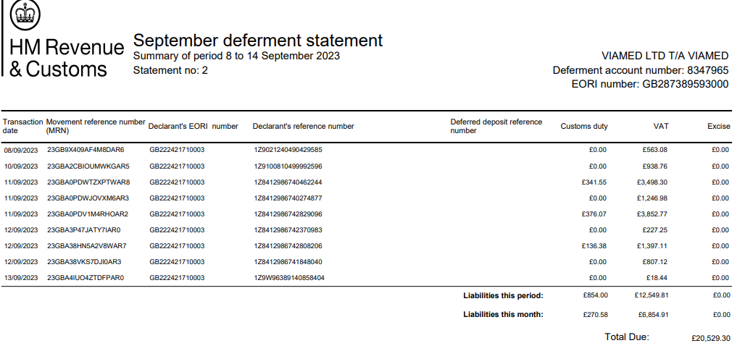

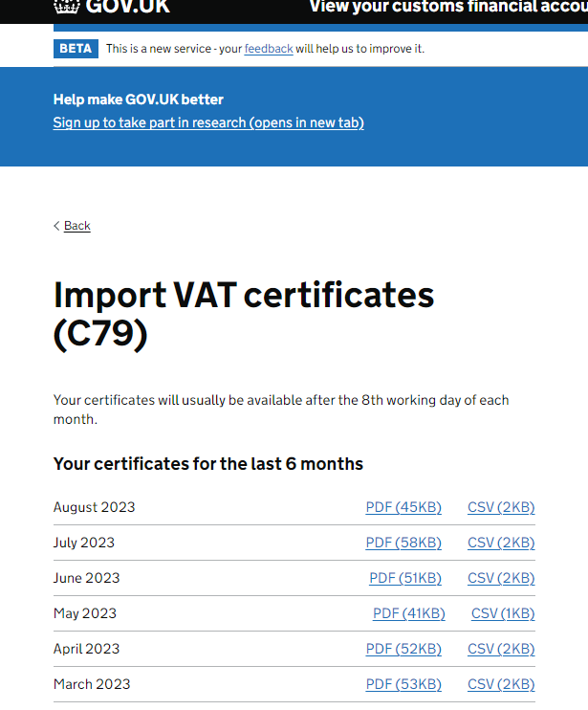
C79 Forms
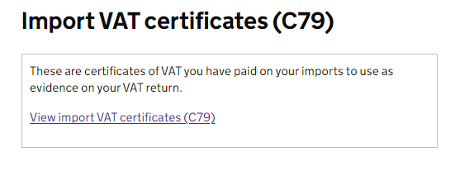

On the accounts package Xero every month a Deferred Duty payment is taken and this payment has to be reconciled with extreme care. It directly affects the profits of the company. The amount charged is mostly VAT all this VAT can be claimed back at the quarterly VAT return.

So what we need is the C79 form to tell us exactly how much VAT and Duty there is in each payment each month. Duty is the none VAT protion, sometimes present. We upload the C79 form so that it can be verified later by us or the accountants. I also keep a copy in the VAT file in my Secure file (documents helen AA secure) .

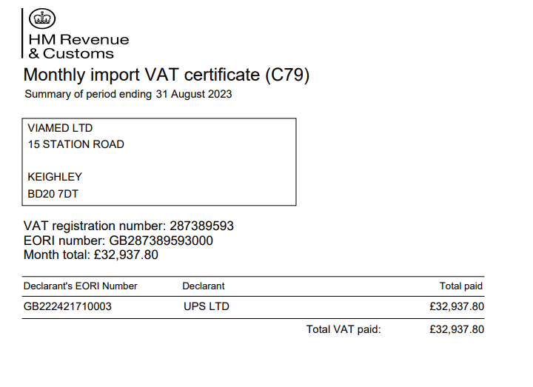
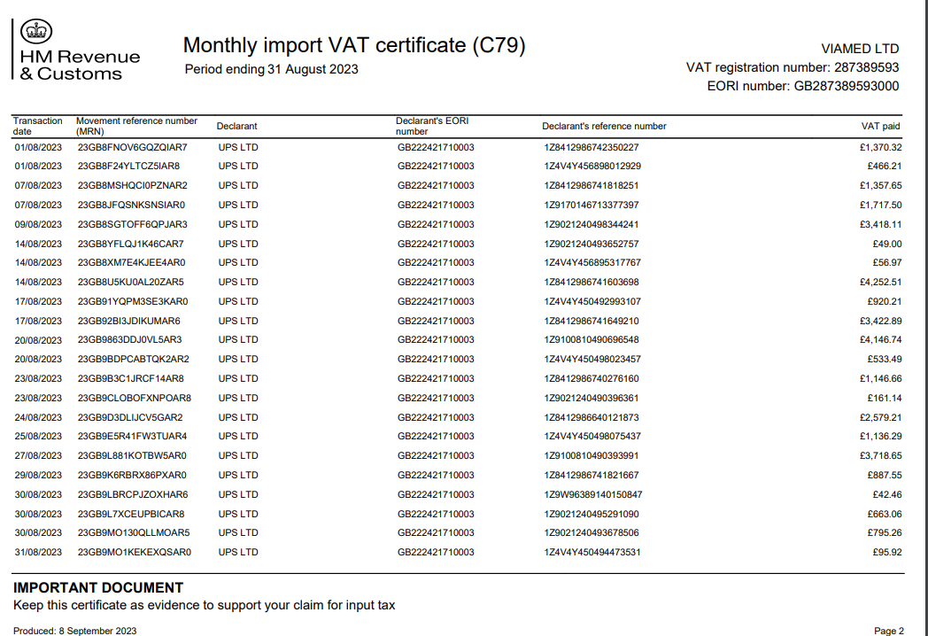

We only need the front page to work out the calculation for Vat in Xero. This is the VAT amount we have to make Xero reflect this using different calculations in Xero to make the VAT correct.


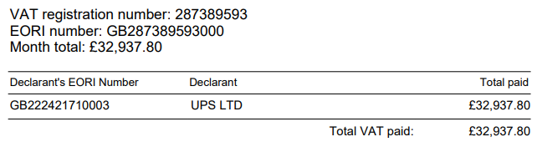

So in this case Augusts Deferent will appear on Xero is September.

In Xero for the Viamed C79 form / deferment. Keep as 3 lines.

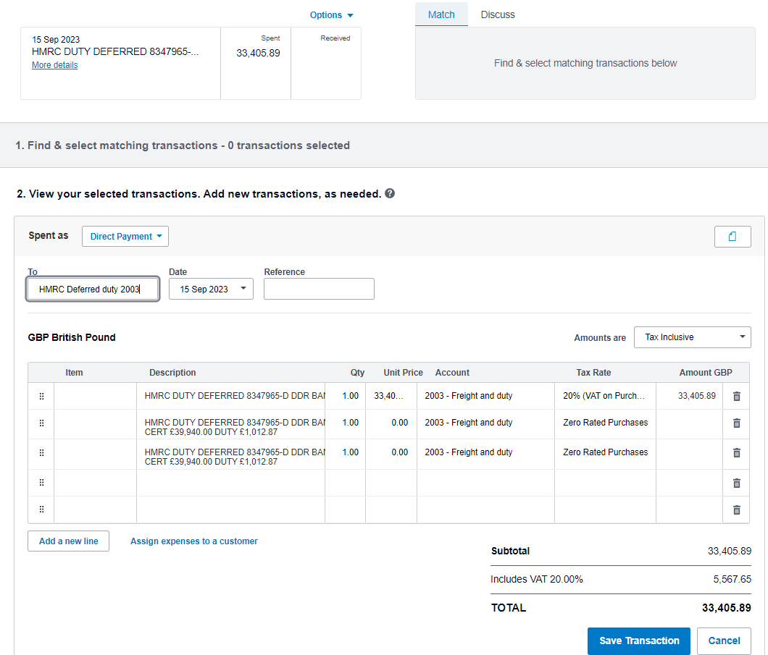

The VAT amount has to be what's on the c79 form no matter if the amount on the bank is smaller of bigger.

Download the C79 form and make sure to add the month to the name. This wants to be copied/ moved to the VAT file in thr C79 folder for the correct company, there is a C79 form and deferment calculation to do for all three of the companies.
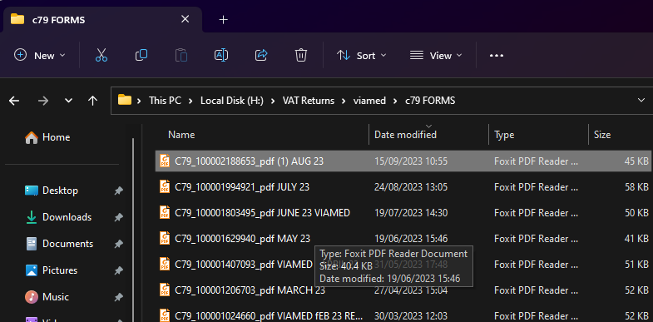

In Xero
To – HMRC Defered Duty 2003
Date – will be filled in by Xero
Reference – put the month and year the C79 form relates to
The description is always the figures that we have on the bank and have on the certificate.

In this case
HMRC DUTY DEFERRED 8347965-D DDR BANK £33405.89 CERT £32937.80 DUTY £468.09

this is copied in to the three description so they show on the vat return so we can verify it later.
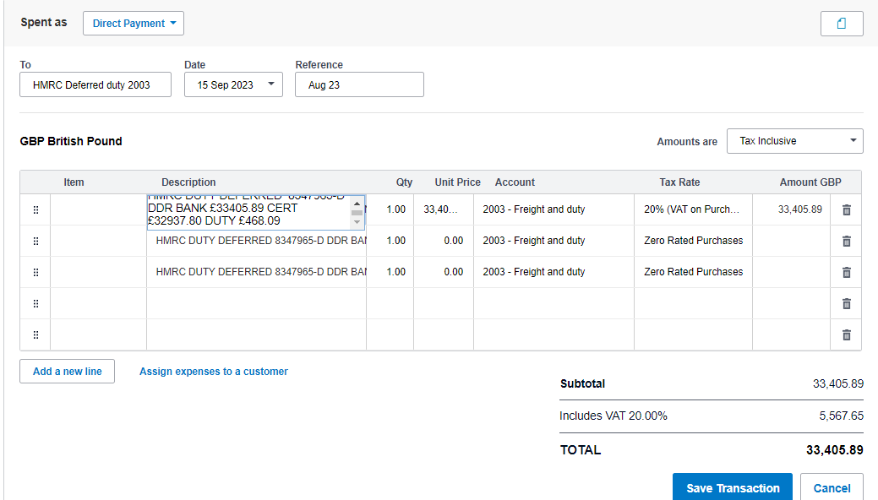

First line has 20% Vat on Purchase the other two is zero rated purchase, Account is 2003 – Freight and Duty (this is the Nominal Account the transaction will go in to as well and the VAT account)

So first line in the unit price add the VAT only amount from the certificate 6*32937.80
Second line the same but unit price is -5*32937.80
Last box is the duty amount – this is the difference between the bank amount we have been charged and the certificate amount from the HMRC C79 form.
£33,405.89 - £32,937.80 = £468.09
Last unit price is £468.09

Now you must check the Subtotal , Includes VAT 20.00% and TOTAL are correct to the C79 form
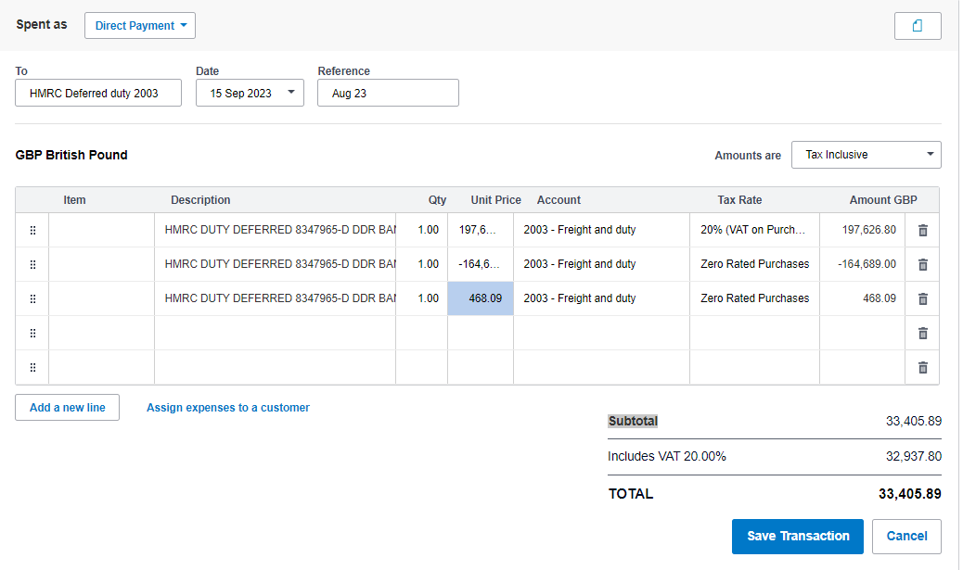

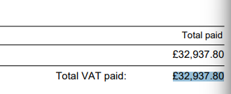
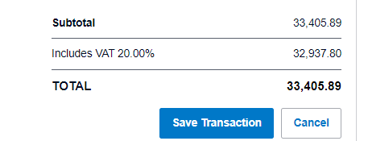

As you can see the VAT amount on Xero (the image on the right has £32937.80 VAT matches to the image on the left, the C79 form. The total on the right matches to the amount on the bank statement.

Once you are happy and have double checked it you can press save. If Xero is happy it balances to the bank then you can reconcile the transaction.

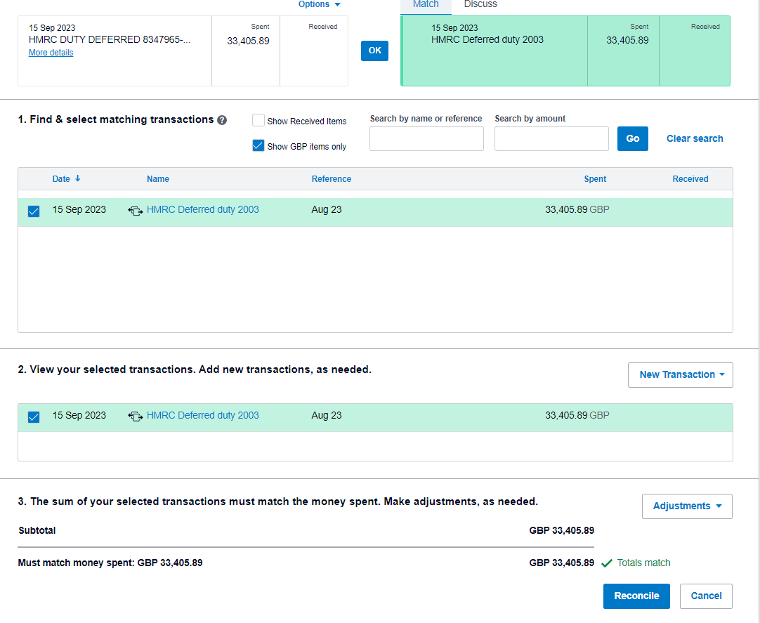

Once done you can go to the VAT return in Xero and see the transaction in the most recent Vat return
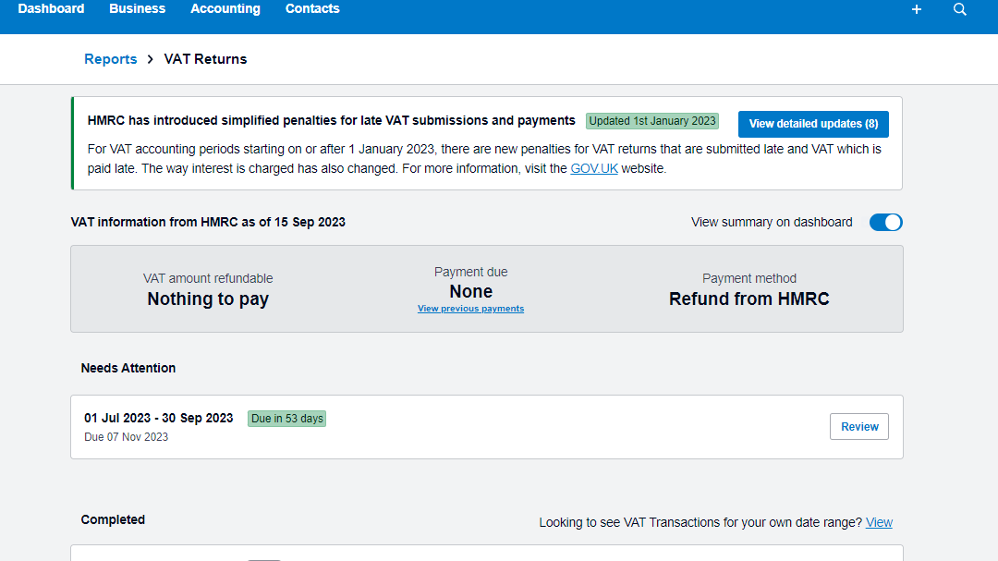

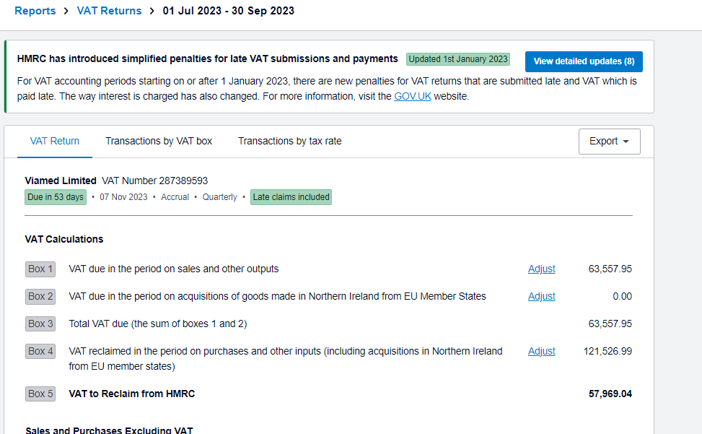

View transactions by tax rate then search HMRC. There will be three Defered duty transactions per VAT return / Quarter.

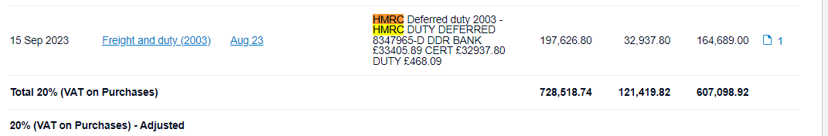
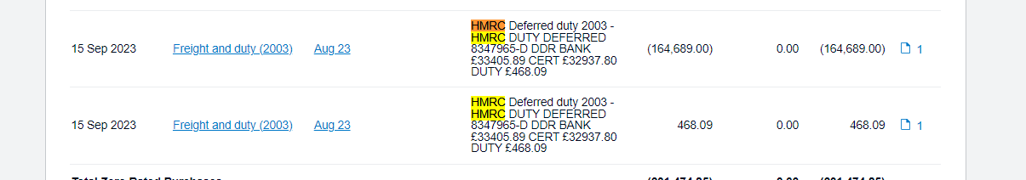

When doing the VAT returns we can check each one as we have the certificate attached and this way we double check its the correct amount and its been allocated in the correct way. If it wrong we can loose many thousands of pounds so do double check.

