QC 21 Non Conformance Report

Date | 11/11/2021
Issue id  unique identifier | 241920
BSI Ref (if applicable)  unique identifier | 2128198-202111-N8
Responsibility  Person Overall responsible | Derek Lamb
Non-Conformance  statement of the problem | 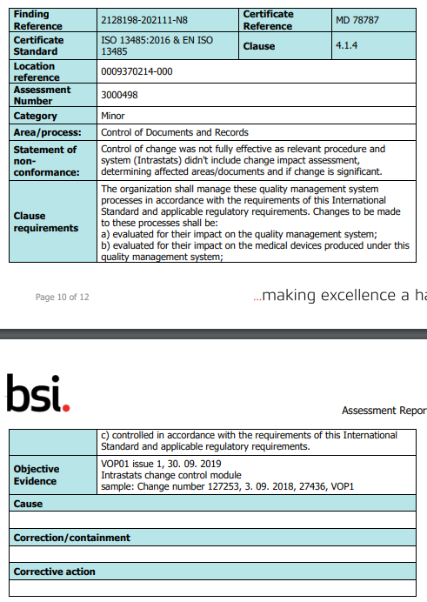
Investigation By:  Person responsible | Derek Lamb
Root Cause Analysis Investigation Issue id  (if applicable) | We were unable to provide adequate proof that we were assessing the impact of changes, to our System documents, processes or to our existing product documentation, that relate to products that are still within their life span.
Corrective Action By:  Person responsible | Derek Lamb
Corrective Action  Issue ID (if applicable):  Relevant Immediate Corrective action (if applicable) | We will update our top level document VOP 01 Documentation and Records, to include the statement -  ‘Any change to system documentation or process(s), if they are linked to either a VOP, ISO Standard, Sub Process, or Controlled Product Technical File, will have a Risk of Change or Impact Assessment created including if any notifications of change are required.  This assessment will then be uploaded to the controlled documents in the Document Index and linked to Top Level Document that is to be updated. ‘
Time Scale for Immediate Corrective Action  Time for completion of all identified actions | 10 Days, 23rd November 2021
Corrective Action:  Relevant and Proportionate Corrective Action | We will update the system to ensure that any changes made to the System or Process documentation, will force a Risk / Impact Assessment of the change to be carried out, in the related areas of the System, process or controlled product Technical File, before the change can be enacted.  This corrective action will prevent us from making changes, to documents, system processes or controlled product technical files, without carrying out an assessment of risk or negative affect.
Time Scale for Corrective Action  Time for completion of all identified actions | 30 days from today, 14th December 2021
Risk Review  Confirm action does not have negative affects and/or risks to any other part of the ISO system | There is no risk in the update of the system, as this is an extra preventative measure.  This action does not have a negative affect and/or risks to this or any other part of the ISO system  See Issue 241920 file  Risk Assessment For Updating Document ID30999 VOP 01
Follow-up future issue id
(Effectiveness verification)
Effectiveness verification
Closed By:
Closed on

