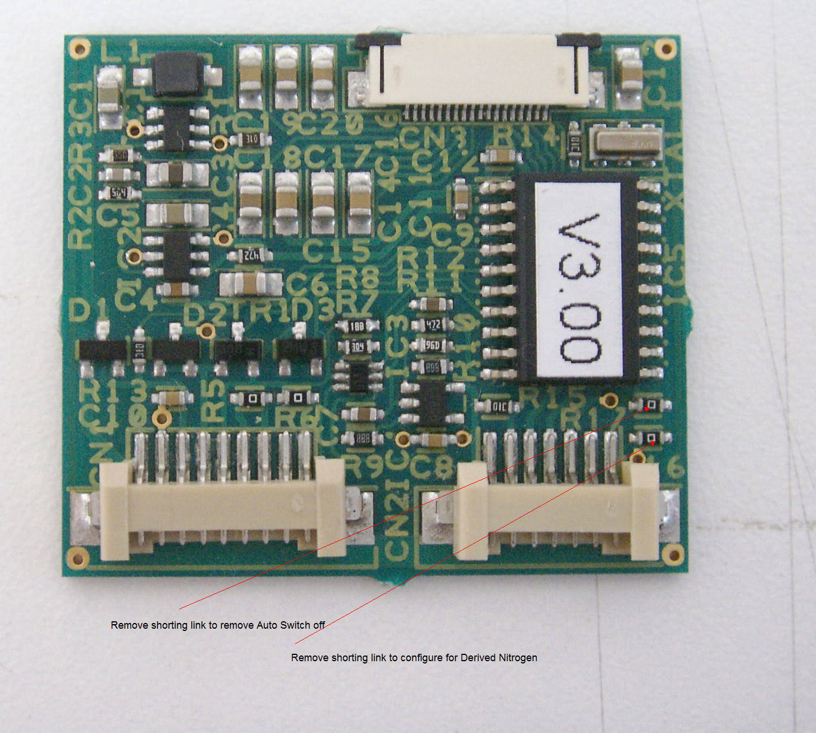
Derived Nitrogen

Nearest Shorting link to the connector allows the display to read 100% - Oxygen measured ;

Non Auto Shut off

The Shorting link nearest the IC disables the Auto shut off

