Oxygen Sensor OEM Price List
Innerspace Systems Corp.

Part number | Model | Connector | Quantity  per delivery | Price  per sensor
8010012 | SC-I22D | 3 pin Molex | 1 - 49 | £35.00
8010012 | SC-I22D | 3 pin Molex | 50 – 99 | £30.00
8010012 | SC-I22D | 3 pin Molex | 100 – 499 | £27.00
8010012 | SC-I22D | 3 pin Molex | 500+ | £25.00
Prices effective: 27th October 2017
Delivery: EXW Vandagraph Sensor Technologies Ltd. UK
Delivery lead time: 4 – 6 weeks

Despatch:
Code PPISU – Courier Delivery, CPT – InnerSpace Corp.
Courier: UPS
Service: Express Saver
Customs / Duty fees to be charged to ISC UPS account:
#Y0F325, zip code 98531.

Goods of UK origin

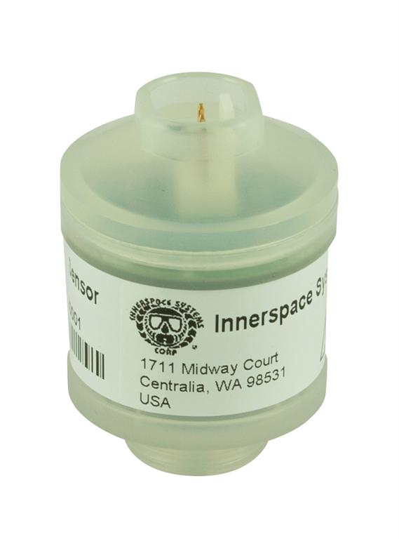
Tariff: 90271010
NOTE: Sensors are for SCUBA diving equipment

Transit time: 3 business days

Sales order contact: Bill Carrier

Delivery address:
1711 Midway Court
Centralia
WA 98531
USA

Tel. +001 360 3309018
Fax. +001 360 3309019
email: accounting@customrebreathers.com

