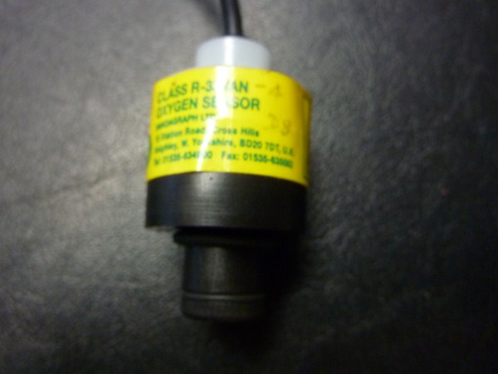
This sensor is basically an R-33VAN with a cable 1.2mtrs long terminating in a 3.5mm Jack plug. The easiest method is to have an original OEM sensor and replace the sensor part. To do this the top is carefully removed. The sensor can be pushed out by pressing a round object up the case funnel. Unsolder the wires and replace the sensor. Re-assemble and test

Parts Required for New version
Quantity | Description | Part No.
1 | R33S no screw thread | 0110214
1 | R-17 Top
1 | R-33VAN Body | 9720200
1 | O ring VIT-0130 10-274 | 9730201
1 | Cable tie | 9711018
1 | Co-ax cable 1.2 mtr long not critical .To fit grommet.
1 | Tini Jack 3.5mm plastic cover | 9071007
1 | Grommet 6mm | 9040031
1 | Sensor Serial number label
1 | Serial number Label for Outer bag
1 | Polythene Bag (outer)
1 | Gas Barrier bag
Warning Use Soldering Iron set at 300C Do Not overheat the PCB on the Sensor
Method.
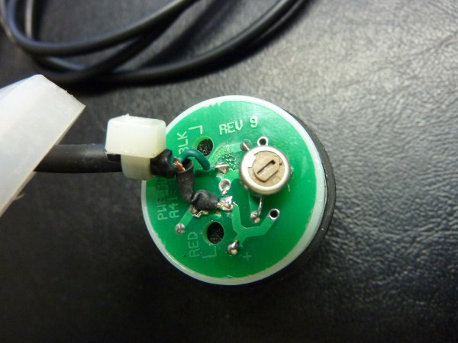
- Fit a grommet into the R-17 type top.
- Remove the molex and wires from the R-33S sensor
- Strip the co-ax cable pass through the grommet and solder to the sensor. Screen to +ve Red. Green to opposite end of the molex
- Strip the other end of the 1.2mtr co-ax cable and solder the Green core to the centre pin and the screen to the screen.
- Insert the sensor into the R-33Van body leaving 0.5 cms proud. For the R-17 cap to fit.
- Add Silicone around the edge of the sensor face to prevent gas leakage around the sensor.
- Carefully fit the cap and glue into position.
- Test for the correct output 25mV +/- 2mV. The 25mV can be adjusted with the pot on the top of the sensor.
- Relabel the sensor and test.
- Relabel the sensor and test

