Measurement Range: | 0 % ... 100 % oxygen (at atmospheric pressure)
Output in Ambient Air: | 9 to 13 mV
Electrical Interface: | 3 pin (Molex 22-11-1031)
Repeatability: | < 1% vol. O₂ @ constant temperature and pressure
Linearity error: | < 3% relative
Accuracy: | 0 % … 3.3 % oxygen: ± 0.1 % absolute  3.4 % … 100 % oxygen: ± 3 % relative
Response time: | < 5 s to 90 % of final value; < 40 s fall time from 20.95 % to 0.1 % oxygen  (when 100 % nitrogen applied)
Zero Offset Voltage: | < 40 μV in 100 % nitrogen
Cross Interference: | < 0.1 % oxygen response to:  15 % CO₂ balance N₂; 10 % CO balance N₂; 3000 ppm NO balance N₂;  3000 ppm C₃H₈ balance N₂; 500 ppm H₂S balance N₂;  500 ppm SO₂ balance N₂; 1000 ppm benzene balance N₂
Influence of Humidity: | - 0.03% rel. per % RH at 25°C
Pressure Range: | 0.6 bar … 2 bar (ppO₂ 0 … 1250 mbar O₂)
Influence of Mechanical Shock: | < 1% relative after a fall from 1m
Operating Temperature: | 0°C to 50°C
Temperature Compensation: | Built-in NTC compensation
Effect of Temperature Compensation (steady state): | between +25 °C and +40 °C: 3 % relative error  between 0 °C and +50 °C: 8 % relative error
Operating Humidity: | 0 - 99% RH non-condensing
Long Term Output Drift: | < 1% vol. oxygen per month
 | Typically < -15% relative over lifetime
Storage Temperature: | -20°C to +50°C
Recommended Storage: | +5°C to +15°C
Recommended Load: | ≥10 kOhms
Warm-Up Time: | < 30 minutes, after replacement of sensor
Nominal Sensor Lifetime: | ≥500,000% vol oxygen hours
Weight: | Approximately 28 grams
Warranty Period: | 15 months (including 3-month shelf life)
Confirmations: | PTB-A 18.10 approved
 | Meet BAR 97 requirements
Part No.: | OOA101-V: 1002496 (REF 0110232 / R-22VAN)
 | OOA101-V: 1002496 (REF 0110301 / 22)
All specifications are applicable at standard conditions: 1013 mbar, 25°C dry ambient air.

Mechanical draft:
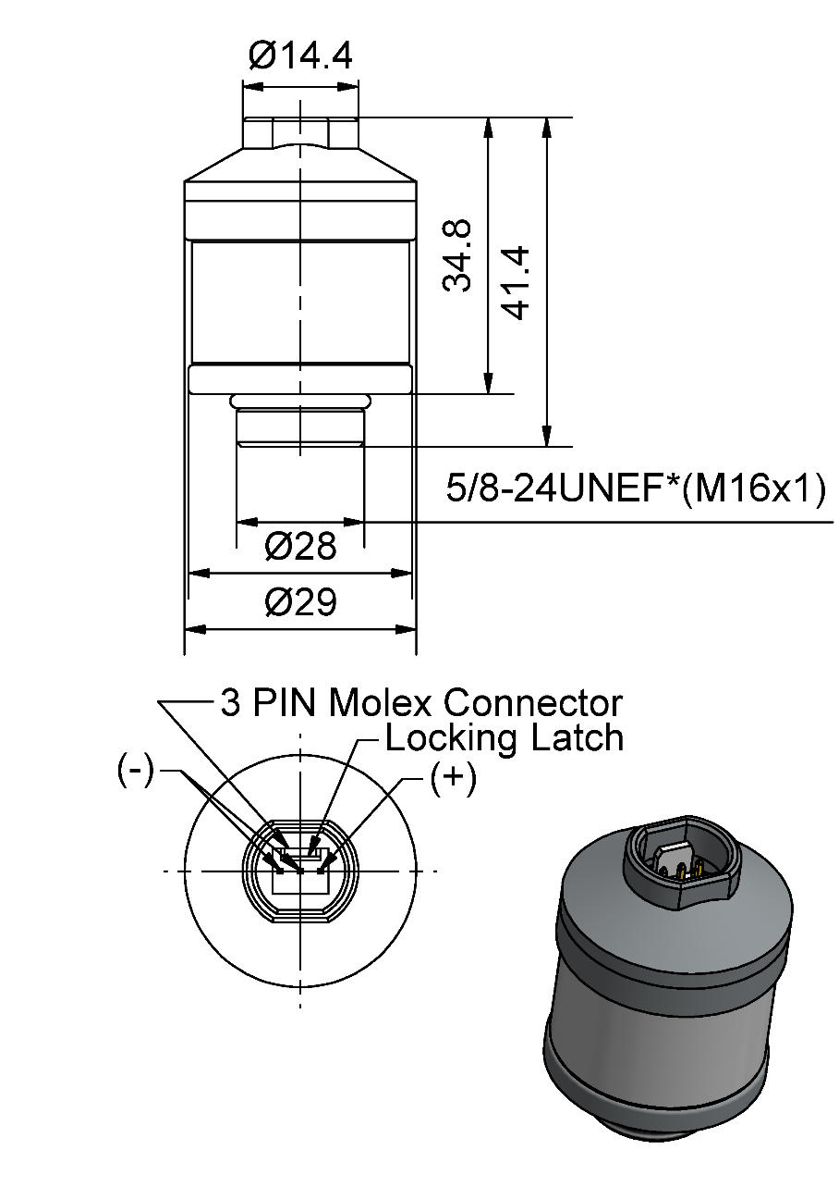
General tolerances ISO 2768-c
Color of housing parts: RAL 7040

Customized Design Specification:

Product Labeling

OOA101-V: 1002496 (REF 0110232 / R-22VAN)
Label on Sensor (90x15) | Label on Blister- Card (63,5x46,6)
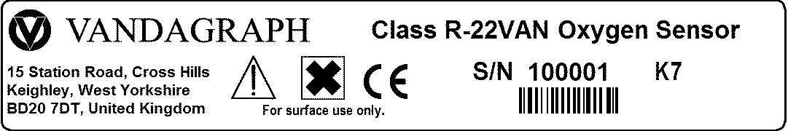 | 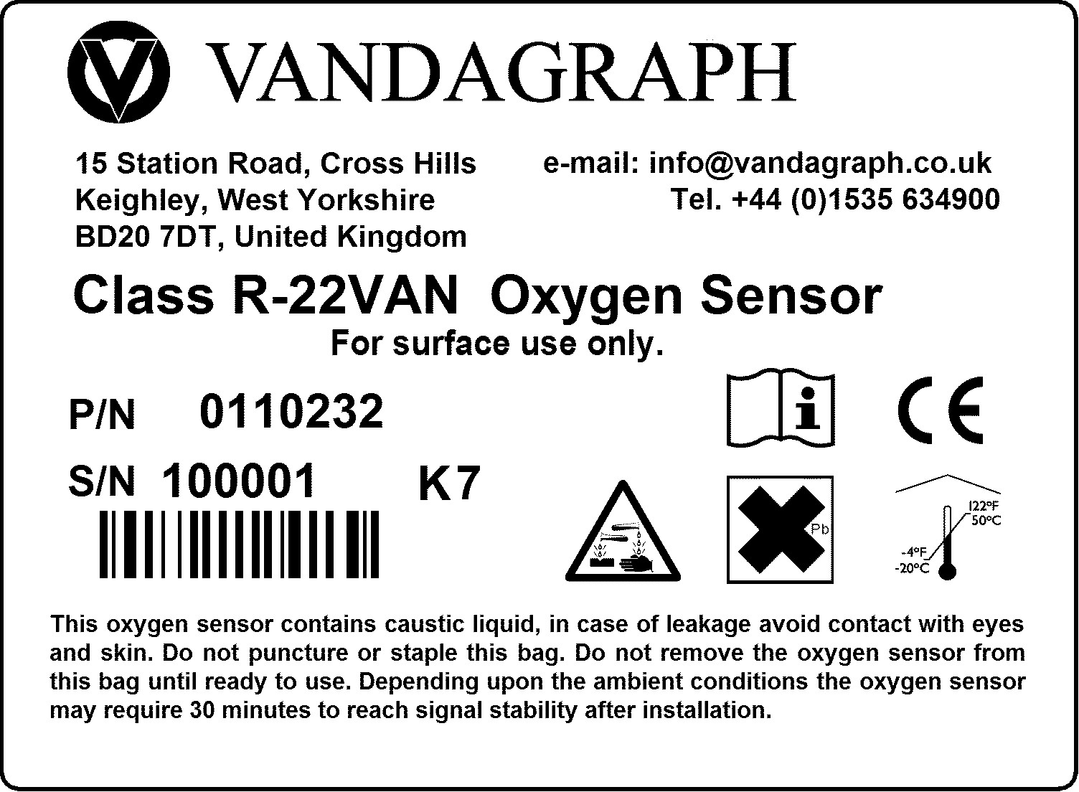
OOA101-V: 1002496 (REF 0110301 / 22)
Label on Sensor (90x15) | Label on Blister- Card (63,5x46,6)
 | 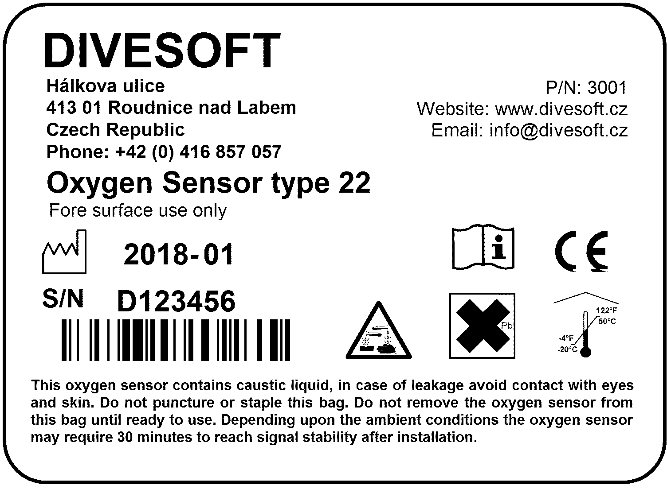

Customer Approval

Date:

Signature:

