NOTE: CapnoTrue®AMP/ASP/MG monitors do not require a routine Safety Check - STK (§6) or routine Measurement Accuracy Check - MTK (§11) according to German regulation (Attachment 1 and 2 of MPBetreibV)

The Handheld capnograph and pulse oximeter CapnoTrue®AMP/ASP/MG with accessories is permanently factory calibrated. The maintenance and calibration-free technology (gas analyzer and SpO₂ Module) integrated in the CapnoTrue®AMP/ASP/MG ensures a robust measurement function throughout the lifetime of the monitor. No routine calibration is required however a basic maintenance plan is highly recommended.

The following maintenance tasks shall be performed:

1) Gas readings should be verified at regular intervals with a reference instrument or with calibration gas (5% ±0.1vol% CO₂, 20.9% O₂ balance N₂). The suggested interval for gas span check is once every year and whenever gas readings are questionable.

2) Perform a functional SpO₂ test using a SpO₂ simulator. However note that a functional tester cannot be used to assess the accuracy of a pulse oximeter probe or a pulse oximeter monitor, only its functionality. The only reliable method of testing the SpO₂ measurement accuracy of the monitor is the clinical validation of the measurement data, indicated by the system monitor with SpO₂ sensor on the basis of a blood gas analysis. During extensive clinical studies, the monitor combined with the approved sensors evidenced the accuracy required. Verify SpO₂ readings at regular intervals with a reference instrument.

3) Test of the alarm system. In order to trigger an alarm for test purposes during monitoring set the upper alarm limit of SpO₂ or pulse rate below the currently indicated measurement value. The device will react with a visual and audible alarm.

4) Check the data download function at a PC with the PC-software

5) Perform a visual inspection of all cables accessories and housing parts

6) Perform a functional check of all power supply options (Li-Poly battery, Mignon AA battery, external power supply)

To document the maintenance, use the following checklist. All recommended test steps are described in detail in the document CapnoTrue Maintenance instructions and Service Manual.

Description of device components for documentation of the maintenance of the device and its components throughout the live time of the device.
Device  Identify device | Device Model (REF on back of label)  CapnoTrue®AMP (3090112001) CapnoTrue®MG (3090112009)  CapnoTrue®ASP (3090112002)  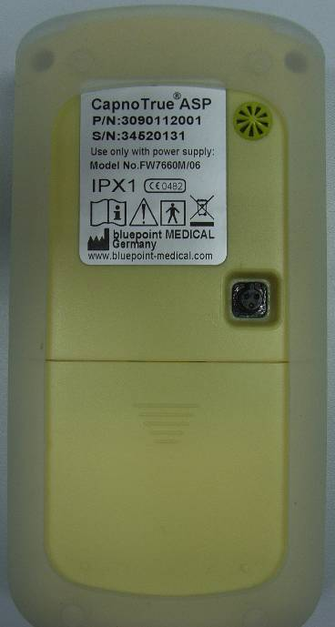
External power supply  documentation of revision | black connector at cable and at device (Rev. 1)  orange connector at cable , metal connector at device (Rev. 2)  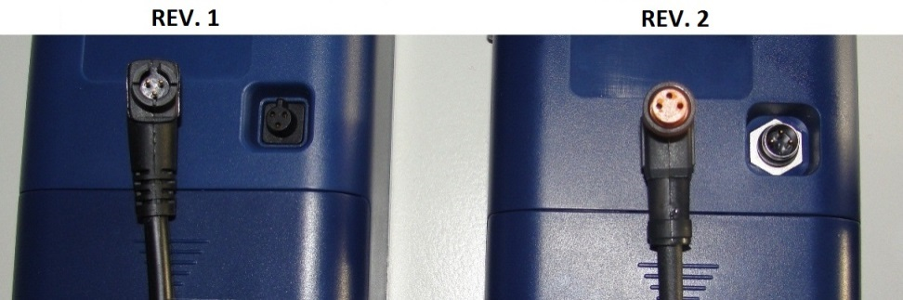
SpO₂-Sensor  Sensor type is noted on the label fixed to the sensor cable | SC 6500 SCP 6500 |  | W 6500
 | SCA 6500 | SCPA 6500 | Disposable
Serial number  Of the SpO2 module in the device menu:  Service Menu> System information > Device information  Changing the default start up settings of the device can seriously affect the functionality of the device and the alarms!  Only suitably qualified personnel with the required technical and medical knowledge are allowed to change the default start up settings! | Device (SN on rear device label):
 | SpO₂-Sensor (SN on cable): 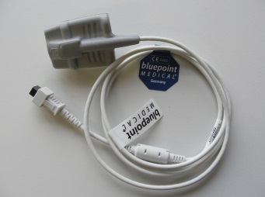
SpO₂ Module (SN in Service Menu):
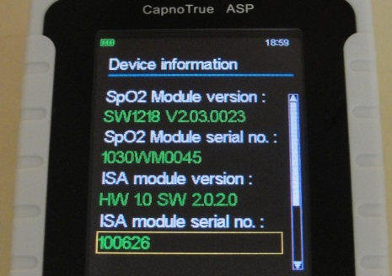

CO₂ Modul (SN in Service Menu or on housing):
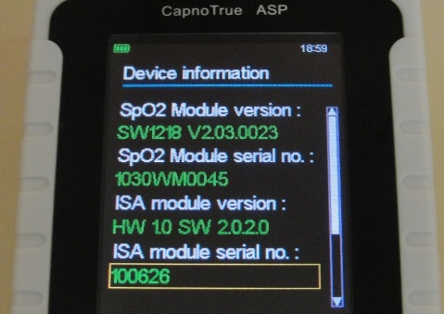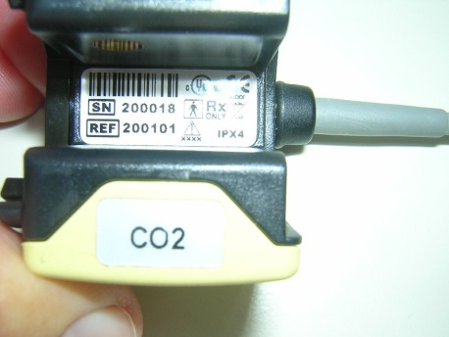

Firmware Version  startin from v7.5 a software upgrade is available at bluepoint Medical | Version (Startup-Screen at switch on):  

Comment | Detailed description on repairs performed to pass the functional test etc.
Result | Pass  AMP/MG: Test 1 – 5  ASP: Test 1 – 6  Tick if all tests successfully passed | Fail  Don’t use device to monitor patients! Perform repair.  Send device to SERVICE of bluepoint MEDICAL or trained and certified service partners
Date | Tester

Test step | Target state | Result |  | comment
1. Visual inspection
Housing, Display, Keypad | No damages or defects | pass | fail
Sensors and cable | No exposed optical components or cables or other damages to the sensor | pass | fail
external power supply (cable+ connector) | No damages or defects | pass | fail
Label + transparent protective foil  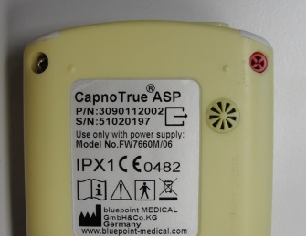 | Label and the transparent protective foil are fixed clean to the back of the device. | pass | fail
Screw lock | Fixed to upper right-hand screw | pass | fail
2. Power Supply Options (AA batteries, Li-Poly rechargeable battery, external power supply)
(switch on with each supply option >Measurements: SpO₂ at finger; etCO2 by breathing through airway adapter > switch off)
only 4 AA Batteries | switch on> measurement> switch off | pass | fail
only Li-Poly | switch on> measurement> switch off | pass | fail
only ext. power supply | switch on> measurement> switch off | pass | fail
ext. power supply  + Li-Poly | switch on > measurement + charging > switch off | pass | fail
Comments: (Pixel defects, etc.)
4 x AA Batteries, or 1 x Li-Poly: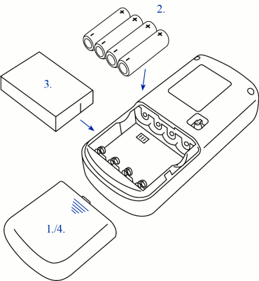external power supply: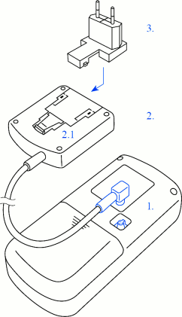
Before measurement ensure that AA batteries are full and Li-Poly charged
3. SpO₂-Function at simulator
SpO₂ at simulator setpoint 82% (BPM or Nellcor curve)  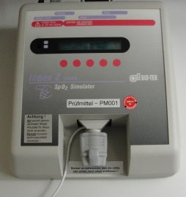  e.g. INDEX II simulator (Biotek, Fluke)  select the SpO2 cal. Curve BPM or NELLCOR under MAKE | 82% SpO₂ (+-2 digits)  NOTE: SpO2 low alarm sounds, SpO2 measurement value turns yellow and is flashing. | pass | fail | value:  write down displayed SpO2 value
Pulse rate at simulator setpoint 75bpm  set pulse rate at simulator | 75 beats/min (+-1 digits) | pass | fail | value:  write down displayed pulse rate value
SpO₂ low alarm | Audible and visual | pass | fail
Comments:
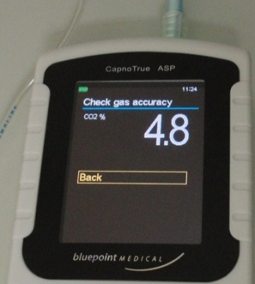
4. CO₂-Measurement (use reference device as alternative means if no breath simulator is available)
Select Mode at CapnoTrue: Main Menu > Service > Maintenance > Check gas accuracy
Calibration gas (5% ±0.1vol% CO2, 20.9% O₂ balance N₂)
Verify gas accuracy reading in Test Screen via SERVICE MENU:
- Switch on device
- connect new IRMA airway adapter (or sampling line for ASP), perform zeroing
- Select at device: Main Menu > Service > Maintenance > Check gas accuracy
- Apply calibration gas to airway adapter and verify reading
5vol% CO₂ calibration gas + airway adaptor  e.g.  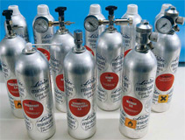 | CO₂ should be Gas conc. (+- (0.2 vol%. + 2% of measurement value)  At 5vol% CO₂ the limits are:  EtCO₂:4.7 – 5.3 vol%  FiCO₂: 0.0 – 0.3vol% | pass | fail | value: EtCO₂ / FiCO₂  write down displayed CO₂ values
Breath per minute  connect airway adaptor to adaptor of reference device. Breath uniformly through adaptors for 30 minutes. Compare values | reference value (+-1 digit)  + tolerance of reference device | pass | fail | value:  write down displayed respiration rate at CapnoTrue and reference device
Comments::
5. Alarms und Data Download (switch on device, SpO₂ Sensor at finger, breath through airway adapter)
Remove SpO₂ Sensor from finger | Alarm sound and message  „SpO2 Probe off !“  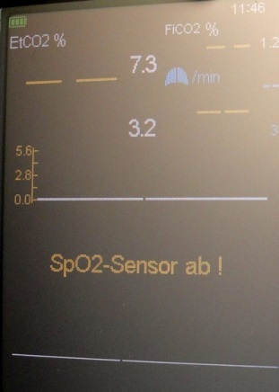  2 x beep every 16s | pass | fail
Breath 3 X through airway adapter and wait 20s | Alarm sound and message  „Apnoea !!“  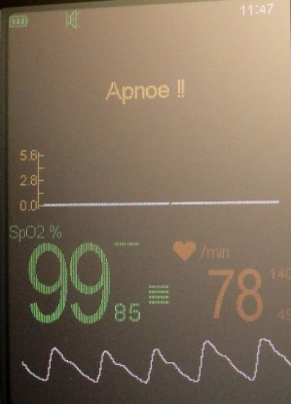  3 x beep every 5s | pass | fail
Download data to PC with CapnoTrue PC-Software  1. Connect device via USB to PC  2. Verify message “USB connected at device  3. Open CapnoTrue SW  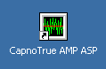  4. download data according to instructions at “communication download” | Successful data download to PC  Compare data in Tab Diagram and stored alarms in Tab Patient info with data at device  - If errors occur during download check compatibility of versions (see page 3 of Instructions for Use)  - check if correct COM port is selected  - check if the USB drivers were installed according to the instructions | pass | fail
Delete all data  Select Delete all data under:  Menu > data management > delete all data | All stored data in the device are deleted | pass | fail
Comments:
6. Check pressure – ISA module (Only for sidestream capnograph CapnoTrue ASP)
Select at device: Main Menu > Service > Maintenance > Check pressure
Compare displayed ambient pressure value with the actual barometric pressure value at the local site  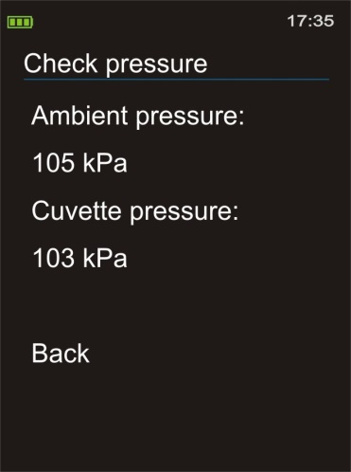 | actual barometric pressure  ±5 kPa | pass | fail
Compare displayed cuvette pressure with ambient pressure | cuvette pressure is 1 to 5 kPa smaller than displayed ambient pressure | pass | fail | Ambient pr. kPa  Cuvette pr. kPa  write down displayed values
Comments:

