DB200381 Oxygen Sensor
Specification

Document Number: DB200-SP-5223
Revision: 01

ISSUED FOR CONSTRUCTION 03-10-2018.
PO: 11807111

Document Information
Number | Title | Classification | Current  Revision | Date
DB200-SP-5223 | DB200381 Oxygen Sensor Specification | Commercial In Confidence | 01 | 08/08/18

Revision History
Rev | Date | BY | CHK | APP | Comments
0 | 2nd April 2018 | MH | SB | SC | Initial Issue
1 | 8th August 2018 | MH | JM | SB | ECN: 22688  Updated dimensions
2
3
4

Original Approvals
Responsibility | Name | Position | Date
Author | Michael Hossack | Senior Electronics Engineer | 02/04/18
Checked | Stephen Blatherwick | Senior Development Engineer | 02/04/18
Approval | Steven Coull | Product Engineering Manager | 02/04/18

Copyright Details
© 2018 JFD
Copyright of this document is the property of JFD and it may not be copied, used or otherwise disclosed in whole or in part except with prior written permission from JFD or, if this document has been furnished under a contract with another party, as expressly authorised under that contract.

Introduction
This document describes the specification for the DB200381 non-magnetic oxygen sensor intended to be installed within JFD’s range of electronic rebreathers.

Specification
Output in ambient air | 6.5 to 9.0 mV
Electrical output | 30 to 60 µA
Output connector | Flying leads or solder pads
Input | Open input  Hydrophobic membrane
Input O ring | Not applicable
Output range | 0 to 2500 mbar PPO2
Pressure range | 600 to 10000 mbar
Repeatability | < 1% volume oxygen at constant temperature and pressure
Linearity error | - to 0.4 bar: < 30 mbar  > 0.4 to 2.0 bar: < 60 mbar  > 2.0 to 2.3 bar: < 100 mbar
Warm up time | < 30 minutes after sensor installed
Zero offset voltage | < 0.5% oxygen reading in 100% nitrogen @ 25 °C after 36 seconds
Cross interference | < 0.5% volume oxygen response to 5% CO_{2,} balance N₂
Response time | < 10 seconds for 90% final value
Operating humidity | 0 to 99% RH (non-condensing)
Influence of humidity | -0.03% relative per % R.H. at 25 °C
Influence of mechanical shock | < 1% after fall from 1 m
Operating temperature range | 0 to 50 °C
Storage temperature range | -30 to +70 °C
Temperature compensation error | 0 to 50 °C, 5 % relative error
Shelf life in original packaging | > 6 months
Operation life | > 2 years in air
Long term output drift | < 1% volume oxygen per month
Required load | 10 K Ohms
Weight | < 30 g
Dimensions | See Section 2.1 below
Magnetic signature | < 3.5 nT
Orientation | <0.2% oxygen in any orientation
Packaging | Gas barrier bag
Marking | JFD logo and part number (DB200381). Serial number in format to be agreed between JFD and supplier. Any other markings as required by relevant legislation.

Dimensions
To be as shown in Figure 1 below. Any external circuitry to be flush with back of sensor body, except for solder joints which may protrude.

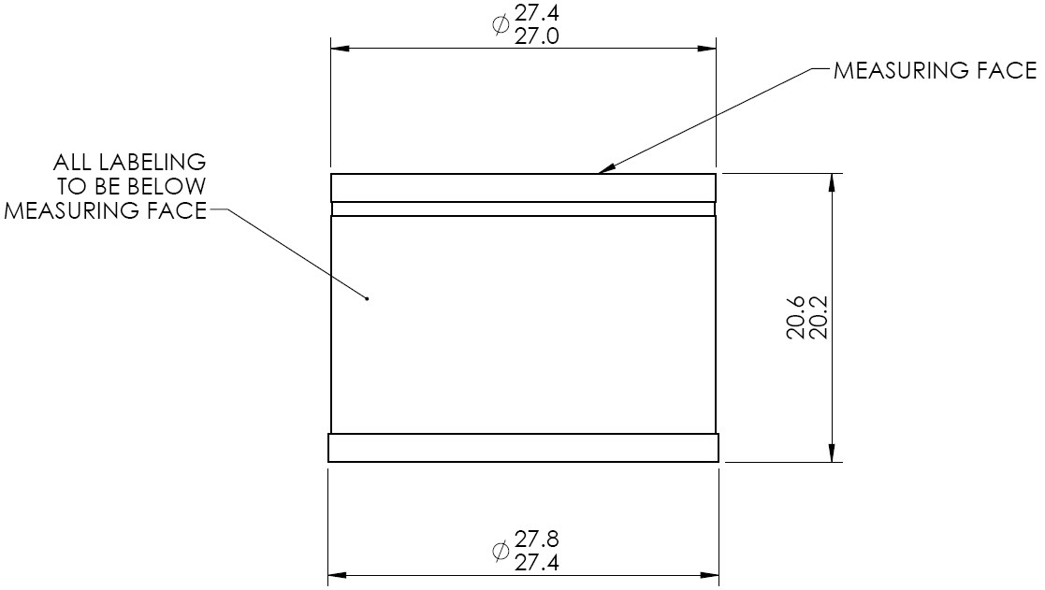
Figure 1 – Sensor Dimensions

Supplier Testing
All sensors to be supplied to JFD with results of testing the following parameters in accordance with this specification:
- Output in air
- Zero offset voltage
- T90 response time
- Linearity error (0 – 100% oxygen at ambient pressure)

