VersaStream Sampling Line Test

Test Protocol No.: TR-11-01-0001-17

Test date: | 2017-01-04
Report date: | 2017-01-05

Responsible for the technical content of the test report:

Examiner: R. Jürgensen

Review: S Nixon

______________________________

COMPANY CONFIDENTIAL
This document is the property of Viamed Ltd.and is protected by English and international copyright law, and may not, without the written permission by Viamed Ltd., be given to any third parties.

This report may only be reproduced or published in its entirety. Extracts could adulterate the stipulations and the results.

Table of Content
1. Summary 3
2. Equipment under Test (EuT) 4
3. Method 5
3.1 Measurement Accuracy 5
3.2 Negative pressure Test 8
4. Results 10
4.1 Measurement Accuracy 10
4.2 Negative pressure Test 16
5. Conclusion 17
5.1 Measurement Accuracy 17
5.2 Negative pressure Test 17

1. Summary

Purpose: | The purpose of this test is to analyze and verify the accuracy and functional compatibility of VersaStream sampling lines compared to Nomoline sampling lines.
Method: | Measure and verify the CO₂ and RR (Respiratory Rate) measurement accuracy of the VersaStream sampling lines with a CO₂ respiration simulator.  The CO₂ measurement accuracy specification: RMS < 0.2.  The RR measurement accuracy specification: RMS < 1.  Measure and verify the negative pressure of the VersaStream sampling lines with a precision digital manometer.  The negative pressure accuracy specification: < 25 mbar
Results: | The VersaStream sampling line test is passed.
Observations: | The CO₂ measurement accuracy is: RMS < 0.2.  The RR measurement accuracy is: RMS < 1.  The negative pressure accuracy are: < 25 mbar
Conclusion: | The CO₂ and RR test verifies that the accuracy of the tested VersaStream sampling lines is observed.  The Pressure Test shows no significant differences between the Nomoline and the VersaStream sampling lines.

2. Equipment under Test (EuT)
Manufacturer | Type | Part No. | Lot Number
Masimo Sweden AB | NomoLine | 108210 | 15020096
Viamed Limited | VersaStream Short Term | 4420821 | 2618.12.16
Viamed Limited | VersaStream Long Term | 4420823 | 2711.12.16

Three examples of each type were used for evaluation testing and the results averaged.
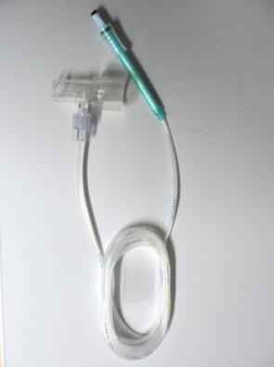
Photos of EuT

Nomoline with Airway Adapter
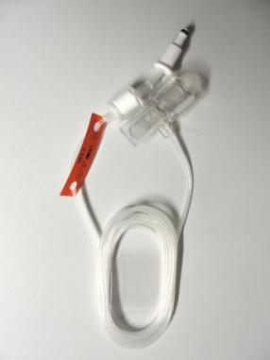

VersaStream Short Term with Airway Adapter
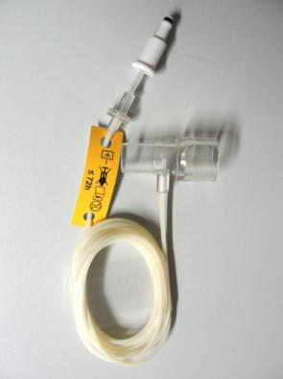

VersaStream Long Term with Airway Adapter

3. Method

3.1 Measurement Accuracy

3.1.1 Test equipment

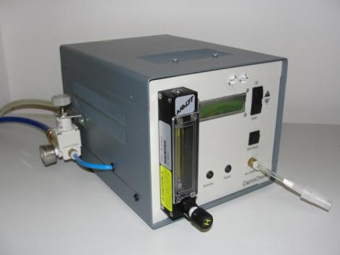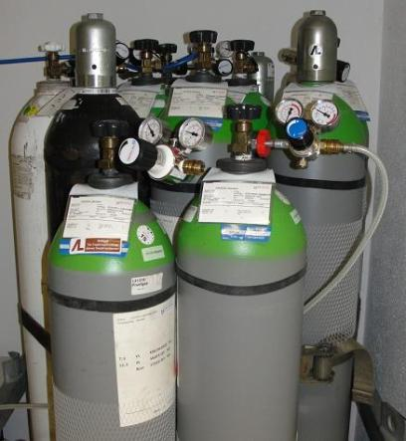
CapnoCheck , CO₂-Respiratory-Simulator Test gas 3, 5, 7.5 Vol% + 0.1 Vol%

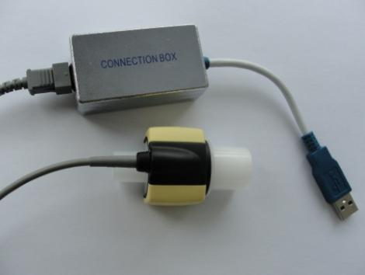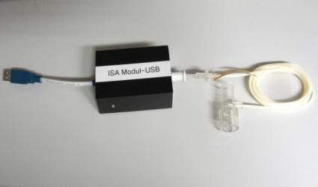
Test
object
IRMA
UART-USB-Converter for mainstream CO₂ UART-USB-Converter with integrated
IRMA-Sensor as reference side stream CO₂ ISA-module

3.1.2 Test Setup

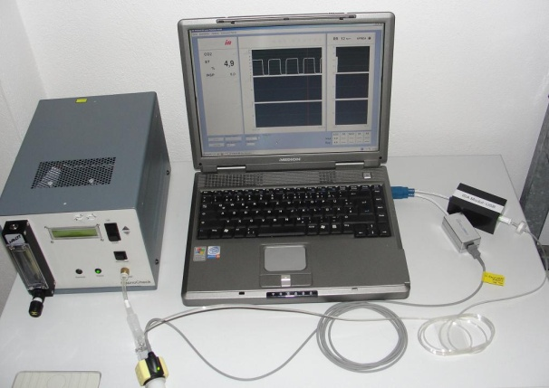
Test set-up

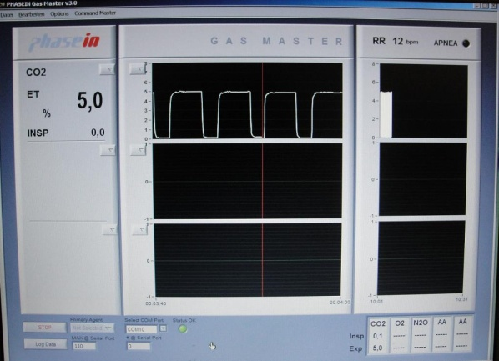
Software Gas Master V3.0 user interface

Test description

Use the Gas Master V3.0 software to record the measurement data.

12 respiratory rate steps are simulated with 3 CO₂ test gas concentrations according to table:

Parameter | Parameter
CO₂ test gas | 3Vol%, 5Vol%, 7.5Vol%,
Respiratory rate | 10, 20, 30, 40, 50, 60, 70, 80, 90, 100, 110, 120

Connect the UART-USB mainstream converter with to the PC and the IRMA CO₂ sensor for reference CO₂ data. Connect the UART-USB side stream converter with integrated ISA-CO₂ module to the PC and the EuT.
Connect the IRMA and the EuT with the outlet valve of the CapnoCheck. Start the CapnoCheck with the parameters in the table above.
Each respiratory rate test step has duration 120 seconds.
In the first 60 seconds the values and simulator are allowed to stabilize. Thereafter the respiratory rate and CO₂ value are recorded

The functional performance criteria required to pass the test:

- CO₂ measurement accuracy: RMS* < 0.2

- RR measurement accuracy: RMS < 1

*RMS: Root Mean Squared difference

$$RMS=\sqrt{\frac{\sum_{i=1}^{n}{(UUT measured _{\text{i}}-{\text{Target }}_{\text{i}})^{2}}}{n}}$$
UUT: Measured value
Target: Target value
n: Number of recorded UUT

The recorded raw data were additional illustrated as a capnogram.

Ambient temperature: 22°C

Rel. Humidity: 34%

3.2 Negative pressure Test

3.2.1 Test equipment

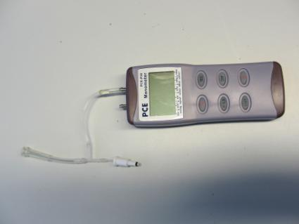
Test
object
Digital Manometer with adapter UART-USB-Converter for side stream
CO₂ ISA-Sensor

3.2.2 Test Setup

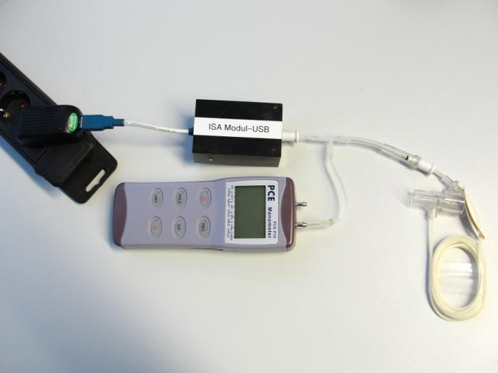
Test set-up

3.2.3 Test description

Connect the UART-USB side stream converter with integrated ISA-CO₂ module with a power supply. Switch on the digital manometer.

In the first 60 seconds the values are allowed to stabilize. Thereafter the momentary pressure value is recorded.

The functional performance criteria required to pass the test:

- Negative pressure accuracy: < 25 mbar

Ambient temperature: 22°C

Rel. Humidity: 34%

4. Results

4.1 Measurement Accuracy
4.1.1 CO₂ Accuracy
Respiratory Rate (RR): 10 bpm to 120 bpm. CO₂ test gas concentration: 3 Vol%
 |  |  | VersaStream | VersaStream
CapnoCheck | IRMA | NomoLine | Short Term |  | Long Term
RR [bpm] | et CO₂ | et CO₂ | et CO₂ |  | et CO₂
10 | 3.0 | 3.0 | 2.9 |  | 3.0
20 | 3.0 | 3.0 | 2.9 |  | 3.0
30 | 3.0 | 3.0 | 2.9 |  | 3.0
40 | 3.0 | 3.0 | 2.9 |  | 3.0
50 | 3.0 | 3.0 | 2.9 |  | 3.0
60 | 3.0 | 3.0 | 2.8 |  | 3.0
70 | 3.0 | 3.0 | 2.8 |  | 3.0
80 | 3.0 | 3.0 | 2.8 |  | 3.0
90 | 3.0 | 3.0 | 2.8 |  | 2.9
100 | 3.0 | 2.9 | 2.8 |  | 2.9
110 | 3.0 | 2.9 | 2.8 |  | 2.9
120 | 2.9 | 2.9 | 2.8 |  | 2.8
RMS | 0.029 | 0.050 | 0.165 |  | 0.076

Respiratory Rate (RR): 10 bpm to 120 bpm. CO₂ test gas concentration: 5 Vol%
 |  |  | VersaStream | VersaStream
CapnoCheck | IRMA | NomoLine | Short Term |  | Long Term
RR [bpm] | et CO₂ | et CO₂ | et CO₂ |  | et CO₂
10 | 5.0 | 5.0 | 5.0 |  | 5.0
20 | 5.0 | 5.0 | 4.9 |  | 5.0
30 | 5.0 | 5.0 | 4.9 |  | 4.9
40 | 5.0 | 5.0 | 4.9 |  | 5.0
50 | 5.0 | 5.0 | 4.9 |  | 4.9
60 | 5.0 | 5.0 | 4.8 |  | 5.0
70 | 5.0 | 4.9 | 4.9 |  | 5.0
80 | 5.0 | 4.9 | 4.8 |  | 4.9
90 | 5.0 | 4.9 | 4.8 |  | 49
100 | 4.9 | 4.8 | 4.8 |  | 4.9
110 | 4.9 | 4.8 | 4.8 |  | 4.9
120 | 4.9 | 4.8 | 4.7 |  | 4.8
RMS | 0.050 | 0.112 | 0.168 |  | 0.091

Respiratory Rate (RR): 10 bpm to 120 bpm. CO₂ test gas concentration: 7.5 Vol%

 |  |  | VersaStream | VersaStream
CapnoCheck | IRMA | NomoLine | Short Term | Long Term
RR [bpm] | et CO₂ | et CO₂ | et CO₂ | et CO₂
10 | 7.5 | 7.5 | 7.5 | 7.4
20 | 7.5 | 7.5 | 7.4 | 7.4
30 | 7.5 | 7.5 | 7.4 | 7.4
40 | 7.5 | 7.4 | 7.4 | 7.4
50 | 7.5 | 7.4 | 7.4 | 7.4
60 | 7.5 | 7.4 | 7.3 | 7.4
70 | 7.5 | 7.4 | 7.3 | 7.3
80 | 7.5 | 7.4 | 7.3 | 7.3
90 | 7.4 | 7.3 | 7.3 | 7.3
100 | 7.4 | 7.3 | 7.2 | 7.3
110 | 7.4 | 7.3 | 7.2 | 7.2
120 | 7.4 | 7.2 | 7.2 | 7.2
RMS | 0.058 | 0.147 | 0.197 | 0.180

Capnogram
Respiratory Rate (RR): 10 bpm
CO₂ test gas concentration: 5 Vol%

Capnogram
Respiratory Rate (RR): 50 bpm
CO₂ test gas concentration: 5 Vol%

Capnogram
Respiratory Rate (RR): 100 bpm
CO₂ test gas concentration: 5 Vol%

4.1.2 Respiratory Rate (RR) Accuracy

Respiratory Rate (RR): 10 bpm to 120 bpm
CO₂ test gas concentration: 3 Vol%
CapnoCheck | IRMA | NomoLine | VersaStream Short Term | VersaStream Long Term
RR [bpm] | RR [bpm] | RR [bpm] | RR [bpm] | RR [bpm]
10 | 10 | 10 | 10 | 10
20 | 19 | 20 | 19 | 20
30 | 30 | 30 | 30 | 30
40 | 40 | 40 | 39 | 40
50 | 50 | 50 | 50 | 50
60 | 59 | 59 | 60 | 60
70 | 70 | 70 | 69 | 69
80 | 80 | 80 | 80 | 80
90 | 90 | 90 | 90 | 90
100 | 99 | 99 | 100 | 100
110 | 110 | 110 | 109 | 109
120 | 120 | 120 | 119 | 119
RMS | 0.50 | 0.41 | 0.64 | 0.50

Respiratory Rate (RR): 10 bpm to 120 bpm
CO₂ test gas concentration: 5 Vol%
CapnoCheck | IRMA | NomoLine | VersaStream Short Term | VersaStream Long Term
RR [bpm] | RR [bpm] | RR [bpm] | RR [bpm] | RR [bpm]
10 | 9 | 10 | 10 | 9
20 | 20 | 20 | 19 | 20
30 | 30 | 30 | 30 | 30
40 | 40 | 40 | 40 | 40
50 | 49 | 50 | 50 | 50
60 | 60 | 60 | 59 | 60
70 | 70 | 70 | 70 | 70
80 | 80 | 80 | 80 | 80
90 | 90 | 89 | 89 | 89
100 | 101 | 100 | 100 | 100
110 | 110 | 110 | 109 | 110
120 | 121 | 119 | 119 | 120
RMS | 0.58 | 0.41 | 0.64 | 0.41

Respiratory Rate (RR): 10 bpm to 120 bpm
CO₂ test gas concentration: 7.5 Vol%
CapnoCheck | IRMA | NomoLine | VersaStream Short Term | VersaStream Long Term
RR [bpm] | RR [bpm] | RR [bpm] | RR [bpm] | RR [bpm]
10 | 10 | 10 | 10 | 10
20 | 20 | 19 | 20 | 19
30 | 30 | 30 | 29 | 30
40 | 40 | 40 | 39 | 40
50 | 50 | 49 | 49 | 49
60 | 60 | 60 | 59 | 60
70 | 69 | 70 | 70 | 70
80 | 80 | 80 | 80 | 80
90 | 90 | 89 | 89 | 89
100 | 100 | 100 | 100 | 100
110 | 110 | 109 | 109 | 109
120 | 119 | 119 | 119 | 120
RMS | 0.41 | 0.64 | 0.76 | 0.57

4.2 Negative pressure Test

Sample volume | NomoLine | VersaStream Short Term | VersaStream Long Term
60ml/min | 19 mbar | 20 mbar | 23 mbar

Diagram

5. Conclusion

5.1 Measurement Accuracy

5.1.1 CO₂ Accuracy
The CO₂ Test verifies that the accuracy of the tested VersaStream sampling lines is observed. The Root Mean Square is < 0.2.

5.1.2 Respiratory Rate (RR) Accuracy
The Respiratory Rate Test verifies that the accuracy of the tested VersaStream sampling lines is observed. The Root Mean Square is < 1.

5.2 Negative pressure Test
The Pressure Test shows no significant differences between the Nomoline and the VersaStream sampling lines. The pressure difference is < 25 mbar.

