VersaStream Sampling Line Test

Test Protocol No.: TR-11-01-0001-17

Test location: | bluepoint MEDICAL GmbH & Co. KG  An der Trave 15  D – 23923 Selmsdorf, Germany
Test date: | 2017-01-04
Report date: | 2017-01-05

Responsible for the technical content of the test report:

Examiner: R. Jürgensen

______________________________

COMPANY CONFIDENTIAL
This document is the property of Bluepoint MEDICAL GmbH & Co. KG and is protected by German and international copyright law, and may not, without the written permission by Bluepoint MEDICAL GmbH & Co. KG, be given to any third parties.

This report may only be reproduced or published in its entirety. Extracts could adulterate the stipulations and the results.

Table of Content
1. Summary 3
2. Equipment under Test (EuT) 4
3. Method 5
3.1 Measurement Accuracy 5
3.2 Negative pressure Test 8
4. Results 10
4.1 Measurement Accuracy 10
4.2 Negative pressure Test 16
5. Conclusion 17
5.1 Measurement Accuracy 17
5.2 Negative pressure Test 17

1. Summary

Purpose: | The purpose of this test is to analyze and verify the accuracy and functional compatibility of VersaStream sampling lines to the original Nomoline sampling lines.
Method: | Measure and verify the CO2 and RR (Respiratory Rate) measurement accuracy of the VersaStream sampling lines with a CO2 respiration simulator.  The CO2 measurement accuracy specification: RMS < 0,2.  The RR measurement accuracy specification: RMS < 2.  Measure and verify the negative pressure of the VersaStream sampling lines with a precision digital manometer.  The negative pressure accuracy specification: < 25 mbar
Results: | The VersaStream sampling line test is passed.
Observations: | The CO2 measurement accuracy is: RMS < 0,2.  The RR measurement accuracy is: RMS < 2.  The negative pressure accuracy are: < 25 mbar
Conclusion: | The CO2 and RR test verifies that the accuracy of the tested VersaStream sampling lines is observed.  The Pressure Test shows no significant differences between the Nomoline and the VersaStream sampling lines.

2. Equipment under Test (EuT)
Manufacturer | Name | Lot Number
Masimo Sweden AB | NomoLine | 15020096
Bluepoint medical GmbH & Co. KG | VersaStream Short Term | 2618.12.16
Bluepoint medical GmbH & Co. KG | VersaStream Long Term | 2711.12.16
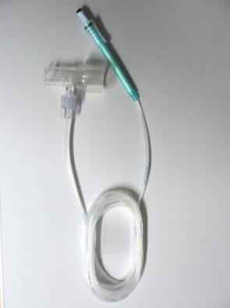
Photos of EuT

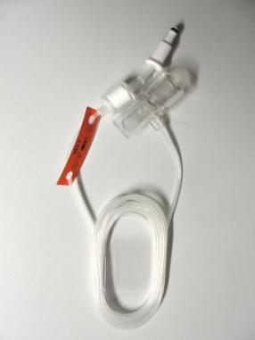
Nomoline with Airway Adapter

VersaStream Short Term with Airway Adapter
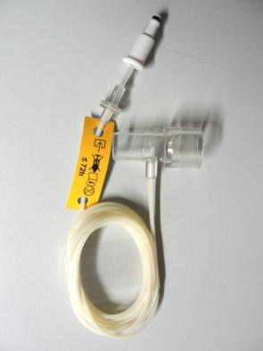

VersaStream Long Term with Airway Adapter

3. Method

3.1 Measurement Accuracy

3.1.1 Test equipment

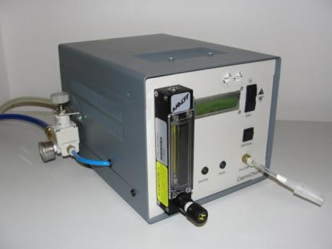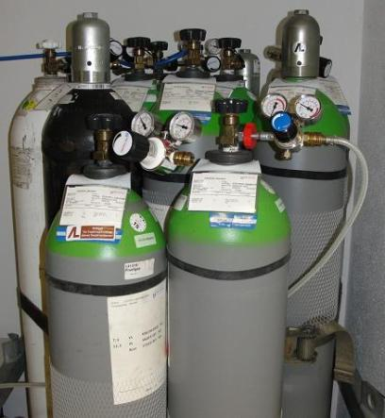
CapnoCheck , CO2-Respiratory-Simulator Test gas 3; 5; 7,5 Vol% + 0,1 Vol%

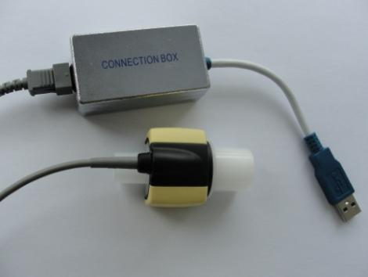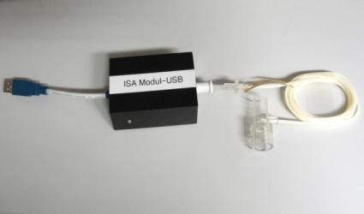
Test
object
IRMA
UART-USB-Converter for mainstream CO2 UART-USB-Converter with integrated IRMA-Sensor as reference side stream CO2 ISA-module

3.1.2 Test Setup

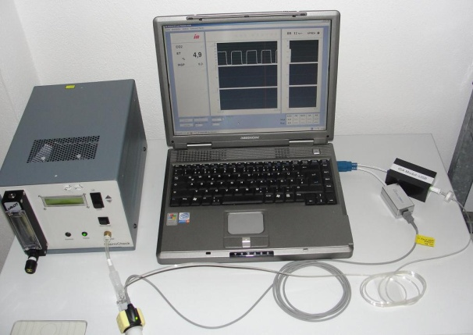
Test set-up

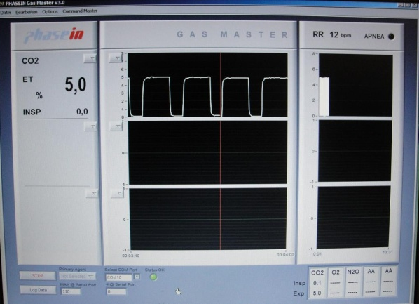
Software Gas Master V3.0 user interface

Test description

Use the Gas Master V3.0 software to record the measurement data.

12 respiratory rate steps are simulated with 3 CO2 test gas concentrations a according to table:

Parameter | Parameter
Co2 test gas | 3Vol%, 5Vol%, 7,5Vol%,
Respiratory rate | 10, 20, 30, 40, 50, 60, 70, 80, 90, 100, 110, 120

Connect the UART-USB mainstream converter with a PC and the IRMA CO2 sensor for reference CO2 data. Connect the UART-USB side stream converter with integrated ISA-CO2 module with a PC and the EuT.
Connect the IRMA and the EuT with the outlet valve of the CapnoCheck. Start the CapnoCheck with the parameter in the table above.
Each respiratory rate test step has duration 120 seconds.
In the first 60 seconds the values and simulator are allowed to stabilize. Thereafter the respiratory rate and CO2 value are recorded

The functional performance criteria required to pass the test:

- CO2 measurement accuracy: RMS* < 0,2

- RR measurement accuracy: RMS < 2

*RMS: Root Mean Squared difference

$$RMS=\sqrt{\frac{\sum_{i=1}^{n}{(UUT measured _{\text{i}}-{\text{Target }}_{\text{i}})^{2}}}{n}}$$
UUT: Measured value
Target: Target value

The recorded raw data were additional illustrated as a capnogram.

Ambient temperature: 22°C

Rel. Humidity: 34%

3.2 Negative pressure Test

3.2.1 Test equipment

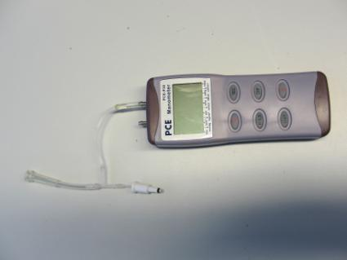
Test
object
Digital Manometer with adapter UART-USB-Converter for side stream
CO2 ISA-Sensor

3.2.2 Test Setup

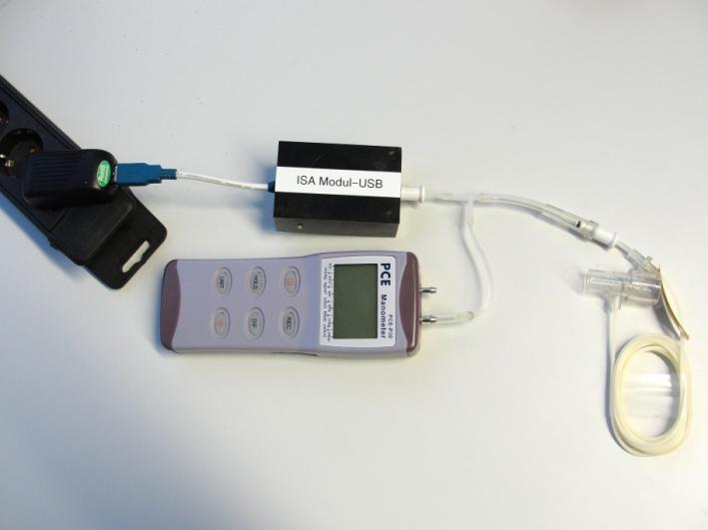
Test set-up

3.2.3 Test description

Connect the UART-USB side stream converter with integrated ISA-CO2 module with a power supply. Switch on the digital manometer.

In the first 60 seconds the values are allowed to stabilize. Thereafter the momentary pressure value is recorded.

The functional performance criteria required to pass the test:

- Negative pressure accuracy: < 25 mbar

Ambient temperature: 22°C

Rel. Humidity: 34%

4. Results

4.1 Measurement Accuracy
4.1.1 CO2 Accuracy
Respiratory Rate (RR): 10 bpm till 120 bpm
CO2 test gas concentration: 3 Vol%
 |  |  | VersaStream | VersaStream
CapnoCheck | IRMA | NomoLine | Short Term |  | Long Term
RR [bpm] | et CO2 | et CO2 | et CO2 |  | et CO2
10 | 3,0 | 3,0 | 2,9 |  | 3,0
20 | 3,0 | 3,0 | 2,9 |  | 3,0
30 | 3,0 | 3,0 | 2,9 |  | 3,0
40 | 3,0 | 3,0 | 2,9 |  | 3,0
50 | 3,0 | 3,0 | 2,9 |  | 3,0
60 | 3,0 | 3,0 | 2,8 |  | 3,0
70 | 3,0 | 3,0 | 2,8 |  | 3,0
80 | 3,0 | 3,0 | 2,8 |  | 3,0
90 | 3,0 | 3,0 | 2,8 |  | 2,9
100 | 3,0 | 2,9 | 2,8 |  | 2,9
110 | 3,0 | 2,9 | 2,8 |  | 2,9
120 | 2,9 | 2,9 | 2,8 |  | 2,8
RMS | 0,029 | 0,050 | 0,165 |  | 0,076

Respiratory Rate (RR): 10 bpm till 120 bpm
CO2 test gas concentration: 5 Vol%
 |  |  | VersaStream | VersaStream
CapnoCheck | IRMA | NomoLine | Short Term |  | Long Term
RR [bpm] | et CO2 | et CO2 | et CO2 |  | et CO2
10 | 5,0 | 5,0 | 5,0 |  | 5,0
20 | 5,0 | 5,0 | 4,9 |  | 5,0
30 | 5,0 | 5,0 | 4,9 |  | 4,9
40 | 5,0 | 5,0 | 4,9 |  | 5,0
50 | 5,0 | 5,0 | 4,9 |  | 4,9
60 | 5,0 | 5,0 | 4,8 |  | 5,0
70 | 5,0 | 4,9 | 4,9 |  | 5,0
80 | 5,0 | 4,9 | 4,8 |  | 4,9
90 | 5,0 | 4,9 | 4,8 |  | 4,9
100 | 4,9 | 4,8 | 4,8 |  | 4,9
110 | 4,9 | 4,8 | 4,8 |  | 4,9
120 | 4,9 | 4,8 | 4,7 |  | 4,8
RMS | 0,050 | 0,112 | 0,168 |  | 0,091
Respiratory Rate (RR): 10 bpm till 120 bpm
CO2 test gas concentration: 7,5 Vol%

 |  |  | VersaStream | VersaStream
CapnoCheck | IRMA | NomoLine | Short Term | Long Term
RR [bpm] | et CO2 | et CO2 | et CO2 | et CO2
10 | 7,5 | 7,5 | 7,5 | 7,4
20 | 7,5 | 7,5 | 7,4 | 7,4
30 | 7,5 | 7,5 | 7,4 | 7,4
40 | 7,5 | 7,4 | 7,4 | 7,4
50 | 7,5 | 7,4 | 7,4 | 7,4
60 | 7,5 | 7,4 | 7,3 | 7,4
70 | 7,5 | 7,4 | 7,3 | 7,3
80 | 7,5 | 7,4 | 7,3 | 7,3
90 | 7,4 | 7,3 | 7,3 | 7,3
100 | 7,4 | 7,3 | 7,2 | 7,3
110 | 7,4 | 7,3 | 7,2 | 7,2
120 | 7,4 | 7,2 | 7,2 | 7,2
RMS | 0,058 | 0,147 | 0,197 | 0,180

Capnogram
Respiratory Rate (RR): 10 bpm
CO2 test gas concentration: 5 Vol%

Capnogram
Respiratory Rate (RR): 50 bpm
CO2 test gas concentration: 5 Vol%

Capnogram
Respiratory Rate (RR): 100 bpm
CO2 test gas concentration: 5 Vol%

4.1.2 Respiratory Rate (RR) Accuracy

Respiratory Rate (RR): 10 bpm till 120 bpm
CO2 test gas concentration: 3 Vol%
CapnoCheck | IRMA | NomoLine | VersaStream Short Term | VersaStream Long Term
RR [bpm] | RR [bpm] | RR [bpm] | RR [bpm] | RR [bpm]
10 | 10 | 10 | 10 | 10
20 | 19 | 20 | 19 | 20
30 | 30 | 30 | 30 | 30
40 | 40 | 40 | 39 | 40
50 | 50 | 50 | 50 | 50
60 | 59 | 59 | 60 | 60
70 | 70 | 70 | 69 | 69
80 | 80 | 80 | 80 | 80
90 | 90 | 90 | 90 | 90
100 | 99 | 99 | 100 | 100
110 | 110 | 110 | 109 | 109
120 | 120 | 120 | 119 | 119
RMS | 0,50 | 0,41 | 0,64 | 0,50

Respiratory Rate (RR): 10 bpm till 120 bpm
CO2 test gas concentration: 5 Vol%
CapnoCheck | IRMA | NomoLine | VersaStream Short Term | VersaStream Long Term
RR [bpm] | RR [bpm] | RR [bpm] | RR [bpm] | RR [bpm]
10 | 9 | 10 | 10 | 9
20 | 20 | 20 | 19 | 20
30 | 30 | 30 | 30 | 30
40 | 40 | 40 | 40 | 40
50 | 49 | 50 | 50 | 50
60 | 60 | 60 | 59 | 60
70 | 70 | 70 | 70 | 70
80 | 80 | 80 | 80 | 80
90 | 90 | 89 | 89 | 89
100 | 101 | 100 | 100 | 100
110 | 110 | 110 | 109 | 110
120 | 121 | 119 | 119 | 120
RMS | 0,58 | 0,41 | 0,64 | 0,41

Respiratory Rate (RR): 10 bpm till 120 bpm
CO2 test gas concentration: 7,5 Vol%
CapnoCheck | IRMA | NomoLine | VersaStream Short Term | VersaStream Long Term
RR [bpm] | RR [bpm] | RR [bpm] | RR [bpm] | RR [bpm]
10 | 10 | 10 | 10 | 10
20 | 20 | 19 | 20 | 19
30 | 30 | 30 | 29 | 30
40 | 40 | 40 | 39 | 40
50 | 50 | 49 | 49 | 49
60 | 60 | 60 | 59 | 60
70 | 69 | 70 | 70 | 70
80 | 80 | 80 | 80 | 80
90 | 90 | 89 | 89 | 89
100 | 100 | 100 | 100 | 100
110 | 110 | 109 | 109 | 109
120 | 119 | 119 | 119 | 120
RMS | 0,41 | 0,64 | 0,76 | 0,57

4.2 Negative pressure Test

Sample volume | NomoLine | VersaStream Short Term | VersaStream Long Term
60ml/min | 19 mbar | 20 mbar | 23 mbar

Diagram

5. Conclusion

5.1 Measurement Accuracy

5.1.1 CO2 Accuracy
The CO2 Test verifies that the accuracy of the tested VersaStream sampling lines is observed. The Root Mean Square is < 0,2.

5.1.2 Respiratory Rate (RR) Accuracy
The Respiratory Rate Test verifies that the accuracy of the tested VersaStream sampling lines is observed. The Root Mean Square is < 2.

5.2 Negative pressure Test
The Pressure Test shows no significant differences between the Nomoline and the VersaStream sampling lines. The pressure difference is < 25 mbar.

