

SBRI Healthcare Interim Phase 1 Report Form
This report must be received 5 working days after the end of a SBRI Healthcare’s Phase 1 project’s first quarter, as defined in the project’s Phase 1 contract. The report should be uploaded onto SBRI Healthcare’s Fluid Review site, using the dedicated Task available for this report.
The aims of this document are:
- To report on the work undertaken, its success in meeting the project’s objectives and to provide information that may be used by the SBRI Healthcare team in the assessment of the project’s progress; and
- To explain expenditure.

Please note that the information supplied by the project in this document will be used by SBRI Healthcare to understand performance against the contracted milestones and financial management.

The report should be completed by the lead contractor, with input from any sub-contractors or project partners if appropriate. When describing technical solutions, please regard your audience as being someone familiar with the field, but not an expert in the technology. Please also explain in the report the meaning of all the acronyms used and avoid the extensive use of technical jargon.
Diagrams or pictures may be added, however be sure to keep the maximum number of pages to 22 sides of A4 in Arial 10pts minimum font size.
Please note that questions 10 to 18 relate to the commercial development and health economics of the product(s) under development. The lead contractor is asked to answer these questions in line with their expectation of the direction of the project and it is appreciated that such understanding will develop during the term of the SBRI Healthcare Phase 1 contract. As SBRI Healthcare has already received information from the project for a number of these aspects from the project’s SBRI Healthcare application form, please do not replicate such information but instead provide further detail to highlight the project’s evolving understanding in these areas.
The authors are allowed to edit the format and size of all the cells and tables in this form to better fit the text for each section. Namely, the authors are allowed to expand or reduce the size of the cells, paste new cells or extra pages, etc. However please do not exceed the maximum number of 22 pages for the complete form. Word limits are provided only as a guide to maximum expected length of responses. If a question is felt to be inapplicable to your project, please indicate this with ‘N/A’.
For enquiries, please contact the SBRI Healthcare team at Health Enterprise East on Tel: 01223 928 040 or sbrienquiries@hee.co.uk

1. Details
SBRI Healthcare project title: Portable wearable paediatric oxygen monitoring device
Registered Company Name: Viamed Ltd.
Registered Address: 15 Station Road
Cross Hills
Town/City: Keighley
Postcode: BD20 7DT
County: West Yorkshire
Report Author: Patrick Trotter and Steve Nixon
Telephone Number: 01535 634 542
E-mail Address: steve.nixon@viamed.co.uk
Total Contract Value: (£s) 93,318.15
Contract Start Date: 16th December 2016 End Date:15th June 2017

2. Please provide a summary of your Phase 1 project that briefly describes the main features of the envisaged product(s) in addition to any other principle project outputs
(max. 100 words)
The project is to develop a wearable, self-adjustable wireless probe (with appropriate paediatric software algorithms) that can be used in children. The wearable technology solution can aid in decision making thereby leading to reduced admissions to hospital and during home monitoring lead to improvements in independence and self-management for children requiring long-term oxygen or home ventilation therapy.

The design focuses on the needs of the clinicians, the children and parents/ carers. As part of the project sophisticated best practice innovation methodologies are utilised to identify and prioritise needs that are translated into design inputs to increase the probability of commercial success.

3. Milestones and key test for Phase 1 as set out in Schedule 1 of the SBRI Healthcare contract.
In reference to the milestones described, please indicate any changes that have occurred. Include the reasons for these changes and any circumstances that assisted or hindered the progress of the project and the actions being taken to overcome them.
 | Original Milestones |  |  |  | Results/Updates/Changes
# | Milestone | Delivery  Date | Resource | Success Criteria | Date Delivered/ Expected | Changes to milestone (include explanation of alterations in outcome and/or resources) | Outcome achieved
 | Benchmark existing pathways | End of month 1  22nd Jan 2017 | Dr Ruth Kingshott  and Prof Heather  Elphick | Understanding of pathway by which patients enter the system. | End of January | None | Yes
 | Focus groups 1,2  and 3 | All by end of April 2017 | Medilink to lead workshop and questionnaire  design (with input  from all) | Identification and  prioritisation of  user needs to  convert to design  inputs to link into product design.  Identification of  clinical evidence  that will be  required to be  collected during  Phase II. | Focus group 1 (now 1:1 interviews + focus group)  Focus group 2 (complete the 9th March 2017)  Focus group 3  (taking part on 11th May 2017) | - Focus group I was changed to 1:1 interviews and an internet survey to get more responses and to eliminate bias that might have occurred at the focus group due to the presence of senior clinicians.  - An additional ethnography step was used in which the team observed patients that had been home monitored during consultation with health care professionals in the NHS. This identified some unmet needs directly and fed into the focus group design. Ethnography is the single most powerful innovation tool that has been proven to help innovates come up with solutions to problems the end use cannot articulate.  The team have decided to split focus group 3 into two focus groups to validate the concepts one patient focussed and one clinical (health care professional focusses). It is expected this approach will enhance the quality of the concept development/enrichment phase. | On track
 | Competitor analysis  and IP assessment | 8 weeks  22nd Feb 2017 | Medilink | Assessment of  freedom to operate  and  gaps/opportunities  to file new IP. The  exercise will also  identify key threats  and potentially  opportunities.  Clarity on route to  Market. | 9th February | None. Good overview of existing IP from main competitors.  IP will need to be monitored and assessed relative to the development of the technical solution. | Yes
 | NHS Ethics  approval | 16 weeks  22nd April 2017 | Prof Heather  Elphick and Dr Ruth Kingshott (SCH) | Permission to  conduct clinical  evaluation for Phase II  (the milestone relates to initiation of preparation of the protocol for phase II (not formal approval). | On track | None  This will be initiated once the plan for phase II is defined. it was articulated in the Phase I application as the team realise this is potentially a rate limiting step and the application needs to be initiated prior to the SBRI Phase II application. | On track
 | Conversion of user  needs to design  inputs | 16 weeks  22nd April 2017 | All. The focus  groups will play a  key role in defining  criteria and using  inputs to refine  product designs. | A report that lists  design inputs that  are critical to  quality (and linked  to the end user  needs).  These design  inputs will feed into  the definition of the  final product  design. | 15th March | None  This was completed ahead of schedule. The definition of design inputs translated from both the clinical and patients’ needs represents best practice and significantly reduces commercialisation and technical risks during Phase II. | On track
 | Enrichment of  concept | 20 weeks  22nd May 2017 | All including the  Non-Woven  Research Institute  (who will be  contracted to aid in  the final design and  prototyping  stages). | The definition of 3-  4 alternative  designs and  benchmarking with  market leader  (using Pugh  matrix).  Success criteria is  definition of  alternative product  designs. | On track | None | On track
 | Clinical study  protocol | 24 weeks  22nd June | Prof Heather  Elphick and Dr Ruth Kingshott | Formal clinical protocol to be used for clinical  evaluation work. | End of Jan 2017for (Phase I clinical work) | None  Protocol is complete at time of writing application was going through ethics. | On track
 | Equipment and  NHS ethics  approval for  benchmark testing  of existing devices | 8 weeks  22nd February | SCH | Approval for equipment to be used in clinical work. | Mid Feb 2017 | None | On track
 | Testing existing  algorithms and  products on 10  patients | 16 weeks  22nd April 2017 | SCH | It is important to  benchmark the  suitability of  existing algorithms  to identify and  design the  algorithm used in  the clinical testing  for Phase II. | On track
 | Selection &  validation of  concept to move  into clinical testing  (Phase II) | 22nd June 2017 | All | A final design spec  and detailed  product design will  be the measure of  success. | On track

Key Test:
A final design and detailed product design will be the measure of success. It is anticipated that at the end of phase I this might be reduced to 2- 3 alternatives.

4. To what extent has the project to date met the key test set out in the Phase 1 contract?
(max. 300 words)
The project is only 3 months in and a substantial amount of progress has been made.
The project is based on using the best practice to innovation in which the unmet need is understood in sufficient detail to defined the design inputs and to define several iterations of the concept and to use a structured approach to concept selection based on clinical needs, patients’ needs and commissioners’ needs.
The focus of Phase I is to ensure the design meets patient needs and clinicians need and this has been the focus of months 0-3 of the work. This strong foundation is expected to reduce technical and commercial risk. A series of interviews, surveys and focus groups have been conducted to understand the needs of patients, clinicians and parents (or carers).
This work has identified some clear needs such as the removal /reduction or wires, need to reduce pressure (and increase comfort at the sensor site), the need to make sensors more durable, to reduce problems associated with sensors falling off and the need to access data remotely.
The team are currently working on concepts based on these needs and are on track to define a desired final concept by the end of phase I. The results of Phase I have already shown the several areas of the anatomy including forehead, nose, fingers (used on existing oximeters), chest and upper arm (proposed new sites) are unacceptable for patients. Future concepts are focussing on devices that could attached to prioritised areas such as the leg, wrist, ear, stomach or toes.
At the time of writing new device concepts and designs are being created. The team look forward to reporting these at the end of Phase 1.

5. Have there been any changes in the management structure or personnel administering the award in the project to date?
(max. 300 words)
There are no changes in management or personnel. The team remains firmly committed and enjoy a strong working relationship.

6. Please provide a detailed summary of the outputs obtained by the project to date, include a description of the current iteration of the product and any associated service offering, along with any available data generated as part of trials/pilots etc. being carried out.
(max. 3 pages)
The project is less than 3 months old and is on track to meet all milestones
In the section below a summary of the main activities is provides.

Competitor analysis
An assessment was made of both products on the market and patent filings of companies that are currently active in the oximeter market.
There are over 1200 patent families that mention the work ‘oximeter’ in the title. This does not include filings that use other descriptive phases). Due to the large number of filings in the oximeter field it was impossible to review every patent. A deeper assessment of Masimo was conducted than the other companies, but key trends and examples of key patents from other players was also covered.

Separate searches were conducts to cover the main players (Masimo, GE Healthcare, Philips Respironics, GE Healthcare, Biochem International (BCI), Nonin Medical, Medtronic (Covidien) and Konica Minolta.

These highlight both technical trends and areas of focus and specific relent patents. The figure below is an example of some of the analysis taken from the report (these were repeated for each competitor and are shown here for illustrative purposes only.
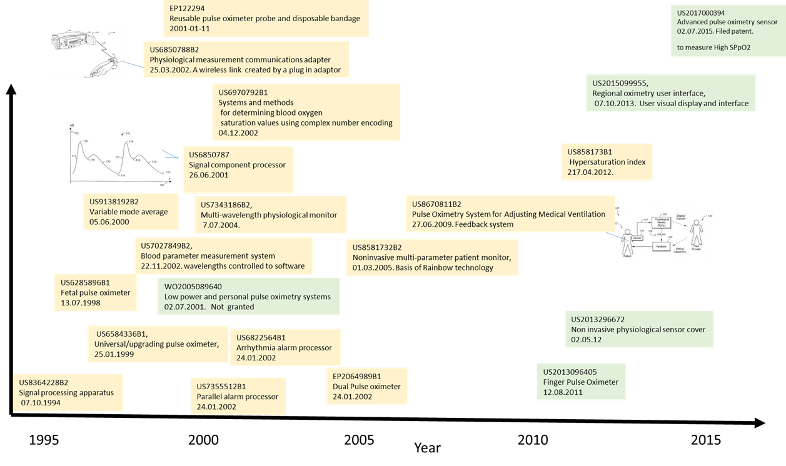

Figure 1: Patent map for Masimo with respect to patent filings and priority date (not granted and non-granted applications are shown with granted patents in yellow).

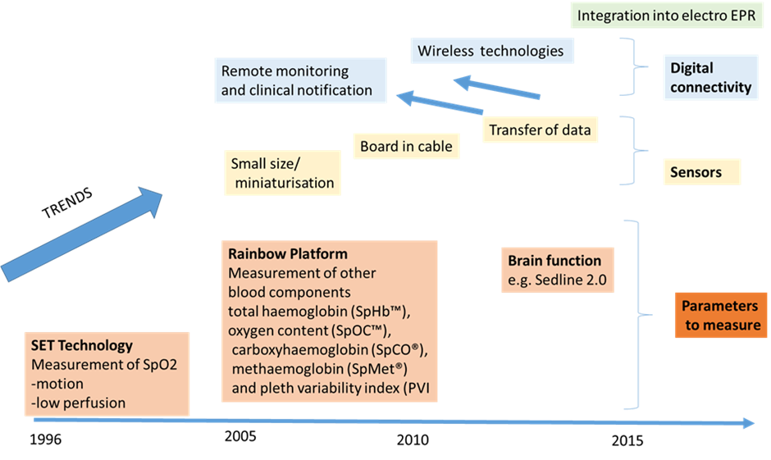
Figure 2: Trend analysis for Masimo

In summary, the data shows there is a clear drive to wireless devices and remote monitoring and that while there is activity around calibration and noise reduction the design, placement and design of sensors might offer an avenue to reduce artefacts while generating strong IP (although the device might have to incorporate Bluetooth or wireless functionality to meet future needs.
In general terms, many of the key players have intellectual property that covers the US and not Europe (although there are exceptions). This means that for a European market freedom to operate might not be a large barrier (but individual inventions will need to be assessed), although this does not necessary equate to an invention being patentable as the team will need to demonstrate that any new patentable invention is novel, non-obvious and reduced to practice. Although there are patent filings on wireless solutions companies appear to be having these rejected or challenged (some are on ongoing correspondence). There are a small number of granted patents (in the US rather than Europe) and more detailed assessment of these should be made as the project progresses (in relation to specific concepts).
This report is intended to be a top level broad report and is intended to help with product positioning and idea generation and defining the overall intellectual property strategy.
Clinical and patient needs and conversion to design
A significant amount of effort has gone in to defining the needs and this has highlighted the user requirement. Innovation techniques were used to get both clinicians to rate and rank needs and specific design features that are important so the team could focus only on the important criteria. Many innovations fail at market because the design team have not focussed on the right areas. the structured approach used in this project has reduced this risk.
Figure 3 shows screen shots that were used during the capturing clinicians needs and rating the importance of specific design elements.

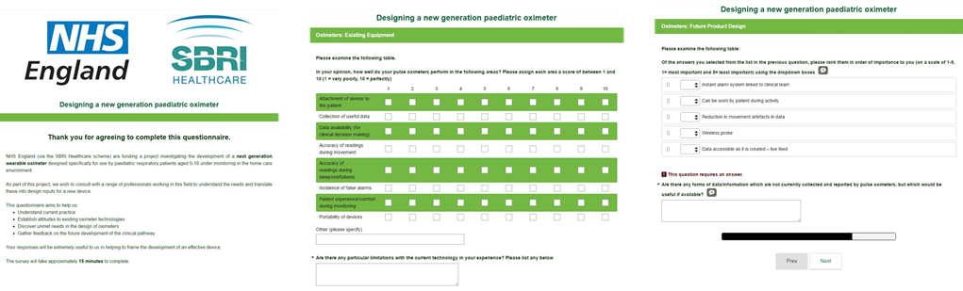

Figure 3: Screen shots showing the example of the approach used to select and prioritise needs and design features.

At the time of writing this information was being translated into a formal list of design inputs and concepts are currently being generated that will be assessed at focus group 3 for prioritisation and selection.

Figure 4 shows a summary of the patient focus group that was conducted on 9th march 2017.

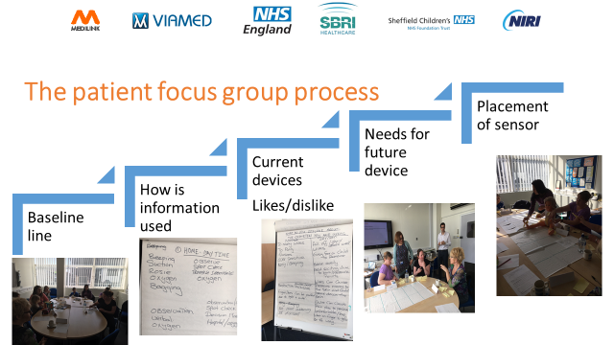

Figure 4: The patient focus group process showing pictures taken during the focus group.

The data and outputs from the workshops were still being interpreted at the time of wring this report. However, figure 5 provides a snapshot of the type of work that patients have contributed directly to with regard to the

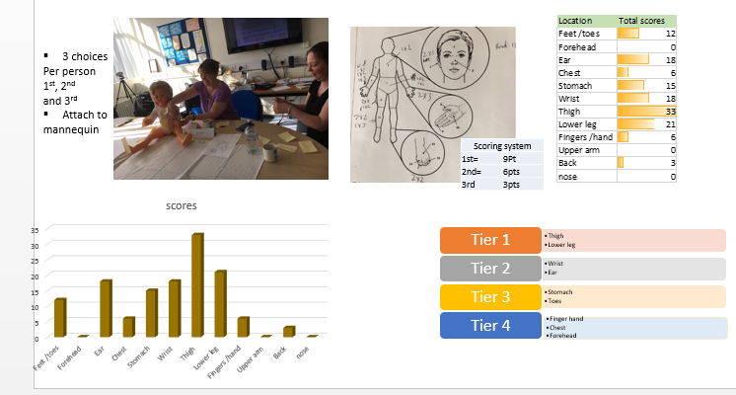

Figure 5: An example of the outputs of the patient focus group. A full appraisal of results and how it relates to new product design will be in the end of Phase I report.

Clinical Phase I
Phase I includes testing existing algorithms and products on 10 patients to get baseline data. This has included protocol development and a series of approval panels (MEMG and Ethics). At the time of writing approval via the MEMG panel had been approved and the team are awaiting approval from the ETHIC Review Panel.
Phase I clinical work will be reported at the end of Phase I

7. Describe the new, innovative aspects of the work, including findings and techniques obtained by the project to date. Clearly identify where any such innovations represent an advance over the state of the art.
(max. 300 words)
The assessment of existing technologies and patient needs show existing solutions do not meet their needs and that there is a considerable gap to exploit.

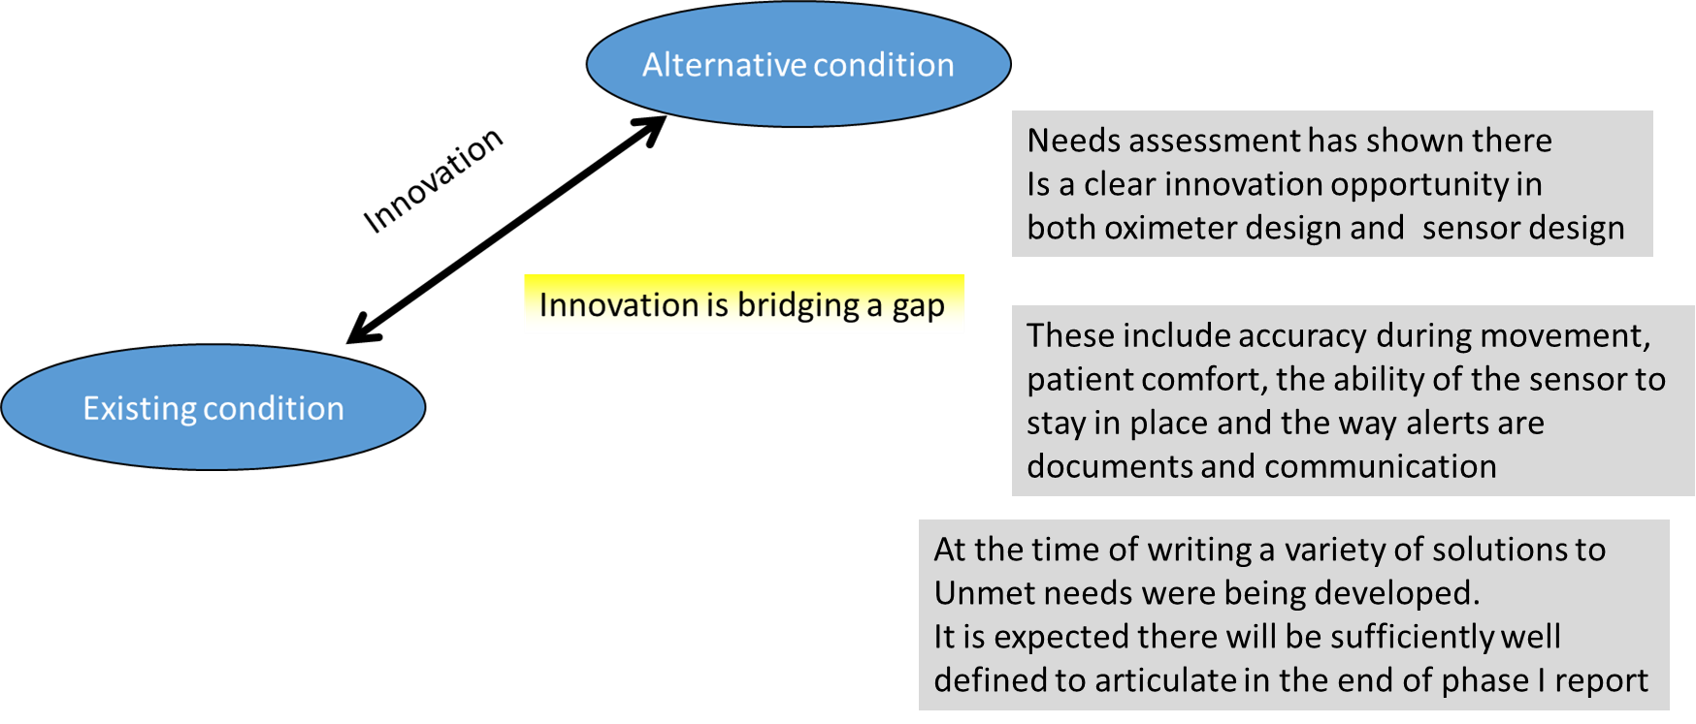
The project team have just completed a detailed assessment of users’ needs. This has already identified some surprising findings that the project team believe have opened the door to new innovations that are non-obvious and that the team believe can be incorporated into the development of the new device.

8. List any new Intellectual Property (IP) which has been filed or for which filing is anticipated – this could include trademarks and designs, as well as patents.
(max. 300 words)

It is too early in the project to articulate this although the competitor analysis shows that freedom to operate for digital type solutions is unlikely to be an issue (at least in Europe) and it is expected the team will develop solutions with novel inventive steps for the problems (identified from the clinicians and patients).
As mentioned above the thorough appraisal of user needs, including the children and their families have identified specific areas for innovation.

It is expected that these will be sufficiently defined by the end of Phase I and that the process of protecting and exploiting this IP can be a focus of Phase II.

9. What is the project’s progress in achieving the required regulatory and governance approvals for the product(s) under development? (e.g. CE marking, NICE technology appraisal)
(max. 300 words)
The project is only 3 months in and these activities are not planned during Phase I (none of the milestones relate to the above), but are expected to be conducted during Phase II.

10. Please describe the product’s planned route to market (distribution, sales, etc.).
(max. 300 words)
Again, it is only 3 months into the project and the plan is as articulated in the Phase I application.

Phase II will involve concept enrichment though to design freeze and clinical testing. Viamed already design, manufacture, market and distribute oximeters both in the UK and internationally and as such there is well defined route to market. The TITCH network are clinical partners in the project and the Y&H AHSN are supporting the project and will take an active role during Phase 2 and after launch to promote spread and adaption (see letter of support -attachment 2).

The team will focus on defining the evidence that is needed to support both regulatory approval and adoption.
Market adoption.
The NHS evaluates performance in accordance with a series of frameworks and indicators that ultimately influence commissioning. These include the NHS Outcomes Framework (clinical outcomes and patient issues), QIPP agenda (efficiency and cost savings), CQUINs and Quality Premium (menu of locally agreed targets).

A value proposition based on the quality indicators of the NHS will be built up as a key element of Phase II. This will include document the new patient pathway (if needed) and benchmarking the value with existing solutions. This value proposition (alongside additional dialogue with end users and commissioners) will play a role in designing the Phase II clinical trial that will incorporate the clinical and efficiency data needed to secure adoption.

Pricing
A pricing sensitivity analysis will be conducted and health economic data complied to support the business case for adoption. Part of the work will be to determine the COGS and conduct a price sensitivity analysis with payers and end users

International
International markets will be assessed and prioritised based on market size, reimbursement drivers and Viamed’s existing presence and relationship with distributors in those markets. Viamed already market and distribute medical devices products in Europe and the Middle East. These established distribution networks will be utilised to ensure the success of the project.

Regulatory
In addition, as part of the design history file a clinical evaluation report (CER) will be requires that will ensure that the product indications and claims are supported and assess that benefits of using the technology outweighs any risk. The team have extensive experience of preparing CERs. Viamed also have experience of securing CE marks for numerous types of medical device. It is anticipated a regulatory submission will be filed before the end of Phase II

Intellectual property
It is expected IP will be filed during Phase II of the project (both in the form of patents and trademarks)

11. What is the envisaged target pricing for the product(s)?
(max. 300 words)
It is too early to determine this. However, it is in the plan for Phase II.

12. What are the margins anticipated for this product?
(max. 300 words)
It is too early to determine this. However, it is in the plan for Phase II.

13. Please indicate the product(s) intended market launch date (e.g. Q1, 2017)
(max. 300 words)
This will depend on the final product design and the size of the clinical trial that is needed.

However, it is anticipated that this will align with the Phase II work and that a regulatory approval application could be submitted before the end of Phase II. However, the development team are aware that the user needs suggest that there may be the need to converge digital and traditional monitoring technologies. This means there are additional regulatory uncertainties that will need to be evaluated during Phase II to understand the implications of these on the time lines to commercialisation. The project team would also need to engage additional partners for Phase II that might also impact the desired launch date.

Assuming Phase II started in July 2017 and ended in July 2018 and allowing 9 months for regulatory a version of the deice could be launched April 2019. Should the final concept have additional complexity (based on the needs of end users the launch date might be late 2019.

14. Provide a description of the health economic benefits that this product will deliver for the NHS, including the numbers of patients/users expected to benefit and potential savings to the NHS.
(max. 300 words)
The technology is initially intended for the paediatric home monitoring market for children with a significant risk of mortality and morbidity.

The NHS outcomes framework, QIPP agenda, CQUINs and the quality premium have many NHS targets relating to child health. These relate to a reduction in infant mortality, reduction in unplanned admissions and a new 2017 target (from the NHS Outcomes framework relating to preventing lower tract infections in children from becoming serious and to reduce emergency admissions with for children with lower respiratory tract infections (home oximetry might offer a solution to this NHS need).

A detailed value proposition to the NHS will be part of the Phase II activities. However, the team are confident that the project is well aligned to help the NHS meet its targets that has many targets related to paediatric health.

15. Provide a brief review of the market size for this product in the NHS and beyond (EU, US, etc.), including growth rate of the market, main competitors and potential adoption issues.
(max. 300 words)
In the UK, the paediatric market is the initial target. However, the technology might have utility for the adult market such as patients with COPD and as solutions for children are designed for the sensor to remain in place it is likely the solution will be appropriate for elderly patients with respiratory conditions including those with dementia. The absolute market is therefore much larger than the paediatric market.

The main competitors are summarised in section 6 with most offering adult solutions to the paediatric market. The growth rate is expected to grow by the need to reduce patient admissions and encourage self-care at home and home monitoring is an important enabler of this solution.

The UK will be the focus for adoption in the first instance, but the evidence gathered will be useful in securing adoption in other markets. The clinical team will also publish the evidence and present details of clinical use and benefits at conferences thereby helping with adoption.

As mentioned above Viamed already export into many markets and existing relationships in these countries will be exploited to overcome adoption barrier.

16. Who are you envisaging the customers for your product(s) will be?
(max. 300 words)
In the UK, the NHS is likely to be the primary customer. Neonatal and sleep units and home oxygen monitoring teams are likely to be early adopters. Sheffield Children’s Hospital are conducting the clinical work

However, our work with patients has already identified that there might be a private market with concerned parents prepared to pay for oximeters independently of the NHS. The opportunity has come somewhat as a surprise to the team and the validity and appropriateness of this market will be assessed in Phase II. The focus however will be the NHS.

Phase II will involve identifying who decision makers in international markets are likely to be along with identifying reimbursement drivers that might help drive adoption. This will be part of the value proposition work.

17. What are your sales forecasts for the developed product(s) for years 1, 2 and 3 post market launch?
(max. 300 words)
This is not known. The team know there is a clear clinical need and that the NHS targets might help drive adoption. There are also international markets and the potential and international priorities. These will be defined and evaluated during Phase II.

18. What are your plans for internationalisation?
(max. 300 words)
See above. However, Viamed currently export internationally (primarily to the EU and middle East).

Viamed also have strong relationships with international distributors. These relationships will be exploited during the commercialisation of the product.

International markets will be prioritised, the international value proposition developed and reimbursement routes defined in Phase II.

19. Will additional funding will be required to commercialise the product(s)? If so, describe the expected capital investment and the plans to raise this.
(max. 300 words)
This is a Phase I project, Phase II funded will be required. It is anticipated this funding should be sufficient to get to market.

20. The budgeted cost for your Q1, as displayed in Schedule 2 of your SBRI Healthcare contract, has been inserted into the report below. Please provide a brief description of how the SBRI Healthcare funds were spent with reference to the original budget and explain any significant variations. Confirm the final total project expenditure (£’s VAT included).

A separate financial spreadsheet template is provided to describe Quarter 1 costs in further detail.
 | Budgeted Costs (£) | Actual Costs (£) | Expenditure Description | Reasons for variance between budget and actual costs
Labour Costs | £11,580.07 | £11,580.07 | Labour costs for Viamed personnel.
Materials Cost | £1,032.00 | £1,032.00 (anticipated) | Parts for datalogger, still under construction.

Capital Equipment Costs
Sub Contract Costs | £29,355.00 | £29,355.00 | Sub-contractor costs for personnel at: Sheffield Children’s Hospital, Medilink and NIRI.
Travel & Subsistence Costs | £1,020.00 | £750.00 (anticipated, may be reduced) | Project members & focus groups. | To date did not incur focus group travel costs
Indirect Costs | £1,050.00 | £1,050.00 | Research Governance, NHS R&D sponsor cost. Focus group costs.

Other Costs

Total Q1 Costs (including VAT) | £44,037.07 | £43,767.07

21. The budgeted cost for your Q2, as displayed in Schedule 2 of your SBRI Healthcare contract, has been inserted into the report below. Please provide a brief description of how the SBRI Healthcare funds will be spent with reference to the original budget and explain any significant variations. Confirm the final total project expenditure (£’s VAT included).

A separate financial spreadsheet template is provided to describe Quarter 2 costs in further detail.
 | Budgeted Costs (£) | Actual Costs (£) | Expenditure Description | Reasons for variance between budget and actual costs
Labour Costs | £11,580.07 | £11,580.07 | Labour costs for Viamed personnel.

Materials Cost

Capital Equipment Costs | £5,520.00 | Yet to be confirmed. | For sensor prototype tooling.
Sub Contract Costs | £29,355.00 | £29,355.00 | Sub-contractor costs for personnel at: Sheffield Children’s Hospital, Medilink and NIRI.
Travel & Subsistence Costs | £750.00 | £750.00 (anticipated, may be reduced) | Project members.
Indirect Costs | £270.00 | £270.00 | Medipex Ltd. 1 day NHS IP support
Other Costs | £2,256.00 | Yet to be confirmed. | Parts for sensors, sensor design, moulding…
Total Q2 Costs (including VAT) | £49,731.07 | Yet to be confirmed. |  | £450.00 indirect costs included in the application, but not added in 7a totals. May not be relevant as I believe we will under spend overall.

22. Describe any potential long-term collaborations/partnerships entered into by the project to date and the roles these are playing in the project. This description should include any partnerships with NHS, social care or third sector providers.
(max. 300 words)
The project is led by Viamed the company that already market and sell oximeters to an international market. Viamed are international leaders in oximetry product design and market several products. The inherent knowledge around oximetry and sensors is central to the current project.

The project is supported by Medilink a not for profit organisation that provides consultancy services around innovation and product development for the medical device industry. Patrick Trotter PhD, MBA (Technol Mgmt.) is a technical and commercialisation expert who has 20 years’ experience working in the development and commercialisation of medical devices. Tom Wright is an expert in market research and market opportunity assessment.

The Non-Woven Research Institute (NIRI) is an organisation that have expertise in materials and offer technical expertise in wearable materials.

The clinical input is from the sleep unit at Sheffield Children’s Hospital. Dr Ruth Kingshott BS Ruth Kingshott BSc PhD is a clinical scientist specialising in paediatric respiratory and sleep
physiology. She has worked in this field for 22 years,16 of 20 working in sleep centres in Edinburgh, New Zealand and Sheffield since 2003. Ruth has considerable experience in setting up and analysing children's clinical sleep studies and was instrumental in setting up the sleep unit at Sheffield Children's Hospital. Heather Elphick MB ChB MRCP MD is head of the department of respiratory medicine at Sheffield Children's hospital. She was appointed as consultant in Paediatric Respiratory Medicine in 2008. She was awarded her MD on non-invasive respiratory measurements in wheezing children in 1999 from Sheffield University and trained in respiratory medicine at Alder Hey Children’s Hospital and Melbourne Children’s Hospital, Australia. Her particular clinical interests are in sleep medicine and long-term ventilation. Heather has a strong track record in research and was awarded a Visiting Professorship with Sheffield Hallam University in 2014 in recognition of her collaborative work in research and innovation. She has been awarded NIHR i4i grants for development of the Contactless Portable Respiratory Monitor (CPRM) and for development of custom-made interfaces for children using non-invasive ventilation. Sheffield Children’s Hospital are one of Europe’s leading centres and are ideally placed to conduct clinical evaluation of the technology and also to help to support the adopt and spread of the technology.

23. Describe the trials or pilots being undertaken by the project to date. Please include an indication of the number of patients/users are benefiting from your product during these trials/pilots.
(max. 300 words)
The team have submitted an application for ethics approval to test existing algorithms
in 10 patients during Phase I. At the time of writing a response from the Ethics Approval Committee had not yet been received

24. How many clinicians/clinical teams across how many trusts/organisations have been involved in developing the technology to this point?
(max. 300 words)
During the course of the work the team engaged in ethnography observing a consultant respiratory paediatric consultant, interview four health care professionals with seven health care respondents responding to an on-line survey. These individuals do not include the central clinical team who are running the Phase I clinical evaluation.

25. Describe how you are working with your local AHSN in respect of this project. What level of support have you received so far?

(max. 300 words)
The project originated from an innovation workshop conducted by the Y&H AHSN and the Y&H AHSN have been supportive of the project. This was manifested during the Y&H AHSN innovation conference in January 25th 2017 at the Royal Armouries in Leeds when Viamed exhibited and publicised the project. The Y&H AHSN will continue to be engaged during the life span of the project and will play a role in the adoption and spread of the technology.

26. Has this project provided your company with any new skills or know-how that will enable growth in the forthcoming years?

(max. 300 words)
Yes, the innovation skills such as ethnography, customer need segmentation and prioritisation are some skills that have already been impaired to the company. In additional it is envisaged new technical knowledge and know how (including digital) will be gained as the project progresses.

27. Has the SBRI Healthcare funding enabled you to create or safeguard jobs within your organisation? If so, how many?
(max. 300 words)
We are only three months into Phase I, so unfortunately it is far too early to be able to qualify this is any way.

28. Include details of additional funding (e.g. venture capital, equity investment or other institutional funding), leveraged as a result of the SBRI Heatlhcare award.

Please also include details of any awards or achievements directly related to the project to date.

(max. 300 words)
None. However, it is possible funding will be leveraged during Phase II (should the application for SBRI HealthCare Phase II funding be successful.

29. Provide additional information that may be pertinent. This may be in the form of text, pictures, diagrams, data, graphs that support the work. Please note this is for additional information only that could not be included in other sections.

(max. 600 words)
None at this stage.

30. Declaration from the author
I confirm that the information given on this report is complete and correct.

Company name: Viamed Ltd.

Signed: ……..……………………………............……. Date 21st March 2017
Print name: Steve Nixon

Company position: Director

