
PARENT/LEGAL GUARDIAN INFORMATION SHEET

Study title

Paediatric Oximetry Algorithms

Invitation paragraph
You and your child are being invited to take part in a research study. Research is important in helping us to improve ways of treating medical conditions. Before you decide whether to take part it is important for you to understand why the research is being done and what it will involve. Please take time to read the following information carefully. Talk to others about the study if you wish.

Part 1 tells you the purpose of this study and what will happen to you and your child if you take part.

Part 2 gives you more detailed information about the conduct of the study.

Ask us if there is anything that is not clear or if you would like more information. Take time to decide whether or not you want your child to take part.

Part 1 – to give you first thoughts about the project

- What is the purpose of the study?
We use pulse oximetry as a way of measuring and monitoring children’s blood oxygen levels in many situations, to diagnose respiratory conditions or to monitor treatment. The monitors that we use are accurate and safe and have been used for many years. The way they are set up to analyse the blood oxygen levels uses a calculation called an algorithm. There are algorithms for newborn babies and adults but no algorithms for children. We think that designing an algorithm for children will improve the accuracy of the information we get from the oxygen saturation monitors.

The purpose of this study is to collect data from children already having their oxygen levels monitored for a clinical reason, so that we can work out an algorithm for children.

This research will be conducted by a research team. Two members of the team, Ruth Kingshott, an expert in oximetry and research and Heather Elphick, a respiratory consultant will have access to your child’s medical record, as they are also members of the clinical team, but none of the other research will be able to access the records.

- Why has my child been chosen?
We want to collect blood oxygen information from children that are already having an oximetry test, as requested by their nurse or doctor. Your child is having this test done and this is why he/she has been chosen.

- Does my child have to take part?
No. It is up to you and your child (wherever possible) to decide whether or not to take part. You are both free to withdraw from the research at any time and without giving a reason.

If you are happy to take part, and are satisfied with the explanations from the research team, you will be asked to sign a consent form. If your child is able to understand the research and is happy to take part and can write their name, they will be asked to sign an assent form with you, if they want to. You will be given a copy of the information sheet and the signed consent/assent forms to keep for your records.

- What will happen to my child if we agree to take part?

Your child has already been asked to have their blood oxygen levels monitored by their nurse or doctor. For this test, they will have an oxygen saturation monitor attached to their toe with a plaster. If you take part in the research study, we will attach a second oximeter with a second plaster to another toe. The two monitors will be connected to a box called a data-logger, which will collect the oxygen information that we need for the research. This will not affect the information that is collected for the test that your doctor or nurse has asked for as this will be analysed separately. The oximeters will stay on for as long as your doctor or nurse has requested, and then they will both be removed.

Here is a photo of the equipment that we will use. The oximeter is about the size of a small shoebox and the only part that will come into contact with your child is the plaster on his/her toe.

Clinical Equipment Disposable or Reusable Probe

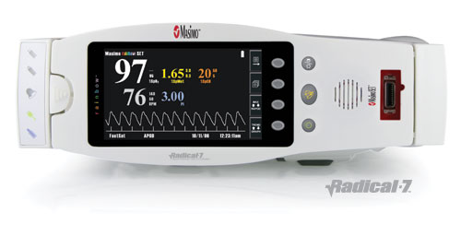
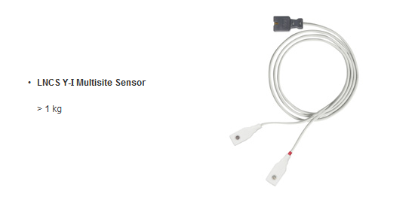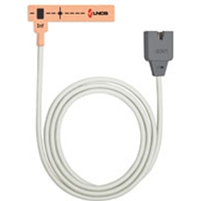

Additional Research Equipment Disposable or Reusable Probe
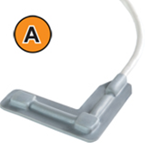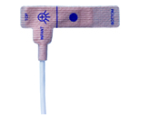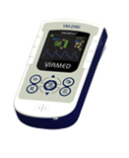

Ruth Kingshott or Heather Elphick will also write down details on a form such as where the plasters have been placed, the date, the age, height, weight, gender and ethnicity of your child, the reason for the oximetry and any medical problems your child has. This information will be used to gain all the necessary approvals for the algorithm to be used in the NHS but there will be no information on the form that will identify your child.

- What will we have to do?
You will not be asked to do anything other than to reassure and comfort your child. You will be asked to write down any breathing problems or disturbances your child has if he/she has the monitors overnight, but this is needed by the clinical staff and is not part of the research.

- What are the possible disadvantages and risks of taking part?
If at any time you or your child feels distressed by the second plaster, please don’t hesitate to tell the research doctor/nurse and we will stop the recordings.

- What are the possible benefits of taking part?
Your child will not benefit from being part of this study. However the information we collect may help us to treat future patients better.

- What happens when the research study stops?
We will collect all the oxygen readings from both monitors and give them to a company called Viamed who will write the new algorithm. All of the information that is given to Viamed will be anonymized and your child will not be identifiable.

- What if there is a problem?
Any complaint about the way you or your child have been dealt with during the study or any possible harm you or your child might suffer will be addressed. The detailed information on this is given in Part 2.

- Will my child’s taking part in the research project be kept confidential?

Yes. We will follow ethical and legal practice and all information about your child will be handled in confidence. The details are included in Part 2.

- Contact for further information
If you would like any further information about this study you could contact:

Name: Heather Elphick
Designation: Consultant Paediatrician
Hospital/Department: Sheffield Children’s Hospital
Tel: 0114 2717400

This completes Part 1 of the Information Sheet.
If the information in Part 1 has interested you and you are considering participation, please continue to read the additional information in Part 2 before making any decision.

Part 2 - more detail – information you need to know if you still want to take part.

- What will happen if we don’t want to carry on with the research?
If you withdraw from the study, we will destroy all your child’s identifiable data if you wish, but we will need to use the data collected up to their withdrawal.

- What if there is a problem?

Complaints
If you have any cause to complain about any aspect of the way in which you or your child has been approached or treated during the course of this study, the normal National Health Service complaints mechanisms are available to you and are not compromised in any way because you have taken part in a research study. If you have any complaints or concerns please contact either the project co-ordinator:

Name: Heather Elphick
Designation: Consultant Paediatrician
Hospital/Department: Sheffield Children’s Hospital
Tel: 0114 2717400

Otherwise you can use the normal hospital complaints procedure and contact the following person:

Mrs Julie Mathers
Patient Advice & Liaison Co-ordinator
Sheffield Children’s NHS Foundation Trust
Tel: 0114 271 7594

Harm
If your child is harmed by taking part in this research project, there are no special compensation arrangements. If your child is harmed due to someone else's fault, then you may have grounds for a legal action.

- Will taking part in this study be kept confidential?
All information which is collected about your child during the course of the research will be kept strictly confidential. Any information about your child which leaves the hospital will have their name and address removed so that your child cannot be recognised from it. Your child’s information will be given a unique study number. The unique study number which will link the patients to their identifiable hospital information will be saved on an encrypted NHS computer for up to 12 months after the study end and only RK and HE will have access to them. They will then be destroyed in accordance with standard operating procedures.

Our procedures for handling, processing, storage and destruction of data are compliant with the Data Protection Act 1998.

Your child’s medical notes may also be looked at by other people within the hospital involved in the running and supervision of the study to check that it is being carried out correctly.

- What will happen to the results of the research study?
When the study has finished we will present our findings to other doctors, and we will put the results in medical magazines and websites that doctors read. They will be anonymous, which means that your child will not be able to be identified from them. You will be able to obtain the results from Dr Elphick if you wish to see them.

- Who is organising and funding the research?
The research has been funded by the Small Business Research Initiative (SBRI), which is a government funded initiative.

- Who has reviewed the study?
The study has been reviewed by reviewers and panel members of the SBRI, as well as by the London City & East NHS Research Ethics Committee.

- How can we find out more about research?
The Clinical Research Facility at this hospital has a Taking Part section on its website http://www.sheffieldchildrens.nhs.uk/research or you could contact the hospital Clinical Research Facility:

Mrs Gillian Gatenby
Directorate Manager of Research
Sheffield Children’s NHS Foundation Trust
Tel: 0114 226 7904

If you and your child decide to take part in this study, you will be given this information sheet and signed consent and assent forms to keep.

Thank you for taking the time to read this information sheet.

