
PARTICIPANT INFORMATION SHEET
FOR YOUNG PEOPLE (age 12-16 years)

Study title: Paediatric Oximetry Algorithms

What is it about?
You have been asked to have a test that will measure the oxygen levels in your blood by your doctor or nurse. We are collecting information about children and young people’s oxygen levels, so we would like you to help us with our research study. Please read this information carefully and ask us if there is anything that is not clear or if you want to know more. Take time to decide if you want to take part. It is up to you if you want to do this. If you don’t then that’s fine, this will not affect your medical treatment.

The following information for you is in 2 parts. Part 1 tells you the purpose of this study and what it will involve for you if you decide to take part. If you are interested, Part 2 gives you more detail information about how the study will be run.

Part 1 – to give you first thoughts about the project

- Why are we doing the research study?
We use pulse oximetry as a way of measuring and monitoring children’s blood oxygen levels in many situations, to diagnose respiratory conditions or to monitor treatment. The
monitors that we use are accurate and safe and have been used for many years. The way they are set up to analyse the blood oxygen levels uses a calculation called an algorithm. There are algorithms for newborn babies and adults but no algorithms for children. We think that designing an algorithm for children will improve the accuracy of the information we get from the oxygen saturation monitors.

The purpose of this study is to collect data from children already having their oxygen levels monitored for a clinical reason, so that we can work out an algorithm for children.

This research will be conducted by a research team. Two members of the team, Ruth Kingshott, an expert in oximetry and research and Heather Elphick, a respiratory consultant will have access to your medical record, as they are also members of the clinical team, but none of the other research will be able to access the records.

- Why have I been chosen?
We want to collect blood oxygen information from people that are already having an oximetry test, as requested by their nurse or doctor. You are having this test done and this is why you has been chosen.

- Do I have to take part?
No! It is entirely up to you. If you do decide to take part:

- you will be asked to sign a form to say that you agree to take part (a consent form)

- you will be given this information sheet and a copy of your signed consent form to keep.

You are free to stop taking part at any time during the research without giving a reason.

- What will happen if I agree to take part?

You have already been asked to have your blood oxygen levels monitored by your nurse or doctor. For this test, you will have an oxygen saturation monitor attached to your toe with a plaster.

If you take part in the research study, we will attach a second oximeter with a second plaster to another toe. The two monitors will be connected to a box called a data-logger, which will collect the oxygen information that we need for the research. This will not affect the information that is collected for the test that your doctor or nurse has asked for as this will be analysed separately. The oximeters will stay on for as long as your doctor or nurse has requested, and then they will both be removed.

Here is a photo of the equipment that we will use. The oximeter is about the size of a small shoebox and the only part that will come into contact with you is the plaster on your toe.

Clinical Equipment Disposable or Reusable Probe

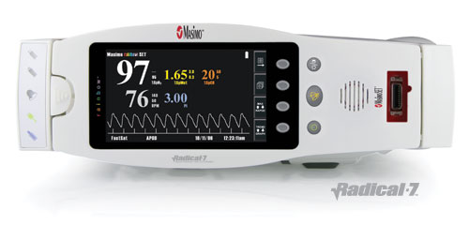
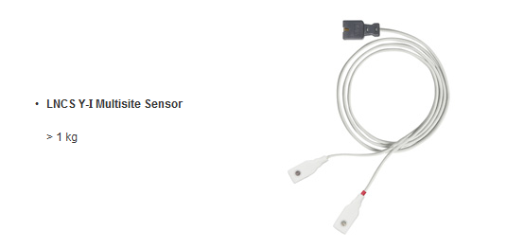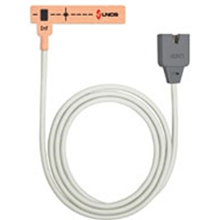

Additional Research Equipment Disposable or Reusable Probe
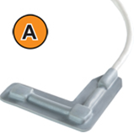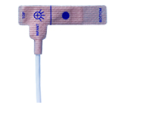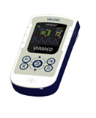

Ruth Kingshott or Heather Elphick will also write down details on a form such as where the plasters have been placed, the date, your age, height, weight, gender and ethnicity, the reason for the oximetry and any medical problems your have. This information will be used to gain all the necessary approvals for the algorithm to be used in the NHS but there will be no information on the form that will identify you.

- What will I have to do?
You will just carry on as normal, with the two plasters attached to your toes. If the test is being done overnight, you will sleep with the plasters on and they will be taken off in the morning.

- Will the study harm me?
No, it is very safe and won’t harm you. If at any time you get upset by having the second plaster on, just let someone know and we can take it off. You will need to keep the first plaster on because your doctor or nurse wants you to have the test but if you are upset about it, you can speak to them.

- Will the study help me?
The study won’t help you, but the information we collect may help us to treat future patients better.

- What happens when the research study stops?
We will collect all the oxygen readings from both monitors and give them to a company called Viamed who will write the new algorithm. None of your personal information will be given to Viamed so nobody will be able to identify you.

- Contact for further information
If you would like any further information about this study you could contact:

Name: Heather Elphick
Designation: Consultant Paediatrician
Hospital/Department: Sheffield Children’s Hospital
Tel: 0114 2717400

This completes Part 1 of the Information Sheet.
If the information in Part 1 has interested you and you are considering participation, please continue to read the additional information in Part 2 before making any decision.

Part 2 - more detail – information you need to know if you still want to take part.

- What if I don’t want to do the research any more?
Just tell someone at any time. They will not be cross with you. This will not affect the care you usually receive from your hospital or care team.

- What if there is a problem or something goes wrong?

Tell us if there is a problem and we will try and sort it out straight away. You can either contact the project co-ordinator:

Name: Heather Elphick
Designation: Consultant Paediatrician
Hospital/Department: Sheffield Children’s Hospital
Tel: 0114 2717400

Otherwise you can use the normal hospital complaints procedure and contact the following person:

Mrs Julie Mathers
Patient Advice & Liaison Co-ordinator
Sheffield Children’s NHS Foundation Trust
Tel: 0114 271 7594

- Will anyone else know I’m doing this?
Only people in our research team will know you are taking part.

All information that is collected about you during the research will be kept strictly confidential. Any information about you will have your name and address removed so that you cannot be recognised from it.

Your information will be given a unique study number. The unique study number will be saved on an encrypted NHS computer for up to 12 months after the study end and only RK and HE will have access to them. They will then be destroyed.

If we think that you are at risk of harm, or disclose something about criminal activity we will need to inform the correct people.

- What will happen to the results of the research study?
When the study has finished we will present our findings to other doctors, and we will put the results in medical magazines and websites that doctors read. They will be anonymous, which means that your child will not be able to be identified from them. You will be able to get the results from Dr Elphick if you wish to see them.

- Who is organising and funding the research?
The research has been funded by the Small Business Research initiative (SBRI), which is a government funded initiative.

- Who has rchecked the study?
The study has been reviewed by reviewers and panel members of the SBRI as well as by the London City & East NHS Research Ethics Committee.

- How can we find out more about research?
The Clinical Research Facility at this hospital has a Taking Part section on its website http://www.sheffieldchildrens.nhs.uk/research or you could contact the hospital Clinical Research Facility:

Mrs Gillian Gatenby
Directorate Manager of Research
Sheffield Children’s NHS Foundation Trust
Tel: 0114 226 7904

Thank you for taking the time to read this information sheet.

