
PARTICIPANT INFORMATION SHEET
FOR CHILDREN (age 6-12 years)

To be shown and read by Mum, Dad or carer

Study title
Paediatric Oximetry Algorithms


- What is research?
Research is a careful experiment to find out the answer to an important question.

- Why is this project being done?
We want to try and find a better way to measure oxygen levels from children by improving the way the machines give us the results. The way the machine calculates the levels is called an algorithm. We want to make one specially for children.

- Why me?
You have been chosen because you can help us find some answers that will help us make other children better.

- Do I have to take part?

No you don’t! It is up to you. We would like you to read this information sheet. If you and your mum, dad or carer agree to take part we would like them to write their name on a form to say it’s OK. You can also write your name on a form too if you like. You can still change your mind later. If you don’t want to take part, just say no!



- What will happen?
Your doctor or nurse has already asked for a test to measure your oxygen levels. To do this, they will put a plaster on your toe like the one below. If you take part in the research we will put another plaster on one of your other toes. The plasters will only be on for one day or one night.

Here is a picture of both bits of equipment. Our machine is about the same size as a shoebox. The only bit that will touch you is the plaster that goes on your toe.

Oxygen monitors Plasters

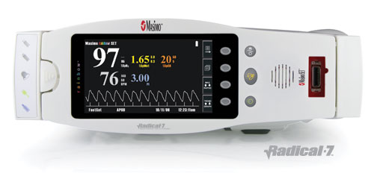
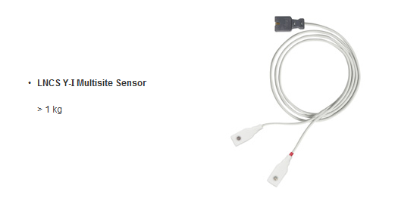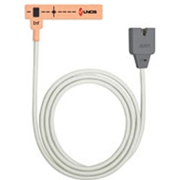

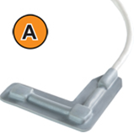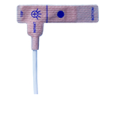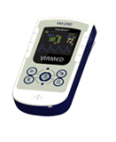

Your Mum, Dad or carer will be with you all the time.
One of the researchers will also write some information down on a form. This will include things like your age, size and any medical problems you have. Nobody will be able to work out who you are from the information that is taken.

- Will joining in help me?
No, but it may help us to know more about measuring oxygen in the future.

- What else might happen?
If you don’t like having your oxygen measured or are uncomfortable at any point we will stop the research.

- What happens when the research study stops?
We will collect all the information together and we will work out the new algorithm from the oxygen levels that we have collected from you.

- What if something goes wrong?
Your mum, dad or carer will be able to talk to someone who will be able to tell them what they need to do about it.

- What if I don’t want to do the research anymore?
Just tell your mum, dad, carer, or the research doctor at any time. They will not be cross with you.

- What if I wish to complain about the study?
If you want to complain you or your mum, dad or carer can talk to Dr Heather Elphick or Ruth Kingshott.

- Will anyone else know I'm doing this?
The people in our research team will know you are taking part. No one else will know because we will not use your name or address. You will get a number which will be used instead.

- What happens to what the researchers find out?
When we collect your information we will make sure it is stored in a safe place and only the people doing the research study can look at it.

No-one will know you were in the study.

- Did anyone else check the study is OK to do?
This study has been checked by several people, to make sure it is alright.

- How can I find out more about this study?
Your mum, dad, carer or other grown up you trust may be able to answer your questions. The research doctors doing the study can also help you find out more about the study.

Thank you for taking the time to read this – please ask any questions if you need to.

