Summary of Parent/carer experiences – published data

The summaries below are taken word for word from the papers.

Bray L, Shaw NJ, Snodin J. Living and managing with the long-term implications of neonatal chronic lung disease: The experiences and perspectives of children and their parents. Heart & Lung 2015: 44;512-516

This paper interviewed 10 children and 12 parents around the long-term implications of neonatal chronic lung disease. There were four main themes that came out of the interview. Below I have added any detail from these themes that are relevant for Phase 2:

- ‘Learning to live with it’ – families developed strategies and expertise to manage the condition. Parents commented that they got used to spotting the signs, and didn’t leave it so long before going into hospital. They got better of earlier identification of when their child was unwell.

- ‘Living with uncertainty’ – not sending the child to school as felt the child was safer at home where the parent could keep an eye

- ‘Stepping back, sitting out and missing out’ – not taking part in activity at school due to physical limitations

- ‘Interaction with health professionals and services’ – increased parental anxiety when discharged from specialist hospital back to local services with lower level of expertise in the condition. Increased anxiety when the parent knows that their child is ‘not right’ but out of hours GP or local hospital not having as much in-depth knowledge of the condition and struggling to get health professionals to acknowledge concerns.

Smith J, Cheater F, Bekker H. Parents’ experiences of living with a child with a long-term condition: a rapid structured review of the literature. Health Expectations 2013:18;452-474.

Review of the literature – 34 papers met the inclusion criteria. Main points relevant for phase 2:
- Ultimate responsibility for child’s health was overwhelming at first. But along with this developed considerable expertise in managing their child’s condition
- Parental contribution to care is not always valued by health professionals
- Parents learn from illness episodes and use these experiences to identify and respond to subsequent illness symptoms.
- The challenge for health professionals is to integrate parent’s expertise with their own clinical knowledge to improve joint understanding of the child’s condition and develop effective treatment care plans [becoming an ‘expert parent’].
Zanardo V, Freato F. Home oxygen therapy in infants with bronchopulmonary dysplasia: assessment of parental anxiety. Early Human Development 2001:65;39-16

10 mothers and 10 fathers of infants with bronchopulmonary dysplasia completed an anxiety questionnaire 3 times
- Just prior to discharge home
- After 2 weeks at home
- Once oxygen was removed from the home.
Questionnaire: State-Trait Anxiety Inventory (STAI Form Y). Standard tool used to assess situational anxiety. 2 x 20 questions. Takes 5-10 minutes to self-complete. There are 10 STATE questions which measure the current emotional state of the subject (apprehension, nervousness and worry). There are 10 TRAIT questions that look at the subjects personality traits and how a person generally feels.
Results: The maternal (but not paternal) STATE anxiety levels significantly decreased over time.

Feeley CA, Turner-Henson A, Christian BJ, Avis KT, Heaton K, Lozano D, Su X. Sleep quality, stress, caregiver burden, and quality of life in maternal caregivers of young children with bronchopulmonary dysplasia. J Pediatr Nursing 2014:29;29-38.

Maternal caregivers of young children with BPD may be at risk for increased levels of stress and caregiver burden, elevated depressive symptoms, combined with poor sleep quality may result in decreased quality of life.
Risk factors for poor sleep quality:
- Elevated anxiety
- Equipment alarms at night
- Night time medications; treatments;
- Child wakings overnight

Assessments were as follows in 61 maternal caregivers of BCD children:
- Sleep quality was measured by the Pittsburgh Sleep Quality Index (PSQI) – 19 items
- Stress was measured by the Perceived Stress Scale (PSS) – 10 items
- Caregiver Burden was measured using the Montgomery-Borgatta Caregiver Burden Scale-Revised (MBCBS-R) – 22 items with 4 subscales (stress burden; relationship burden; objective burden & an uplifts scale)
- Quality of life was measured by WHO QOL-BREF – 26 items
- Depressive symptoms were measured by the Center for Epidemiological Studies Depression Scale (CES-D).
Study found maternal caregivers reported sleeping a mean of 5.8hrs / night. Sleep quality (independent) and depressive symptoms (covariate) were significant predictors of quality of life. Discussion says not only to consider hours of sleep but also location, napping and child’s sleep schedule.

Ray LD. Parenting and Childhood Chronicity: Making Visible the Invisible Work Journal of Paediatric Nursing 2002:17;424-438.

This study validated a model called the parenting and childhood chronicity model (PACC). 30 families of children with chronic health conditions underwent interviews based around the model. Interviews lasted 1-3 hours.
Model:
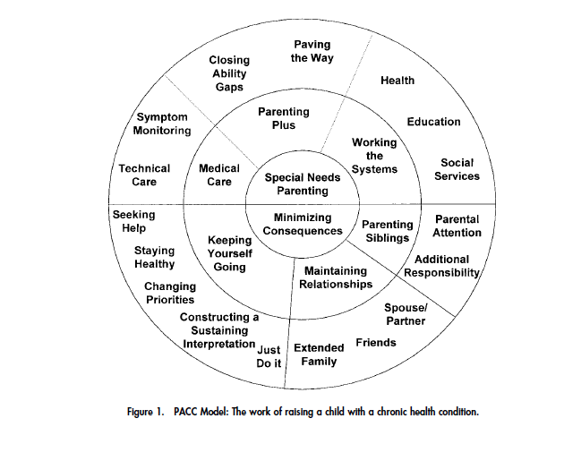
The area that we are interested in is ‘Medical Care’.
- Technical care: Within this is the area of Technical Care. Parents estimated that it took 6 months at home before technical aspects of the care became a normal part of child’s care. The technology was also reported to frighten the extended family, school and the public.
- Symptom Monitoring: Within this area caregivers reported having primary responsibility for accurately diagnosing and managing worsening symptoms, complications and emergencies.

