Directorate |  | Medicine |  |  |  |  |  |  | Risk Ref:
Department |  | Respiratory and Sleep Medicine
Source of risk  (e.g. Incident Form) |  | To accompany MEMG form as using new equipment in the trust
Risk Assessment of |  | Viamed VM-2160 oximeter and battery operated data logger
Type of Risk |  | Health & Safety |  |  |  | x |  | Patient Safety |  |  | x |  | Security
Location |  | Sleep unit, wards and home community setting
Risk Assessor |  | Ruth Kingshott |  |  | Department Manager |  |  |  |  |  |  | Heather Elphick
Signed |  |  |  |  | Signed |  |  |  |  |  |  | 
Date of Assessment |  | 27/12/2016 |  |  | Review date
Contact Phone No. |  | 07599913138
Indicate below whether this risk is department only or for inclusion on directorate or trust risk register?
Internal Department Risk Assessment? |  |  |  |  |  |  |  | Yes |  |  | x |  | No
Escalate to Risk Register? |  |  |  | No |  | x |  | Strategic |  |  |  |  | Directorate
Current revision |  | Summary Of Changes
1.0 |  | -
Description Of Risk Being Assessed
We are assessing the risk of introducing a new piece of oximetry kit and a data logger entering the sleep and respiratory department as per the current MEMG protocol for new equipment.

There are currently three different brands of oximeter used by the respiratory and sleep service

- Masimo Radical 7’s and 8’s
- Minolta wrist watch oximeters
- Nellcor SomnoMedics oximeters incorporated into the sleep kit.

For our research project we will be using the following new equipment
- Viamed VM-2160 with SMART sat oximeter
- Battery operated data logger

We are doing the research in collaboration with Viamed to record anonymous data for paediatric algorithms. To do this we need to use Viameds oximeter and a data logger.

Viamed oximeter:
This is a standard piece of oximetry kit used in hospitals all over the UK. However it is new to SCH. In our research project, the Viamed oximeter would be attached by a standard reusable or disposable Viamed sensor to the child’s toe who is already undergoing routine oximetry.

Battery operated data logger:
This is a small microcontroller unit that houses an SD card to collect the anonymous SpO2, pulse, alarm status and recovery periods. The data logger will be connected to both the SCH Masimo oximeter and the Viamed oximeter by the standard isolated USB ports on the oximeters. The data logger has no direct connection to the patients. The research team have chosen to use a battery operated data logger, so that in the home community setting there is less need for available plug sockets.

The risks are as follows
- Viamed oximeter is new to the trust and so this piece of kit has not been used before in SCH. The kit will be set up by the research physiologist (Ruth Kingshott) and she will receive full training from Viamed prior to its use. The Viamed oximeter will undergo the standard procedures at clinical engineering including: indemnity insurance certificate for loan kit, acceptance testing, logging of the serial numbers and a set loan period time agreed upon.

- The battery operated data logger is new to the trust and so this piece of kit has not been used before in SCH. The kit will be set up by the research physiologist (Ruth Kingshott) and she will receive full training from Viamed prior to its use. The Viamed oximeter will undergo the standard procedures at clinical engineering including: indemnity insurance certificate for loan kit, acceptance testing, logging of the serial numbers and a set loan period time agreed upon

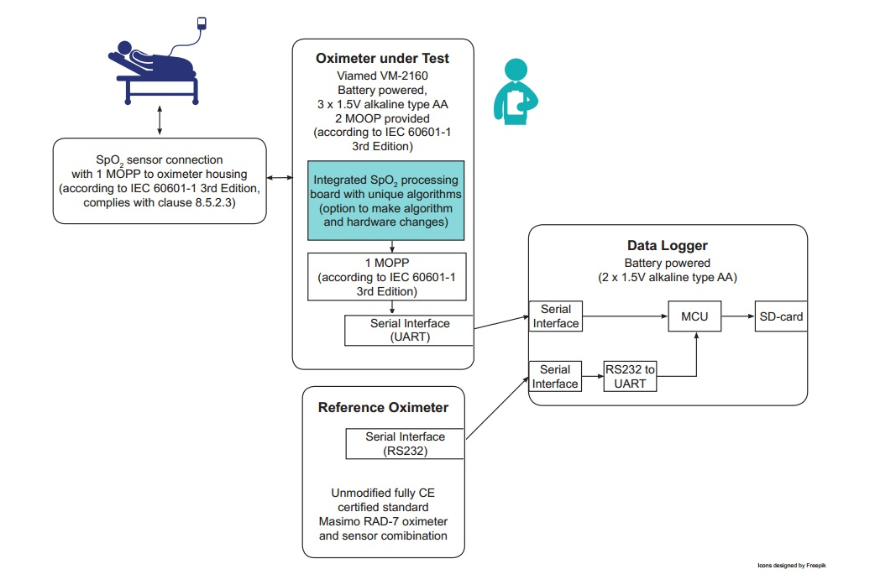

Summary Of Current Control measures
- CE marked kit where appropriate
- Has to pass MEMG approval
- Full training of research staff who will be using the kit

Overall Risk Grading
Consequence (C) | 2 |  | Likelihood (L) |  |  |  | 1 |  |  | Risk (C x L) |  |  |  |  | 1
See over for grading table

Consequence |  |  |  | Likelihood
1 | Negligible | Minimal injury, none or minor treatment / adverse health outcome / some disruption to service / small financial loss / potential for public concern |  | 1 | Rare | This will probably never happen / recur (not expected to occur for years)
2 | Low | Minor injury / <3 days off work / adverse health outcome / short term disruption to service / financial loss or claim < £10,000 / local media coverage short term |  | 2 | Unlikely | Do not expect it to happen / recur but it is possible it may do so (expected to occur annually)
3 | Medium | Medium injury / 4-14 days off work / adverse health outcome / moderate service disruption / financial loss or claim £10,000-£100,00 / local media coverage long term |  | 3 | Possible | Might happen or recur occasionally (Expected to occur monthly)
4 | Very high | Major injury or disability / closure of a service / financial loss or claim £100,000-£1 Million / possible litigation / national media coverage short term |  | 4 | Likely | Will probably happen / recur but it is not a persisting issue (Expected to occur weekly)
5 | Extreme | Death(s) / multiple permanent injury or health effects / extended service disruption or closure / financial loss or claim >£1 Million / national media coverage long term |  | 5 | Almost certain | Will undoubtedly happen / recur possibly frequently (Expected to occur daily)
Extreme 15 -25 |  |  | High 8 – 12 | Moderate 4 – 6 |  |  | Low 1 -3
Extreme risk, immediate action required |  |  | High risk, action planned immediately, commenced within one month | Moderate risk, action planned within one month, commenced within three months |  |  | Low risk, action planned within three months, reviewed within 1year

Activity and Task | Hazards and Risks  Identified | People at Risk | Controls In Place | Consequence | Likelihood | Risk Rating | Recommended  Additional Controls | Post  Risk  Rating
 |  |  |  | 1-5 | 1-5 | 1-25
 |  |  |  | C x L = R
1  Transporting the kit to the place of testing | Dropping of equipment | N | Wipeable plastic carry trolleys to transport equipment (already standard issue). | 1 | 1 | 1 | Nil | 1
2  Setting up the kit by the bedside in hospital | Not enough plug sockets  Kit falling off bedside tables onto floor or patient in hospital | N  Y | Viamed oximeter & datalogger are battery powered so no extra plug sockets required  The viamed oximeter is handheld and small, as is the data logger and both will be placed on the bedside table on top of the masimo | 1  1 | 1  1 | 1  1 | Adequate supply of batteries  Adequate cable length to reach bedside table. | 1
3  Setting up the kit by the bedside at home | Not enough plug sockets  Kit falling off bedside tables onto floor or patient in hospital | N  Y | Viamed oximeter & datalogger are battery powered so no extra plug sockets required  Kit is placed on the floor at home to prevent falling kit | 1  1 | 1  1 | 1  1 | Adequate supply of batteries  Adequate cable length to reach onto floor. | 1  1
4  Attaching sensor to patient | Potential strangulation risk | Y | Sensors are placed on toes, with cables fed along clothing and out from bottom of bed to avoid strangulation risk | 2 | 1 | 2 | In addition, oximeters have in built low oxygen levels alarms which would be set off if significant SpO2 levels were detected | 2
5  Connecting oximeters to data logger | Risk of connecting a patient to an extra piece of electrical kit | Y | The data logger is battery powered. In addition the connections to mains powered masimo oximeter are isolated and fulfil all electrical safety and patient isolation requirements. | 2 | 1 | 2 |  | 2

You will have inevitably used some subjectivity in completing the risk assessment based on your knowledge, experience and judgement. You should record the rationale behind your decision making throughout this assessment. You should also provide supporting evidence for your rationale if the rating is High or Extreme.

Rationale
The risk form has been completed as part of the MEMG application because the kit being used is on trial for a research project. All of the risks mentioned above currently apply to standard clinical practice for our respiratory service oximeters. The only added risk here is the connection to the data logger (which is battery powered and isolated).

Action Plan For Risk Control
Where additional controls from those already in place have been identified record your action plan

No. | Risk | Recommended  Additional Controls | Cost and Time to Implement | Action By | Target  Date | Date Completed | Post  Risk  Rating



