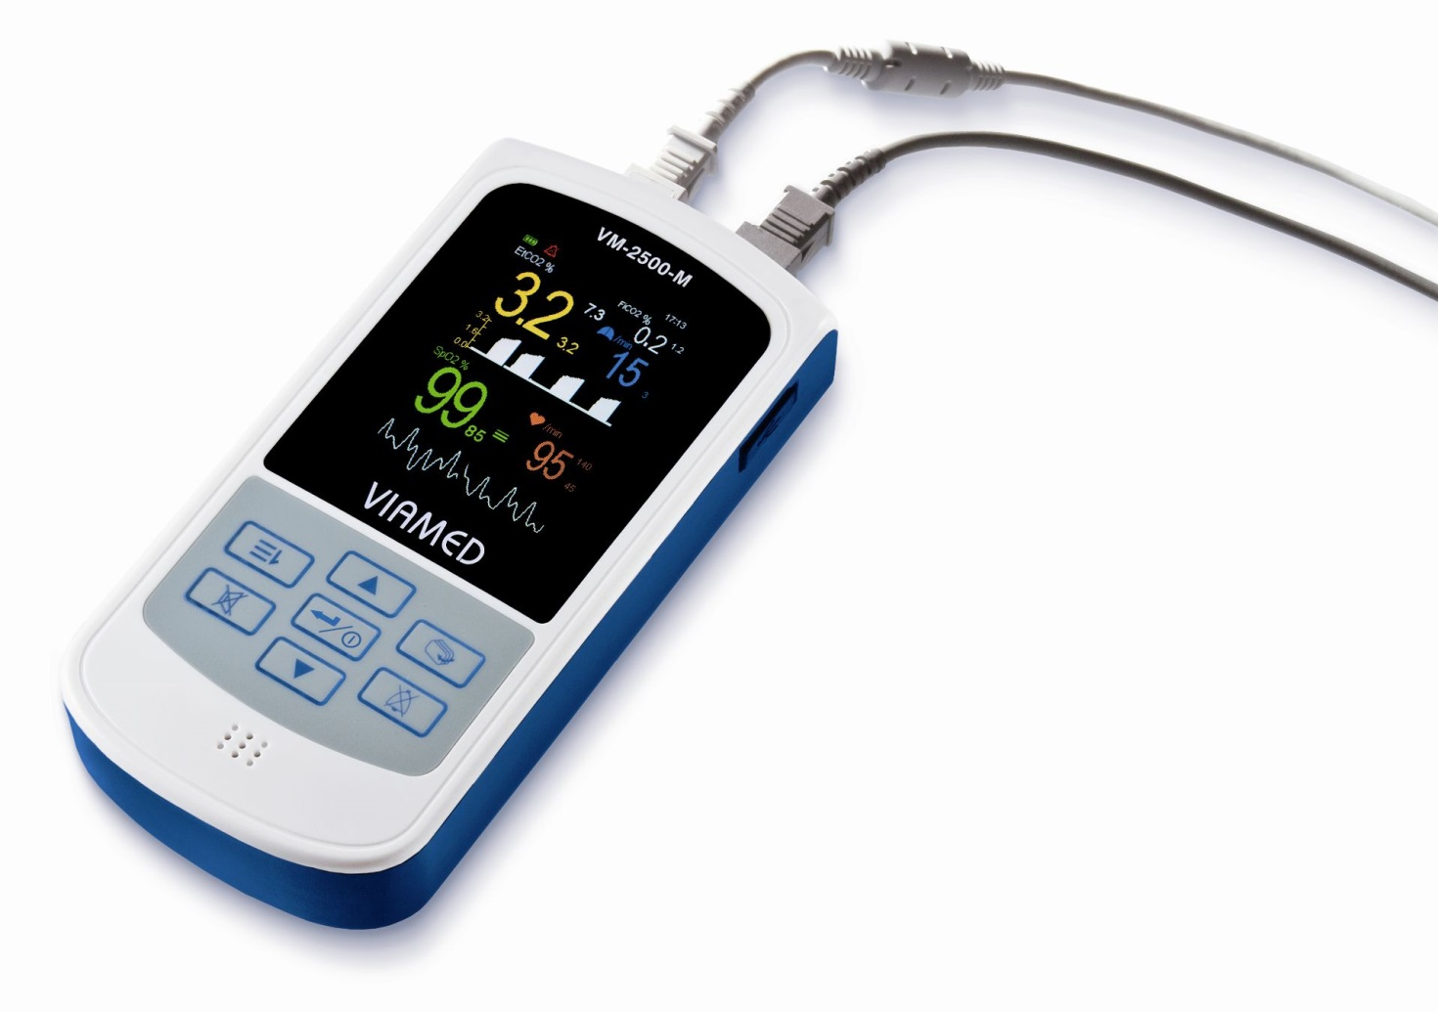

Handheld Mainstream and Sidestream CO₂/SpO₂ Monitors
VM-2500-M and VM-2500-S
User Manual

VM-2500 User Manual

Version: EN 4.2
Released: 06/2016

The information in this document is subject to change without notice.

Copyright © 2016 Viamed Ltd.. All Rights Reserved.
This document contains proprietary information that is protected by copyright. All rights are reserved. No part of this document may be photocopied, reproduced or translated to another language without prior written consent of Viamed Ltd..

Contact information

Viamed Ltd.
15 Station Road
Cross Hills
Keighley
West Yorkshire BD20 7DT
United Kingdom
Tel: +44 (0)1535 634542
Fax: +44 (0)1535 635582

E-mail: info@viamed.co.uk
www.viamed-online.com

Declaration of Conformity

 0482

This product meets the requirements of the 93/42/EEC guidelines for medical products.

Liability
Viamed Ltd. shall in no event be liable for any direct, indirect, special or consequential damages including without limitation damages for loss of business profits, loss of income, business interruption, loss of business information, loss of use or other related exposures, however caused, arising from the faulty or incorrect use of the product.
Viamed Ltd. guarantees that the product delivered has been thoroughly tested to ensure that it meets its published specifications.

Warranty
Viamed Ltd. warrants the products manufactured or distributed by them to be free from faulty materials and workmanship for a period of 24 months from date of original shipment to first end user except for disposable products or products which have a stated guarantee longer or shorter than 24 months. Viamed Ltd. will perform warranty service at its factory.
The obligations for Viamed Ltd. under this guarantee shall be limited to repair, or at Viamed Ltd. 's discretion, replacement of necessary parts or assemblies and shall not include shipping costs or other incidental damages.
Claims for damages during shipment must be filed promptly with the transportation company. All correspondence concerning the products must specify both the name of the product and its serial number as written on the label on the product.
Use of the equipment for other than its intended use, or if it has been repaired by anyone except Viamed Ltd. or a Viamed Ltd. authorized service centre, or altered or modified or used without following the instructions in the user manual, will void this guarantee.

Patents
Masimo Sweden AB holds the following patents regarding products described in this manual:
SE519766; SE519779; SE523461; SE524086. Other patents pending

Trademarks
Viamed Ltd. owns the following registered trademarks:
VM-2500, SoftFlap®, SC 6500 VM and W 6500 VM.
IRMA™, XTP™, ISA™ and LEGI™ are trademarks of Masimo Sweden AB.

Table of Contents
1 Introduction 7
1.1 Intended Use 7
1.2 Contraindications/ Hazards 7
1.3 Warnings 7
1.4 Cautions 12
1.5 Symbol Description 14
1.6 Terms and Definitions 16
1.7 User Requirements 18
2 Theory of operation 18
2.1 CO₂ measurement 18
2.2 SpO₂ measurement 19
3 Product overview 20
3.1 Available models 20
3.2 Mainstream Capnography Accessories 21
3.2.1 IRMA CO₂ analyzer 21
3.2.2 IRMA airway adapter 21
3.3 Sidestream Capnography Accessories 22
3.4 SpO₂ Sensors 23
4 Exterior View, Controls and Connectors 24
4.1 Mainstream Capnograph/Pulse Oximeter - VM-2500-M 24
4.2 Sidestream Capnograph/Pulse Oximeter - VM-2500-S 25
5 Preparation for Use 26
5.1 Selecting Power Supply 26
5.1.1 Power Supply 26
5.1.2 Li-Poly Battery or AA Alkaline Batteries 27
5.2 Connecting Sensors / Sampling Line Configurations to the VM-2500 28
5.2.1 IRMA CO₂ Analyzer (mainstream) 28
5.2.2 Disposable sampling line (sidestream) 28
5.2.3 SpO₂ Sensor 29
5.3 Visual Check 30
5.4 Switching on the Device 30
5.5 Connecting Sensors / Sampling Line Configurations to the Patient 30
5.5.1 IRMA CO₂ Analyzer (mainstream) 30
5.5.2 Disposable sampling line configuration (sidestream) 32
5.5.3 SpO₂ Sensor 33
5.6 Commencing Monitoring 34
5.7 Switching off the Device 34
6 Display Modes and Displayed Data 35
6.1 Toggling Between Display Modes 35
6.2 Symbols and Indicators 36
6.3 Pulse Tone 37
7 Alarms 37
7.1 Alarm Priority and Appearance 37
7.2 Audible Alarm Volume 38
7.3 Default Alarm Limits 38
7.4 Limit Alarms 38
7.5 Alarm Messages 39
7.6 Resetting of Alarm Signals 39
7.7 Alarm Mode 40
7.7.1 Standard mode 40
7.7.2 Neonatal mode (  ) 40
7.7.3 Alarm delay mode (  ) 40
8 Menu Structure 41
8.1 Main Menu 41
8.1.1 Submenu: Alarm Settings 41
8.1.2 Submenu: Data Management 43
8.1.2.1 Recording Data 43
8.1.2.2 Data Management 43
8.1.3 Submenu: Setup 45
8.1.3.1 General Information 45
8.1.3.2 Parameters 46
8.1.4 Submenu: Patient ID 50
8.1.5 Start Up Settings 50
8.2 Other 51
8.2.1 Volume Control Shortcut 51
8.2.2 Brightness Control Shortcut 51
8.2.3 Power-Save Mode 51
9 Adverse effects on performance 52
9.1 CO₂ measurements 52
9.1.1 Interfering gases or vapours 52
9.1.2 Humidity or Condensation 52
9.1.3 Spectral broadening 53
9.2 SpO₂ Measurement 54
10 Troubleshooting guide 55
10.1 Error Message – Cause - Corrective Action 55
10.2 Failure – Cause - Corrective Action 56
10.3 IRMA LED Status and LEGI Status 57
10.4 Problems with EMI (Electromagnetic Interference) 57
11 Maintenance 59
11.1 Maintenance 59
11.2 Cleaning 59
11.3 Testing 60
11.4 Zeroing the Capnograph 60
11.4.1 Mainstream VM-2500-M 60
11.4.2 Sidestream VM-2500-S 61
12 VM-2500 PC-Software 61
13 Technical Specifications 63
14 Testing summary 67
15 Component Lists and Ordering 68
15.1 Packing List 68
15.2 Order Number 69
15.3 Accessories and Replacement Parts which may be used during transport or in home care environment 69
15.4 Accessories and Replacement Parts only for use inside Healthcare Facilities: 71

Introduction

Intended Use
The VM-2500 CO₂ / SpO₂ Monitor is intended to provide continuous monitoring of end-tidal CO₂ concentration (EtCO₂), inspired CO₂ concentration (FiCO₂), functional arterial oxygen saturation (SpO₂), respiration rate (RR) and pulse rate (PR) of adult, paediatric, infant and neonatal patients. The CO₂ measurement can be performed either with the mainstream method using the VM-2500-M or with the sidestream method using the VM-2500-S.

Depending on the SpO₂ sensor connected, the VM-2500 may be used in hospital, hospital type facilities, operating suites, intensive care units, emergency medicine/emergency transport as well as in the home care environment (under supervision of a healthcare professional). Refer to section 14 for more detail on sensors and field of application

The VM-2500 CO₂ / SpO₂ Monitor is not intended to be used as the only means of monitoring a patient. It shall always be used in combination with other vital sign monitoring devices and/or professional human judgments of a patient’s condition. The VM-2500 is intended to be used by trained and authorized health care professionals only.

Contraindications/ Hazards
The handheld capnograph and pulse oximeter VM-2500-M/S with accessories is indicated for use in any environment, where continuous monitoring of patients breathing gases and functional arterial oxygen saturation is needed.
There are no known contraindications for patient monitoring with the VM-2500, provided that the data obtained is evaluated with consideration given to the patient's clinical condition.
Note that the handheld capnograph and pulse oximeter VM-2500-M/S with accessories is:
- not defibrillator proof
- not intended to be used in the presence of flammable anesthetics mixture with air, oxygen, or nitrous oxide
- not intended to be used in a MRI, CT or while an electrosurgical unit is in use
- Physiological conditions, medical procedures, or external agents may interfere with the monitor’s ability to detect and display accurate measurement results (see section 9 for detail)

For further information regarding possible hazards during operation of the device - see section 1.3 and 1.4.

Warnings
Adhere to the following warnings for safe operation of the VM-2500-M mainstream CO₂ / SpO₂ Monitor and the VM-2500-S sidestream CO₂ / SpO₂ Monitor.

For VM-2500 in General:

Warning:
The monitor is to be operated only by trained personnel and is for attended monitoring only.

Warning:
Do not make any clinical judgments based solely on the VM-2500. The monitor is intended only as an adjunct in patient assessment. It must be used in conjunction with clinical signs and symptoms. The interpretation of the measurement values should be done only by trained health care professionals.

Warning:
The monitor should only be used for the purpose and in the manner described in this manual.

Warning:
Explosion hazard. Do not use the monitor in the presence of flammable anaesthetic mixtures with air, oxygen, or nitrous oxide.

Warning:
Routinely monitor the patient to make sure that the VM-2500 is functioning correctly and the SpO₂ sensor, the mainstream IRMA CO₂ analyzer and the CO₂ sidestream sampling configuration are correctly placed.

Warning:
Do not place the monitor in any position that might cause it to fall on to the patient.

Warning:
Certain environmental and physiological conditions, medical procedures, sensor application errors and external agents may interfere with the monitor‘s ability to detect and display accurate measurements. (Chapter 9 provides information on possible interferences)

Warning:
For the SpO₂ measurement, the monitor uses red and infrared light with specific fixed wavelengths. Consider that these wavelengths might influence diagnostic parameters of other optical applications. The specifications of the wavelengths used are listed in the ‘Instructions for Use’ of the specific sensor.

Warning:
The monitor detects respiratory effort via changes in CO₂ concentration of exhaled air; therefore, the CO₂ measurement can be used to detect apnoea. The device however is unable to discriminate between a patient not breathing and a sensor that is disconnected from the patient circuit. Always monitor and set alarms for SpO₂ when using the VM-2500 to monitor respiratory function.

Warning:
If you are uncertain about the accuracy of any measurement, check the patient’s vital signs by alternate means; then make sure the monitor is functioning correctly.

Warning:
The use of accessories, sensors, and cables other than those specified may result in increased electromagnetic emission and/or create invalid readings of the monitor.

Warning:
In high ambient light conditions it is required to shield the SpO₂ sensor application site with opaque material. Too much ambient light may result in inaccurate measurements.

Warning:
Check all alarm settings and auditory alarm before use of the monitor.

Warning:
Do not silence the audible alarm function, or decrease the audible alarm volume if patient safety could be compromised.

Warning:
No modifications of the monitor are allowed without authorization of the manufacturer.

Warning:
Measurements can be affected by mobile and RF communications equipment. Make sure that the monitor is used in the electromagnetic environment specified in this manual.

Warning:
Disconnect the monitor and probes from the patient during computed tomography (CT).

Warning:
Disconnect the monitor and probes from the patient during magnetic resonance imaging (MRI) scanning. An induced current could potentially cause burns.

Warning:
The VM-2500 is not defibrillator proof. Remove the sensors from the patient throughout defibrillation to avoid shock of the caregiver or patient.

Warning:
The use of high frequency electrosurgical equipment in the vicinity of VM-2500 may produce interference and cause incorrect measurements.

Additional warnings regarding the power supply system:
To prevent the possibility of the Li-Poly battery CT-2500 from leaking, heating or explosion, observe the following precautions.

Warning:
Do not immerse the battery in water or seawater. Store it in a cool and dry environment if not used.

Warning:
Do not discard, store or use the battery near a heat source (e.g. a fire or heater).

Warning:
Only charge the Li-Poly battery CT-2500 while inserted in the VM-2500 monitor using the provided power supply FW 7660M/06.

Warning:
Do not connect the positive and negative terminal with metal objects such as wire and do not transport or store the battery together with metal objects such as necklaces or hairpins as this may short-circuit the battery.

Warning:
Do not strike, throw or trample the battery or pierce it with a nail or other sharp object.

Warning:
Only use the Li-Poly battery Model No. CT-2500 provided with the monitor. Contact the manufacturer for replacements.

Warning:
Only use the power supply Model No. FW 7660M/06 provided with the monitor. The use of a power supply other than this may result in hazardous situation and effect patient’s safety.

Warning:
Do not use rechargeable AA sized batteries instead of alkaline AA sized batteries to operate the device, as this may affect the function of the device.

Warning:
Batteries may leak or explode if used or disposed of improperly.

Warning:
Explosion hazard — Do not use AA rechargeable Lithium-ion batteries.
Use only Alkaline (1,5 Volt, Type AA LR6) or rechargeable NiMh AA (1,2 Volt, Type AA HR6, 1200 mAh)

Additional warnings regarding the mainstream device - VM-2500-M:

Warning:
Disposable IRMA airway adapters shall not be reused. Used airway adapters shall be disposed of in accordance with local regulations for biohazardous waste.

Warning:
Do not use the IRMA airway adapter (adult/paediatric) with infants as the adapter adds 6ml dead space to the patient circuit.

Warning:
Do not use the IRMA airway adapter (infant) with adults or paediatric as this may cause excessive flow resistance.

Warning:
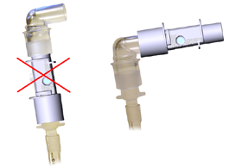
Do not place the IRMA airway adapter between the endotracheal tube and an elbow as this may allow patient secretions to block the adapter windows and result in incorrect operation.

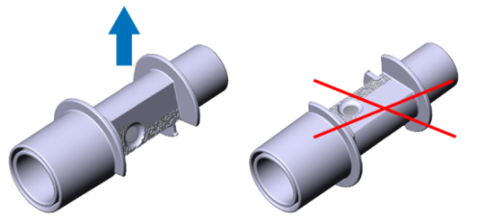
Warning:
To keep secretions and moisture from pooling on the windows, always position the IRMA™ analyzer in a vertical position with the LED pointing upwards.

Warning:
Do not use the IRMA CO₂ analyzer with metered dose inhalers or nebulised medication as this may affect the light transmission of the airway adapter windows.

Warning:
A successful zeroing requires the presence of ambient air (21% O₂ and 0% CO₂) in the IRMA airway adapter during zeroing. Incorrect zeroing of the IRMA CO₂ analyzer will result in false gas readings.

Warning:
Replace the IRMA airway adapter if rainout/condensation occurs inside the adapter.

Additional warnings regarding the sidestream device - VM-2500-S:

Warning:
Do not use the VM-2500-S to analyse gasses (e.g. anaesthetics like nitrous oxide etc.) that need to be returned to the patient circuit or a scavenging system. The gas outlet of the sidestream device is not designed to return the exhaust gases to the patient circuit or a scavenging system.

Warning:
Excessive positive or negative pressure in the patient circuit might cause incorrect readings and internal damage of the monitor.

Warning:
Carefully route the sampling line to reduce the risk of patient entanglement or strangulation.

Warning:
Do not lift the VM-2500-S by the sampling line as this could disconnect from the monitor, causing the monitor to fall on the patient.

Warning:
Do not use adult or paediatric type sampling line configurations with infants or neonates, as this may add dead space to the patient circuit.

Warning:
Do not use infant or neonatal type sampling line configurations with adults or children, as this may result in excessive flow resistance.

Warning:
Do not use the VM-2500-S with metered dose inhalers or nebulised medication as this may block the bacteria filter integrated in the disposable sampling line.

Warning:
Since a successful zeroing requires the presence of ambient air (21% O₂ and 0% CO₂) in the device, ensure that the VM-2500-S is placed in a well ventilated environment. Avoid breathing near the monitor before or during the zeroing procedure. Incorrect zeroing of the integrated CO₂ analyzer will result in false gas readings.

Warning:
Replace the blocked part of the sampling line configuration if a sampling system occlusion message is displayed by the monitor.

Warning:
Do not re-use the disposable sampling lines and airway adapters.

Warning:
Used disposable sampling lines shall be disposed of in accordance with local regulations for biohazardous waste.

Warning: Replace the disposable sampling line if “Sampling system occlusion !” is displayed by the monitor whilst only the disposable sampling line is connected.

Cautions
Adhere to the following recommendations to avoid damage or malfunction of the VM-2500-M mainstream CO₂ / SpO₂ Monitor and VM-2500-S sidestream CO₂ / SpO₂ Monitor.

For VM-2500 in General:

Caution:
Do not spray, pour, or spill any liquid on the monitor, its accessories, connectors, switches, or openings in the enclosure as this may damage it.

Caution:
Do not immerse the monitor or its accessories in liquid.

Caution:
Do not autoclave or steam sterilize the monitor or its accessories.

Caution:
Refer to the specific ‘Instructions for Use’ of the used SpO₂ sensor for correct cleaning and/or sterilization.

Caution:
Do not apply excessive tension to any of the monitor cables.

Caution:
Do not operate the monitor outside the specified operating temperature environment.

Caution: The monitor requires no routine calibration. A basic maintenance plan conducted by qualified service personnel is recommended. Please refer to the Service Manual for detailed information.

Caution: There are no user-serviceable parts inside the VM-2500. The cover should only be removed by qualified service personnel.

Caution:
Clean contaminated and/or dirty equipment before returning, following the cleaning procedure described in this manual.

Caution:
Clean the device separately from the sensors. For instructions on cleaning pulse oximeter sensors, refer to the respective sensor instructions for use.

Caution:
Do not use caustic or abrasive cleaning agents on the device or the sensors.

Additional cautions regarding the power supply system:

Caution: Do not use or store the Li-Poly battery at very high temperature conditions e.g. strong direct sunlight or in a heated vehicle. Under these conditions the battery can overheat, causing it to burn or its performance will degenerate and its service life will be decreased.

Caution: Do not use the Li-Poly battery in an electromagnetic environment other than specified in this manual, as this may damage the safety features of the battery and result in unforeseen danger.

Caution: If the Li-Poly battery leaks and the electrolyte gets into the eyes, immediately rinse the eyes with clean running water and seek medical assistance to prevent injury of the eyes.

Caution: If the Li-Poly battery gives off an odour, generates heat, becomes discoloured or deformed, or in any way appears abnormal during use, recharging or storage, immediately remove it from the device and stop using it.

Caution: If the Li-Poly battery terminals are dirty, clean the terminals with a dry cloth before use, otherwise a power failure or charging failure may occur due to poor connection with the device.

Caution: Discharged batteries may cause fire; tape the terminals to isolate them.

Caution: Remove the batteries if the device is to be stored or not used for a longer period of time.

Additional cautions regarding the mainstream device - VM-2500-M:

Caution:
Never sterilize or immerse the IRMA CO₂ analyzer in liquid.

Caution:
The IRMA CO₂ analyzer and the IRMA airway adapters are non-sterile devices. Do not autoclave these components as this will damage them.

Caution:
Use only Masimo manufactured IRMA airway adapters.

Additional cautions regarding the sidestream device - VM-2500-S:

Caution:
The disposable sampling lines and their patient interfaces are non-sterile devices. Do not autoclave these components as this will damage them.

Caution:
Use only disposable sampling line configurations manufactured by Viamed.

Symbol Description

 | Accompanied with “Warning: Supplementary text.” within this document. Warnings indicate potential harmful conditions that may lead to injury or death.
Accompanied with “Caution: Supplementary text.” within this document.
Cautions indicate conditions that may lead to damage to or malfunction of the device.
Note: | Denoted as “Note: Supplementary text.” within this document.  Notes inform the user to relevant facts and conditions in connection with the device.
 / | Consult User Manual for detailed operating information.
 | Consult accompanying documents for important safety-related information
 | Manufacturer
 | Date of manufacture
 | Type BF applied part
or P/N | Order number
 | Serial number
 | Batch code
 | Use by [YYYY-MM-DD] (indicates that the device should not be put into service after the date accompanying the symbol)
 | UL Recognized Component Marks for Canada and the United States
 | Electrical protection class II (IEC 60417-5172)
 | Approved for use in Japan (Product Safety Electrical Appliance & Material)
 | Temperature limitation
 | Humidity limitation
 | Pressure limitation
 | Do not re-use
 | Fragile, handle with care
 | Indicates that the transport package has to be kept out of heated areas
 | Latex free
 | PHT free
 | Do not dispose in the consumer waste. Electrical and electronic equipment shall be collected and recycled in accordance with (Directive 2002/96/EC)
 0000 | European Union approval (complies with 93/42/EEC Medical Device Directive)
IP21 | IP Code (International Protection Rating) according to IEC 60529  IP2X: protection against contact with the fingers, protection against solid foreign bodies with Ø > 12 mm  IPX1: Protection against vertically falling water drops provided the device is in the intended position of use with the display facing the top while placed on the back.

Terms and Definitions

BTPS | Body Temperature and Pressure Saturated
VM-2500 | Handheld CO₂/SpO₂ monitor developed by Viamed. Available as mainstream (VM-2500-M) or sidestream (VM-2500-S) version.
CO₂ | Carbon dioxide
EtCO₂ | End-tidal expired CO₂ gas concentration
FiCO₂ | Inspired CO₂ gas concentration
Hb | Deoxygenated haemoglobin
HbO₂ | Oxygenated haemoglobin
HME | Heat Moisture Exchanger
IR | Infrared
IRMA | Infrared mainstream CO₂ analyzer
LEGI | Light Emitting Gas Inlet: Status indicator integrated in the gas sample inlet port.
Li-Poly battery | Lithium-ion polymer rechargeable battery
MDD | Medical Device Directive
MRI | Magnetic Resonance Imaging
N/A | Not applicable. Data does not apply to the configuration.
PR | Pulse rate
RF | Radio frequency
RH | Relative humidity
Rise time | Time required to achieve an increase from 10% to 90% of final value when step function change in concentration occurs at the sampling site.
RR | Respiration rate
Sampling line config. | A sampling line configuration consists of a water/vapour removal section and hydrophobic bacterial filter to prevent cross contamination which is connected to a sampling line with an appropriate patient interface for sampling gas, e.g. a oral/nasal cannula or airway adapter.
sidestream module | Infrared sidestream CO₂ analyzer incorporated in the VM-2500-S
SpO₂ | Functional arterial oxygen saturation
TBD | To Be Determined. Value or property not yet decided; further investigations may be necessary.
Total system response time | Time from a step function change in gas level at the sampling site to the achievement of 90% of the final gas reading of the capnograph.  Total system response time = Delay time + Rise time
USB | Universal Serial Bus
Zeroing | Ambient gas reference measurement used to establish zero concentration level for CO₂. Zeroing needs to be performed ONLY when an offset in gas measurement values is observed, or when an unspecified accuracy message is displayed.

User Requirements
The user(s) of the monitor shall have an in-depth knowledge of gas analyzing and non-invasive monitoring of functional arterial oxygen saturation.

Theory of operation

CO₂ measurement

Principle
The measurement of CO₂ in gas mixtures with the VM-2500 is based on the fact that different gases absorb infrared light at specific wavelengths. The absorption spectra for CO₂, N₂O and different anaesthetic agents are shown in the figure below.

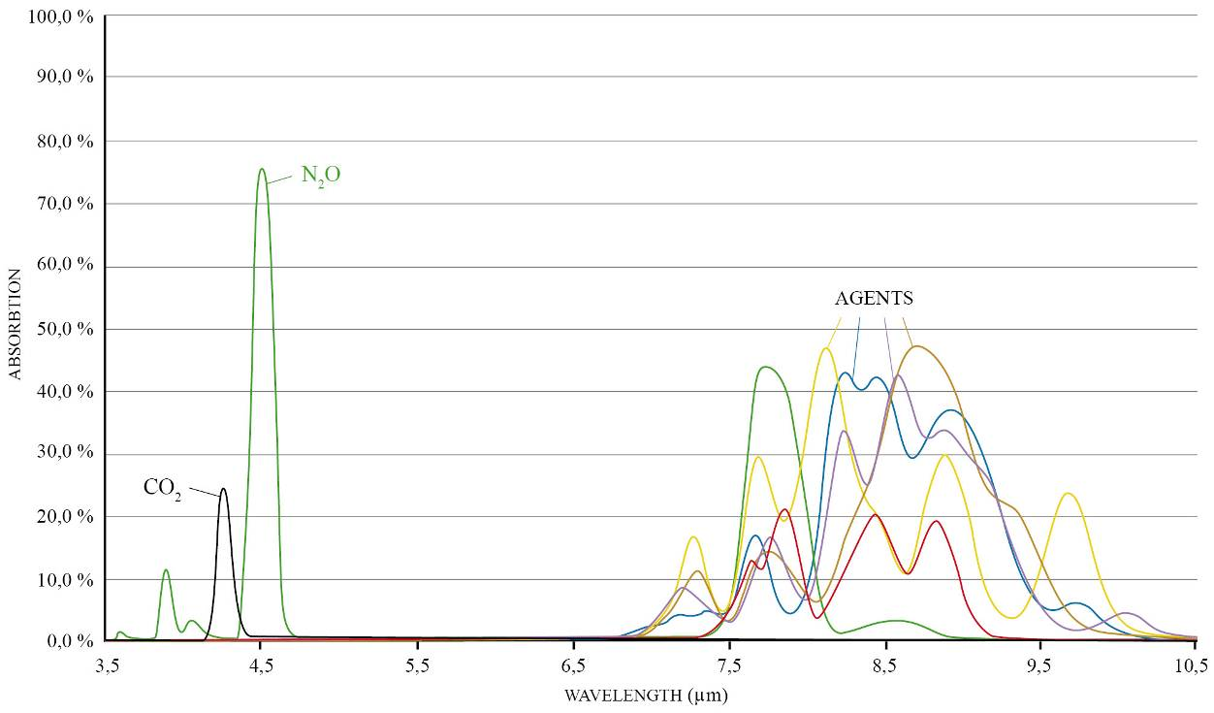
Figure 1: Gas absorption spectra

The CO₂ analyzer of the VM-2500 uses the absorption peak at 4.2μm to determine the CO₂ concentration in the gas. Two additional wavelengths beside this absorption peak are used as reference.
To measure the absorption of light at these wavelengths, a broadband infrared radiation source is used. The light transmitted from the infrared source passes through the gas sample and is then filtered using a set of narrow optical bandpass filters. The individual filters are mounted in a rapidly rotating filter wheel that intersects the light path before the light reaches the infrared detector.
The infrared detector detects the portion of the light that is not absorbed by the gas. The amplitude of the detector output is an inverse function of the gas concentration. Thus, at a concentration of zero, the amplitude is at its maximum.

Capnogram
A capnogram is a graph representing the CO₂ concentration in respiratory gasses plotted against time. The capnogram waveform is typically divided into 4 phases (Bhavani-Shankar & Philip, 2000). In the waveform below the inspiration (phase 0) is plotted in blue and the expiration (phase I - III) in red.

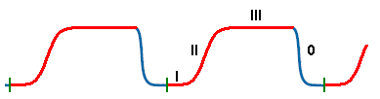
Figure 2: Normal capnogram waveform

Phase I: Baseline (FiCO₂)
Phase II: Positive expiration slope (alveolar gas)
Phase III: Alveolar plateau (EtCO₂)
Phase 0: Inspiration

A capnogram provides valuable information regarding the health situation of patients in respiratory distress.

Measurement methods
Determining the CO₂ concentration of respiratory gases is done either using the mainstream method or the sidestream method. In both cases the measurement principle is very similar (infrared spectroscopy) the position of the sensor in the measurement setup however differs.

In mainstream capnography an airway adapter is, for example, inserted between the endotracheal tube and the Y-piece of the breathing circuit. The airway adapter has an optical window over which the infrared mainstream CO₂ sensor is positioned. The respiratory CO₂ measurements are obtained by continuously measuring the infrared light absorption, in the gas flow, through the optical windows.

For sidestream capnography a sampling line is connected to an endotracheal tube with the help of a sidestream airway adapter or directly from the nose via a nasal prong. Gas samples are continuously taken from the patient at a constant flow rate (VM-2500-S has a suction rate of 50ml/min) and transferred to the infrared CO₂ sensor incorporated in the capnograph. The CO₂ measurement is taken within the device and after measurement the waste gas is exhausted through the gas outlet.
Typically water traps and bacteria filters are positioned between the sampling line and the device inlet to avoid damage to the device.

SpO₂ measurement
SpO₂ measurement is performed in transmission mode. The SpO₂ sensor consists of emitters which pass red and infrared light through peripheral sites such as a finger, toe or ear to a light-sensitive detector.

For both wavelengths the change in absorption is continuously measured. In this way the pulsatile signal due to the arterial blood alone is extracted, excluding the offset due to absorption by venous blood, skin, bone, muscle and fat.
This signal is used to determine the functional arterial oxygen saturation (SpO₂) based on the fact that the amount of absorbed infrared light and red light is different for oxygenated haemoglobin (HbO₂) and deoxygenated haemoglobin (Hb).
The amount of red and infrared light received is compared and the percent of haemoglobin molecules bound with oxygen molecules calculated:

These measurement values are continuously displayed as a waveform (plethysmogram) and also used to determine the pulse rate. Note that the pulse oximeter equipment is calibrated to display the functional oxygen saturation.
Certain physiological conditions, medical procedures, and external agents may interfere with the monitor’s ability to detect and display accurate SpO₂ measurements (see chapter 9.2 for detailed information).

Product overview

Available models

The VM-2500-M /ASP is for sidestream / mainstream capnography and used together with an application appropriate SpO₂ sensor. The monitor features:

- Self-explanatory, ergonomic operating functions facilitate intuitive operation
- Colour information display, as well as the simple information structure, support quick decisions and a rapid user reaction in critical situations
- Leading-edge power management with standard alkaline batteries, Li-Poly batteries or medical external power supply (or combination)
- Innovative micro-optic gas measurement technology
- Wide range of high-quality SpO₂ sensors available
- Maintenance and calibration-free technology
- 2 years warranty

Mainstream Capnograph/Pulse Oximeter - VM-2500-M
Mainstream CO₂ monitoring is performed with the IRMA CO₂ analyzer. This key technology sets new standards in CO₂ mainstream measurement and provides reliable, safe and easy CO₂ monitoring.

Key features of VM-2500-M:
- Small, light-weight and shock-resistant: IRMA analyzer weighs less than 30 g
- Fast mainstream measurement without time delay
- IRMA airway adapter with XTP™ non-condensing light transmission window
- Warm-up time <10 sec (full accuracy)
- Adult/paediatric and infant IRMA™ airway adapters available

Sidestream Capnograph/Pulse Oximeter - VM-2500-S
Sidestream CO₂ monitoring is performed with the CO₂ analyzer incorporated in the VM-2500-S. Together with the connected disposable sampling line configuration that remove water from the sampled gas, the CO₂ analyzer with integrated sampling pump delivers highest performance in ultra-compact format.

Key features of VM-2500-S:
- Specially designed for all applications using low flow sampling (50 ml/min); from adults to new-borns
- For intubated and non-intubated patients
- Warm-up time < 10s (full accuracy)
- innovative water/vapour removal concept and hydrophobic bacterial filter incorporated in disposable sampling lines and cannula reduce the potential for water intrusion and cross contamination

Mainstream Capnography Accessories

IRMA CO₂ analyzer
The IRMA CO₂ analyzer is an ultra compact measurement device for mainstream CO₂ measurement with the VM-2500-M. As all necessary calibration constants are stored within each IRMA CO₂ analyzer, the analyzer can be replaced without the need for recalibration.
The analyzer has a rugged mechanical design providing reliable shock resistance.
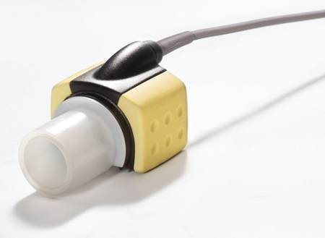
Figure 3: IRMA CO₂ analyzer with airway adapter

To perform gas measurements, the IRMA CO₂ analyzer requires an airway adapter. The IRMA CO₂ analyzer connects in place on top of the IRMA airway adapter. This airway adapter is, for example, inserted between the endotracheal tube and the Y-piece of the breathing circuit.
Respiratory CO₂ measurements are obtained by continuously measuring the infrared light absorption, through optical XTPTM windows, in the gas flow through the adapter.

IRMA airway adapter
The IRMA airway adapter is designed as a single-patient-use disposable product and is available as:

Airway Adapter Adult/Paediatric
- ≤ 6ml deadspace
- 0.3 cmH₂O resistance @ 30 lpm
- ET tubes > 4mm (normally patients over 1 year of age or 10kg in weight)

Airway Adapter Infant
- ≤ 1ml deadspace
- 1.3 cmH₂O resistance @ 10 lpm
- ET tubes ≤ 4mm (normally patients up to 1 year of age or 10kg in weight)

The IRMA airway adapter (infant) has specially designed connectors for minimizing the dead space and can be used on very small patients.
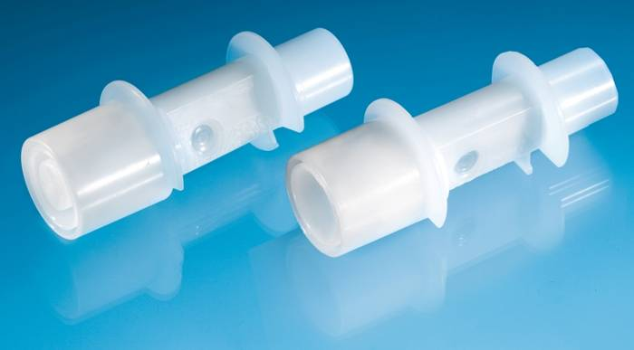
XTPTM window
Figure 4: IRMA airway adapters: Infant (left) and Adult/Paediatric (right)
As the airway adapter is positioned directly in the airway, its performance can be affected by water vapour, patient secretions or nebulised medications that can accumulate on the adapter’s windows.
The water vapour can condense on the surface of the adapter windows in the format of small discrete water droplets. This condensation can affect light absorption through the windows, thus affecting the precision of the measurement.
The XTP™ windows of the IRMA airway adapter therefore have special features that prevent a decrease in performance when vapour is present. Using the latest advances in material technology they are designed to provide a window minimizing the impact of water vapour on light transmission.
For optimal results, the airway adapter shall not be placed between an endotracheal tube and an elbow, as this may allow patients secretions to block the adapter window.
Replace the IRMA airway adapter if condensation occurs on the inside of the adapter's XTP windows; or if after being prompted by the error message 'Check CO2 adapter', the adapter's windows are found to be occluded or dirty.
It is also recommended to replace the IRMA airway adapter after 2 weeks of continuous use (e.g. long-term ventilation).

Sidestream Capnography Accessories
Sidestream CO₂ measurement is performed by continuously removing a gas sample at a flow of 50ml/min from the respiratory circuit and analyzing it within the sidestream CO₂ analyzer incorporated in the VM-2500-S.
To transport the gas sample from the patient to the device, a sampling line configuration is required.
A sampling line configuration consists of a water/vapour removal section with hydrophobic bacterial filter to prevent cross contamination which is connected to a sampling line with an appropriate patient interface for sampling gas, e.g. an oral/nasal cannula or airway adapter.
Sampling with intubated patients is typically performed with an appropriate sidestream airway adapter (Adult / Infant).
Sampling with non-intubated patients is typically performed with a nasal or nasal/oral cannula. The cannula is used to sample the patients breathing gases (CO₂). Models are available which can sample the patients breathing gases and also apply oxygen to the patient (CO₂/O₂).

nasal sampling line CO₂ sampling line with airway adapter
- non-intubated patients: - intubated patients:
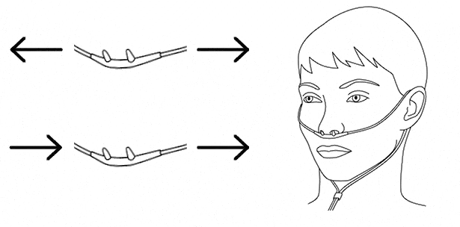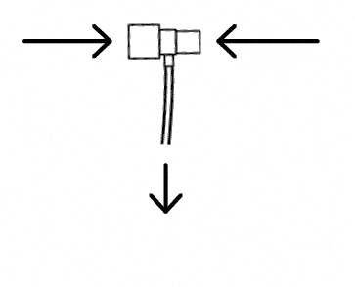
CO₂

Ventilator Y-piece

Endo-trachial tube
CO₂

CO₂
with O₂

CO₂

oral/nasal sampling line oral/nasal sampling line
- non-intubated patients: - non-intubated patients:
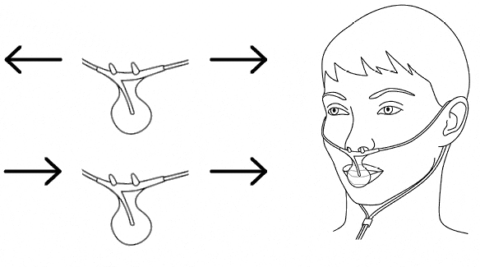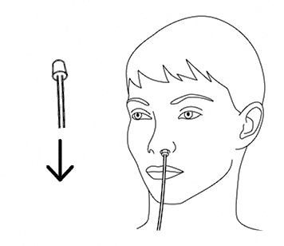
CO₂

CO₂

CO₂
with O₂

CO₂

For further instructions, warnings and precautions refer to the “Instructions for Use” provided with the selected sampling line configuration.

SpO₂ Sensors
Viamed supplies a large variety of disposable and reusable SpO₂ sensors for use with the VM-2500. Depending on the sensor type and model, their application ranges from adults to neonates, providing application specific features and design.
The SC 6500 VM Sensor is typically used for adult applications and the W 6500 VM Sensor for pediatric and infant applications (see figure 7). Other sensors are available upon request.

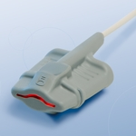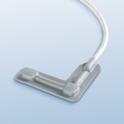
Figure 5: SpO₂ sensor SC 6500 VM (left) and W 6500 VM (right)

All sensors operate in transmission mode. The light source emits red and infrared light with wavelengths of 660nm and 905nm respectively at a typical radiant power of 3.5mW.
The SpO₂ sensor is applied to peripheral areas of the body such as finger tips and toes for adults, and paediatrics, and the foot or palms for infants and neonates.

Exterior View, Controls and Connectors

Mainstream Capnograph/Pulse Oximeter - VM-2500-M

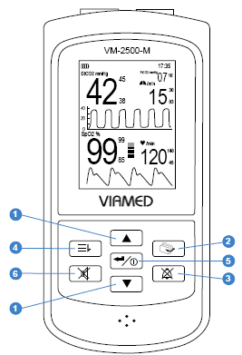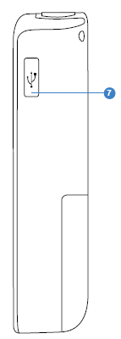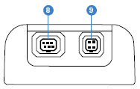
Front view Side view Top View

Rear view is the same as for VM-2500-S but without gas outlet (see Chapter 4.2)
No. | Symbol | Feature/Button | Function
1 |  | Arrow buttons  (up/down) | Multifunction buttons used for:  1. Scrolling through menu items  2. Increasing/decreasing parameters  3. Shortcuts to volume/brightness control during  monitoring
2 |  | Display mode | Toggles between various display modes. Shortcut to return to display mode during menu mode.
3 |  | Alarm silenced/reset | 1. The audible alarm can be silenced for a maximum period of two minutes. Optical alarm remains activated.  2. To reset alarms press and hold the button for approx. 3 seconds.
4 |  | Menu | Menu selection. Shortcut to return to the previous menu level during menu mode.
5 |  | On/Off and ENTER button | 1. To turn on the device: press and hold the button briefly.  2. To turn off the device: press and hold the button for approx. 3 seconds.  3. To confirms selection at the device: press and hold the button briefly while the device is switched on
6 |  | Pulse tone | Turns pulse tone on/off
7 |  | USB | USB 2.0 interface
8 |  | SpO₂ Sensor port | Port to connect the SpO₂ sensor
9 |  | CO₂ Mainstream port | Port to connect the IRMA CO₂ analyzer

Sidestream Capnograph/Pulse Oximeter - VM-2500-S

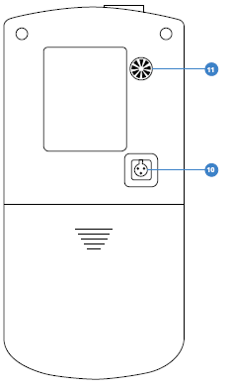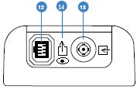
Rear view Top view

Front and side views are the same as for VM-2500-M (see Chapter 4.1)

No. | Symbol | Feature/Button | Function
10 |  | Power input | Port to connect the external power supply (100-240V AC / 50-60Hz, Model No. FW 7660M/06)
11 | 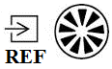 | REF inlet port | Gas inlet port for sampling gas during zeroing
12 |  | SpO₂ sensor port | Port to connect the SpO₂ sensor
13 | 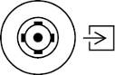 | CO₂ Sidestream gas inlet port | Port with Light Emitting Gas Inlet (LEGI) to connect the disposable sampling line
14 |  | Gas outlet port | Gas outlet of the sidestream module

Preparation for Use

Selecting Power Supply
Power is supplied to the monitor either via external power supply, rechargeable Li-Poly battery, or 4 x AA alkaline batteries.

Power Supply
The external power supply (100-240V AC / 50-60Hz, Model No. FW 7660M/06) is used for continuous operation of the monitor and to charge the Li-Poly battery.
Connecting the power supply (see figure 8):
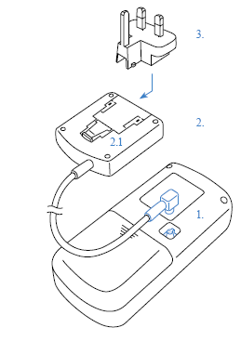
- To operate by mains, connect the power supply cable into the power input socket located at the back of the device.

- Ensure that the correct power supply plug is connected to the power supply. It can be exchanged by pressing the release button (2.1) on the power supply. As standard the device is supplied with a European and United Kingdom plug. Additional plugs are available upon request.

- Connect the power supply to an AC outlet.

Figure 6: Connect the power supply

Warning:
Only use the power supply Model No. FW 7660M/06 provided with the monitor. The use of a power supply other than this may result in hazardous situation and effect patient’s safety.

Li-Poly Battery or AA Alkaline Batteries
For convenient monitoring in emergency medicine or during patient transport the monitor can be powered by the rechargeable Li-Poly battery (3.7 V / 2500 mAh, Model No. CT-2500) or with 4 x AA alkaline batteries.
When the device is connected to an AC outlet the Li-Poly battery will begin recharging. This is represented by the three segments of the battery level indicator illuminating in sequence. When the Li-Poly battery is completely recharged the three segments of the battery level indicator will be displayed fully.

Note: The charging function is not available at the battery contacts of the 4 x AA alkaline batteries.

Battery Installation (see figure 9):

- Slide down the cover of the battery compartment on the rear panel of the device.

- Insert four alkaline batteries (1.5V, AA), ensuring the correct orientation in accordance with the polarity markings.

- Alternatively, insert the rechargeable Li-Poly battery (Model No. CT-2500), orientated according to the guiding grooves.

- Slide the battery-compartment cover back into its initial position to close.

Figure 7: Insert a Li-Poly battery or 4 x AA alkali batteries

Warning:
Only charge the Li-Poly battery CT-2500 while inserted in the VM-2500 monitor using the provided power supply FW 7660M/06.

Caution:
Do not dispose the Li-Poly battery or the alkaline batteries in the consumer waste, if they are empty or can no longer be recharged. Batteries may contain substances which are harmful to the environment and to the health.
Dispose the batteries at the available battery collecting sites or the recycling yards of the municipalities. Please only dispose discharged batteries into the designated containers. Tape the terminals of the Li-Poly batteries at the poles before disposing.

Caution: Remove the batteries if the device is to be stored or not used for a longer period of time.

Connecting Sensors / Sampling Line Configurations to the VM-2500

IRMA CO₂ Analyzer (mainstream)
For CO₂ mainstream capnography with VM-2500-M inspect the IRMA CO₂ analyzer and connector cables for any external damage.
Insert the connector of the IRMA CO₂ analyzer into the CO₂ Mainstream port located on the top edge of VM-2500-M. Secure the IRMA CO₂ analyzer on top of the IRMA airway adapter. It will click into place when correctly seated.

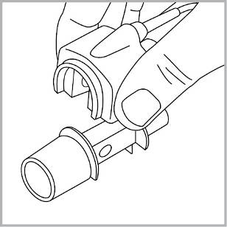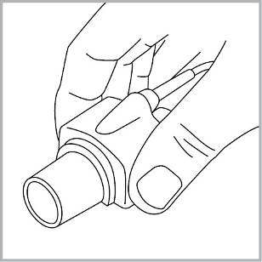

Warning:
Do not use the IRMA airway adapter (adult/paediatric) with infants as the adapter adds 6ml dead space to the patient circuit.

Warning:
Do not use the IRMA airway adapter (infant) with adults or paediatric as this may cause excessive flow resistance.

Caution: Use only Masimo manufactured IRMA airway adapters.

Disposable sampling line (sidestream)
For CO₂ sidestream capnography with the VM-2500-S inspect the disposable sampling line for any external damage.

Connect a Versastream sampling line configuration to the CO₂ sidestream inlet port at the top of VM-2500-S. Versions available for long-term use ≤ 72h and short term use ≤ 24h.

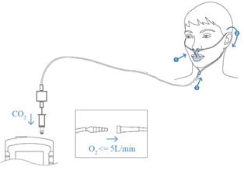

VM-2500-S performs zeroing automatically by switching the gas sampling from the respiratory circuit to ambient air. The automatic zeroing is performed 1 to 3 times per 24 hours, and takes less than 3sec.

Warning: Successful zeroing requires the presence of ambient air (21% O2 and 0% CO2). Ensure that the VM-2500-S is placed in a well ventilated environment. Avoid breathing near the monitor before or during the zeroing procedure. Incorrect zeroing will result in false gas readings.

Warning: Replace the disposable sampling line if “Sampling system occlusion !” is displayed by the monitor.

Warning:
Do not re-use or autoclave disposable sampling lines and airway adapters, due to the risk of cross contamination.

Warning:
Used disposable sampling lines and airway adapters shall be disposed of in accordance with local regulations for biohazardous waste.

Caution:
Use only disposable sampling lines manufactured by Viamed.

SpO₂ Sensor
Inspect the SpO₂ sensor and connector cables for any external damage.
Insert the SpO₂ sensor cable into the SpO₂ sensor port located on the top edge of the device, ensuring correct orientation of the sensor connector and the port.

Visual Check
Before commencing operation, ensure that the device, power supply, sensors or sampling line configurations are not damaged.
During the visual check of the VM-2500-S sidestream device, ensure that the gas outlet is clear of any obstruction.

Warning: Do not use sensors, cables or lines that appear to be damaged. Do not use sensors when optical components are exposed. Do not use a device that appears damaged. Replace the monitor immediately in cases of visible damage.

Warning: Ensure that the speaker is clear of any obstruction and that the speaker holes are not covered. Failure to do so could result in an inaudible alarm tone.

Warning: Ensure that the gas outlet of the sidestream device is clear of any obstruction. Failure to do so could result in CO₂ sidestream measurement errors.

Warning: Check the compatibility of the monitor, probe and cable before use. Incompatible components can result in degraded performance.

Switching on the Device
Press and hold the ON/OFF button  briefly until an opening “welcome screen” appears. The power-on self-test is successfully completed after a single loud tone sounds.

Connecting Sensors / Sampling Line Configurations to the Patient

IRMA CO₂ Analyzer (mainstream)
A green LED indicates that the IRMA CO₂ Analyzer is powered and ready for use.

Perform the following tests prior to connecting the IRMA CO₂ Analyzer to the patient circuit:

1. Breath into the airway adapter and check that valid CO₂ waveforms and values are displayed by the monitor.
2. Remove the airway adapter and wait for 5 seconds.
3. Check that the airway adapter alarm is displayed and that the LED at the IRMA CO₂ Analyzer shows a flashing red light.
4. Connect a new airway adapter to the IRMA CO₂ Analyzer

Connecting the IRMA airway adapter to the patient circuit:

1. Connect the 15 mm male connector of the IRMA airway adapter to the breathing circuit Y-piece.

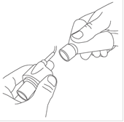

2. Connect the 15 mm female connector of the IRMA airway adapter to the endotracheal tube with or without an angled connector.

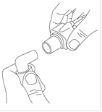

Alternatively, connect a HME (Heat Moisture Exchanger) between the patient’s endotracheal tube and the IRMA CO₂ analyzer. Placing a HME in front of the IRMA CO₂ analyzer protects the airway adapter from secretions and effects of water vapour and eliminates the need of changing the adapter. It allows free positioning of the IRMA CO₂ analyzer as well.

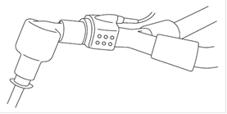

3. Perform the tightness check of the patient circuit with the IRMA CO₂ analyzer connected on the airway adapter.

Warning:
Do not place the IRMA airway adapter between the endotracheal tube and an elbow as this may allow patient secretions to block the adapter windows and result in incorrect operation.

Warning:
To keep secretions and moisture from pooling on the windows, always position the IRMA™ analyzer in a vertical position with the LED pointing upwards.

Warning: Replace the adapter if condensation occurs inside the airway adapter.

Disposable sampling line configuration (sidestream)
A constant green light at the Light Emitting Gas Inlet (LEGI) at the VM-2500-S indicates that the system is working correctly.

Perform the following tests prior to connecting the assembled sampling line configuration to the patient circuit:

1. Breath into the sampling line configuration and check that valid CO₂ waveforms and values are displayed on the VM-2500-S.
2. Occlude the sampling line by bending and kinking it.
3. Check that an occlusion alarm is displayed and that the LED shows a flashing red light.
4. Connect a new sampling line configuration to the patient circuit.

A. In the case of intubated patients
The sidestream airway adapter is connected to the tubing of the patient circuit.

- First connect the male connector of the sidestream airway adapter to the breathing circuit Y-piece.
- Now connect the female connector of the sidestream airway adapter to the endotracheal tube with or without an angled connector.

B. In the case of non-intubated patients
The nasal or oral sampling configuration is directly connected to the nose or mouth respectively.
For further instructions, warnings and precautions refer to the ‘Instructions for Use’ provided with the sampling system configuration.

Note: Our sampling line configurations are continuously updated; please contact Viamed for detailed information. Specific patient sampling line configurations and interfaces are available upon request.

Warning:
Do not use adult or paediatric type sampling line configurations with infants or neonates, as this may add dead space to the patient circuit.

Warning:
Do not use infant or neonatal type sampling line configurations with adults or paediatric, as this may result in excessive flow resistance.

Warning:
Do not use the VM-2500-S with metered dose inhalers or nebulised medication as this may block the bacteria filter.

SpO₂ Sensor
1. Refer to the sensor ‘Instructions for Use’ to determine if an appropriate sensor is being used, and if it is applied correctly.

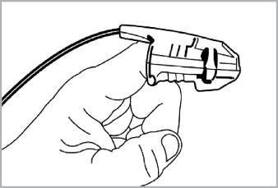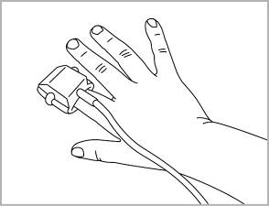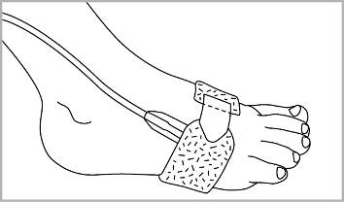
Adult Paediatric Neonatal

2. Confirm that all connections have been made correctly by verifying an actual SpO₂ waveform on the monitor display.

Warning: Avoid application of the SpO₂ sensors to oedematous or fragile tissue.

Warning: Do not use the SpO₂ sensor if it is damaged. Use of a damaged sensor could cause patient injury or equipment failure.

Warning: Excessive patient motion, excessive ambient light, electromagnetic interference, dysfunctional haemoglobin, low perfusion, intravascular dyes, finger nail polish and long or artificial finger nails may affect the sensor performance and the accuracy of the measurement.

Warning: Do not autoclave the SpO₂ sensor.

Warning:
For the SpO₂ measurement, the monitor uses red and infrared light with specific fixed wavelengths. Consider that these wavelengths might influence diagnostic parameters of other optical applications. The specifications of the wavelengths used are listed in the ‘Instructions for Use’ of the specific sensor.

Caution: Depending on the sensor model, specifications can differ. For sensor specific information on wavelengths and radiant power, please refer to the ‘Instructions for Use’ provided with your SpO₂ Sensor.

Caution: For further instructions, warnings and precautions refer to the ‘Instructions for Use’ provided with the SpO₂ Sensor.

Commencing Monitoring
Once the sensors / sidestream sampling line configuration is connected and correctly positioned on the patient, monitoring begins automatically.
An audio-visual alarm appears, if any of the sensors or the disposable sampling line is disconnected from the device.
The VM-2500 can be reset to the start-up configuration by resetting the alarms (refer to Chapter 7.6).

Switching off the Device
Press and hold the on/off button … for approx. 3 seconds to switch off the device. The VM-2500 will also power off automatically after 5 minutes when not in use.

Display Modes and Displayed Data

Toggling Between Display Modes
The operator can toggle between various display modes by pressing the button.
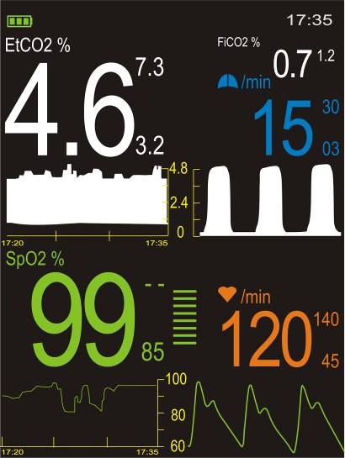
Display 3 to 5:Trend
(15 min, 1 h and 6 h Trend, parallel to ongoing measurement)
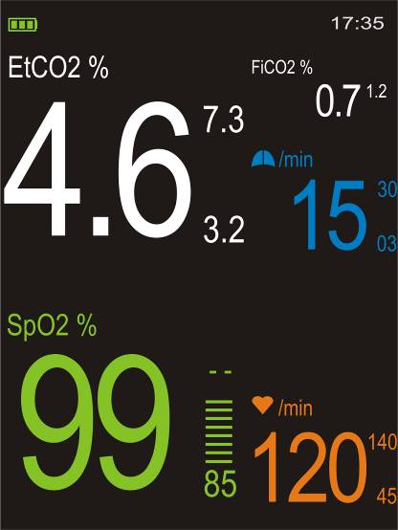
Display 2: Numerical
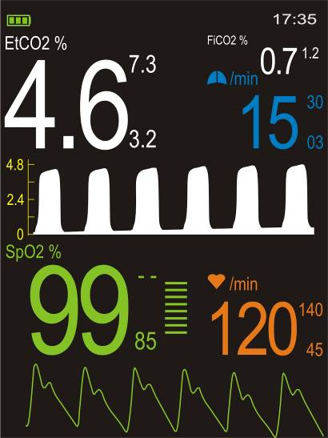
Display 1 : Standard

The small numbers on the right hand side of the measurement value of a parameter indicate the upper and lower alarm limits. In all displays the measurement value, alarm limits, curve, name and unit of each parameter are displayed in the same colour.

- End-tidal expired CO₂ gas concentration in vol %, kPa or mmHg
- Inspired CO₂ gas concentration in vol %, kPa or mmHg
- Respiration rate in breaths per minute
- CO₂ waveform (Capnogram)
The default setting of the amplitude scale is Auto scaling. Here the reading is automatically adjusted to the signal strength; therefore, a waveform with strong amplitude should be visible at all times. The scale however can also be defined by the user (refer to chapter 8.1.3).
- Functional blood oxygen saturation in units of percent SpO₂
- Bar graph for pulse amplitude
Indicates the dynamic pulse amplitude and rate. As the detected pulse becomes stronger, more bars light with each pulse. The reverse is true for weak pulses.
- Pulse rate in beats per minute
- Pulse waveform (plethysmogram)
The reading is automatically adjusted to the pulse strength; therefore, a waveform with strong amplitude should be visible at all times.
- Combined EtCO₂ and FiCO₂ trend waveform
- SpO₂ trend waveform
- Start and end times

Symbols and Indicators
8
5
8
9
1
2
3
7
6
4

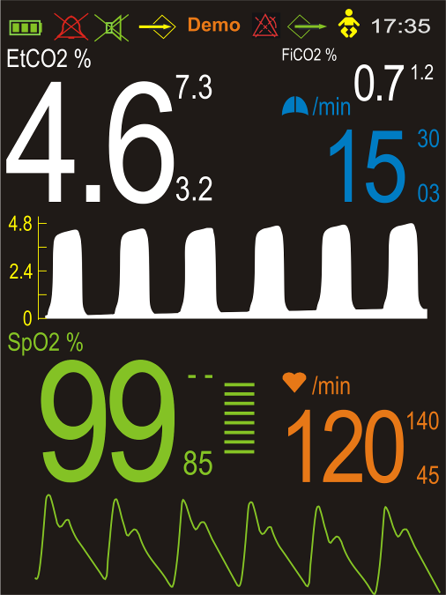
11
12
10
8

No. | Symbol/Indicator | Function
1 |  | Battery level indicator:  The three segments represent the battery charge level. The symbol flashes yellow when the battery capacity is low. During charging of the Li-Poly battery, the three segments of the indicator are illuminated in sequence.
1 |  | Power supply indicator:  The power supply is connected and no batteries are inserted.
2 |  | Alarm silence indicator:  The audible alarm can be silenced for a maximum period of two minutes. Optical alarm remains activated.
3 |  | Pulse tone off
4 |  | Memory full indicator:  The device’s memory for measurement data is full. No new data can be stored. Old data can be erased or are overwritten.
5 | DEMO | Demo mode indicator:  The device is operated in demo mode. All measurement data are simulated. This mode is accessed via the service menu.
6 |  | Alarm delay mode indicator:  The device is operating in home care mode. Limit alarms are only activated if the limit is infringed for >15 seconds continuously.  (see 7.7.3)
7 |  | Real-Time Mode indicator:  The device is operated in the Real-Time mode. Data is available at the USB port
8 |  | Neonatal mode:  The device is operated in the neonatal mode. On activation the alarm limits are changed to neonatal defaults.
9 | 17:53 | Current time, displayed in 12h or 24h format.
10 |  | Respiration rate, displayed in breaths per minute.
11 |  | Pulse rate, displayed in beats per minute.
12 |  | The colour of the bar graph is an indicator of the signal quality:  - Green: good signal quality, very accurate measurement  - Yellow: average signal quality, measurement may be inaccurate  - Red: poor signal quality, unreliable measurement

Pulse Tone
During monitoring a pulse beep is sounded for every detected pulse. The pitch of the pulse tone is dependent on the measured SpO₂ value. A higher pitch is indicative of higher oxygen saturation.
The pulse tone volume can be adjusted under the menu item ‘Volume’. The pulse tone can be also silenced using the  button. Pressing this button for a second time will reactivate the pulse tone.

Alarms

Alarm Priority and Appearance
The VM-2500 differentiates between alarms of high, medium and low priority.

Priority Level | Audio Signal Sequence (repeatedly) | Visual Alarm | Condition
High  (Warning) | 5 tone beep + 2 seconds pause + 5 tone beep and  3 seconds pause | Red and !!! | For potentially life-threatening situations
Medium  (Caution) | 3 tone beep and  5 seconds pause | Yellow and !! | For potentially serious problems that are presumed to be not life threatening
Low  (Advisory) | 2 tone beep and  16 seconds pause | Yellow and ! | Advisory alarms

An alarm of higher priority will always overlay alarms of respective lower priority. Vice versa, an alarm of high priority cannot be silenced by an alarm of lower priority. In this way the VM-2500 will always display the alarm with the highest priority, if more than one alarm condition exists at the same time.

Audible Alarm Volume
The alarm volume is not adjustable; however, it is possible to silence the alarm for a period of two minutes using the button. It has an audibility of at least 55dB (A) in 1 meter distance of the device.

Default Alarm Limits
Default settings are active according to the selected device mode “Adult” or “Neonatal”.

Limit | Unit | Range | “Adult” | “Neonatal”
EtCO₂ High | % | 0.1 - 9.9 / off | 7.3 | 7.3
EtCO₂ Low | % | off / 0.1 - 9.9 | 3.2 | 3.2
FiCO₂ High | % | 0.1 - 9.9 / off | 1.2 | 1.2
RR High | /min | 4 - 150 / off | off | off
Apnoea | sec | 20, 40, 60 | 20 | 20
SpO₂ High | % | 1 - 99 / off | off | 95
SpO₂ Low | % | off / 1 - 99 | 85 | 85
PR High | /min | 1 - 250 / off | 140 | 150
PR Low | /min | off / 1 - 250 | 45 | 30

Limit Alarms
The table below shows the limit alarms, alarm conditions and priority of the VM-2500. Depending on the priority of the alarm the respective measurement value will change colour and an audible alarm sounds.

Limit Alarm | Condition | Priority
EtCO₂ High | EtCO₂ value above set alarm limit | Medium
EtCO₂ Low | EtCO₂ value below set alarm limit | Medium
FiCO₂ High | FiCO₂ value above set alarm limit | Medium
RR High | Respiratory rate above set alarm limit | Medium
Apnoea !! | No breath detected within set terms (if ≤ 1min) | Medium
Apnoea !!! | No breath detected within set terms (if > 1min) | High
SpO₂ High | SpO₂ value above set alarm limit in the standard mode | Low
SpO₂ High (neonatal mode) | SpO₂ value above set alarm limit in the neonatal mode | Medium
SpO₂ Low | SpO₂ value below set alarm limit | Medium
PR High | Pulse rate above set alarm limit | Medium
PR Low | Pulse rate below set alarm limit | Medium

Alarm Messages
The table below presents the alarm messages, alarm condition and priority of the VM-2500. The colour of the alarm message and its audible alarm depend on the priority of the alarm message.

Alarm Messages | Condition | Priority
Bad signal quality !!! | Poor-quality pulse signal, for example as a result of low perfusion. | High
No CO₂ Sensor ! | No connection to the mainstream IRMA CO₂ analyzer | Low
Check CO₂ Adapter ! | The mainstream IRMA adaptor is dirty, not positioned correctly etc. | Low
No Nomo Adapter ! | No connection to the sidestream disposable sampling line. | Low
Sampling system occlusion ! | A component of the sidestream sampling system (sampling line or gas outlet) is blocked (occluded) | Low
CO₂ Over range ! | Measured CO₂ concentration is outside of the specified accuracy range | Low
No SpO₂ Sensor ! | No connection to the SpO₂ sensor | Low
SpO₂ Probe off ! | SpO₂ sensor is connected to the device, a signal was detected and then the finger has been removed / slipped of | Low
Excess light ! | High ambient light sources near the SpO₂ sensor, e.g. surgical lights | Low
Battery low ! | Low battery level at start up results in error message and dysfunction. Low battery level during monitoring results in audible alarm and battery indicator to flash yellow for 3 minutes. Thereafter the indicator turns red, the battery low message appears and the device switches off. | Low

Warning:
The monitor detects respiratory effort via changes in CO₂ concentration of exhaled air; therefore, the CO₂ measurement can be used to detect apnoea. The device however is unable to discriminate between a patient not breathing and a sensor that is disconnected from the patient circuit. Always monitor and set alarms for SpO₂ when using the VM-2500 to monitor respiratory function.

Resetting of Alarm Signals
Once triggered, an alarm will only be reset if the cause of the alarm has been resolved. Individual alarm limits can also be completely deactivated if required.
Alarm signals can be reset by pressing and holding the button for 3 seconds. If the initial condition for the warning is still present after resetting the warning signals, the warning will return immediately.
In case of the alarm signals “No SpO2 Sensor !”, “SpO₂ Probe off !”, “No Nomo Adapter !” and “No CO₂ Sensor !” the device reverts to the on-position. Parameters which have been set by the user will remain once an alarm is reset.
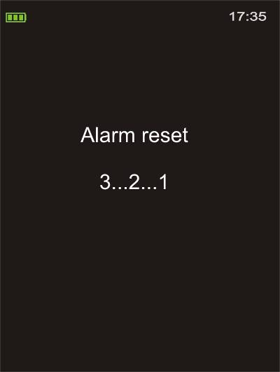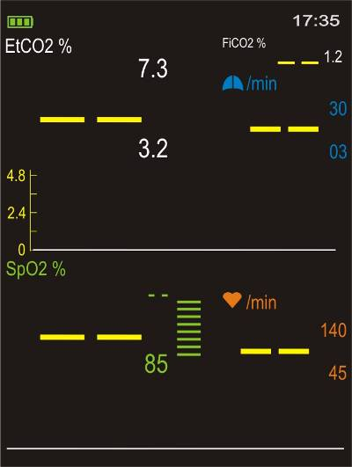

Press and hold button Display after reset of alarms

Alarm Mode

Standard mode
In the standard mode the default alarm limits are set to the adult default settings (refer to Chapter 7.3).

Neonatal mode ( )
In the neonatal mode the default alarm limits are set to the neonatal default settings (refer to Chapter 7.3).
Ensure that accessories appropriate for neonates are used.

Alarm delay mode ( )
The function of the alarm delay mode is to reduce false alarms which are typical during long term monitoring (movement and other artefacts).
In this mode all alarm functions are the same as in the standard mode, but the sensitivity of the limit alarms is changed as follows:
In alarm delay mode limit alarms are only activated, if the limit is infringed for > 15 seconds continuously.

Note: During monitoring all measurement values are displayed and stored independently of the audible and visible alarms. In case of the alarm messages and apnoea messages the sensitivity of alarms is the same as during standard mode.
The alarm delay mode can only be activated in the PIN protected service menu. Only authorized service personnel can access this menu.

Menu Structure

Main Menu

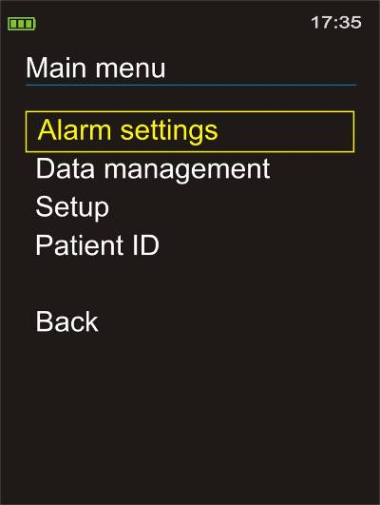
All important and frequently used settings are accessible through the main menu, which can be accessed by pressing the button.

Navigating the Menu
Use the buttons to scroll through menu items. The currently selected menu item is highlighted by a coloured frame. Press the button to confirm your selection.
Select the menu item “Back” to return to the previous menu level. Alternatively use the menu button as shortcut for “Back”.

Entering Data
In some submenus it is possible to adjust a certain parameter. In this case the parameter can be increased or decreased using the buttons. The value will increase or decrease more quickly when the respective button is held down. Press the button to confirm the new value.

Exiting Menu and Returning to Display
Press the display button at any time, in any menu to return immediately to the monitoring display.
If no button has been pressed for more than 30 seconds, the device will automatically return to the monitoring screen.

Submenu: Alarm Settings

General Information
The VM-2500 alarm limits for EtCO₂, FiCO₂, SpO₂, respiration rate and pulse rate can be set individually. The current alarm limits are displayed as small numbers on the right hand side of the measurement value. If a measured value either exceeds the upper limit or falls below the lower limit, visual and audible alarms will be triggered immediately.

Visual alarm
When an alarm has been triggered the critical value will flash and turn yellow together with the violated alarm limit.

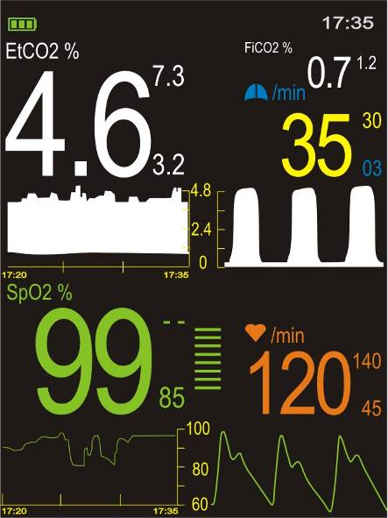
Visual alarm which was triggered by a violation of the upper respiration rate alarm limit

An alarm will also be triggered if the SpO₂ sensor is removed from the patient, the SpO₂ signal quality remains poor over a longer period of time, the mainstream IRMA airway adapter is dirty or the sidestream disposable sampling line is occluded. This is also the case if the SpO₂ sensor, the IRMA CO₂ analyzer or the disposable sampling line is disconnected from the device.

Adjusting Settings

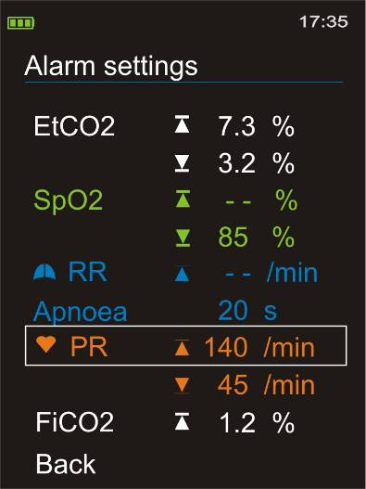

Selection with buttons /confirmation with button

Use the Alarm settings menu to set the upper and lower alarm limit of EtCO₂, SpO₂, respiration rate, pulse rate and FiCO₂. Select “ - - ” to deactivate the respective alarm limit.
“Apnoea” represents the lower alarm limit of the respiration rate. If no breath is detected within the set time, the apnoea alarm is activated. After restarting the device, the default alarm limits will be reset. This is also the case, if the power supply is interrupted.

Submenu: Data Management

Recording Data
The VM-2500 device can store more than 400 hours of monitoring data. Each individual data set, regardless of its actual length, uses at least 110 minutes of memory space. A new data set is generated automatically each time the device is turned on or the current Patient ID is changed. This is also the case if the date or time of the device is adjusted via the setup menu.
When the device is turned off or the current Patient ID is changed, all of the measurements that were taken are automatically stored in the devices memory, together with the respective alarm limits, patient ID, date and time.
The device warns the user when the memory is almost full by displaying the  symbol. If the memory is full the oldest data set is overwritten upon confirmation by the user. Stored data sets can be retrieved and erased under the menu item “Data management”. The data sets can also be downloaded on PC with the user-friendly VM-2500 PC-Software.

Data Management

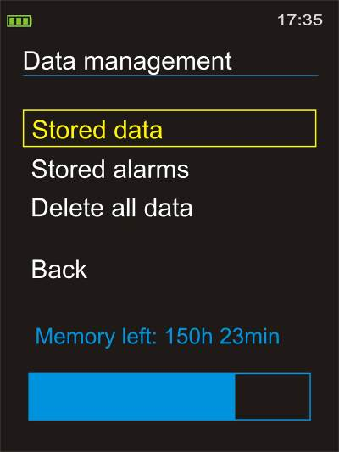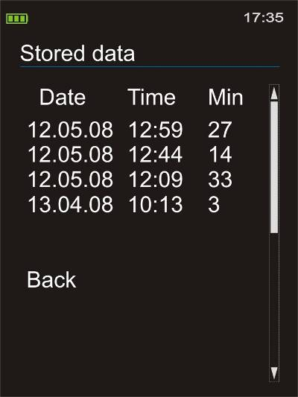

Use the Data management menu to access the list of stored data sets and stored alarms, to delete all data in the memory or to view the remaining recording time.

Retrieve the selected data set by pressing the button.

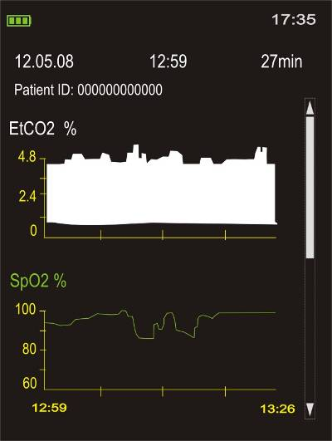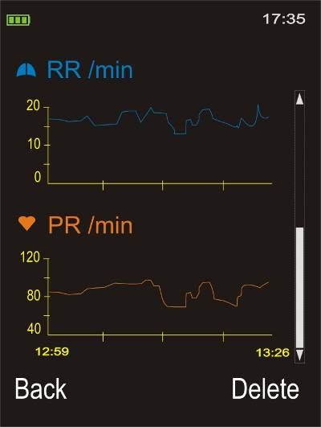

The stored measurements are displayed in graphic form together with the date, start time, duration of the recording and Patient ID. The colour code of the displayed data is as follows:
EtCO2 – white, SpO2 - green, respiration rate – blue, pulse rate - orange.
Select “Back” to return to the list of stored data or “Delete” to erase the data set and its corresponding stored alarms.

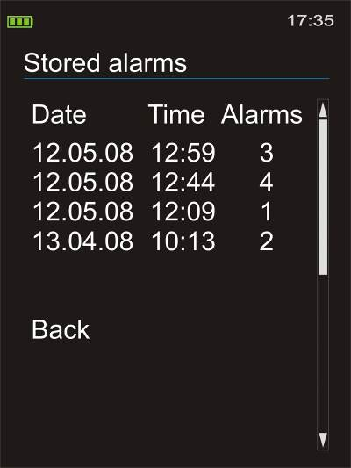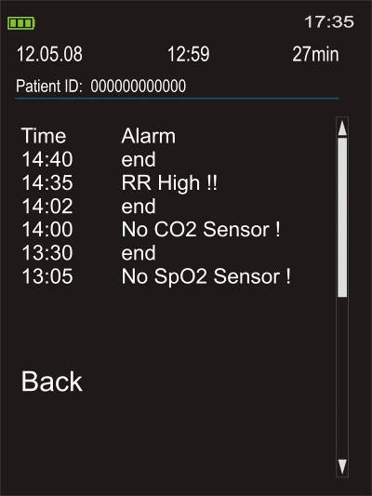

For each stored data set a file with the stored alarms is generated. The stored alarms are displayed as list together with the date, start time, duration of the recording and Patient ID.
Next to the stored alarm message the start time of the alarm is displayed. Above the start time the time at which the alarm condition stopped is displayed.

Submenu: Setup

General Information

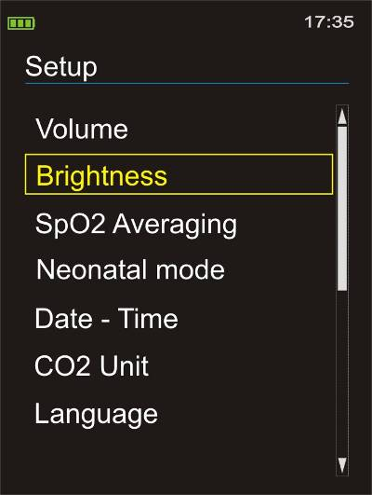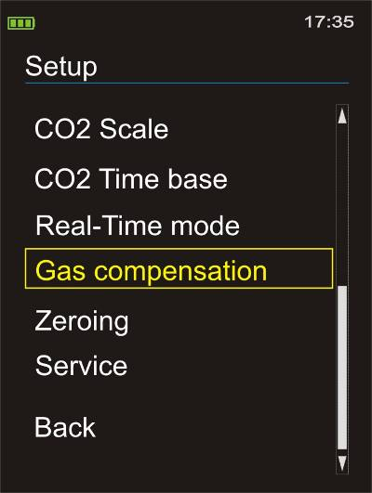

This submenu offers access to various device settings; confirm selection by pressing the button.

Parameters

Volume  Adjust the pulse tone volume using the buttons. Confirm the new setting by pressing the button. | 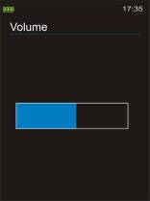
Brightness  Adjust the display brightness using the buttons. Confirm the new setting by pressing the button.  Note: Very high brightness settings will shorten the battery life considerably! | 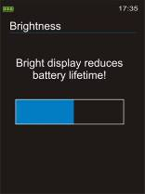
SpO₂ Averaging  Stable: When this setting is selected any strong and sudden variations in data will not immediately affect the reading (data incorporated over time); minor irregularities have little or no effect on the displayed reading.  Standard: Averaging parameters used for this setting are between those of the stable and sensitive settings.  Sensitive: The reading is more sensitive to irregularities but reacts very quickly to any changes in measured parameters.  Refer to Chapter 13 "Technical Specifications" for further details on the influence of the SpO₂ averaging settings on the SpO₂ reaction time. | 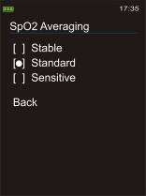
Neonatal mode  The neonatal symbol indicates that the neonatal mode is activated. In this mode the default alarm limits are adjusted to neonatal default settings (refer to Chapter 7.3). Please ensure that accessories appropriate for neonates are connected. | 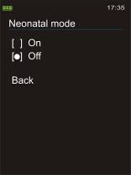
Date and Time  First, select between Y/M/D and D/M/Y mode (respectively 12h mode and 24h mode), then set the date and time. Settings for the date and time are not erased when the batteries are temporarily removed. | 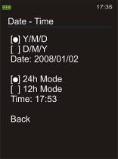
CO₂ Unit  By changing the CO₂ unit, the measurement values and default limits of EtCO2 and FiCO2 are converted accordingly.  For conversion to the units kPa and mmHg automatic barometric pressure compensation is performed. | 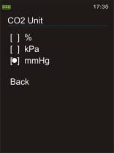
Language  All messages and menus will be displayed in the selected language.  The standard language package comprises up to 16 languages. Please refer to the manufacturer for detailed information on the current languages available. | 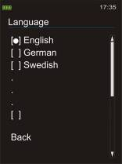
CO₂ Scale  The scale maximum of the capnogram and CO₂ trend can be fixed to 6 %, 10 % or 15 %. Select the option “Auto Scaling” for optimal amplitude scaling of the data. Depending on the selected CO₂ scale, the values will be adjusted accordingly. | 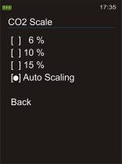
CO₂ Time Base  For an optimal time resolution the time base of the capnogram can be adjusted to 15 seconds or 30 seconds. | 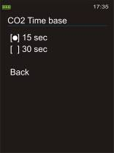
Real-Time Mode  The Real-Time mode symbol indicates that the Real-Time mode is activated.  Activation of the Real-Time mode enables visualization and storage of measurement data on a PC.  In this mode the ongoing measurement values of EtCO₂, FiCO₂, SpO₂, respiration rate and pulse rate are available every 4 seconds at the USB port for download to the PC. For more information please refer to the enclosed Software Manual. | 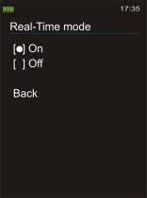
Gas Compensation  The presence of oxygen and nitrous oxide can cause some interference in the CO₂ measurement. These interferences are compensated by setting the range of O₂ and N₂O concentration under the menu point “Gas compensation” accordingly.  When the O₂/N₂O concentrations are set correctly, the measurement is within the accuracy range stated in the Technical Specifications (refer to Chapter 13).  Note: Only the mainstream VM-2500-M may be used to analyse gasses which contain nitrous oxide. Be sure that the IRMA airway adapter is correctly connected to the patient circuit.  Warning:  Do not use VM-2500-S to analyse gasses (e.g. anaesthetics like nitrous oxide etc.) that need to be returned to the patient circuit or a scavenging system. The gas outlet of the sidestream device is not designed to return the exhaust gases to the patient circuit or a scavenging system. | 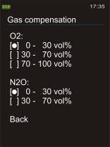
Zeroing  Zeroing needs to be performed only when an offset in EtCO2 and FiCO2 values is observed, or when an unspecified accuracy message is displayed.  Warning:  Incorrect zeroing will result in false CO2 gas readings. Refer to chapter 11.4 for detailed information. | 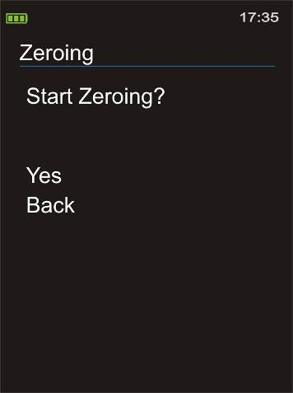
Service  The Service submenu is protected by a PIN code; only authorized service personnel can access this menu. | 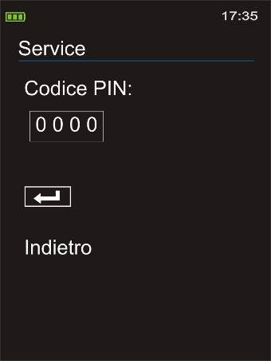

Submenu: Patient ID
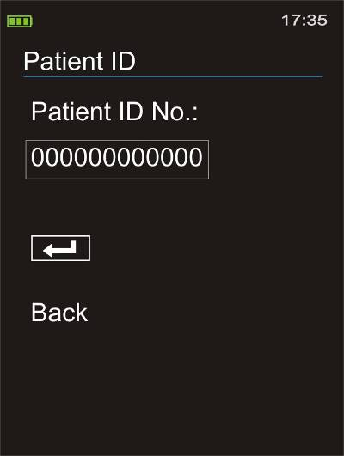

The VM-2500 features the possibility of saving a 12 digit patient ID together with every created data file.
If the Patient ID is changed via the menu during measurement, the current data file is closed and a new data file with the new Patient ID is opened. A message is displayed to inform the user.

Start Up Settings
The device Start Up Settings are defined according to their method of adjustment.

User adjustable start up settings
After restart of the device the last parameter setting selected by the user in the main menu will be active.

The following parameters are user adjustable start up settings:
- Type of measurement screen
- Brightness setting of the display
- Time and Date format
- Language
- CO₂ Time base
- CO₂ Unit
Default start up settings
Changing settings different to the “User adjustable start up settings” are in effect only as long as the VM-2500 remains switched on. Once the VM-2500 has been switched off, at the next start up, the default settings will be reactivated.

The following parameters are default start up settings:
- Alarm limits
- Pulse tone
- Volume
- O₂ compensation
- SpO₂ averaging
- Etc.
Default start up settings can only be changed in the PIN protected Service Menu. Only authorized service personnel can access this menu.

Other

Volume Control Shortcut
If the button is pressed during any monitoring display mode, the volume control screen will open. Adjust the volume using the buttons. Confirm the new setting by pressing the button.

Brightness Control Shortcut
If the button is pressed during any monitoring display mode, the brightness control screen will open. Adjust the brightness using the buttons. Confirm the new setting by pressing the button.

Power-Save Mode
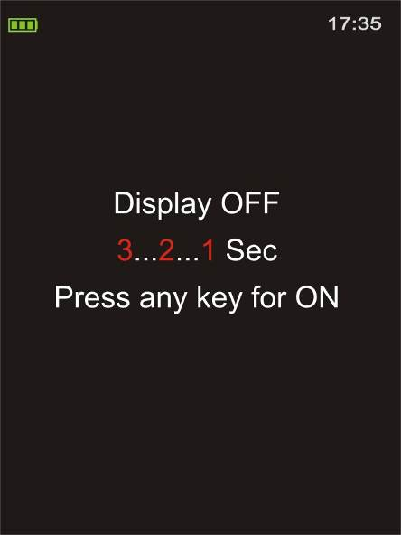
The device’s display can be turned off to save power and extend battery life. This can be accomplished by pressing and holding the button. A countdown will start, after which the display will be switched off. The device is now in economy power mode. The pressing of any button or activation of an alarm will reactivate the display.

Adverse effects on performance

CO₂ measurements

Interfering gases or vapours

Gas or Vapour | Gas Level | CO₂
N₂O ⁴⁾ | 60 vol% | -^{1&2)}
HAL ⁴⁾ | 4 vol% | -¹⁾
ENF, ISO, SEV ⁴⁾ | 5 vol% | +8% of reading³⁾
DES ⁴⁾ | 15 vol% | +12% of reading³⁾
Xe (Xenon) ⁴⁾ | 80 vol% | -10% of reading³⁾
He (Helium) ⁴⁾ | 50 vol% | -6% of reading³⁾
Metered dose inhaler propellants ⁴⁾ | Not for use with metered dose inhalers propellants
C₂H₅OH (Ethanol) ⁴⁾ | 0.3 vol% | -¹⁾
C₃H₇OH (Isopropanol) ⁴⁾ | 0.5 vol% | -¹⁾
CH₃COCH₃ (Acetone) ⁴⁾ | 1 vol% | -¹⁾
CH₄ (Methane) ⁴⁾ | 3 vol% | -¹⁾
CO (Carbon monoxide) ⁵⁾ | 1 vol% | -¹⁾
NO (Nitrogen monoxide) ⁵⁾ | 0.02 vol% | -¹⁾
O₂ ⁵⁾ | 100 vol% | -^{1&2)}

Note 1: Negligible interference, effect included in the specifications “accuracy, incl. interfering gases
Note 2: Negligible interference with N₂O/O₂ concentrations correctly set, effect included in the specifications “accuracy, incl. interfering gases”
Note 3: Interference at indicated gas level. For example, 50 vol% Helium typically decreases the CO₂ reading by 6%. This means that if measuring on a mixture containing 5.0vol% CO₂ and 50 vol% Helium, the measured CO₂ concentration will typically be (1-0.06)*5.0 vol% = 4,7 vol% CO₂
Note 4: According to the EN ISO 80601-2-55:2011 standard
Note 5: In addition to the EN ISO 80601-2-55:2011 standard

Humidity or Condensation
The partial pressure and the volume percentage of CO₂ will depend on the amount of water vapour in the measured gas.
Both the mainstream and sidestream devices (VM-2500-M and VM-2500-S) will always show the actual CO₂ partial pressure at the current humidity level.

For sidestream sampling (VM-2500-S) the following has to be considered:
In the alveoli of the patient, the breathing gas is saturated with water vapour at body temperature (BTPS). When the breathing gas is sampled, and passing the sampling line, the gas temperature will almost reach the ambient temperature before reaching the VM-2500-S monitor. As the Viamed disposable sampling lines remove all condensed water, no water will reach the measurement unit. The relative humidity of the sampled gas will be approximately 95%.

If CO₂ values at BTPS are required, the following equation can be used:

EtCO₂ (BTPS) = EtCO₂ * (1-(3.8/Pamb))
With:
EtCO₂ = EtCO₂ value displayed by VM-2500-S [vol%]
Pamb = Ambient pressure
3.8 = Typical partial pressure of water vapour condensed between the patient circuit and the VM-2500-S [kPa]
EtCO₂ (BTPS) = EtCO₂ gas concentration at BTPS [vol%]

Spectral broadening
The presence of oxygen and nitrous oxide can cause some interference in the CO₂ measurement. This is known as spectral broadening, and must be compensated.

Nitrous oxide N₂O:
When using the VM-2500-M the interference is compensated by setting the range of N₂O concentration in the device menu point “Gas compensation” accordingly. In this case the measurement is within the accuracy range stated in the Performance Specifications.

The effect on measurement accuracy is listed in the table below in case the N₂O is not adjusted in the device menu.

N₂O conc. in gas mixture | Effect on gas reading | Displayed value if true conc. is 5.0vol% CO₂
0 vol% | 0.00 % relative | 5.0 vol%
30 vol% | 5.17 % relative | 5.3 vol%
60 vol% | 10.34 % relative | 5.5 vol%
82 vol% | 14.14% relative | 5.7 vol%

Note:
Only the mainstream VM-2500-M may be used to analyse gasses which contain nitrous oxide. Be sure that the IRMA airway adapter is correctly connected to the patient circuit.

Warning:
Do not use VM-2500-S to analyse gasses (e.g. anaesthetics like nitrous oxide etc.) that need to be returned to the patient circuit or a scavenging system. The gas outlet of the sidestream device is not designed to return the exhaust gases to the patient circuit or a scavenging system.

Oxygen O₂:
The interference caused by oxygen is compensated by setting the range of O₂ concentration in the device menu point “Gas compensation” accordingly. By selecting the correct range the maximum relative CO₂ error will be limited to 1.2%.

The effect on measurement accuracy is listed in the table below in case the O₂ is not adjusted in the device menu, but left at the default value (corresponding to 21vol% O₂).

O₂ conc. in gas mixture | Effect on gas reading | Displayed value if true conc. is 5.0vol% CO₂
21 vol% | 0.00 % relative | 5.0 vol%
50 vol% | -2.76% relative | 4.9 vol%
70 vol% | -4.67 % relative | 4.8 vol%
95 vol% | -7.05% relative | 4.7 vol%

SpO₂ Measurement

Physiological conditions, medical procedures, or external agents that may interfere with the monitor’s ability to detect and display accurate SpO₂ measurements include:

• Incorrect applications of the sensor
• Externally applied colouring agents such as nail polish or artificial nails
• Intravascular dyes
• Placement of the sensor on an extremity with blood flow restrictors (arterial catheters, blood pressure cuffs, infusing lines, etc.)
• Failure to shield the sensor site in high ambient light conditions
• Excessive patient activity
• Low perfusion
• Venous pulsations
• Anemia or low hemoglobin concentrations
• Cardiac dysrhythmia like extrasystole or atrial / ventricular fibrillation
• Dysfunctional haemoglobin, e.g. caused by carbon monoxide intoxication
• Electromagnetic interference
• Electrosurgical interference

Troubleshooting guide

Error Message – Cause - Corrective Action

Error Message | Cause | Corrective Action
Battery low ! | Low battery level at start up results in error message and dysfunction. Critical level during monitoring results in audible alarm and battery indicator to flash yellow. After 3 minutes device switches off. | Replace batteries immediately or connect the external power supply to the AC line.
Device defective ! | Defective hardware, e.g. PCB. | Send the device to qualified service personnel.
No SpO₂ Sensor ! | No connection to the SpO₂ sensor. | Check sensor connection.
SpO₂ Probe off ! | The SpO₂ sensor is connected to the device, a signal was detected and then the finger has been removed / slipped off. | Check that the sensor is correctly attached to the patient.
SpO₂ Sensor fault ! | The connected SpO₂ sensor is either defective or not compatible with the device. | Replace sensor.
Excess light ! | High ambient light sources near the SpO₂ sensor, e.g. surgical lights. | Shield sensor more effectively from external light.
Bad signal quality !!! | Poor-quality pulse signal, for example as a result of low perfusion. | Check other vital signs to ensure sufficient perfusion. Move the sensor to a different site on the patient or provide more effective monitoring conditions.
CO₂ Over range ! | The measured CO₂ concentration is outside of the specified accuracy range. | Ensure that device is used in an environment with a CO₂ concentration within the specified accuracy range.
No Nomo Adapter ! | No connection to the sidestream disposable sampling line. | Check disposable sampling line connection.
Sampling system occlusion ! | A component of the sidestream sampling system (sampling line or gas outlet) is blocked (occluded). | Remove the occlusion by e.g. replacing the sampling line.
No CO₂ Sensor ! | No connection to the mainstream IRMA CO₂ analyzer. | Check connection.
Check CO₂ Adapter ! | The mainstream IRMA adaptor is dirty, not positioned correctly etc. | Check airway adapter and replace if required
CO₂ Sensor fault ! | The mainstream IRMA CO₂ analyzer is defective. | Replace IRMA CO₂ analyzer.
Data memory full, Data will not be stored! | Message is displayed at every start-up of device if the memory is full. | Delete files
Zeroing disabled | The IRMA CO₂ analyzer / disposable sampling line is not connected. | Connect the IRMA CO₂ analyzer / disposable sampling line and try again.
Zeroing disabled | The CO2 measurement module has not reached its working temperature after power on or after changing the IRMA airway adapter / disposable sampling line. | Wait10 seconds for warm up of the IRMA CO2 analyzer / sidestream module before proceeding with the zeroing procedure.
Zeroing disabled | Other causes | Send the device to qualified service personnel.

Failure – Cause - Corrective Action

Failure | Cause | Corrective Action
No response to the power button | Power button is not fully depressed. | Ensure that the power button is fully depressed.
No response to the power button | The batteries may be missing, discharged, or oriented incorrectly or no power supply is connected. | Install new batteries or connect the power supply to the AC line.
Audible medium priority alarm sounds while the device is off and cannot be restarted again | Power supply is disconnected during operation while no batteries are installed. Medium priority audible alarm occurs for 2 minutes whereupon device switches off. | Reconnect power supply immediately or insert battery.
No pulse signal found or the pulse signal cannot be found anymore | Patient has no pulse signal. | Check the patient.
 | The incorrect SpO₂ sensor is used. | Check the sensor ‘Instructions for Use’ to determine if an appropriate sensor is being used and if it is applied correctly.
 | SpO₂ sensor or extension cable is defective. | Check the sensor and extension cable connections. Test the sensor on another subject. Try another sensor or extension cable.
 | Perfusion may be too low for the monitor to track the pulse. | Check the patient. Test the monitor on yourself. Change the sensor site. Try another sensor.
 | Interference due to patient activity may be preventing the monitor from tracking the pulse. | Keep the patient still, if possible. Verify that the sensor is securely applied and replace it if necessary. Change the sensor site.
 | The sensor may be too tight, there may be interference due to ambient light, or the sensor may be on an extremity with a blood pressure cuff, arterial catheter, or intravascular line. | Reposition sensor, as necessary.
 | Electromagnetic interference may be preventing the monitor from tracking the pulse. | Remove the source of interference.
No pulse tone | Pulse beep volume is off. | Switch volume on.
No pulse tone | Speaker/audio has malfunctioned. Signal is corrupted. The VM-2500 has stopped functioning. | Contact qualified service personnel.
EtCO₂ values are inconsistent | Physiological reasons. | Check the patient.
EtCO₂ values are inconsistent | Leakage in the system. | Check the tubes and connections to the patient
EtCO₂ values are continuously higher or lower than expected. | Physiological reasons. | Check the patient.
EtCO₂ values are continuously higher or lower than expected. | Zeroing or calibration required. | Contact qualified service personnel.

IRMA LED Status and LEGI Status

Indication | Status | Action
Steady green light | System OK | -
Blinking green light | Zeroing in progress | -
Steady red light | System Error | check device error message
Blinking red light at IRMA LED | IRMA adapter defective | Check IRMA adapter
Blinking red light at LEGI | Sampling system defective | Check sampling system

Problems with EMI (Electromagnetic Interference)
The VM-2500 has been tested and found to comply with the limits for medical devices according to: EN 60601-1- 2, (second edition) and the Medical Device Directive 93/42/EEC.

These limits are designed to provide reasonable protection against harmful interference in a typical medical installation.

Due to the proliferation of radio-frequency transmitting equipment and other sources of electrical noise in healthcare environments it is possible that high levels of such interference due to close proximity or strength of a source may result in disruption of performance of this device. Examples of noise sources in healthcare environments that could cause electromagnetic interference include:
• Electrosurgical units
• Cellular phones
• Mobile two-way radios
• Electrical appliances
• High-definition televisions (HDTVs)

The measurement values of VM-2500 can be obscured by electromagnetic interference. During such interference measurements may seem inappropriate or the monitor may not seem to operate correctly.
Disruption may be evidenced by erratic readings, cessation of operation or other incorrect functioning. If this occurs, the operating environment should be surveyed to determine the source of disruption and the following actions taken to eliminate the source:

• Turn equipment in the vicinity off and on to isolate the offending equipment.
• Reposition or relocate the interfering equipment.
• Increase the distance between the interfering equipment and this equipment.

The VM-2500 will generate, use and radiate radio frequency energy. Failure to follow these instructions may cause harmful interference with other devices in the vicinity.

Maintenance

Maintenance
The VM-2500 monitor is permanently factory calibrated. The maintenance and calibration-free technology integrated in the VM-2500 (gas analyzer and SpO₂ Module) ensures a robust measurement function throughout the lifetime of the monitor. No routine calibration is required, however a basic maintenance plan is highly recommended. More information regarding recommended maintenance tasks, see the Service Manual.

If service is necessary, contact qualified service personnel or your local sales representative.

Caution: There are no user-serviceable parts within the VM-2500. The cover should only be removed by qualified service personnel.

Caution: The VM-2500 requires no routine calibration. A basic maintenance plan conducted by qualified service personnel is recommended. Please refer to the Service Manual for detailed information.

Cleaning

Surface-clean and Disinfection
The VM-2500 and its accessories should be cleaned on a regular basis. Use a soft cloth moistened (not wet) with either a commercial, nonabrasive cleaner, or a solution of 70% alcohol or isopropanol in water to clean the device. Lightly wipe the surface of the monitor.
To prevent cleaning liquids and dust from entering the VM-2500-S sidestream device through its LEGI connector, keep the disposable sampling line connected while cleaning the monitor.

Warning:
Do not use aggressive chlorine disinfectant and chlorine cleaners to clean the IRMA and the VM-2500. If chlorine solutions/cleaners are used in the operating /procedure room the IRMA and VM-2500 should be removed during the cleaning process.

Caution:
Do not immerse the VM-2500 or its accessories in liquid.

Caution:
Do not spray, pour, or spill any liquid on the VM-2500, its accessories, connectors, switches, or openings in the enclosure as this may result in damage to the unit.

Disinfection
Use a soft cloth saturated with a solution of 10% chlorine bleach in tap water to disinfect the device housing. Use 70% alcohol or isopropanol to disinfect the IRMA CO2 Analyzer and the SpO2 sensor.

Caution:
Do not autoclave or steam sterilize the VM-2500 device, or its disposable accessories.

Caution:
Do not autoclave or steam sterilize the IRMA CO2 Analyzer or the disposable sampling configuration.

Testing

Test of the alarm system
In order to trigger an alarm for test purposes during monitoring set the upper alarm limit of SpO₂ or pulse rate below the currently indicated measurement value.
The device will react with a visual and audible alarm.

Test of the measurement accuracy SpO₂
The only reliable method of testing the SpO2 measurement accuracy of the monitor is the clinical validation of the measurement data, indicated by the system monitor with SpO2 sensor on the basis of a blood gas analysis. During extensive clinical studies, the monitor combined with the approved sensors evidenced the accuracy required.
Verify SpO2 readings at regular intervals with a reference instrument.
Note that a functional tester cannot be used to assess the accuracy of a pulse oximeter probe or a pulse oximeter monitor; it is used to verify functionality of the SpO₂ measurement.

Test of the measurement accuracy CO₂
The CO₂ units of the VM-2500 (sidestream and mainstream) are permanently factory calibrated.
During extensive measurements with calibration gas, the gas measurement unit evidenced the accuracy required.
Gas readings should be verified at regular intervals with a reference instrument or with calibration gas (5% ±0.1vol% CO₂, 20.9% O₂ balance N₂). The suggested interval for gas span check is once every year and whenever gas readings are questionable.

Zeroing the Capnograph

Warning:
Incorrect zeroing of the VM-2500 will result in false gas readings.

Mainstream VM-2500-M
Zeroing needs to be performed only when an offset in gas values is observed, or when an unspecified accuracy message is displayed:

- First connect a new IRMA airway adapter onto the IRMA CO₂ analyzer, without connecting the airway adapter to the patient circuit.
- Allow 10 seconds for warm up of the IRMA CO₂ analyzer after power on or after changing the IRMA airway adapter before proceeding with the zeroing procedure.
- Select MAIN MENU > SETUP > ZEROING at the monitor.
- Ensure that ambient air (21% O₂ and 0% CO₂) is present in the IRMA airway adapter.
- Start the zeroing by selecting “Yes” when the message “Start Zeroing?” is displayed.
- The message “Zeroing completed !” indicates that the zeroing was successful.

Special care should be taken to avoid breathing near the airway adapter before or during the zeroing procedure. Always perform a pre-use check after zeroing the IRMA CO₂ analyzer.

Warning:
Always perform a pre-use check after zeroing the IRMA analyser.

Warning:
A successful zeroing requires the presence of ambient air (21% O₂ and 0% CO₂) in the IRMA airway adapter during zeroing. Incorrect zeroing of the IRMA CO₂ analyzer will result in false gas readings.

Sidestream VM-2500-S
The VM-2500-S performs zeroing automatically by switching the gas sampling from the respiratory circuit to ambient air. The automatic zeroing is performed 1 to 3 times per 24 hours, and takes less than 3 seconds.

Next to the automatic zeroing a manual induced zeroing is also possible, however needs to be performed only when an offset in gas values is observed, or when an unspecified accuracy message is displayed:

- First connect a disposable sampling line to the VM-2500-S.
- Allow 10 seconds for warm up of the sidestream module after power on or after changing the disposable sampling line before proceeding with the zeroing procedure.
- Select MAIN MENU > SETUP > ZEROING at the monitor.
- Ensure that the monitor is placed in a well ventilated environment. Avoid breathing near the monitor housing.
- Start the zeroing by selecting “Yes” when the message “Start Zeroing?” is displayed.
- The message “Zeroing completed !” indicates that the zeroing was successful.

Warning:
Since a successful zeroing requires the presence of ambient air (21% O₂ and 0% CO₂) in the device, ensure that the VM-2500-S is placed in a well ventilated environment. Avoid breathing near the VM-2500-S before or during the zeroing procedure. Incorrect zeroing of the integrated sidestream CO₂ module will result in false gas readings.

VM-2500 PC-Software

With the user-friendly VM-2500 PC-Software all measurement data, selected alarm limits and alarm messages can be stored on a PC via the USB interface. Here the data can be viewed and patient data added. The file can be printed or exported as CSV file for processing with additional software.

Furthermore the software can be used to display and save measurement values and alarm messages on a PC, parallel to ongoing measurements.
To enable this function the Real-Time mode has to be selected on the device. During this mode the device sends the current EtCO₂, FiCO₂, SpO₂, respiration rate and pulse rate measurement values every 4 seconds via USB to the PC.

For more information please refer to the enclosed Software Manual.

Technical Specifications

General
Parameters displayed
Numerical: End-tidal CO₂ concentration (EtCO₂), Inspired CO₂ concentration (FiCO₂), Oxygen saturation (SpO₂), respiration rate (RR), pulse rate (PR)
Graphical: Capnogram, Plethysmogram, trends of numerical data (15min/1h /6h)

Indicators
Signal strength and signal quality, pulse amplitude, battery status, alarm mute, pulse tone mute, storage status, Real-Time mode, neonatal mode, time

Alarms
Limits: Adjustable limits for all numerical parameters
Alerts: Audible and visual alarms (complies with EN 60601-1-8)

Storing Data
Communication interface: USB 2.0
Data memory on device: up to 400 hours in total
Real-Time mode: Visualise and save numerical parameters every 4 seconds on PC
PC-Software: VM-2500 PC-Software (for data download and Real-Time mode)

Capnograph
Warm up time
< 10 seconds (concentrations reported and full accuracy)

Measurement Range
EtCO₂ and FiCO₂: 0 - 15%
Respiration rate: 0 - 150 breaths/min

Accuracy
EtCO₂ and FiCO₂: +/- (0.2 vol%. + 2% of reading),
+/- (0.3 vol% + 4% of reading.) incl. interfering gases
Respiration rate: +/-1 digit

Standard conditions: Valid for dry single gases at 22 ±5°C and 1013 ± 40hPa

Parameter renews:
EtCO₂ and FiCO₂: Displayed after one breath and then a continually updated breath average. Respiration rate: Displayed after three breaths and then average value updated every breath.

Barometric pressure compensation:
The total pressure of the gas mixture is estimated by measuring the actual atmospheric pressure in the gas analyzer. For conversion to the units kPa and mmHg an automatic barometric pressure compensation is performed by the VM-2500-M/S.

Breath detection:
Adaptive threshold, minimum 1 vol% change in CO₂ concentration

CAPNOGRAPH | Mainstream | Sidestream
Operation principle | State-of-the-art, single path, non-dispersive infrared (NDIR), mainstream sensor | Ultra-compact infrared spectrometer with integrated low-flow pump
Flow rate | - | 50 ± 10 ml/min
Calibration | No span calibration required.  Manual zeroing required when offset in gas values is observed. | No calibration required  Automatic zeroing is performed at start-up and then every 24 hours.
Rise time | ≤ 90ms (at 10 l/min) | ≤ 200ms (at 50 ml/min sample flow)
Total system response time | < 1 second | < 3 second (with 2 m sampling line)
Airway adapter | Disposable Adult/Paediatric:  Adds less than 6ml dead space; Pressure drop less than 0.3 cm H₂O at 30 l/min  Disposable Infant:  Adds less than 1ml dead space, Pressure drop less than 1.3 cm H₂O at 10 l/min | Disposable Adult/Paediatric:  Adds less than 6ml dead space, Pressure drop less than 0.3 cm H₂O at 30 l/min
Water handling | XTP™ windows of the IRMA airway adapter with special features that prevent a decrease in performance when vapour is present. | Disposable sampling lines with integrated bacteria filter and water removal section.
Length of interface | Cable length mainstream sensor:  2.55 m | Sampling line length: 2 m with male/male Luer Lock connection

Pulse Oximeter
Measurement Range and accuracy:
Parameter | Range | Accuracy
SpO₂ | 0 - 100% | +/- 2% (70 to 100%)
Pulse Rate | 20 - 300 beats/min | +/- 1 digit (up to 100 beats/min),  +/- 1% (> 100 beats/min)

Reaction time:
First displayed value after application:
SpO2: Between 3 seconds and 7 seconds, depending on measurement conditions.
Pulse rate: Between 5 seconds and 8 seconds, depending measurement conditions.

Measurement dynamics |  | Beat to beat  min/max | Sensitive  min/max | Standard  min/max | Stable  min/max
SpO₂ | First reaction after | N/A | 1 sec | 2 sec | 4 sec
 | Determined value reached after | N/A | 4 sec | 8 sec | 12 sec
Pulse rate | First reaction after | 1 sec / 7 sec | 1 / 7 sec | 1 / 7 sec | 1 / 7 sec
 | Determined value reached after another | N/A | 1 / 4 sec | 1 / 6 sec | 1 / 8 sec

Physical characteristics
Display
Active OLED colour graphic display, 262 000 colours, 240 x 320 pixels

Dimensions
(L x W x H): 15 cm x 7.5 cm x 3.5 cm

Weight
< 400 g (complete device with batteries)

Power supply
Power may be supplied by battery, rechargeable battery or by AC power supply

4 x Batteries:
Alkaline battery (AA / LR6 / AM3 / MN1500 / Mignon), 1.5V, working time with full functionality 4-5 hours (VM-2500-S 3-4 hours)

Li-Poly battery, Model No. CT-2500:
Li-Poly battery, 3.7V, 2500mAh, charging time 5-6 hours, working time with full functionality 7-8 hours (VM-2500-S 5-6 hours)

AC power supply, Model No. FW 7660M/06:
Medical power supply with option for country-specific input plug
Input: 100-240V AC / 50-60Hz / 250mA
Output: 6V DC / 1.4 A

Environmental conditions¹⁾

 | Operating limits | Storage limits
Temperature | CO₂ Module (ASP): 0 to +50°C  IRMA CO₂ (AMP): 0 to +40°C | AMP/ASP: -30 to +70°C
Humidity | 15 to 95% R.H. (non-condensing) | 10 to 95% R.H. (non-condensing)
Pressure | 600 to 1200 hPa  (corresponding to a max altitude of 4206m/13801feet) | 600 to 1200 hPa
Ambient CO₂ | ≤ 800 ppm (0.08vol%) | -

NOTE: With Li-Ion battery the environmental limits are reduced to:
operating/charging limits: 0 to +45°C; 860hPa to 1060hPa; storage limits (1 month): -20 to +60°C; 860hPa to 1060hPa

NOTE: Should the device experience condensation it should be stored for more than 24 hours in an environment with relative moisture content below 95%RH (non-condensing)

Classification

Directive applied | Annex II of the Council Directive 93/42/EEC concerning Medical Devices
Declaration | Declaration of Conformity  The Declaration of Conformity is based on the application of the Quality System approved for the design, manufacture and final inspection of the products concerned in accordance with Annex II of the EC Directive.
Medical device Classification: | IIb according to Rule 10 Annex IX, 93/42/EEC
Applied Part: | Type BF– Type and degree of protection against electrical shock
Electrical Protection: | Class of protection II
Mechanical Protection: | IP21 degree of protection against foreign bodies and water provided the device is in the intended position of use with the display facing the top while placed on the back. Classification of sensor see instruction for use
Portability: | Inter hospital transit-operable and hand-held
Use cycle: | Continuous and spot check operation
Sterile: | Not sterile

Note: This product complies with ISO 10993-1, Biological Evaluation of Medical Devices
Part 1: Evaluation and Testing.
Note: This device is not made with natural rubber latex.

Applied standards
The applied standards are listed in the directory COMPLIANCE on the CD-ROM provided with the device.

Testing summary

SpO₂ Accuracy:
To validate the SpO₂ accuracy controlled hypoxia studies are conducted on a pool of consenting subject volunteers at an independent research laboratory. The pool consists of healthy, female and male with skin tones ranging from light to dark subjects that are 18 years of age and older. In the range of 70 – 100% the measured SpO₂ value (arterial hemoglobin saturation) of the sensors is compared to SaO₂ value (arterial hemoglobin oxygen) in comparison to blood gas analyser samples.
The determination of accuracy and is be stated in terms of the root-mean-square (A_{rms}) difference between measured values (SpO₂) and reference values (SaO₂) for all subjects and relates to the ISO 80601-2-61 Medical electrical equipment – Part 2-61: Particular requirements for basic safety and essential performance of pulse oximeter equipment

Component Lists and Ordering

Packing List

VM-2500-M:

• Mainstream device
• IRMA CO₂ analyzer
• IRMA airway adapter (adult/paediatric)
• Reusable SpO₂ sensor (selectable, see order numbers)
• USB data cable
• Power supply (FW7660M/06)
• Power supply adapter (Europe plug)
• Power supply adapter (UK plug)
• Li-Poly battery (CT-2500)
• 4 x Batteries (AA Mignon)
• Silicone protective cover
• User manual + PC software (CD-ROM)
• Transportation case

VM-2500-S:

• Sidestream device
• 1 x CO₂ sampling line A22-S-VIA-200, Short-term application, Airway adapter, adult/paediatric
• 1 x CO₂ sampling line A22-L-VIA-200, Long-term application, Airway adapter, adult/paediatric
• 1 x CO₂ sampling line LLM-L-VIA-200, Long-term application – Luer connector, universal
• Reusable SpO₂ sensor (selectable, see order numbers)
• USB data cable
• Power supply (FW7660M/06)
• Power supply adapter (Europe plug)
• Power supply adapter (UK plug)
• Li-Poly battery (CT-2500)
• 4 x Batteries (AA Mignon)
• Silicone protective cover
• User manual + PC software (CD-ROM)
• Transportation case

Order Number

Please indicate language version and SpO₂ Sensor Style when ordering.

VM-2500 Starter Kit Versions |  | Order number
Device | Language Version | Order number
Mainstream  VM-2500-M | Europe | 4410500
Mainstream  VM-2500-M | Asian | 4410501
Sidestream  VM-2500-S | Europe | 4410520
Sidestream  VM-2500-S | Asian | 4410521

Language Version¹⁾
Europe: EN, DE, ES, FR, IT, NL, SE, RU (additional languages available upon request)
Asian: EN, CN, JP (additional languages available upon request)

¹⁾Refer to the manufacturer for detailed information on the current languages available.

SpO₂ Sensor Style
SC 6500 VM, SCP 6500 VM, W 6500 VM, EP 6500 VM, SF 6500 VM

Accessories and Replacement Parts which may be used during transport or in home care environment

CO₂ Mainstream:

• IRMA™ airway adapter (adult/paediatric), REF 4420511, Mainstream airway adapter for adult and paediatric use, box of 25

• IRMA™ airway adapter (infant), REF 4420521, Mainstream airway adapter for infants, box of 10

• IRMA™ CO2 analyzer, P/N 4420505, mainstream CO2 analyzer

CO₂ Sidestream:

See separate documents

VIAMED versastream flyer and selection guide

Note:
Our sampling line configurations are continuously updated; please contact Viamed for detailed information. Specific patient sampling line configurations and interfaces are available upon request.

SpO₂:

• SC 6500 VM, P/N 0014750, 3rd generation adult soft sensor, 1.2m silicone cable

• SF 6500 VM, P/N 0014650, Fingerclip sensor, 1.2 m long cable, PVC cable

• SCP 6500 VM, P/N 0014751, 3rd generation paediatric soft sensor, 1.2m silicone cable

• SCA 6500 VM, P/N 0014590, 3rd generation adult soft sensor, 1.2m silicone cable, ≥200 autoclaving cycles

• SCPA 6500 VM, P/N 0014591, 3rd generation paediatric soft sensor, 1.2m silicone cable, ≥200 autoclaving cycles

• W 6500 VM, P/N 0014835, silicone wrap sensor, 1.2m silicone cable

Additional SpO₂ sensors are available upon request

Other:

• Universal Mounting Kit, P/N 4420600, V-adapter with female pole-mount thread

• Universal Mounting Clamp, P/N 0121200, Adapter with vertical and horizontal adjustment

• Functional protective case, P/N 4420615, Open access to all ports and buttons - with shoulder strap and stand function

• Soft carry case, REF 0022170, Carrying bag for main unit and sensor, with shoulder strap “yellow”

• Transportation case, REF xxx, Hard cover carrying case for main unit, sensors and disposables

• Europe power supply plug, REF 4430604, Europe adapter for power supply FW7660M/06

• UK power supply plug, REF 4430603, UK adapter for power supply FW7660M/06

• AUS power supply plug, REF 4430605, Australian adapter for power supply FW7660M/06

• USA/JP power supply plug, REF 4430606, USA/Japan adapter for power supply FW7660M/06

• Power supply, FW7660M/06, REF 4420595, Power supply for continuous operation of the VM-2500 and charging of Li-Poly battery, Input: 100-240V AC / 50-60Hz, Output: 6V DC / 1.4A

• Silicone Protective Cover, REF 4420610, Protective cover for the VM-2500 device

• Li-Poly battery, CT-2500, REF 4420590, special rechargeable battery for use with the VM-2500, 3.7V / 2500mAh

• VM-2500 CD-ROM, CD with the VM-2500 User Manual + PC software

Accessories and Replacement Parts only for use inside Healthcare Facilities:

• XT 6500 VM Extension cable, P/N 0014895, 1.2m cable length, PVC cable

• XT 6501 VM Extension cable, P/N 0014896, 2.4m cable length, PVC cable

• USB Data Cable, P/N 0022174, Data cable for data transfer between the VM-2500 and PC

As inherent to their functional principle, pulse oximetry measurements underlie statistical spread, therefore only two thirds of the measurement data are within the specific range of +/- A_{RMS}
Measured at de-saturation / re-saturation between 96 % and 84 % SpO2 under favourable measurement conditions. The values can be extended by a bad pulsation strength or motion artefacts.
Maximum values are measured with sudden change from 40 to 200 beats/minute and vice versa. The reaction depends on the difference (variance) of the beats among themselves

