
CO Screen Distributor GBP Price List.
Valid April 2016

Cat. No. CO50 CO Screen complete with hard shell carry case,
5 sample SafeBreath mouthpieces,
9v PP3 battery, calibration stem connector
and operating manual. £180.00

Cat. No. C20100 12 Litre can 100 ppm CO balance air £26.40
Cat. No. C20110L 110 Litre can 100 ppm CO balance air £71.50
Cat. No. CV20 Control valve for 12 Litre can £28.60
Cat. No. CV110 Control valve for 110 Litre can £64.90
Cat. No. FC100 Replacement Fuel cell for CO Screen £27.50
Cat. No. MP500 Standard Mouthpieces 22mm (500 per box) £28.60
Cat. No. FM200 SafeBreath filtered mouthpieces 22mm (200 per box) £31.50
Cat. No. MP250 EcoStraw cardboard mouthpieces 10mm (250 per box) £15.75
Cat. No. IP20 Intermediate plastic adapters 10mm for MP250 (10 per pack) £17.60
Cat. No. IP10 Intermediate plastic adapters 22mm for MP500 (10 per pack) £17.60
Cat. No. TDW01 Bacterial cleansing wipes 125 wipes per canister £4.95
Cat. No. TDW12 Bacterial cleansing wipes 125 wipes per canister
Case of 12 £52.80
Cat. No. PP3B 9v PP3 alkaline battery £3.19
Cat. No. CAS01 Hard shell carry case £7.50
Cat. No. CAS02 Soft shell carry case £5.50

Registered in England No: 6715726 VAT Reg No: GB 981 1838 95

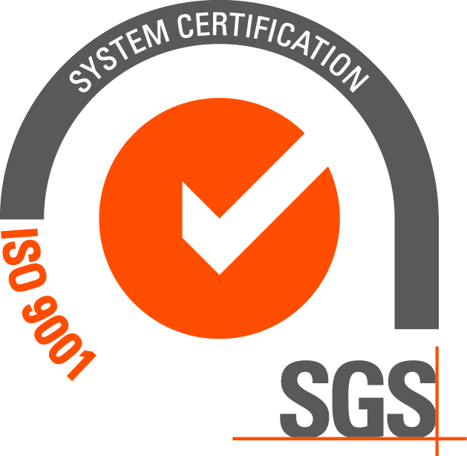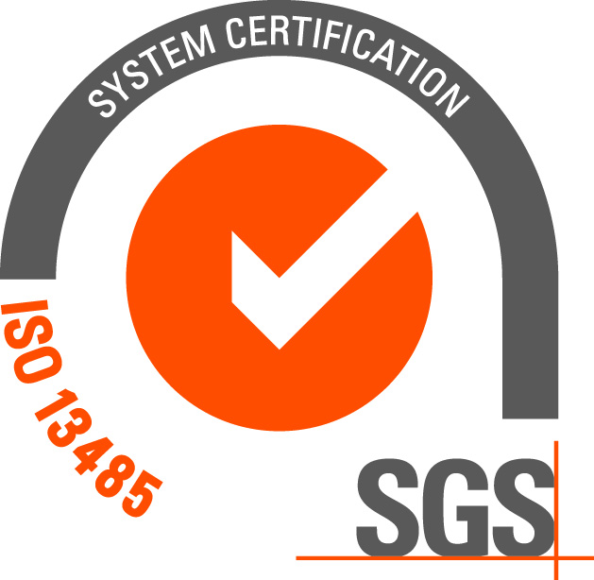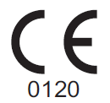
MD Diagnostics Ltd.
15 Hollingworth Court
Turkey Mill
Ashford Road
Maidstone
Kent
ME14 5PP UK
Tel: + 44 (0)1622 682686
Fax: + 44 (0)1622 681693
Email: sales@mdd.org.uk
www.mdd.org.uk

