Operating manual –
OOM Series Medical Oxygen Sensor (except OOM109-X)

Warnings and Precautions:
- It is the responsibility of the user to determine the suitability for use of the sensor.
- Follow the instructions for use of the oxygen analyzer and for replacement of oxygen sensor.
- To avoid cross infection please follow strictly the instructions of the oxygen analyzer manufacturer.
- Refer to the oxygen analyzer operation manual to determine any needed preoperative checks.
- Sensor contains encapsulated by a housing, lead (Pb), lead oxide (PbO) and concentrated potassium hydroxide solution (between 2 and 5 mol/L). Lead and lead oxide are toxic and dangerous for the environment. Concentrated potassium hydroxide is corrosive (see safety data sheet). Do not open the housing or penetrate the permeable membrane. Do not touch a damaged sensor without protective gloves. In the case of leakage avoid contact with eyes.
- The sensor is not suited for use in a magnetic resonance imaging (MRI) environment.

Indications for Use:
The EnviteC Medical Oxygen Sensors are intended as oxygen-sensing component of an oxygen analyzer that measures oxygen concentration in breathing gas mixtures in the following applications:

- Sensing device for oxygen in control device of oxygen concentrators
- Sensing device for oxygen in medical ventilators
- Sensing device for oxygen in anesthesia equipment
- Sensing device for oxygen in incubators

The use is limited to system monitoring. The sensors are not suited for breath by breath analysis of breath gases.

If the sensor is intended to replace the original oxygen-sensing component of an oxygen analyzer, consult the EnviteC Cross Reference List under http://www.EnviteC.com for choosing the appropriate sensor. Do not use sensor/device combinations that are not specified in the cross reference list nor in the operating manual of the device. The use of the sensor is restricted to professional users.
Caution: Federal law (USA) restricts this device to sale by or on the order of a physician.

Instructions:
The sensor should be replaced only by a professional user. Before insertion into the device check the sensor for mechanical damages and for humidity or crystallization of salts on the housing. Do not use a damaged sensor or a sensor with crystallization of salts outside. Follow the instructions for use of the oxygen analyzer for replacement of the sensor. Verify that the sensor can be properly attached to the mechanical and electrical connections of the oxygen analyzer. Calibrate the analyzer according to the instructions in the analyzer’s operation manual and verify proper gas readings. Oxygen analyzer readings in room air will typically be between 19 % and 23 % when calibrated in 100% oxygen or another calibration gas level required in accordance with the analyzer’s instructions. The sensor should be calibrated in regular intervals (see instructions for use of the analyzer). If calibration problems or instable signals occur the sensor must be replaced.

Technical Sensor Specifications:
The sensor meets the requirements of ISO 80601-2-55. For detailed technical specifications, please refer to the sensor’s technical specification sheets (http://www.envitec.com).

Environmental Specification:
Operating temperature: | 0 °C … 50 °C (no fast temperature changes, 30 minutes equilibrium time after fast temperature change)
Operating humidity: | 0 %… 99 % RH non-condensing
Storage temperature: | -20 °C … +50 °C
Recommended storage: | +5 °C … +15 °C
Pressure range: | 600 hPa … 2000 hPa
Warm-up time: | < 30 minutes, after replacement of sensor
Influence from anesthetic agents | meets ISO 80601-2-55 requirements

Principles of Operation:
EnviteC Medical Oxygen Sensors are based on the principle of electro-galvanic sensors. They are constructed in a plastic housing containing two electrodes - a precious metal cathode and a lead anode immersed in a liquid electrolyte medium. Electrically the device resembles a very low voltage battery cell. A gas permeable diffusion membrane provides the interface to the gas sample. The oxygen gas is reduced on the sensing electrode (Cathode) and lead is oxidized on the second electrode (Anode). The resulting current produces on the load resistor an external electrical voltage signal that is proportional to the conversion of the oxygen. The sensor signal is temperature dependent and most sensor types are temperature compensated with an internal temperature-compensating resistor network.

Cleaning / Disinfection:
The sensor membrane and the printed circuit board should not come in contact with disinfectant or cleaning agent. The other parts of the sensor can be disinfected by disinfectant wipes or with a surface disinfection agent. Follow the instructions of the producer of the disinfection material.

Disposal:
Medical Oxygen Sensors contain lead (Pb) and should be disposed of in accordance with local regulations.

Manufacturer:
EnviteC-Wismar GmbH
a Honeywell Company
Alter Holzhafen 18
23966 Wismar, Germany

Symbols on Label:

Symbol | Description
TYPE | Sensor Type
SN | Serial number
 | Observe instructions for use
 | Risk: Lead inside
 | Date of manufacture
 | CE-Symbol with EnviteC Body Number
 | In accordance with Directive 2002/96/EC (WEEE), the manufacturer will accept the return of the electrical and electronic device for proper disposal.  Please note: Medical Oxygen Sensors contain lead (Pb) and should be disposed of in accordance with local regulations.
 | Corrosive
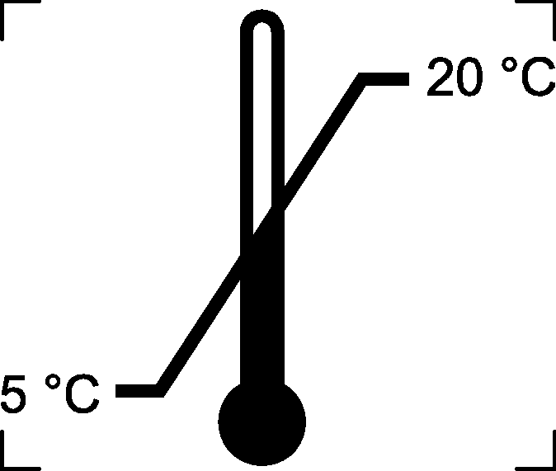 | Storage Conditions



