R22AHJR Sensors returned by Viamed Ltd per RMA #07155: Report, MG 9/03/15

Complaint from Ryan at Viamed to Steve Broy, Sept 3, 2015:

It is with regret that I have to inform you that we still appear to be having the overshoot issues with the R-22AHJR Sensors that have the improved Rhodium Plating.

My colleague Jonathan has returned some of the faulty sensors to Mike Gonzalez under the following returns reference: RMA0007155

Please can you take a look in to this for me and confirm if the Improved Rhodium Plating has actually been applied to these sensors or if this improvement has not actually resolved the problem?

Evaluation Results:

No external damage were seen from any of the R22AHJR sensors.

So three (3) of the R22AHJR Sensors returned were thoroughly evaluated:
SN 547554, SN 547564 and SN 547577 were inspected.

SN 547554: Sensing membrane heat-seal was good. - A few double/defective rows on the cathode were seen.
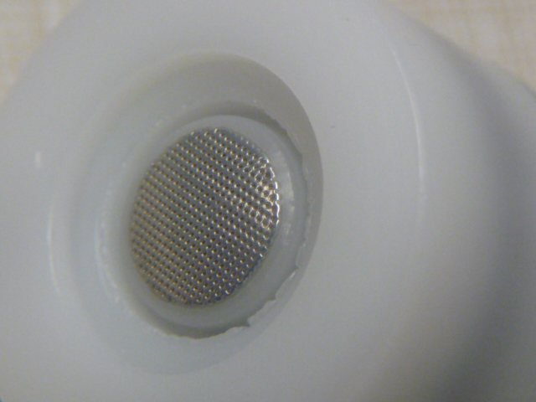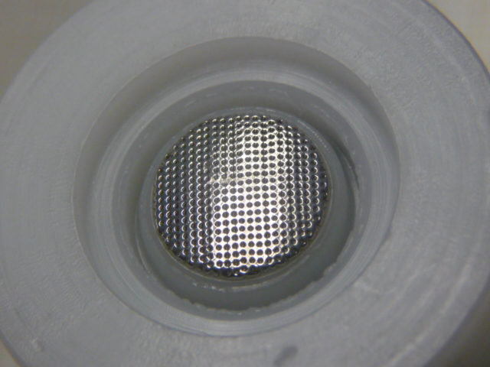

- A few double/defective rows on the cathode were seen. - No air pocket/bubbles or loose particles were seen.
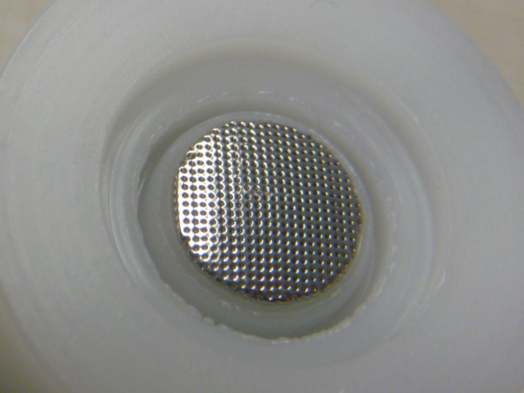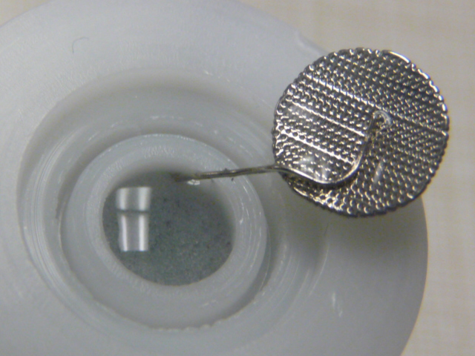
Plenty of electrolyte;
no bubbles seen.

SN 547554: Sensing memb. seal was over heat-sealed. - A few double/defective rows on the cathode were seen.
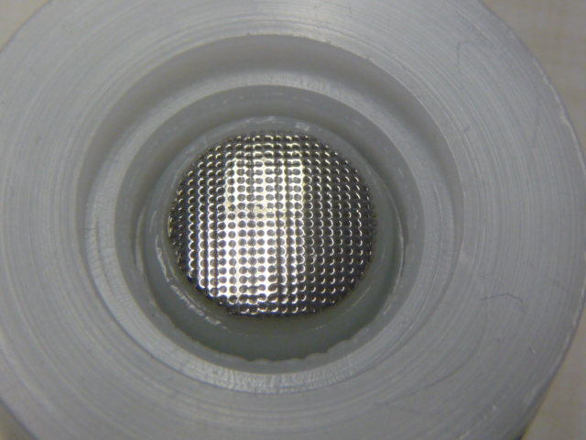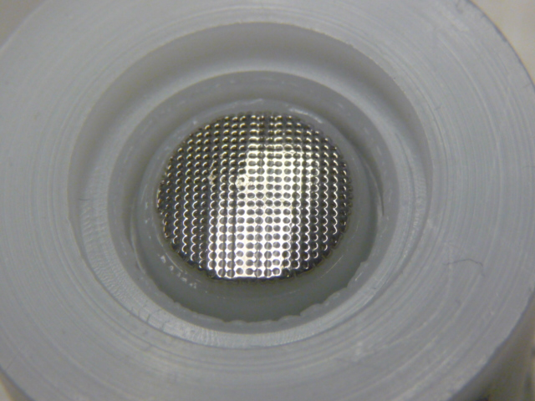

- A few double/defective rows on the cathode were seen. - No air pocket/bubbles or loose particles were seen.
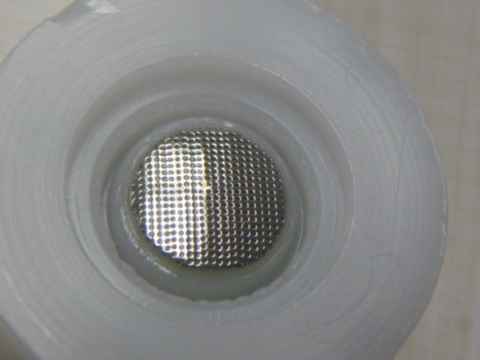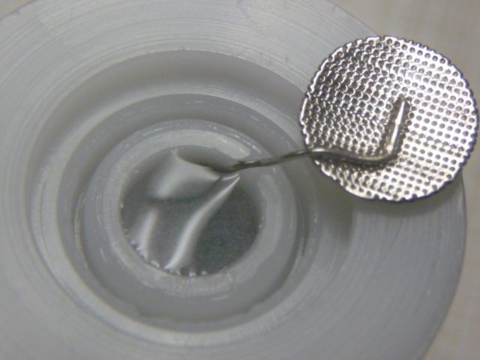

SN 547577 Sensing memb. heat-seal was over sealed. - Sensing membrane seal was over heat-sealed.
- few double/defective rows on the cathode were seen.
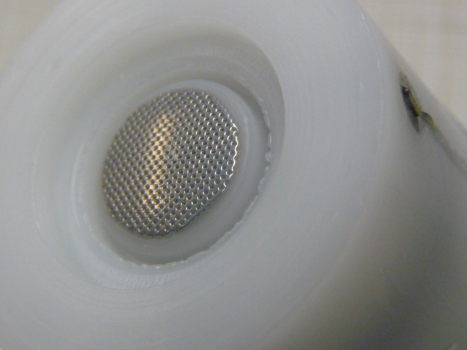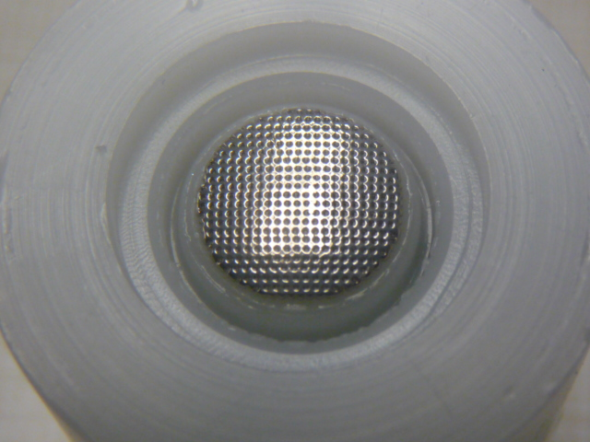

- A few double/defective rows on the cathode were seen. - No air pocket/bubbles; small floating particles present.
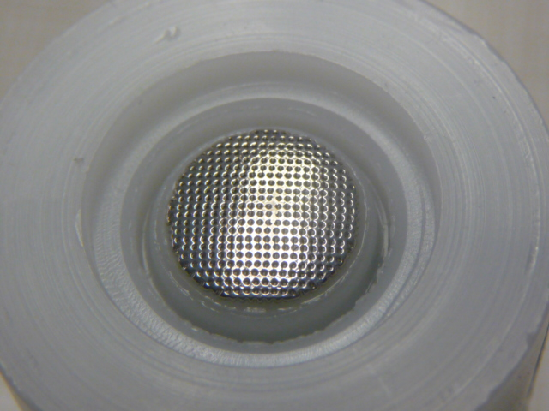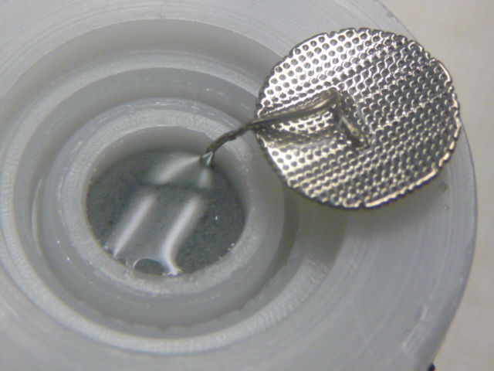

Conclusion:

All 3 sensors evaluated had double/defective rows on the cathode surface. Two (2) of the 3 had slight over heat-sealed sensing membranes. One (1) sensor has also a few floating particles.

