
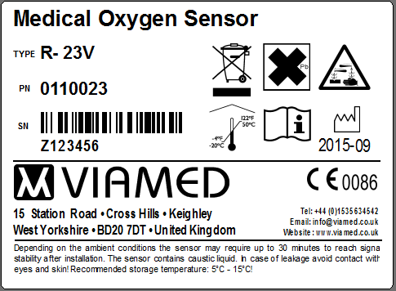
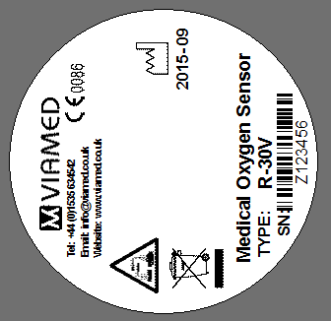
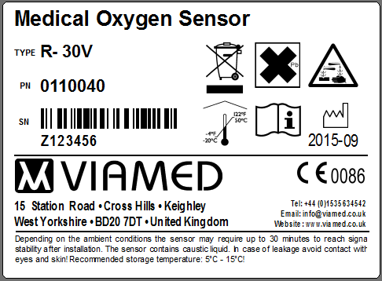
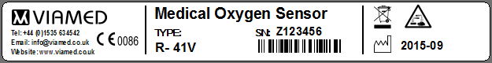
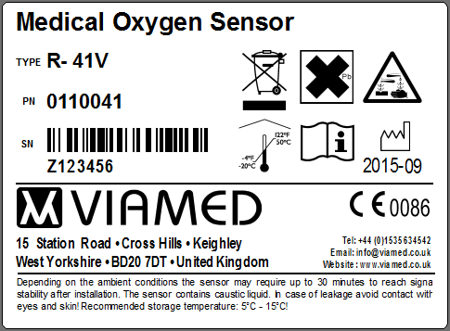
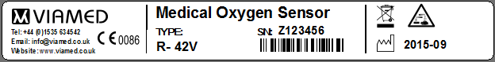
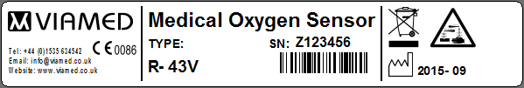
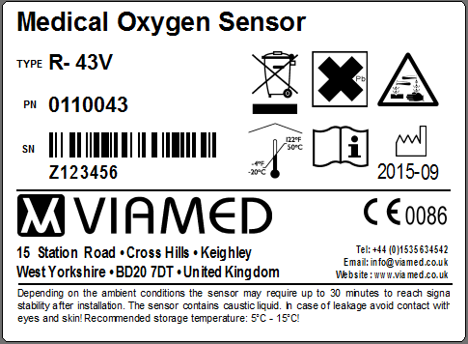
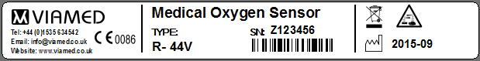
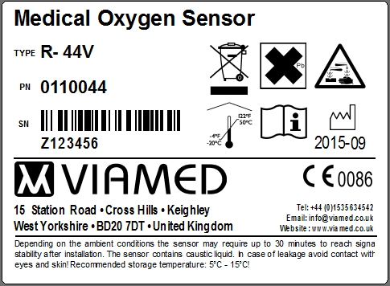
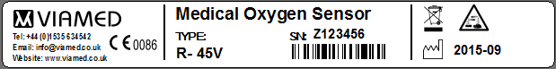
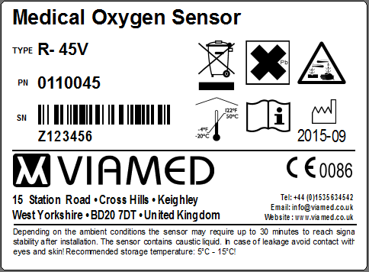

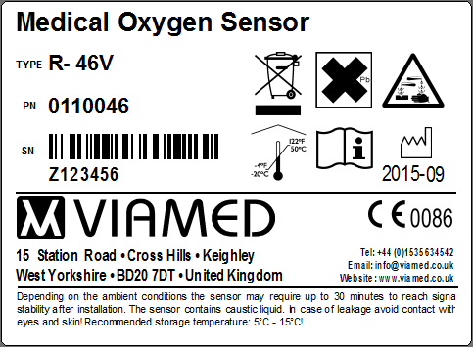
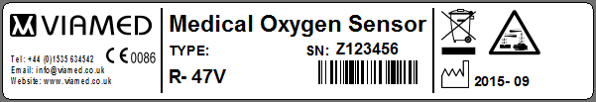
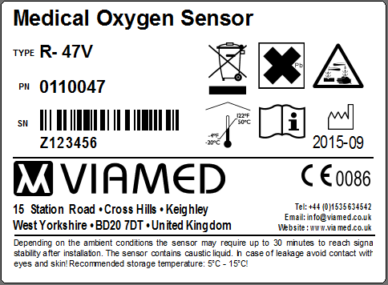
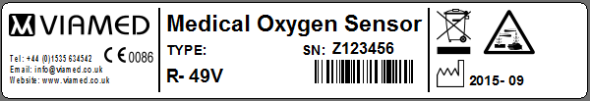
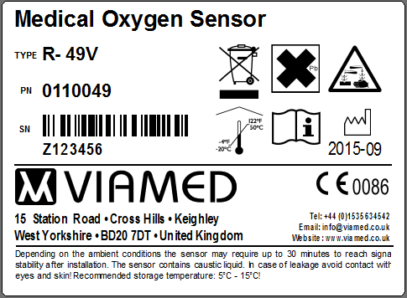

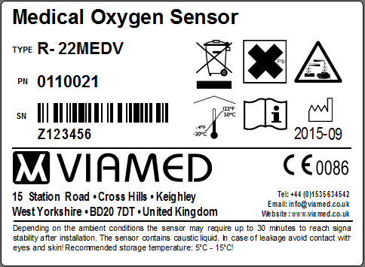

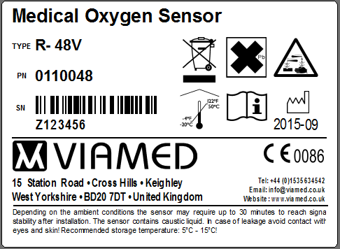


List of Sensors
No. | EnviteC Sensor - Type | Viamed  PN = EnviteC Order Ref. | Envitec  Article number | Final model number
1 | OOM201 | 0110023 | 01-00-0014 | R- 23V
2 | OOM110 | 0110040 | 01-00-0098 | R- 30V
3 | OOM202-1 | 0110041 | 01-00-0021 | R- 41V
4 | OOM202-2S | 0110042 | 1000106 | R- 42V
5 | OOM112 | 0110043 | 1001202 | R- 43V
6 | OOM202-2 | 0110044 | 01-00-0068 | R- 44V
7 | OOM106 | 0110045 | 01-00-0091 | R- 45V
8 | OOM111 | 0110046 | 01-00-0114 | R- 46V
9 | OOM204 | 0110047 | 01-00-0097 | R- 47V
10 | OOM202 | 0110049 | 01-00-0047 | R- 49V
11 | OOM103 | 0110021 | 01-00-0015 | R- 22MEDV
12 | OOM113 | 0110048 | 1002178 | R-48V

Änderungsregister / Change log
Revision | Date | Author | Description
0 | 10.12.2014 | Maik Lingies | New document design data from document “Private Label VIAMED_update_2013-07-16” and add the Sensor type OOM202, OOM204 and OOM113

R- 23V (OOM201)
Label on Sensor (90x15)

R- 30V (OOM110)
Label on Sensor (dia. 39,8)

R- 41V (OOM202-1)
Label on Sensor (90x11)

R- 42V (OOM202-2S)
Label on Sensor (90x11)
Label on plastic container (90x11)

R- 43V (OOM112)
Label on Sensor (90x15)

R- 44V (OOM202-2)
Label on Sensor (90x11)

R- 45V (OOM106)
Label on Sensor (90x11)

R- 46V (OOM111)
Label on Sensor (90x15)

R-47V (OOM204)
Label on Sensor (90x15)

R-49V (OOM202)
Label on Sensor (90x15)

R- 22MEDV (OOM103)
Label on Sensor (90x15)

R- 48V (OOM113)
Label on Sensor (90x15)

Customer Approval

Date:

Signature:

