«DEAR» «CONTACT»
«TITLE»
«DEPARTMENT»
«COMPANY»
«ADDRESS1»
«ADDRESS2»
«ADDRESS3»
«CITY» «STATE»
«ZIP»

April 2015

Dear «UPOSITION»,


Expanding the Posey range from Viamed

Viamed are proud to introduce the new expanded Posey range, which now includes:

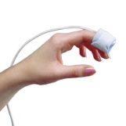 |  | 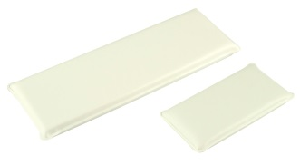 |  | 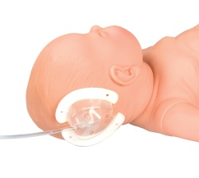
Pulse Oximetry Sensor Wraps | Removable I.D. Bracelets | I.V. Armboards | SecureSleeve & Elbow Splints | I.V. Shield

FREE DELIVERY &
QUANTITY DISCOUNTS AVAILABLE*

*All prices quoted include standard carriage free of charge, making it simpler for you to order.

Please find enclosed a price list on these products, I hope you find this of interest; should you require further information, please do not hesitate to contact a member of our sales team on (01535) 634542 between 09:00 and 17:30.

Yours sincerely

Catrin Hollings
Sales & Marketing Co-ordinator

