Measurement Range: | 0 % ... 100 % oxygen (at atmospheric pressure)
Output in Ambient Air: | 9 mV ... 13 mV
Electrical Interface: | 3 pin (Molex® 22-11-1031)
Repeatability: | < 1 % volume O₂ at constant temperature and pressure
Linearity error: | < 3 % relative
Response time: | < 12 s to 90 % of final value
Zero Offset Voltage: | < 200 μV in 100 % nitrogen, applied for 5 min
Cross Interference: | meets ISO 80601-2-55 requirements
Influence of Humidity: | -0.03 % rel. per % RH at 25 °C
Pressure Range: | 0.6 bar ... 2 bar (ppO₂ 0 ... 1250 mbar O₂)
Influence of Mechanical Shock: | < 1 % relative after a fall from 1 m
Operating Temperature: | 0 °C ... +50 °C
Temperature Compensation: | built-in NTC compensation
Effect of Temperature Compensation (steady state): | between +25 °C and +40 °C: 3 % relative error  between 0 °C and +50 °C: 8 % relative error
Operating Humidity: | 0 % ... 99 % RH non-condensing
Long Term Output Drift: | < 1 % volume oxygen per month
 | typically < -15 % relative over lifetime
Storage Temperature: | -20 °C ... +50 °C
Recommended Storage: | +5 °C … +15 °C
Recommended Load: | ≥ 10 kOhms
Warm-Up Time: | < 30 minutes, after replacement of sensor
Nominal Sensor Lifetime: | ≥ 1 000 000 % volume oxygen hours
Weight: | approximately 28 grams
Warranty Period: | 15 months (including 3-month shelf life)
Part No.: | OOM102-A: 1002504 (REF 0110039 / R-22VA)
All specifications are applicable at standard conditions: 1013 mbar, 25°C dry ambient air.

Mechanical draft:
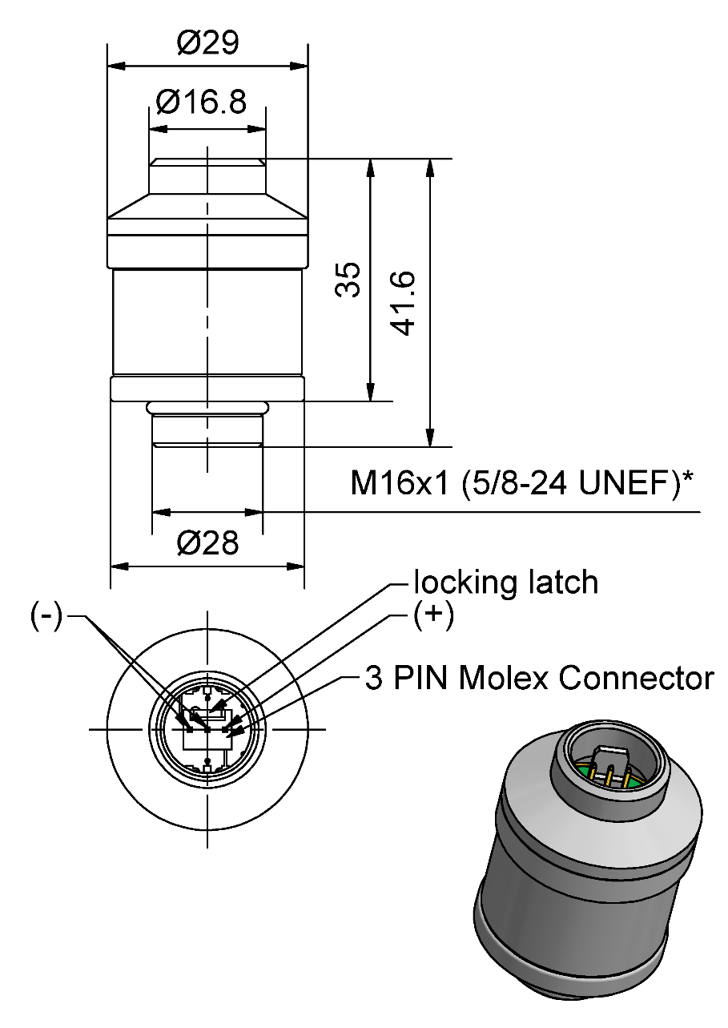

General tolerances ISO 2768-c
*Intermediate thread: Metric / Unified Extra Fine

Customized Design Specification:
- NA

Product Labeling

OOM102-A: 1002504 (REF 0110039 / R-22VA)
Label on Sensor (90x15) | Label on Blister- Card (63,5x46,6)
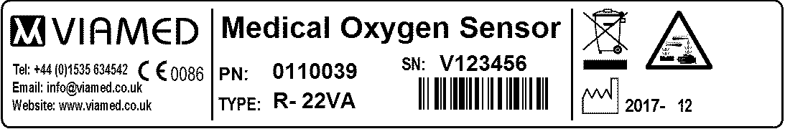 | 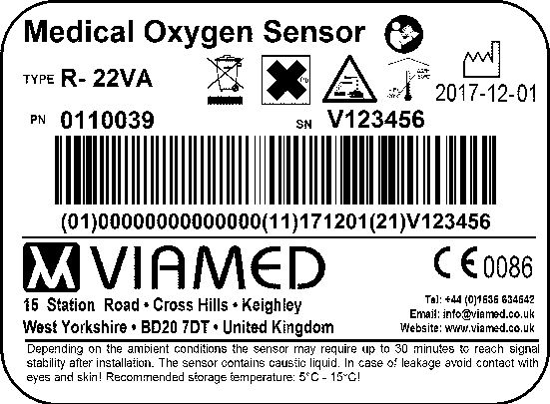

Customer Approval

Date:

Signature:

