Measurement Range: | 0-100 % oxygen
Output in ambient air: | 9 to 13mV
Electrical Interface: | OOD103: 3pin (Molex 22-11-1031)
 | OOD103-1: 3.5mm phone jack (Switchcraft type 41)
 | OOD103-1V: Mini HF (RADIALL R114.426.000)
 | OOD103-2V: Mini HF (RADIALL R114.186.000)
 | OOD103-OG: 3pin (Molex 22-11-1031)
 | OOD103-ISC: 3pin (Molex 22-11-1031)
Repeatability: | < 1 % vol. O₂ @ constant temp. and pressure
Linearity error: | 0.1 to 1.0 bar less than 3 % relative
 | 0.1 to 2.5 bar less than 5 % relative
Response time: | < 5sec. to 90 % of final value
Zero Offset Voltage: | < 0.5% oxygen reading in 100 % nitrogen @ 25°C after 36 seconds
Cross Interference: | < 0.5 % vol. O₂ response to:
 | 5 % CO₂ balance N₂
Influence of Humidity: | - 0.03% rel. per % RH at 25°C
Pressure Range | 600 to 2500 mbar
Influence of Mechanical Shock: | < 1% relative after a fall from 1m
Operating Temperature: | 0 to 50°C
Temperature Compensation: | built-in NTC compensation
Effect of Temperature Compensation: | between 0 °C and +50 °C: 5 % relative error (steady state)
Operating Humidity: | 0-99% RH non-condensing
Long Term Output Drift: | < 1% vol. oxygen per month
 | typically < - 15 % relative over lifetime
Storage Temperature: | -20 to +50 °C
Recommended Storage: | +5 to +15 °C
Recommended Load: | ≥ 10 kOhms
Warm-Up Time: | < 30 minutes, after replacement of sensor
Nominal Sensor Lifetime: | ≥ 500,000 % vol oxygen hours
Weight: | approximately 28 grams
Warranty Period: | 15 months (including 3 months shelf life)
Part No.: | OOD103: 1001570 (REF 8010000 / VST2200)
 | OOD103: 1001570 (REF 8010001 / APD 5)
 | OOD103: 1001570 (REF 8010006 / CR22D)
 | OOD103: 1001570 (REF 8010008 / NaNM01)
 | OOD103: 1001570 (REF 8010014 / K-22D)
 | OOD103: 1001570 (REF 8010016 / H22)
 | OOD103: 1001570 (REF 8010015 / UDT-22)
 | OOD103: 1001570 (REF 8010018 / M3S)
 | OOD103-1: 1001580 (REF 8010003 / VR1700)
 | OOD103-1: 1001580 (REF 8010005 / VST1700)
 | OOD103-1: 1001580 (REF 8010017 / VMS1700)
 | OOD103-1V: 1001581 (REF 8010002 / APD 11)
 | OOD103-1V: 1001581 (REF 8010007 / NaNS01)
 | OOD103-1V: 1001581 (REF 8010022 / APD 16)
 | OOD103-2V: 1001721 (REF 8010004 / JJ-CCR)
 | OOD103-OG: 1001930 (REF 8010010 / RBL-23D)
 | OOD103-ISC: 1002106 (REF 8010012 / SC-I22D)
All specifications are applicable at standard conditions: 1013 mbar, 25°C dry ambient air

All dimensions in mm

Customized Design Specification:

- Integration of additional Zitex membrane in sensor gas diffusion way
- 2mm hole drilled in sensor cap near to the connector at sensor type OOD103-D
- Conformal coating on the sensor PCB with PLASTIK 70
- 2 x 2mm holes drilled in the sensor PCB
- None information about EnviteC on PCB top side / bottom side only information for ordering
process and traceability

PCB Layout:

Type: 8010000 / 8010001 / 8010003 / 8010004 / 8010005 8010002 / 8010007 / 8010022
/ 8010006 / 8010008 / 8010010 / 8010012 / 8010014
/ 8010015 / 8010016 / 8010017 / 8010018

Top Bottom Top Bottom

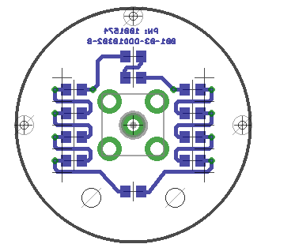
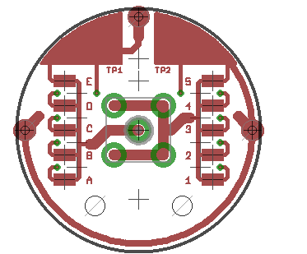
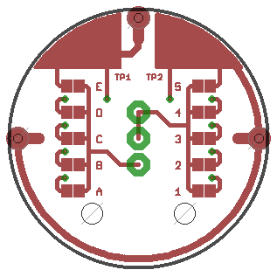
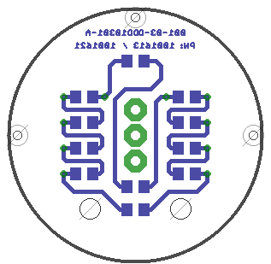

Marking of product

Customized Label Specification is part of separate document.

ENVITEC- WISMAR GMBH

Alter Holzhafen 18
D-23966 Wismar

Phone: +49-(0) 3841- 360 1
Fax: +49-(0) 3841- 360 222
E-Mail: info@envitec.com
http://www.envitec.com

