PRO-NOX vs Pre-mixed– Cost Comparison
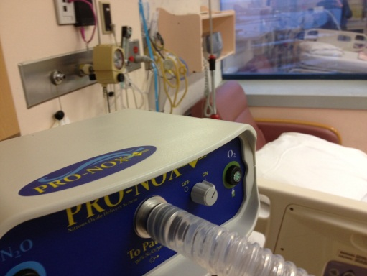
If you currently use pre-mixed nitrous oxide/oxygen tanks
If you can use piped gases, the savings you will see on gas are roughly equivalent to the cost of the premixed tanks.
Yearly spending on premixed tanks ___________

These savings will pay for a PRO-NOX system in ________________________________
Equipping one room for nitrous oxide delivery
Improved infection control
No tanks to lift, agitate or change (fewer back injuries!)
Lower maintenance
No tank-carts at the bedside
No running to find the pre-mixed tank
Premix - 1- regulator w/ patient-held demand valve __________
1- spare demand valve ____________
(to allow cleaning between patients – as per manual)
vs
1 PRO-NOX system ____________
Savings on gas expenses will pay the difference in ___________
Improved infection control
Change 1 N₂O tank instead of 5 premixed tanks
Lower maintenance
Can mount tank onto wall
PRO-NOX using piped O₂ and N₂O cylinders (no piped N₂O)
Using N₂O cylinders will cost ~10-20% of using premixed
Savings on gas (85% of cost of premixed) ____________
This will pay for your PRO-NOX in ________________________
PRO-NOX using O₂ and N₂O cylinders (portable)
Improved infection control
Clear indicators of low tank pressure
Safety alarms and shut-offs
Lower maintenance
Fewer tanks to change

Gas savings will be approx. 75% of premixed. ___________
This will pay for your PRO-NOX in ________________________
PRO-NOX Enhanced Infection Control and built-in safety measures keep your patient safe.
And the active scavenger protects the staff.
You can’t put a price on that!

Conversions
1 cubic meter (m3) of gas = 1000 litres of gas
1 litre of liquid O₂ = 861 litres of gas
1 cubic meter of liquid O₂= 861,000 litres of gas
1 litre of liquid N₂O = 670 litres of gas
1 cubic meter of liquid N₂O = 670,000 litres of gas
1 e-cylinder of O₂ has 625 litres of gas
1 e-cylinder of N₂O has 1590 litres of gas
1 e-cylinder of premixed gas has ~310 litres of O₂ and ~310 litres of N₂O
Calculating the true cost of gas
Cost of premixed = $73.55
1. $1 per cubic metre of O₂ gas = $0.001 per litre
X 310 (litres of O₂ in an E-cylinder of premixed gas) = $0.31 per tank equivalent
$30 per cubic metre of N₂O gas = $0.03 per litre
X 310 (litres of N₂O in an E-cylinder of premixed gas) = $9.30 per tank equivalent
0.31 + 9.30 = $9.61 for the equivalent of 1 tank of premixed
73.55 – 9.61 = savings per ‘tank’ of $63.94

2. $1 per cubic metre of O₂ gas = $0.001 per litre
X 310 (litres of O2 in an E-cylinder of premixed gas) = $0.31 per tank equivalent
$81.95 per e-cylinder of N₂O x 0.2 (1590 litres/310 litres) = $16.39 per tank equivalent
0.31 + 16.39 = $16.70
73.55 – 16.70 = savings per ‘tank’ of $56.85

3. $36.45 per e-cylinder of O₂ x 0.5 = $18.23 per tank equivalent
$81.95 per e-cylinder of N₂O x 0.2 = $16.39 per tank equivalent
18.23 + 16.39 = $34.62 for the equivalent of 1 tank of premixed
73.55 – 34.62 = savings per ‘tank’ of $38.93

These prices are taken from Linde list pricing and are used as an example only. Individual customer pricing and volume discounts will significantly affect results. Use customer-specific prices if possible.

