Dave Edmondson
Royal Preston Hospital
Medical Engineering
Sharoe Green Lane
Fulwood
Preston
PR2 9HT

10th April 2025

Dear Dave,

Re: Blender and Tom Thumb service exchange units ref. SOR974

Please find enclosed a service exchange Tom Thumb TT480 and low-flow air-oxygen blender to allow you to return your devices for service.

Serial Number Description
SE007 Tom Thumb Infant Resuscitator TT480
093A06B Low-flow air-oxygen blender
Please can you send your devices back to us using returns ref SRS69097 to the following address:
Returns Dept – SRS69097
Viamed Ltd.
15 Station Road
Cross Hills
Keighley
BD20 7DT
We will service your units using order ref TP19298 and return them to you as soon as possible.
Regards,
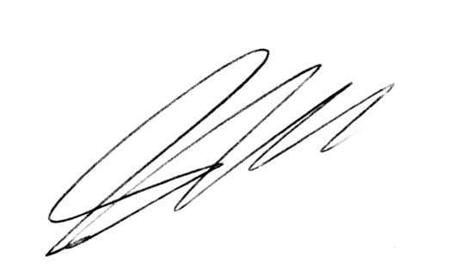
Steve Hardaker
Technical Support Manager
Viamed Ltd.

