Kamal Pacitti
Clinical Engineering Department
North Middlesex University Hospital
Sterling Way
Edmonton
London
N18 1QX

19th December 2024

Dear Kamal

Re: Blender service loan units ref. SOR970

Please find enclosed 2 service exchange low-flow air-oxygen blenders to allow you to return your devices for service.

Serial Number | Description
BX1651896 | Low-flow air-oxygen blender
BX1653066 | Low-flow air-oxygen blender
Please can you send your first 2 devices back to us using returns ref SRS68983 to the following address:
Returns Dept – SRS68983
Viamed Ltd.
15 Station Road
Cross Hills
Keighley
BD20 7DT

We will issue you with a new returns number for each pair of blenders, if you have any queries please let me know.
Regards,
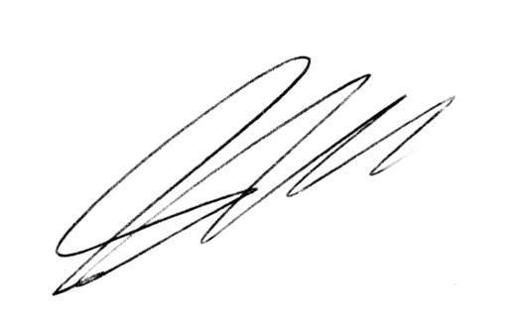
Steve Hardaker
Technical Support Manager
Viamed Ltd.

