VM3COP03.02 Processing A Card Payment
Please note: Card payments are only accepted within the UK or for Arrabon Trading, should customers outside of the UK request to pay by card please check with the Accounts Department.
Login into Square using your provided login.
URL: https://squareup.com/login?lang_code=en-gb
Sending an Invoice from an already signed off Proforma or Invoice
- Click Invoices in the left hand menu.
Should you need to get back to the main menu at any point, please click the 3 lines to the top left of the screen.
- Then click Send an Invoice in the top right corner.
- Using the Viamed proforma/invoice, Add the Customer. Please be aware some are already included. If not already include, click Add Customer and add the relevant information.
- Then copy and paste the details into the invoice.
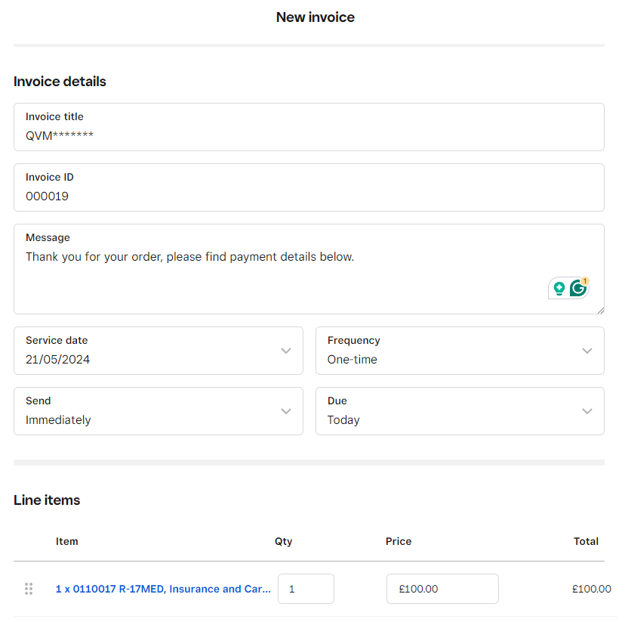
- Please be aware, you do not need to include all lines separately.
A single line including the relevant details will suffice.
For example: 1 x 0110017 R-17MED, Insurance and Carriage
Qty: 1
Price: £***.** - this includes the VAT charged.
- Payment Options: Credit or Debit Card should already be selected.
- Communication: Share via Email should already be selected.
- Attachments: Add a copy of the Proforma/Invoice here.
- When all complete, click Preview to check details against the already signed off Proforma/Invoice from Intrastats.
- Click send to send through the Square system to the customer.

Taking a Payment (Over the Phone)
- Click the 3 lines at the top left of the screen and select ‘Virtual Terminal’.
- Click the ‘Take a Payment’ blue button on the right hand of the screen.
- Using the ‘Quick charge’ option, follow the fields required, adding the following information:
- Amount (including VAT)
- Payment Details – Add a Customer (Search or Add New Customer).
- Add the Card details as provided by the customer into ‘Manually enter card’
- When correct, as per the amount required, click the blue ‘Charge’ button to the top right of the screen.

