VM3COP20.94 Logging Information Requests and Sales Projects
All enquiries are required to be logged within the Intrastats system.
How to create a new Information Request or Sales Project
1. Search for the customer’s account in Intrastats.
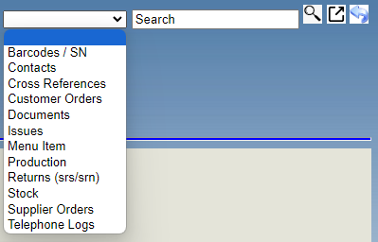

2. Find the relevant contact, if requires adding see VM3COP20.081.
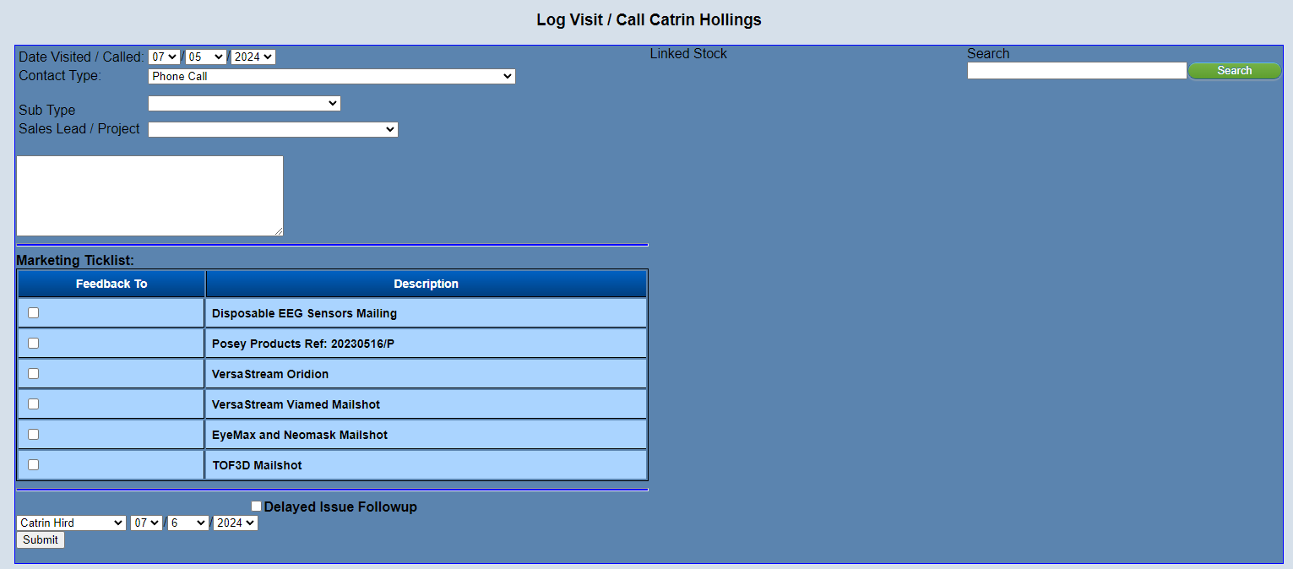

3. Click Log Activity and the following screen will show.
4. Review the information which has been preselected to check it is correct, if not please amend.
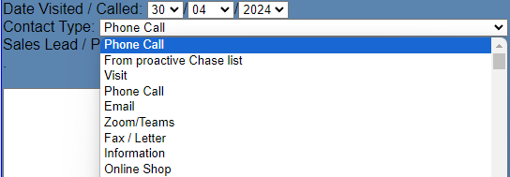
5. Select from the “Sales Lead / Project” drop down.
Information Request
This option should be selected when a new enquiry is received which is for consumable items such as oxygen sensors, eye masks, samplings within the current quantity discount structure.
Sales Projects
This option is for high value orders over £1000 and also for products such as monitors and eqiuipment. This option should also be selected if the order is out of the oridinary for the customer i.e. they used to order single units and now want to purchase 50. All new distributor enquiries should also be under this option.
This option should also be selected when an enquiry has already been logged but it is felt that the questions and quantities required are larger than can be processed/answered by the main office.
Should you be unsure which option to select, please check with a Sales or Technical Manager.
6. Add a Description for the lead in the following format:
Company/Hospital: Product
7. Add a short description including quantities and any time frames which have been discussed.
8. Tick any relevant “Marketing Ticklist”.
9. Tick the “Delayed issue followup” tick box and amend date to 1 week from initial enquiry.
10. Using the Search box to the right, search and link relevant stock by click the associated tick box.
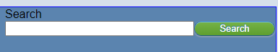

11. Click “Submit” button

Review Information Request or Sales Project
There are 2 options to review the above.
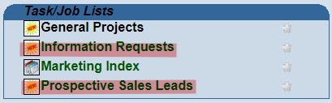
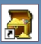
Option 1. →This option will show you a full list of Information Requests and Sales Leads for all users.Option 2. Search for the company/hospital using the top right search box and scroll down to below the list of contact names. This will show you a full list of Active Sales/Project linked to that Company/Hospital.Click the Details **** under Lead ID and this will open the task.Option 1. →This option will show you a full list of Information Requests and Sales Leads for all users.Option 2. Search for the company/hospital using the top right search box and scroll down to below the list of contact names. This will show you a full list of Active Sales/Project linked to that Company/Hospital.Click the Details **** under Lead ID and this will open the task.
Updating the Information Requests
A structured list of tasks required to be completed will automatically added to the task.
- Information Sent
Insert date to brief notes and tick when completed.

- Confirmed Information Received
A delayed issue should have been added when the original enquiry was logged, one week after the original enquiry was responded to. When this issue is received you can add this issue number to the Issue against this line and complete the line when done.
- Confirmed Information Received Attempt 2
Should a reply not be received, please email the customer three weeks after the original enquiry was responded to.
- Confirmed Information Received Attempt 3
Should a reply not be received, please email the customer five weeks after the original enquiry was responded to.
- Confirmed Information Received Attempt 4
Should a reply not be received, please email the customer two months after the original enquiry was responded to.
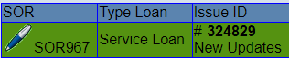
- Customer Requested Sale or Return
Should a Sale or Return be requested by the customer, please add the main Issue ID, when available.
- Pass to Manager to Convert to Sales Projects:
Ryan Swaine for International Sales and Steve Hardaker for UK
If you feel that the enquiry is becoming too complicated and/or is above
£$€ 1000 value then a request to pass to a manager can be completed. To do this click the new issue icon against this line, this will refresh the page and create a related issue.
Click this issue number, this will open the issue for you to complete and send to the relevant manager.
- Customer Purchased
- Customer Declined
- Customer Purchased Follow-up
Once a customer has ordered the product, please chase two weeks after the dispatch date to check all received.
- Complete Job to be Signed off
Once all tasks have been completed, please complete the job.
Updating the Sales Projects / Leads
A structured list of tasks required to be completed will automatically added to the task.
- Sent product information and pricing
- Send pricing schedule or quotation
- PAQ
If this is required, please contact Marketing or Technical Support for assistance.
- SOR Terms and Conditions Sent
See VM3COP20.13 regarding the SOR procedure.
- SOR Signed Terms Received
- SOR Sent to Customers
- SOR Decision Made/Closed
- SOR Feedback
- Follow up Progress
- Purchase Order Received
- Verify Goods Received

