SOR System Improvements Required

The Date on the MIA Call-Off Agreement needs to reflect the date on the SOR input page, as we often set up the SOR in advance. At the moment, if I go back to the input page and change the date, the PDF when re-exported keeps the original date.

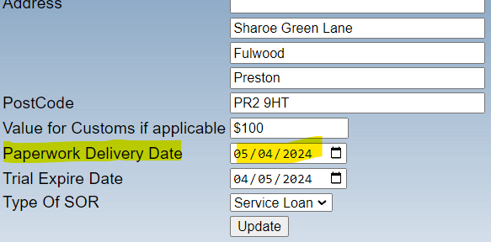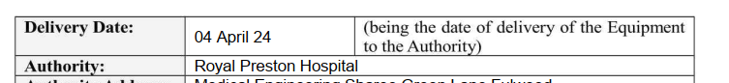

The MIA agreement number has changed since moving from Dept of Health to NHS Supply Chain. New number is NHSE MIA/0640/24 for the England* MIA Form / Delivery Note and needs to appear on the MIA form, see below.

The ‘Purpose of loan or transfer’ box needs to contain the statement that was inputted in the trial/testing box on the SOR input page, it currently appears blank.

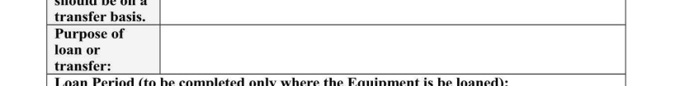

The Loan Period box on the MIA Call-Off Agreement needs to reflect the date on the SOR input page.
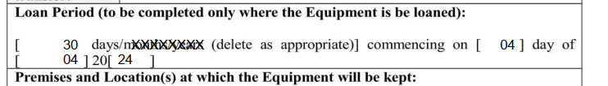

The Premises and Location box on the MIA Call-Off Agreement needs to detail the contents of the Company and Dept on the SOR input page.

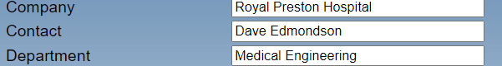

The signed box is meant to contain a signature, I drop mine in by editing, but as a minimum can you make it contain the name of the person sending it, not just ‘Viamed’ with no name.

Name and position box should also contain job title, can be a free type box on the input screen if you don’t have Staff job titles pre-stored in Intrastats:

The Signed Date on the MIA Call-Off Agreement needs to reflect the date on the SOR input page:

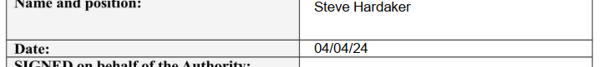

Note: please check using a test record whether changing the date on the input screen changes the date on the exported MIA Agreement PDF for all date corrections.

*Taken from the NHS Supply Chain website:
Is the MIA register just for England or does it also cover Scotland / Wales?
England only – organisations based in Scotland or Wales are not currently covered by this documentation.
So we only have to update the England version of the form at this stage.

