MEDICAL DEVICE - LESSON PLAN © |  |  |  |  | [NHS Trust logo removed]
Device Description  (GMDN Code / Category) |  |  | MaxBlend2 Oxygen Monitor & Flowmeter |  | [NHS Trust logo removed]
Device Type | Make | Maxtec |  |  | [NHS Trust logo removed]
Device Type | Model | MaxBlend 2 |  |  | [NHS Trust logo removed]
Aims: To ensure the user can safely and competently operate the device to deliver mixed blend oxygen/air gas and continuously monitor oxygen concentration being delivered.

Objectives:  The user will:  - ensure the MaxBlend 2 is appropriate for the intended use  - be able to operate MaxBlend 2 safely and competently  - be able to use appropriate accessories  - be able to respond to alerts and alarms  - have knowledge of moving and handling ergonomics when moving or repositioning the MaxBlend 2  - be able to clean and store the MaxBlend 2 safely |  |  |  | 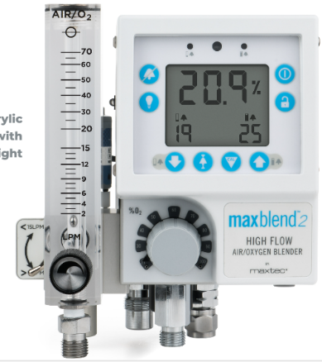
References:

Documents upon which this Lesson Plan is based -
- MaxBlend 2 Instructions for Use R229M01_J-MaxBlend-2.pdf (maxtec.com)
- MaxBlend 2 product leaflet ML-0263_H-maxblend-product-document.pdf (maxtec.com)

Time | Topic | Teaching Method | Student Activity | Resources
00:00 | Registration  - House Keeping:  - Fire Alarms  - Facilities | Discuss | Q&A | Registration Form
00:02 | How to be sure that this is the most appropriate device for the intended use:  - The MaxBlend 2 is designed to provide a continuous air/oxygen gas mixture and to continuously monitor the concentration of oxygen being delivered to the infant/paediatric patient. It is the low flow model designed for flows 0-30LPM. | Discussion | Q&A | MaxBlend 2
00:04 | How to check for damage / wear / faults and service date  - Check for obvious signs of physical damage to the MaxBlend 2  - Check the service sticker to ensure the MaxBlend 2 is within its service period | Demonstration/Explanation | Q&A | MaxBlend 2
00:06 | Are there any limitations or contra-indications for the use of the device  - This device should only be used by staff who have been trained and assessed as competent as per the [NHS Trust] Medical Devices Training Policy  - This device is not MR safe  - It is not intended as a life supporting device  - Always confirm the prescribed flow before administering to patient and monitor flow when recording patient observations.  - Ensure visual and functional checks are performed before use  - Ensure all accessories are available | Discussion/Explanation | Q&A | MaxBlend 2
00:10 | How to be sure all the relevant accessories are available  - Ensure MAX 550E oxygen sensor is installed and present at all times
00:12 | Have Knowledge of moving and handling ergonomics when moving or repositioning the device  - The total weight of this device is 2.4kg  - If in doubt regarding the moving and handling of this device contact your local moving and handling link person or the Authorised Trainer/Assessor for this device | Discussion | Q&A | MaxBlend 2  [NHS Trust] Manual Handling Policy 2020
00:13 | Device setup  - Connect pressurised air source to air inlet connector  - Connect pressurised oxygen source to oxygen inlet fitting  - Flush gas at highest possible flow rate through blender for at least 1 minute to eliminate any particulate  - Check sensor is installed into sensor port  Calibrate the device  100% oxygen calibration  - Attach just the oxygen hose  - Turn on  - Turn FiO2 knob to 100% & allow a few minutes to stabilise  - Unlock the keypad & press CAL key  - CAL will display for approximately 5 seconds, then finish with 100.00%  - The unit is now calibrated & in normal operating mode  Calibrate to room air  - Connect just the air supply line  - Turn on  - Turn FiO2 knob to 21% & allow a few minutes to stabilise  - Unlock the keypad & press CAL key  - CAL will display for approximately 5 seconds, then finish with 20.9%  - The unit is now calibrated & in normal operating mode  - Set high and low alarm limits appropriately (smart alarm mode will set alarm +/-%3% to current oxygen reading for high/low setting)  For total combined flows of <3LPM the bleed toggle switch must be turned on (up position)
00:20 | How to identify and understand all the functions of the device  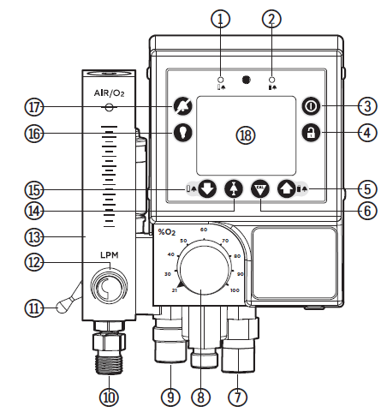  - Low alarm LED flashes twice a second with audio buzzer if low alarm condition  - High alarm LED flashes twice a second with audio buzzer if high alarm condition  - On/Off key to prevent accidental power-off must be held down while 3-2-1 countdown takes place  - Unlock Key locks & unlocks  - Up (alarm high) key this sets the high alarm limit must be in unlocked state to set  - Calibration key this is calibrate the device must be in unlocked state to set  - O2 inlet fitting to allow connection to the O2 inlet hose from gas source  - Oxygen concentration selector allows for mixed oxygen concentrations from 21-100%  - Medical gas inlet connector to allow connection to the air inlet hose from air gas source  - Flowmeter outlet to connect patient delivery tubing  - Bleed toggle switch  - Flow control knob controls the flow of gas exiting flowmeter  - Oxygen flowmeter measures flow of mixed gas exiting flowmeter outlet  - Smart alarm key used to help set high-low alarm window quickly  - Down (low alarm) key this sets the low alarm limit must be in unlocked state to set  - Backlight key manually activates backlight for 30 seconds  - Silent key deactivates audio alarm for 2 minutes  - LCD display provides direct readout of oxygen concentrations, displays error codes, alarm set modes & calibration codes
00:25 | What factors may affect the safe operation or accuracy of the device  Display indicators  - Oxygen concentration current oxygen concentration percentage from oxygen sensor  - High alarm indicator high alarm setting is displayed at all times below the ‘HIGH’ icon  - Oxygen high alarm limit audible & visual alarms will trigger when this limit is exceeded  - Calibration provides reminder weekly reminders for calibration  - Sleep mode indicator used to help with battery consumption  - Low battery indicator located in the middle of the display & is only activated when battery voltage is below normal operating level  - Alarm silence/smart alarm indicator  - Oxygen low alarm limit audible & visual alarms will trigger when this limit is exceeded  - Low alarm indicator low alarm setting is displayed at all times below the ‘LOW’ icon  - <18% alarm indicator located above the low alarm indicator, when low alarm setting is <18% indicator will flash each second to alert the operator
00:30 | What actions to take if there is an error or failure of the device  - Remove device from use  - Quarantine the device along with any associated accessories/consumables  - Complete a Clinical Engineering Decontamination form detailing any error codes or messages  - If the device is involved in an incident ensure the DATIX number is recorded on the decontamination form  - Ideally return the device to Clinical Engineering as it was set up and used. If this is not possible take an image of the set up and ensure this is uploaded to the DATIX incident form | Discuss | Q&A | Device  Clinical Engineering Decontamination Form
00:35 | How to clean / decontaminate the device  - Clean the device following the [NHS Trust] policy and or manufacturers guidelines/instructions using Green Clinell Wipes  - Ensure battery drawer is closed and sensor/diverter are inserted into their port  - Ensure all obvious signs of dirt and contamination are removed  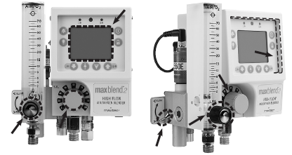  Be sure to thoroughly clean & disinfect areas highlighted above | Discussion/Explanation | Q&A | Device  [NHS Trust] Cleaning Manual 2020 (General Guidance)
00:40 | How to store the device safely  - Ensure the device is stored in a clean and dry environment | Discussion/Explanation | Q&A | Device
00:40 | Any Questions? | Q&A | Q&A | Device
00:40 | Competence Assessment | Observation/Q&A | Demonstration/Q&A | Device  [NHS Trust] Competency standard
00:50 | Evaluation & Close | Observation/Q&A | Evaluate Session | Evaluation Document

