Dave Edmondson
Royal Preston Hospital
Medical Engineering
Sharoe Green Lane
Fulwood
Preston
PR2 9HT

5th April 2024

Dear Dave,

Re: Blender and Tom Thumb service exchange units ref. SOR967

Please find enclosed 2 service exchange Tom Thumb TT480 service exchange units and 2 low-flow air-oxygen blenders to allow you to return your devices for service.

Serial Number | Description
SE007 | Tom Thumb Infant Resuscitator TT480
SE008 | Tom Thumb Infant Resuscitator TT480
BX1651896 | Low-flow air-oxygen blender
BX1653066 | Low-flow air-oxygen blender
Please can you send your devices back to us using returns ref SRS68750 to the following address:
Returns Dept – SRS68750
Viamed Ltd.
15 Station Road
Cross Hills
Keighley
BD20 7DT
We will service your units using order ref 226947589 and return them to you as soon as possible.
Regards,
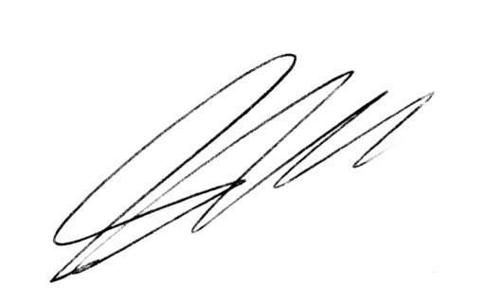
Steve Hardaker
Technical Support Manager
Viamed Ltd.

