Viamed Ltd Carbon reduction statement, Aiming for net zero

Carbon Footprinting

The Greenhouse Gas Protocol classifies emissions sources into three Scopes, with Scope 1 and 2 emissions being related to our own operations and Scope 3 emissions relating to the wider value chain (Our company’s value chain includes all the activities that it takes to create a product from start to finish, including all upstream and downstream activities to the end customer.)
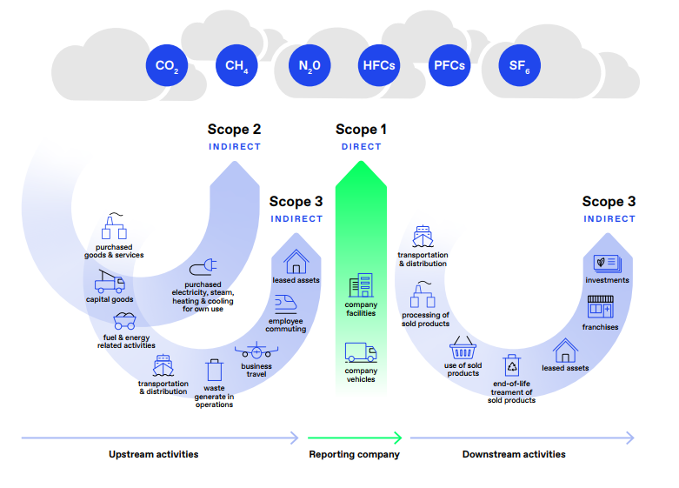

Scope 1 and Scope 2 Emissions Statement

Viamed Ltd recognizes the importance of addressing its carbon footprint, particularly in terms of Scope 2 emissions, which are indirect emissions associated with procured energy. While our Scope 1 emissions are either zero or very low, we are committed to monitoring and reviewing this regularly to ensure accuracy.

Scope 1 Emissions:

Facility Operations: As Viamed Ltd does not own company cars or produce its own energy, Scope 1 emissions are either zero or very low.

Use of Bottled Gases for Testing: Viamed Ltd utilises bottled gases for the testing of oxygen sensors and medical equipment, which constitutes a direct emission associated with our operations.

Mitigation Strategy for Scope 1 Emissions:

Regular Monitoring: We commit to regularly monitoring and reviewing our Scope 1 emissions status, including emissions from the use of bottled gases for testing. Any changes in our operations that may affect Scope 1 emissions will be promptly identified and addressed.

Optimization of Gas Usage: We will implement measures to optimise the usage of bottled gases for testing, such as minimizing leaks, improving gas storage practices, and ensuring efficient utilisation during testing procedures.

Monitoring and Reporting:

Progress Tracking: We will establish robust systems for monitoring and tracking Scope 1 emissions, including emissions from the use of bottled gases for testing. Regular assessments will be conducted to track progress and identify opportunities for further emission reduction.

Transparency and Accountability: We are committed to transparently reporting our emissions data, mitigation efforts, and progress towards our sustainability goals. Stakeholders will be provided with regular updates through recognized reporting standards and frameworks.

Conclusion:

Viamed Ltd remains steadfast in its commitment to reducing its carbon footprint, including Scope 1 emissions associated with the use of bottled gases for testing. By implementing optimisation measures and exploring alternative testing methods, we aim to minimize our environmental impact and contribute to a sustainable future.

Scope 2 Emissions:

Procured Energy: We acknowledge that Scope 2 emissions, associated with procured energy (such as electricity and heat), constitute a significant portion of our carbon footprint.

Mitigation Strategies for Scope 2 Emissions:

Transition to Renewable Energy: Currently, we sources 80% of our energy from renewable sources. We have set a target to transition to 100% renewable energy by 2030. Regular monitoring and review processes will be in place to track our progress towards achieving this target.

Energy Efficiency Measures: In addition to transitioning to renewable energy, we will implement energy efficiency measures to further reduce Scope 2 emissions. This includes optimizing energy use, investing in energy-efficient technologies, and promoting conservation practices.

Carbon Offset Initiatives:

Viamed Ltd is committed to offsetting its carbon emissions by partnering with the Woodland Trust. Through our annual donation, the Woodland Trust will undertake woodland care and planting initiatives to capture and store carbon on our behalf. This support will contribute to the creation of sustainable native woodland, which not only benefits wildlife and people but also helps us achieve our net-zero carbon target.

Monitoring and Reporting:

Progress Tracking: Viamed Ltd will establish robust systems for monitoring and tracking both Scope 1 and Scope 2 emissions, as well as our progress towards achieving our renewable energy targets and carbon offset initiatives.

Transparency and Accountability: We are committed to transparently reporting our emissions data, mitigation efforts, and progress towards our sustainability goals. Stakeholders will be provided with regular updates through recognised reporting standards and frameworks.

Conclusion:

Viamed Ltd remains steadfast in its commitment to reducing its carbon footprint and transitioning towards a sustainable future. By focusing on renewable energy adoption, energy efficiency measures, and carbon offset initiatives, we aim to minimize our environmental impact and contribute to global efforts to combat climate change.

Scope 3 Emissions Statement

Viamed Ltd is dedicated to addressing Scope 3 emissions, which represent indirect emissions associated with activities outside of our direct operational control but are integral to our business processes. Recognizing the significance of these emissions in our overall carbon footprint, we are committed to implementing robust strategies to mitigate their environmental impact and foster sustainable practices throughout our supply chain. We have broken Scope 3 down into individual categories to better assess and understand them and to target areas for improvement.

Category 1 – Purchased Goods and Services:
We procure most of our products externally, with only a few manufactured in-house. Additionally, we engage in the procurement of other services including calibration services for our test equipment, acknowledging the emissions associated with the sourcing and transportation of these essential services.

Category 2 – Capital Goods:
We purchase capital goods when required. These include test equipment, new computers and equipment for the general running of the business. We also procure other items such as chairs and office equipment.
We recognize the emissions generated throughout the lifecycle of these assets, from production to disposal.

Category 3 – Fuel and Energy-Related Activities:
We rely entirely on purchased energy from suppliers to meet our operational needs. Currently, 80% of our energy is sourced from renewable sources, with a target to transition to 100% renewable energy by 2030. We acknowledge the importance of reducing emissions associated with energy consumption and are committed to sustainable energy procurement practices.

Category 4 – Upstream Transportation and Distribution:
Our logistical operations rely on trusted partners such as UPS and occasional FedEx, both of which adhere to net-zero policies. We recognize the emissions generated during the transportation and distribution of goods upstream in our supply chain and actively collaborate with our logistics partners to optimize efficiency and minimize environmental impact.

Category 5 – Waste Generated in Operations:
We meticulously manage various waste streams generated in our operations. We have a small amount of general waste. We recycle all of our paper, card, soft plastics, electronics, batteries, and chemicals and oxygen sensors. Our commitment to environmental stewardship is evident through our prioritization of waste reduction, recycling, and responsible disposal practices. We ensure that all recyclable materials are diligently sorted and processed for recycling, minimizing environmental impact and maximizing resource recovery.
We assess out recycling partners to ensure they commit to good environmental practices and we ensure we receives waste transfer notices from all of them annually.

Category 6 – Business Travel:
Efforts to minimize business travel include the use of digital communication platforms such as phone, email, and Zoom and Teams meetings. We consolidate trips to reduce the need for travel and prioritize sustainable transportation options when travel is necessary.

Category 7 – Employee Commuting:
To minimize the environmental impact of employee commuting, we prioritize local hiring and have initiated hybrid working so staff that can work remotely more than half the week. Meetings are conducted virtually whenever possible to reduce the need for commuting.

Category 8 – Upstream Leased Assets:
We lease essential assets such as phone systems and a franking machine, recognizing the emissions associated with their production, operation, and eventual disposal.

Category 9 – Downstream Transportation and Distribution:
Our downstream transportation and distribution operations are facilitated by partners such as UPS and Royal Mail, all of which have established Net Zero carbon reduction plans. We collaborate closely with our distribution partners to optimize efficiency and reduce emissions in our supply chain.

Category 10 – Processing of Sold Products:
We acknowledge the emissions associated with the processing of sold products, including manufacturing, assembly, packaging, and refurbishment activities. We strive to minimize emissions throughout the product lifecycle by promoting sustainable manufacturing practices and responsible waste management.

Category 11 – Use of Sold Products:
Our product offerings include medical equipment and oxygen sensors, both medical and non-medical. We recognize the emissions associated with the use phase of these products and prioritize product design and functionality to minimize environmental impact during use.

Category 12 – End-of-Life Treatment of Sold Products:
To promote responsible product stewardship, Viamed Ltd accepts back equipment and oxygen sensors for recycling at the end of their lifecycle. We provide customers with convenient recycling options to ensure proper disposal and minimize environmental impact.

Monitoring and Reporting:
Viamed Ltd is committed to establishing comprehensive monitoring and reporting mechanisms to track Scope 3 emissions across all categories. Regular assessments will inform our emission reduction strategies, and transparent reporting will ensure accountability and foster stakeholder trust.

Conclusion:
By addressing Scope 3 emissions comprehensively and implementing targeted mitigation measures, Viamed Ltd demonstrates its commitment to environmental stewardship and sustainability. Through collaboration with stakeholders and continuous improvement initiatives, we strive to minimize our carbon footprint and contribute to a more sustainable future for generations to come.

Our commitment is rooted in a comprehensive life cycle analysis aimed at minimizing the carbon impact of this framework. We acknowledge the urgency of addressing climate change and are dedicated to achieving net-zero greenhouse gas emissions by 2050.

We will foster collaboration within our supply chain, emphasizing transparency and shared responsibility. Engaging suppliers in our sustainability goals, we will encourage the adoption of eco-friendly practices, from sourcing materials to manufacturing. Regular communication channels and collaborative internal workshops will be established to ensure a unified effort toward net-zero emissions.

To deliver additional environmental benefits, we will focus on the following key areas throughout the contract lifecycle:
- Design Phase
- Manufacturing
- Packaging
- Transport and Delivery
- In-Use Phase
- End of Life and Disposal

