Setting up new mailboxes.

- Log into Fast Hosts (https://login.admin.fasthosts.co.uk)
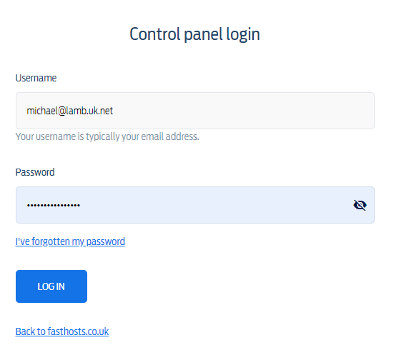
- go to Domain Names, Find the domain, Example Viamed.co.uk
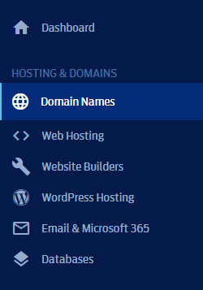

- go to Email category
- Remove Forwarder for existing email (existing emails only)
- Add Mailbox
  - Email address: Firstname.lastname@domain
  - Name: First Name Last Name
  - Password: (See Spreadsheet)
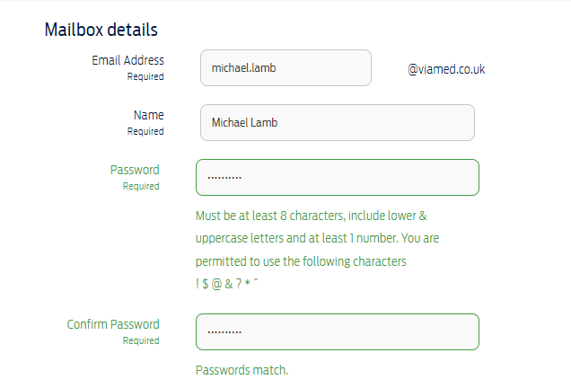
- Inside Email category select the new email
- Set up Mail Fowarding
  - Go to Email Forwarding
  - add viamed.Firstname.Lastname@gmail.com
  - add viamedinbox@gmail.com
  - Send test email to new mailbox(XXX@domainHere.com) check main inbox & gmail
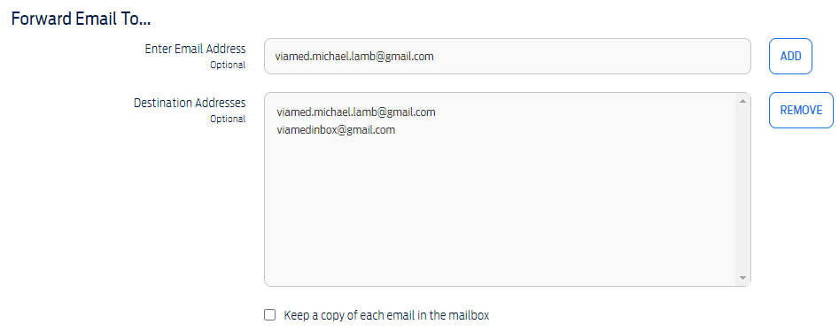
- Set up SMTP
  - Inside Gmail go to inbox settings, Accounts and import
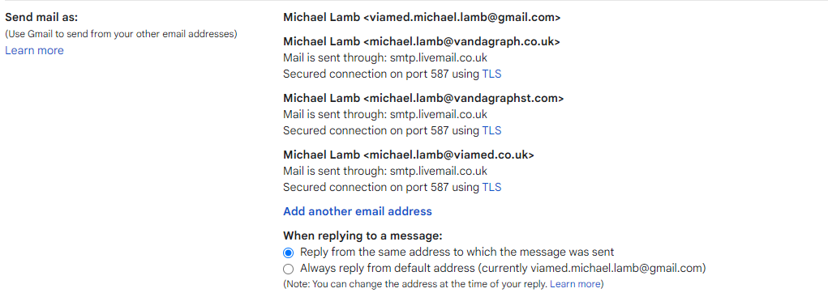
  - Send mail as: Add another email address
  - Details
    - Name : FirstName LastName Companyname
    - Email: MAILBOX EMAIL (XXX@domainHere.com)
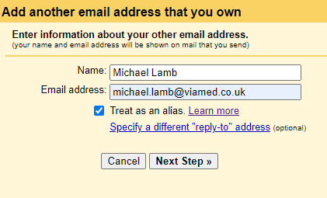
  - SMTP Server
    - SMTP Server: smtp.livemail.co.uk
    - Username: Mailbox Email (XXX@domainHere.com)
    - Password: Mailbox Password (See Spreadsheet)C
    - confirm SMTP via Link in Email.
    - Send test email to confirm.
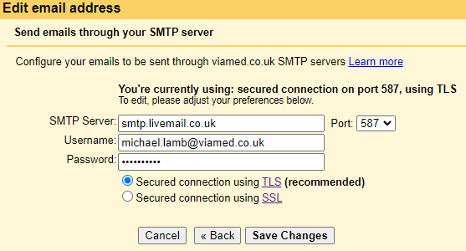
- Reply settings
  - Reply from the same address to which the message was sent
- AUTO BCC MAINBOX CloudHQ
  - Set up an account for each email. Viamed Vandagraph VST
  - Set up 1 rule on each. BCC Viamedinbox@gmail.com
  - Save, and Test
- f

