
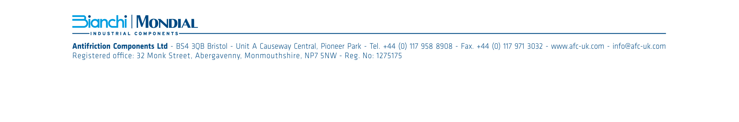
ANTIFRICTION COMPONENTS BANK DETAILS;

Bolton branch;
ANTIFRICTION COMPONENTS LTD
UNIT 16 WATERSMEETING
BRITANNIA WAY
THE VALLEY
BOLTON
BL2 2HH

TEL; 01204 532211
EMAIL; boltonsales@antifriction.co.uk

HEAD OFFICE;
ANTIFRICTION COMPONENTS LTD
UNIT A CAUSEWAY CENTRAL
PIONEER PARK
BRISTOL
BS4 3QB

ACCOUNTS;
TEL; 01179 588908
EMAIL; julie.dolling@antifriction.co.uk
BANK DETAILS;
ANTIFRICTION COMPONENTS LTD
BANK NATWEST
SORT CODE 52 10 14
ACCOUNT NO 90647831
ADDRESS CORN STREET BRISTOL
IBAN GB 94NWBK52101490647831
COMPANY REG 1275175
VAT NO GB 140 4857 77

