VM3COP40.13 R-33DE Oxygen Sensor Production Procedure
Parts list
Qty | Description | Part No.
1 | Oxygen sensor – R-33S1 | 0110132
1 | 2 pin JST connector | 9071014
1 | Anti-static gas barrier bag | 0150000

Tool list
Soldering iron
Wire cutters
Stanley knife
Super glue
Small pliers

Production:
- Remove the R-33S1 Oxygen sensor from the gas barrier bag. | 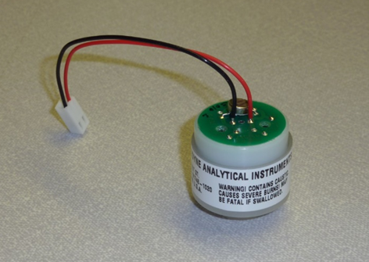
- Using a soldering iron, remove the black and red wires. | 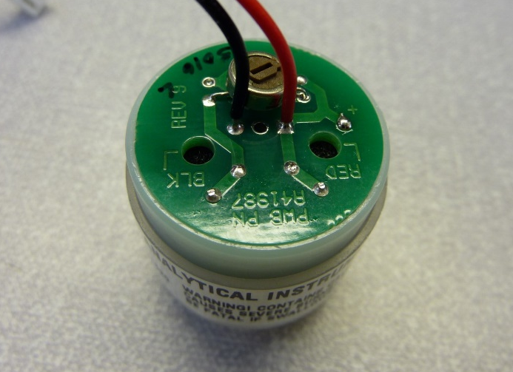
- Ensure that the PCB is free from any excess solder or residue. | 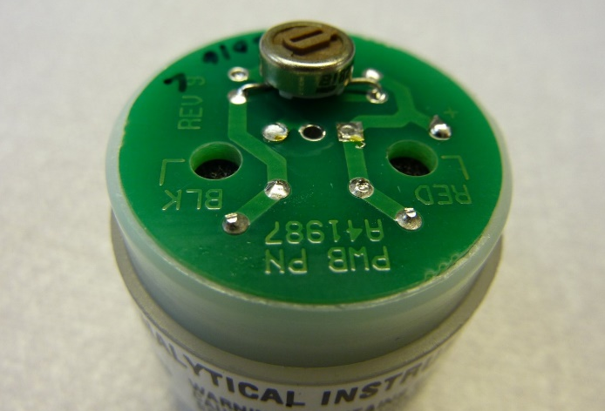
- Using the flat edge of a Stanley knife, remove a small area of surface lacquer from in front of the solder contacts. | 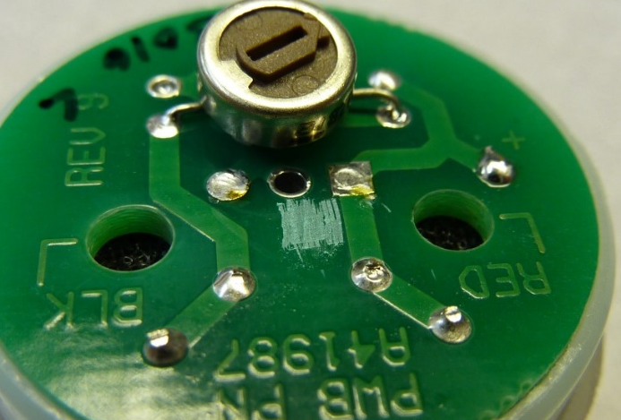
- Using small pliers, remove the marked contacts. | 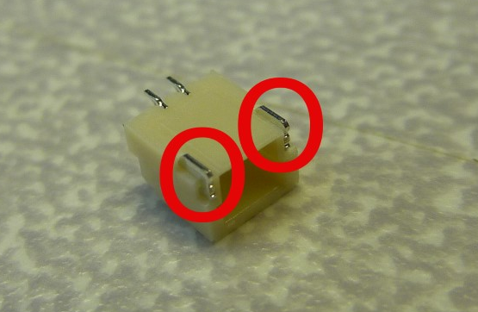
- Splay the solder contacts to around a 30° angle. | 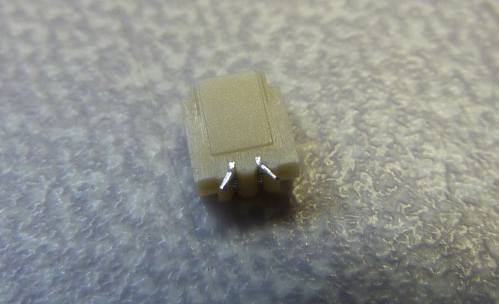
- Place a drop of super glue on to the de-lacquered area of the PCB. | 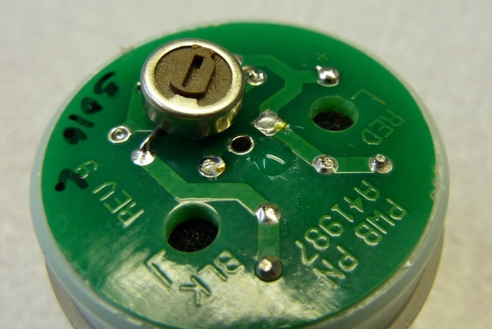
- Place the JST connector on to the super glue, ensuring that the connector contacts align with the contacts of the PCB. | 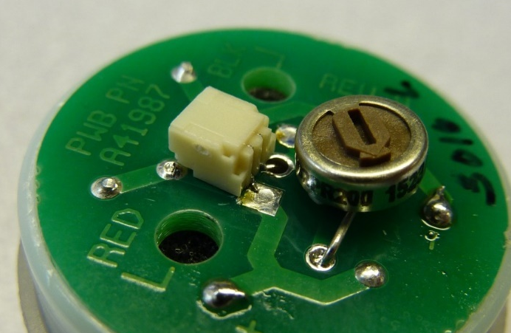
- Solder the connector into place. | 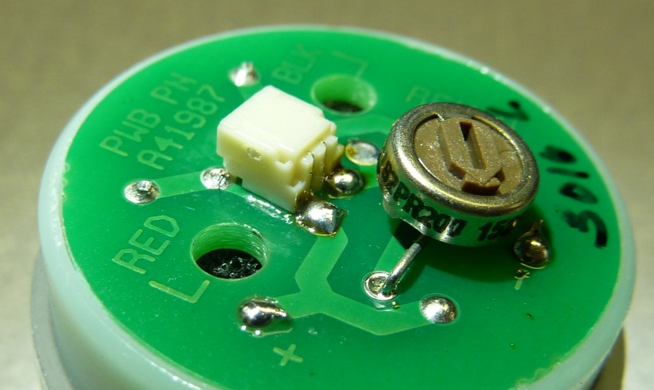
- Using a Stanley knife and steel rule, remove the excess from the bottom on the serial number label. | 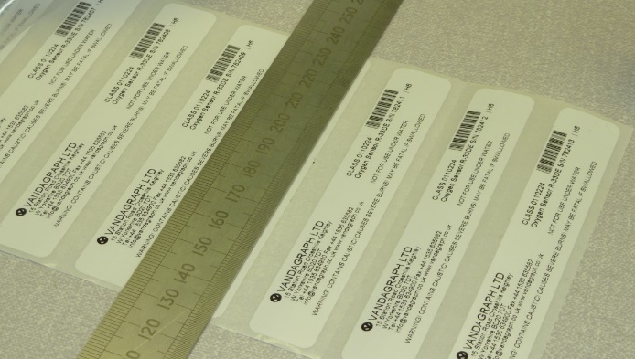
- Remove the Teledyne label (R-33S1) and replace it with the Vandagraph (R-33DE) label with the same serial number.  NB. To ensure retention of the original serial number, each sensor should be done individually. | 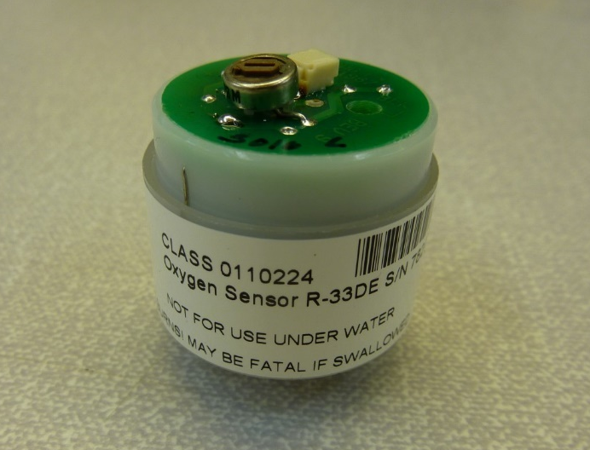
QA:
- Using the appropriate test lead, connect the sensor to a digital volt meter. | 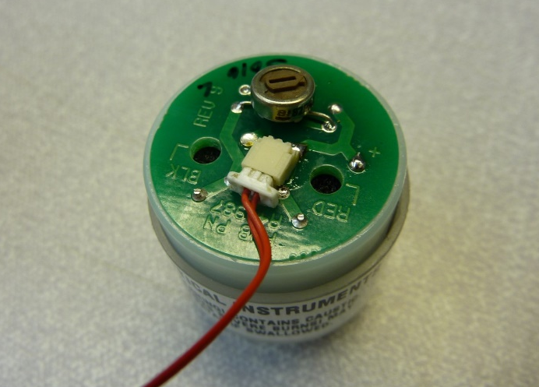
- Set the digital volt meter to the millivolt scale.  - Observe the output of the sensor. The output must be between 23mV and 27mV.  - Using the Intrastats system, mark the sensor as having passed or failed QA as applicable. | 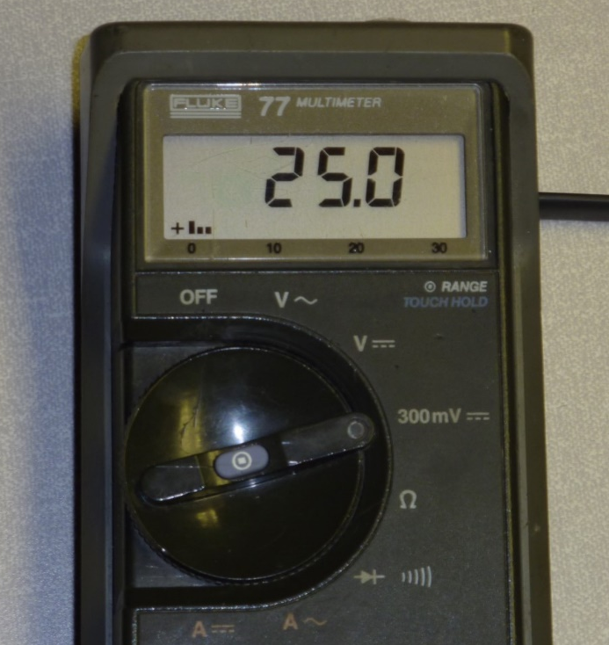
Packing:
- Take a sensor that is to be packed, note its serial number, and affix that corresponding bag serial number label to the bag. | 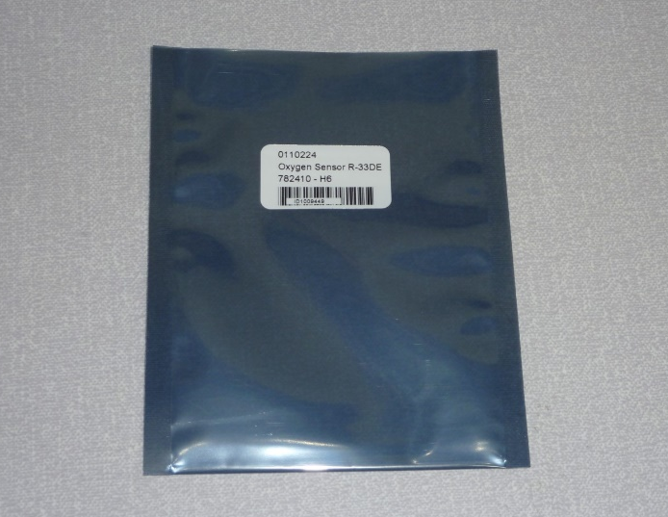
- Place the sensor in the bag.  - Using a strip heat sealer, seal the sensor into the gas barrier bag.  - Once passed, place the finished product, along with the production sheet, on to the production shelf to await stock entry. | 