Completing a RMA

Once we have received paperwork stating either a repair or a credit from a supplier.

First go to the file marked supplier returns sent back to supplier. Located on spare desk of goods out. In this file are all the current repairs out with supplier, they are sectioned off by supplier. Please note that Honeywell will have two sections one for Viamed repairs and one for VST repairs.

In the file locate the correct returns paperwork from the file that matches the returned supplier paperwork.ie Matching supplier name and also the RMA number that will be on all paperwork. Pull this copy of the paperwork out.

Paperwork will look like below.
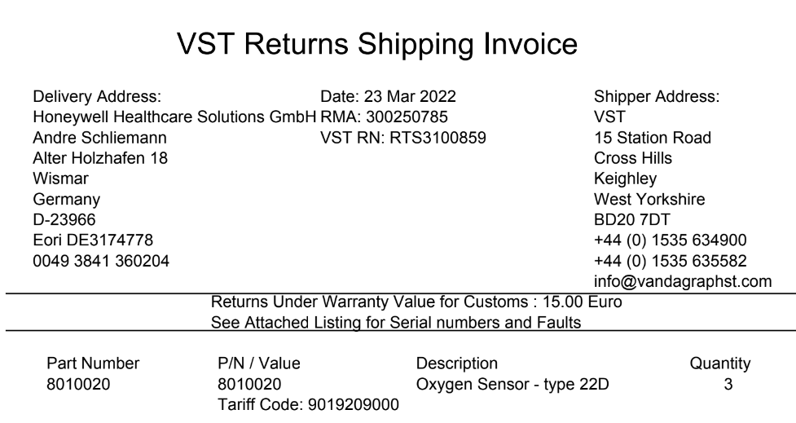

Or for Viamed

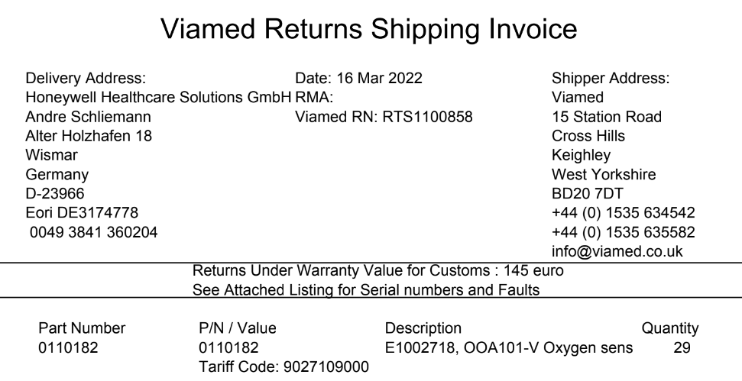

For credits we will receive paperwork by email back from suppliers

Honeywell will sent a copy of a credit invoice and a fault report.
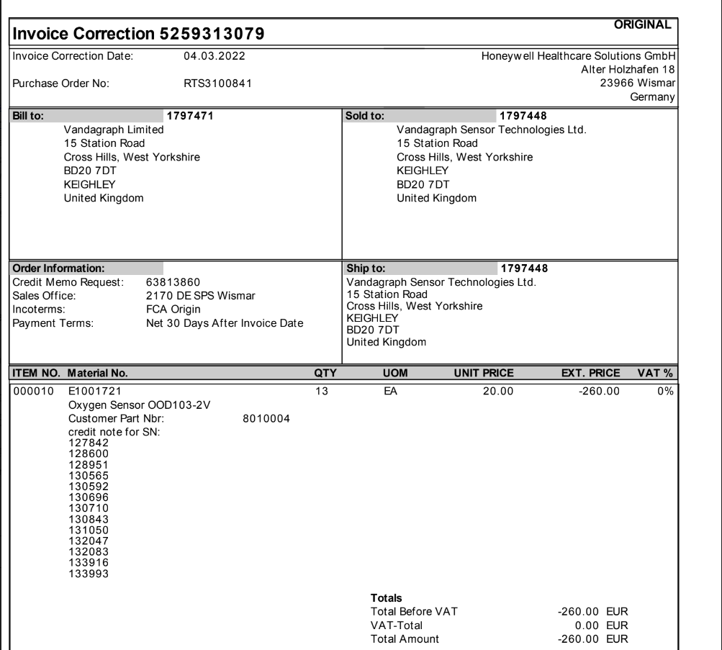

Maxtec will send a copy of a credit note/invoice by email

Repair paperwork will be sent back with products.

Go to return tab on top line of intrastats and press enter. This will display a list
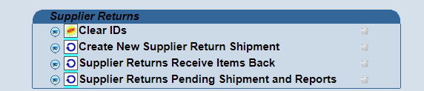

Click on the icon that stays supplier returns receive items back. This will now open a new screen up, which will be a list of all the outstanding repairs that we have with our suppliers.
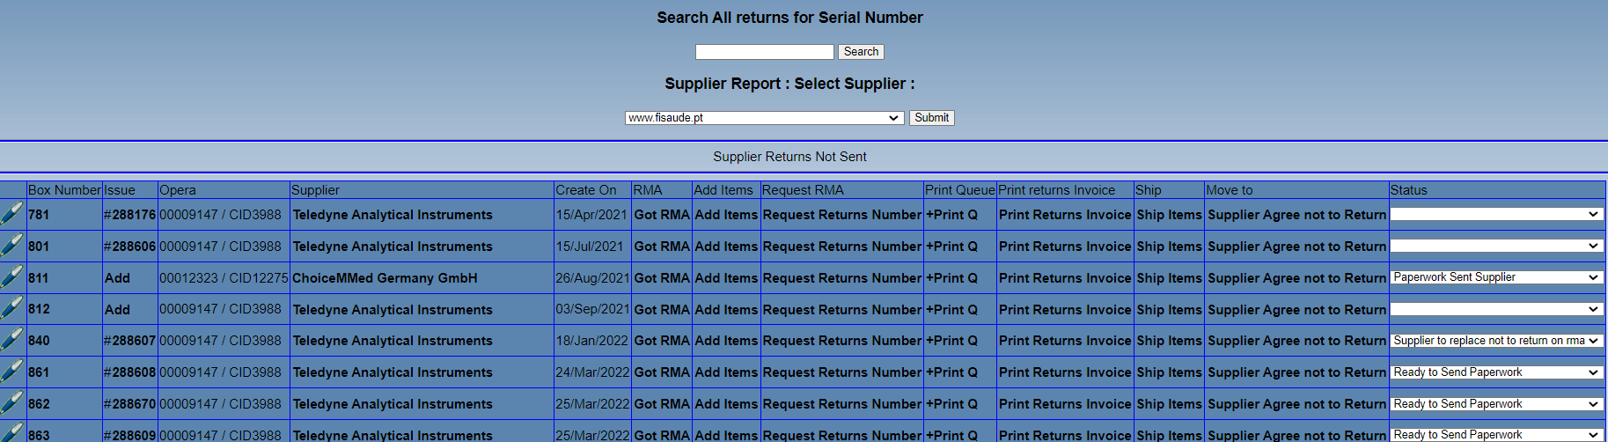

Locate the correct repair from the list. This must match what is on the paperwork received back. Supplier name, RMA number and also box number (only on our paperwork)

Once identified press the icon that states return items on the correct repair, this will open up a new window.
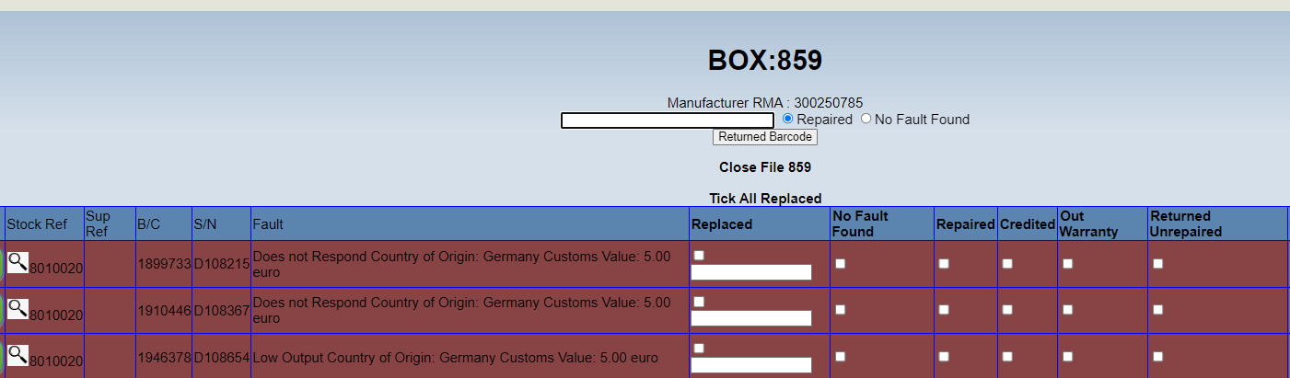

Then from the information provided from the supplier, double check the details. If this is a credit then click the box that states credit, if the item has been replaced then tick that box and also enter the replacement serial number. Once all items have been entered print out a copy of the page, then click update details.
Go back into repair icon and back to repair supplier receive, locate the repair that you have just completed, go to the end of the line and press the close file button, only do this if you are fully completed.

Sign and date the paperwork, scan the completed paperwork into L drive under current month and year. Label as RMA number xxxx supplier name and date. And save.
Staple all paperwork together and place in the completed returns folder located in goods in.

If we have received a credit from the supplier, please send a copy of the credit note to our accounts, by either email or skype.

If it was a VST credit, send an issue to Steve Nixon with all the paperwork for him to arrange a credit for the customer, also update the SRS that is on the system, and upload the supplier paperwork received back to the SRS and also state that this has been passed to manager to arrange credit and also add the issue number to the notes.

If its a repair, update the SRS and upload the returns paperwork , make a note on the SRS to state that we have received the repair back from supplier. Then put the repair back into its correct repair ducket located in the repair section, and then pass back to the engineer asking them to check it over before we return back to customer.

