Technical Assessment of Dehas periPAP Neonatal Resuscitator

First impressions are that the device looks robust, with a cleanly engineered body block with a chamfered edge to soften any sharp angles.

On the rear of the body block is a mounting slide, which allows the device to mount into a standard blender mounting bracket: for testing purposes, we used a standard Bio-Med Devices rail mount but it did seem quite loose, allowing the blender to rock to the left and right approximately 10 degrees.

Question: are dedicated brackets available?

The gauge is manufactured by Wika, which we know from experience to be reliable. However, it is marked with a mbar scale, whereas neonatal guidelines in the UK refer to pressures in cmH20 as the default unit (the Wika gauge used on Viamed’s Tom Thumb resuscitator had cmWG printed on the face).

The flowmeter looks to be modern, with a gas inlet on the right-hand side. The inlet appears to be configurable to the left-hand side if required, but not to the back (which might be advantageous to keep the hose out of the way) due to the fixed safety release valve obstructing that rear port.

The fixed safety release valve is a Witt valve with 30 mbar etched onto it, but the device manual states that this is fixed at 25 mbar.
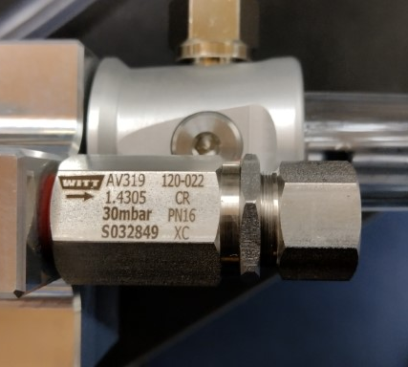
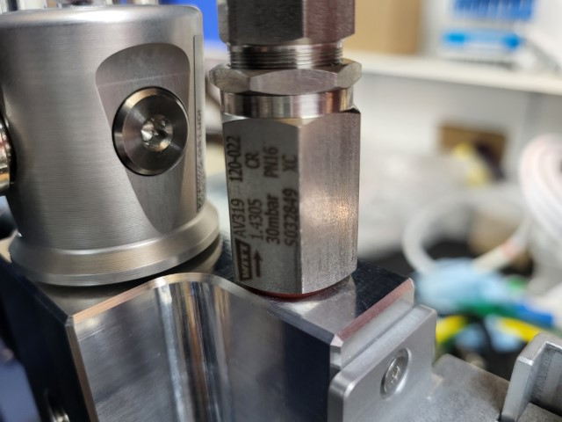

I query whether this would be suitable for use in the EU or UK, as European resuscitation guidelines state that “...higher initial pressures may sometimes be required, with median peak pressures of 37 cm H2O required for successful stabilisation.”*
*[Source: European Resuscitation Council Guidelines 2021: Newborn resuscitation and support of transition of infants at birth.]

Question: can this valve be adjusted and is the maximum configurable setting 30 mbar?

Attached to the underside of the device is an Ambu PEEP valve, which is being used to set the Peak Inflation Pressure (PIP) value.
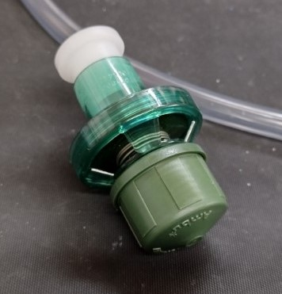
I have concerns over whether this valve is suitable as it only allows for a maximum PIP of 18mbar, which does not comply with the current UK newborn resuscitation guidelines:

“A starting pressure of 25 cm H2O is suggested for preterm infants < 32 weeks gestation.”*
“Inflation pressures: Term: 30 cm H2O. Preterm: 25 cm H2O”*
*[source Newborn resuscitation and support of transition of infants at birth Guidelines, Resuscitation Council UK]
Operational Testing

Testing the device revealed immediately that the Ambu valve being used to set the PIP was emitting a loud rasping sound, which sounds very similar to the alarm emitted by an air/oxygen blender reed valve when a gas pressure differential is present.

The rasping sound was present at around 6 L/min flow rate, getting louder as flow rates increased. In the UK, flow rates of 5-7 L/min are routinely used during neonatal resuscitation.

As a minimum, this would be very distracting for the user; in the worse case, it may cause a false alarm condition that contributes to patient risk.

The PIP is adjusted by adjusting the PIP valve attached to the bottom of the device. This valve is inserted into a push-fit adapter, which is in turn screwed onto a thread on the bottom of the periPAP.

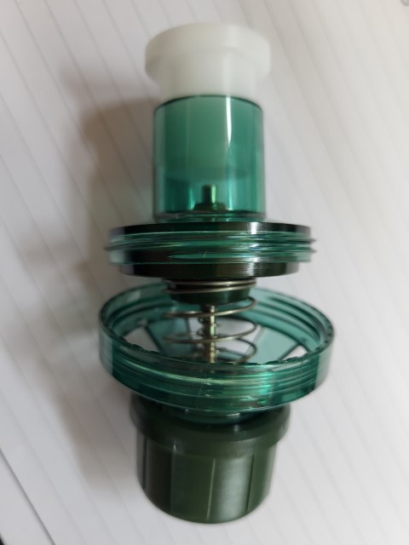
By inadvertently operating the valve incorrectly (by holding the valve body rather than the knob), it is very easy to make the valve come apart.

As this valve is positioned underneath the device and out of view, it is not inconceivable that a user might make this error.

Additionally, when used in the same manner, if the valve doesn’t come apart, the whole valve and adapter assembly can be very easily unscrewed from the base of the periPAP. It is reasonable to expect that dismantling of this nature would require the use of tools, unless the valve is considered single-patient use.

The flowmeter seems very insensitive to adjustment, requiring 3.5 full turns to reach 5 L/min, and 4.5 full turns to reach 7 L/min. This makes setting up the device slightly slower. By contrast, the Tom Thumb device reaches these values in under half a turn with no problems in accurately setting the flow rate.

Fixed Safety Valve Pressure Tests

The Instructions For Use states that the fixed safety release valve is set at 25 mbar, the valve itself claims a maximum pressure of 30 mbar. During testing, these pressure values were massively exceeded at all flow rates, causing a serious over-pressure condition.

Flow rate  L/min | Pressure mbar  (0.5 resolution)
1 | 41.5
2 | 44
3 | 46
4 | 47
5 | 48.5
6 | 51
7 | 52.5
8 | 54
9 | 55
10 | 56.5
11 | 58
12 | 60
13 | 62
14 | 63
15 | 64

Conclusion

In its current form, the device does not appear to be compliant with the UK or European Resuscitation Council Guidelines as it does not use a suitable PIP valve to deliver pressures in the correct range for neonatal resucitation.

The device does not adequately protect against excess pressure delivery.

