Keith Douglas  Medical Engineering  Kings College Hospital  Faraday Building Ground Floor  Denmark Hill  London  SE5 9RS | Purchase order number: **  Serial number: **  Last Serviced: **  Ref: 20180723/499  07 February 2023
Dear Mr Douglas,

Certificate of Calibration and Service Options: Microstim DB3 Nerve Stimulator

I am writing with regards to the Microstim DB3 Nerve Stimulator that your organisation has previously purchased from Viamed.  In order to comply with local standards and in response to customer requests, we offer the following servicing options. | 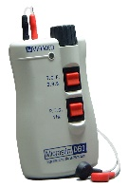
- Service and Certificate of Calibration – The following are checked and assessed: ??
The price for this is £45.00 plus £12.00 return carriage (excluding VAT) –
part number 2540010.
- Repair Service – This covers the labour on a cost of per hour basis to repair a returned faulty Microstim DB3. We will provide a quotation before any work is carried out.

Should you wish to utilise one of these services, please advise us of the serial number/s of the unit/s and we will provide you with a returns reference number. When returning units to us, please may we ask that you ensure that the packing is adequate and we advise that you use a traceable delivery service.

So that we can keep our records up-to-date, if the Microstim DB3 is no longer in service, please email service@viamed.co.uk with the serial number/s and we will update our records accordingly. Please be aware this product is now discontinued. We do have an alternative available: TOF^{3D} Neuromuscular Monitor, please contact us for a quote.

Should you have any further queries or require any further information, please do not hesitate in contacting us.

Yours sincerely
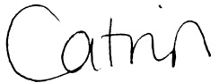
Catrin Hollings
Marketing

