Richard Tuckwood
Medical Equipment Services Department
Nottingham City Hospital
Hucknall Road
Nottingham
NG5 1PB

24th June 2022
Dear Richard,

Re. Sale Or Return trial, ref. SOR947

Please find enclosed a MaxO2ME Oxygen Monitor with pole clamp, which we have supplied on a 30 day Sale Or Return basis at the request of Sefanos Choptiris in the Trent Cardiac Centre.

• 1x MaxO2 Oxygen Monitor - s/n HD71499002
• 1x V-mount pole clamp

The trial is without obligation; if the instrument does not prove suitable, please just return it in its original condition by a traceable service complete with all the original packaging and any accessories.

Please be aware that Viamed does not operate with field sales representatives and unfortunately, we are not able to provide application training for this device. Viamed asks that the Trust gives due consideration to this prior to purchase.
If the trial is successful and the Trust wishes to purchase the instrument, we would just need a Purchase Order to cover the items already supplied. I have previously sent a quotation via email (quote ref. QVM137784), if you purchased multiple units we would make up the balance and leave this one with the Trust, as it is new and unused when supplied.
I would appreciate it if you could attempt to collate some feedback to help us to understand the Trust's decision regarding suitability, regardless of the outcome, as this is an important part of our ISO procedures and helps to guide product development.

If you have any queries, please do not hesitate to contact me.

Your sincerely,
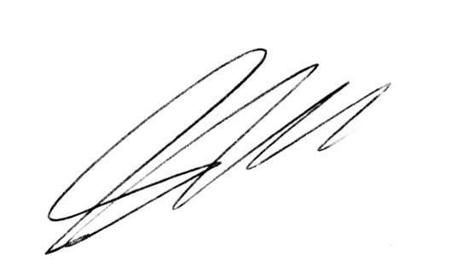

Steve Hardaker
Technical Support Manager

