Technical Investigation – Stability of MaxO2 ME with V-Mount Pole Clamps

A report was received from Maxtec that originated from Southmead Hospital regarding the security of Maxtec MaxO2 ME when mounted using a V-mount pole clamp. Southmead Hospital is a large National Health Service (NHS) hospital in Bristol, UK.

Paul Derman, Head of Clinical Equipment Services at Southmead Hospital, reported the following quality concerns in an email to Maxtec on 22nd February:

“Please can you advise if you produce a substantial monitor clamp for the Maxtec O2ME analyser. We routinely repair devices which have been knocked out of the basic pole clamp. We are required to tether new devices using a hole drilled in the bracket and looped around the battery compartment ring. This stops the monitor from hitting the floor when easily knocked out of the clamp. This is useful to stop damage, although NICU express their dislike for the system.
I am having difficulty persuading them to purchase more devices with this current arrangement.
The design of the monitor and its operation is excellent, although is let down by the clamp v grove attachment. Can you offer any substantial/secure alternatives?”

In a conversation with Paul Derman I found that the devices are falling from the pole-mounted V-mounts with even a very slight impact; as little as brushing a hand against the unit.

Using a MaxO2 ME and R206P75 pole mount with V-mount socket, I found this to be the case: a slight lateral pressure on the device causes it to rotate within the V-mount and fall out through the bottom of it. This occurs even if the device is forcibly inserted into the V-mount.

Closer inspection of the kick-stand on the MaxO2 ME reveals that the profile of the edge does not follow the same angles as the corresponding V-mount, and due to a change in the angle of this edge, results in very small points of contact within the V-socket (highlighted in yellow in fig.1).

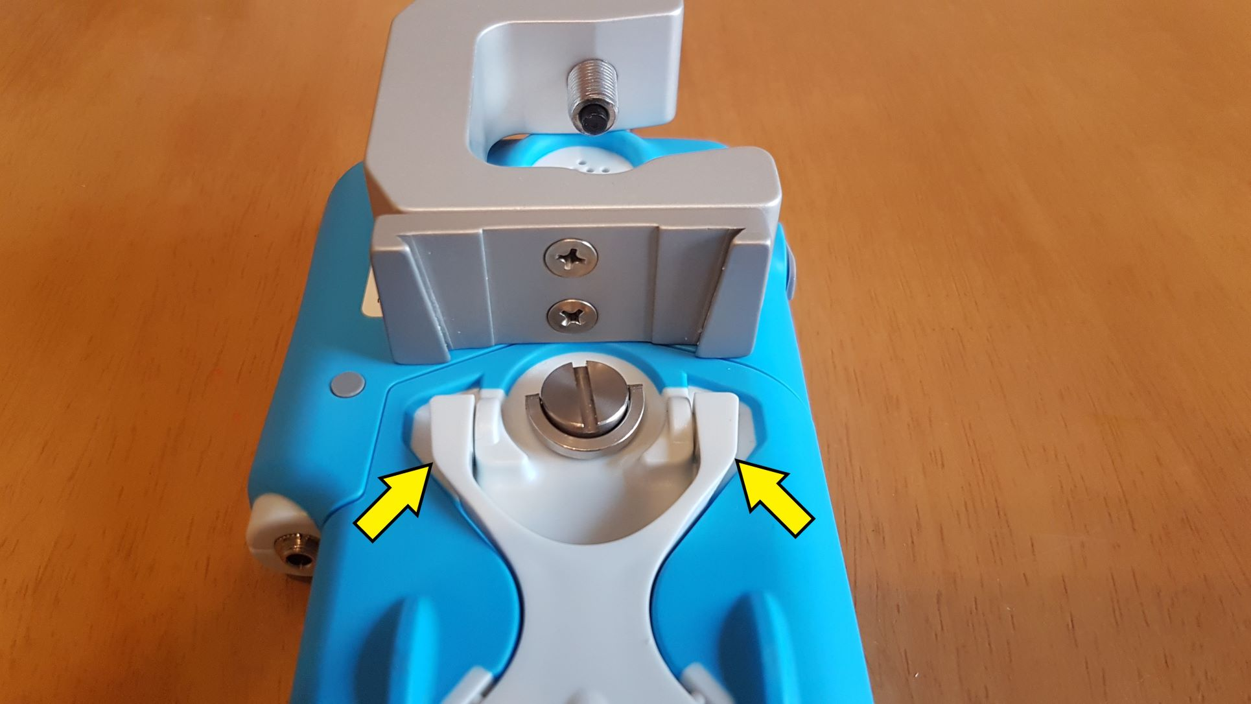
Fig.1

Furthermore, at the point where the angle on the side of the dovetail kick-stand changes (marked by the arrows), the profile is a curve, resulting in a rounded edge that allows the device to ‘roll’ when a sideways lateral force is applied to the top or bottom of the device.

A third contributing factor is that the point where the V-mount mates to the kick-stand is central on the device, allowing a very small lateral movement of the top of the device to create a moment of force that translates into a rotation at this central point, causing the device to roll within the mounting clamp and subsequently fall through the clamp with very little rotation required. A short video of this is available as an addendum to this written report.

Proposed solutions

Solutions are to be investigated by Maxtec. To provide supporting input to that process, my observations are that in order to continue to use the MaxO2 ME with a V-mount, the dovetail profile and V-mount socket profile need to be more closely matched. As V-mounts are largely universal, this would suggest a re-design of the dovetail kick-stand on the back of the device is the appropriate solution.

A secondary solution would be to source or design a mounting clamp that utilises the battery door retaining thread* on the rear of the MaxO2 ME, which is used to hold the battery door in place, as a secure mounting option. I have attempted to use photographic mounts with little success as the threaded screws on those items are too short to grab the recessed threads in the MaxO2ME unless the battery door is removed completely.
Viamed does not currently have a solution to offer Southmead Hospital: I have advised that we will investigate and hope to offer a solution in due course as their future purchases of oxygen monitors will depend upon this.
*Note: the MaxO2 ME data sheet specifies this as a M16x1 thread, but I have determined it to be a 1/4”-20 UNC / M6x1 thread, as commonly used on optical and photographic equipment.

