Below are my comments on the revised draft Instructions For Use for Bluepoint Temperature Probes, provided in the sales meeting on Wednesday 9th November 22.
- SJH 11/11/22

Suggest all instances of the phrase “instructions for use” be in Title Case, i.e. “Instructions for Use” or “Instructions For Use”.

Accuracy spec disagrees with our latest (Sept 22) leaflet. If this is correct, leaflet needs changing.

Response time spec for Neonatal has changed from 15s on previous instructions to 25s on these, is that correct?

Cleaning agents: Lists 2 types: Neodisher is a German product, I’m not sure if this is used in the NHS but the second listed product is by Steris and is used in the NHS, which gives us a UK cleaning solution.

However, the IFU doesn’t state the specific agent - Prolystica is the brand name, I can see at least 3 different types (i.e. Neutral, Enzymatic and Detergent) but they haven’t specified which type applies.

Sterilization: Hospitals in the UK must adhere to HTM-01-01 Part D:

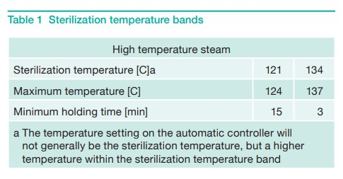

This standard states that in a 134C cycle, temperatures may be up to 137C. The Instructions allow for the following: “134C, 5 min hold time, 20 min drying time” with the caveat: “Temperatures up to 134C and higher hold time as described above are acceptable” but it doesn’t mention temperatures above 134C. As the table above shows in comment a) it will generally be a higher temperature within that band of 134C to 137C.

It would be fully compliant if they can add a statement that temperatures up to 137C are acceptable, if this is in fact possible. We will likely get asked this.

Storage: Grammatical error, should say “Store protected from dust…”

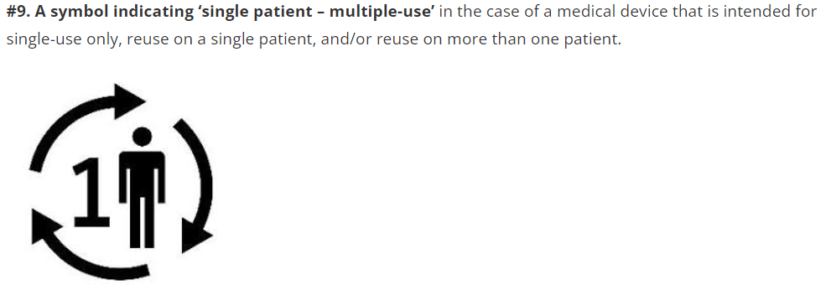
If the temperature probes are being certified under MDR, they will need the new symbol relating to ‘single patient – multiple-use’, it might be prudent to add it now.

No UK REP

No CE Mark

No UKCA but I assume not applied, does it require ‘Pending’ statement?

