Below are my comments on the revised draft Instructions For Use for Bluepoint Temperature Probes, provided in the sales meeting on Wednesday 9th November 22.
- SJH 11/11/22

Suggest all instances of the phrase “instructions for use” be in Title Case, i.e. “Instructions for Use” or “Instructions For Use”.
Comment: no problem, we will change to ‘Instructions for Use’

Accuracy spec disagrees with our latest (Sept 22) leaflet. If this is correct, leaflet needs changing.
Comment: Yes, the values specified in the draft IFU are correct.

Response time spec for Neonatal has changed from 15s on previous instructions to 25s on these, is that correct?
Comment: all response time values have been validated by our third party lab and are correct based on ISO 80601-2-56 requirements. Please note that the values may vary from probe to probe. Therefore we specify ‘…< 25 s’. The information in the IFU is covering all types of probes (R/O and Skin). Therefore, the slowest types (Skin probes) have the highest response time, which is listed in the IFU.

Cleaning agents: Lists 2 types: Neodisher is a German product, I’m not sure if this is used in the NHS but the second listed product is by Steris and is used in the NHS, which gives us a UK cleaning solution.
Comment: neodisher is a German product. However, it is listed at the NHS (https://www.cleaning-matters.co.uk/page_292000.asp). So no need to change now.

However, the IFU doesn’t state the specific agent - Prolystica is the brand name, I can see at least 3 different types (i.e. Neutral, Enzymatic and Detergent) but they haven’t specified which type applies.
Comment: will double-check for the specific type. As far as we know, all Prolystica types have the same work mechanism, but are adjusted for sensitive (neutral) devices or machine or manual use.

Sterilization: Hospitals in the UK must adhere to HTM-01-01 Part D:

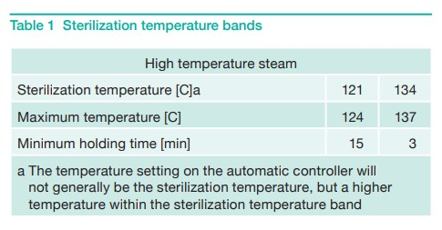

This standard states that in a 134C cycle, temperatures may be up to 137C. The Instructions allow for the following: “134C, 5 min hold time, 20 min drying time” with the caveat: “Temperatures up to 134C and higher hold time as described above are acceptable” but it doesn’t mention temperatures above 134C. As the table above shows in comment a) it will generally be a higher temperature within that band of 134C to 137C.
Comment: is it acceptable for Viamed to have a separate statement from the manufacturer that the probes can generally stand temperatures above 134°C (up to 137°C)? Technically the efficacy of the sterilization is guaranteed at higher temperatures (final validation of efficacy has been made at 132°C).

It would be fully compliant if they can add a statement that temperatures up to 137C are acceptable, if this is in fact possible. We will likely get asked this.

Storage: Grammatical error, should say “Store protected from dust…”
Comment: ok, we will change to ‘Store protected from …’

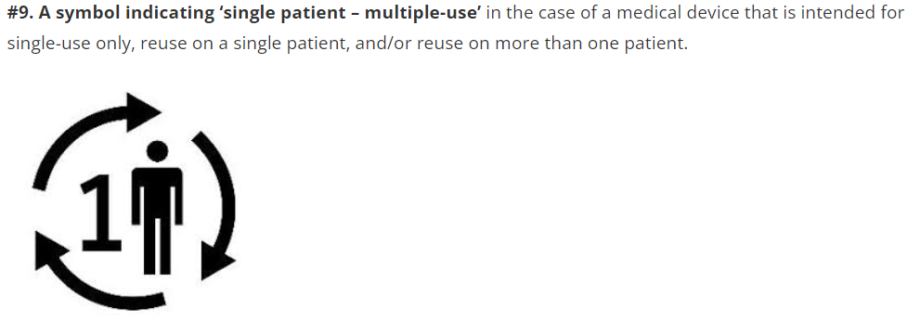
If the temperature probes are being certified under MDR, they will need the new symbol relating to ‘single patient – multiple-use’, it might be prudent to add it now.
Comment: this symbol does in general not apply to our temperature probes as they are defined as ‘multiple patient – multiple use’.
No UK RP
Comment: we do not know of a legal requirement, that UK responsible Person needs to be mentioned in IFU or labels. However, we have a UK Rep. since more than one year.

No CE Mark
Comment: OK, we will add it.

No UKCA but I assume not applied, does it require ‘Pending’ statement?
Comment: we do not plan to make those kind of statements. It might be confusing to customer and users.

