Department Manager
<<Department>>
«COMPANY»
«ADDRESS1»
«ADDRESS2»
«ADDRESS3»
«CITY»
«ZIP»

Ref: 20190703/0191197/386D

September 2022

Dear Sir or Madam,

Flowsensors
For flow measurement of gas delivered by anaesthesia systems and ventilators

SpiroTrue A and A(PC) Hot-wire flow sensor for use with Dräger ventilators

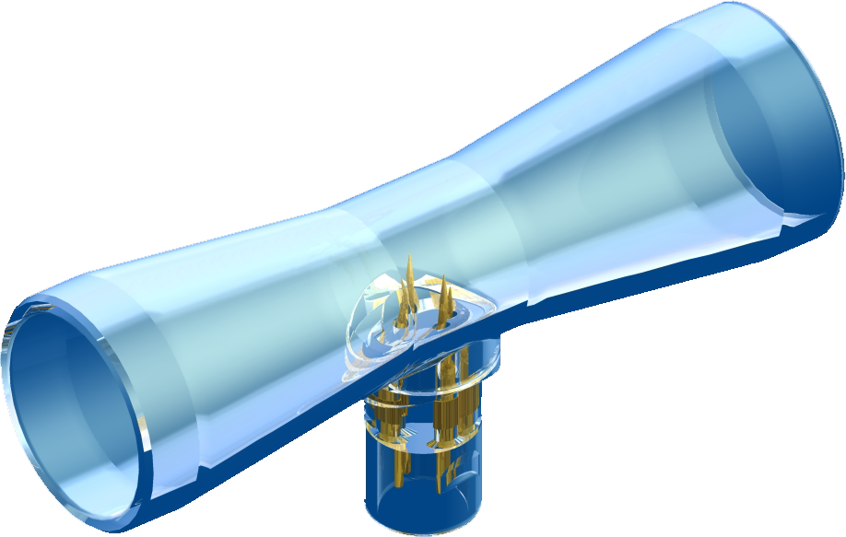
In 2009 Viamed introduced the 4310001 SpiroTrue A flow sensor, which is compatible to the Dräger Spirolog® flow sensor part no. 84 03 735. The sensor can be disinfected and in practice used either on single or multiple patients - depending upon the application and in accordance with local guidelines.

As clinical practices do vary - we have developed an autoclavable version of the sensor, in order to meet with market requests. In turn this allows users to abide by differing local protocols and guidelines, and to also meet with all interpretations of current and future regulations.

This variant, the SpiroTrue A(PC) is compatible to the standard version, but is manufactured from strong Polycarbonate material as opposed to ABS plastic. The SpiroTrue A(PC), which is compatible to the Dräger SpiroLife® flow sensor part no. MK 01900, is also available at the same competitive price.
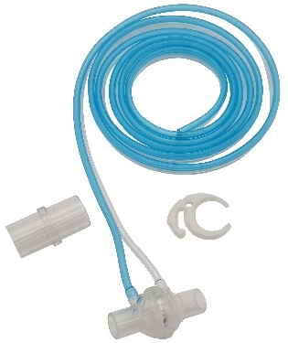
SpiroTrue H Differential pressure flow sensor for use with Hamilton ventilators

The SpiroTrue H is compatible to the Hamilton Medical H7000 Accu Tach flow sensor for use with Hamilton Medical: Aladdin, Amadeus, Arabella, C1, C2, Galileo, H72, VR1, H7200, MR1, Raphael, S1, T1, Veolar…

Please find enclosed full details on our flowsensor range including price list overleaf. Should you require further information please contact a member of our sales team on 01535 634542.

Yours sincerely

Catrin Hollings
Marketing

