Roger Smith
Leicester Royal Infirmary
Neonatal Unit
Kensington Building
Infirmary Square
Leicester
LE1 5WW

Dear Roger,

Re: Tom Thumb service exhange units ref. SOR939

Please find enclosed 3 Tom Thumb TT480 service exchange units to allow you to return your 3 devices for annual service.

Barcode | Serial Number | Description
836911 | SE006 | Tom Thumb Infant Resuscitator
836912 | SE007 | Tom Thumb Infant Resuscitator
836913 | SE008 | Tom Thumb Infant Resuscitator
Please can you send your devices back to us using returns ref SRS67998 to the following address:

Returns Dept – SRS67998
Viamed Ltd.
15 Station Road
Cross Hills
Keighley
BD20 7DT
We will service your units and return them to you as soon as possible.

Regards,
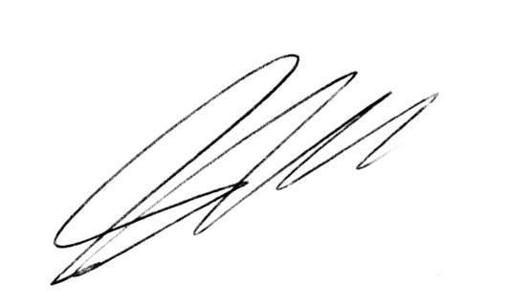
Steve Hardaker
Technical Support Manager
Viamed Ltd.

